**Documentation**

**Of**

**Automation Testing Using**

**Selenium IDE on IMDb.com**

**TABLE OF CONTENTS**

1. Test Plan Identifier………………………………………………………………………………..3
2. References………………………………………………………………………………………..3
3. Introduction………………………………………………………………………………………3
4. Test Items…………………………………………………………………………………………4
5. Software Risk Issues………………………………………………………………………………4
6. Features to be tested………………………………………………………………………………5
7. Features not to be tested………………………………………………………………………......6
8. Approach………………………………………………………………………………………….6
9. Item pass/ fail……………………………………………………………………………………..6
10. Suspension Criteria and resumption requirements………………………………………………..7
11. Test deliverables…………………………………………………………………………………..8
12. Remaining test task……………………………………………………………………………….8
13. Environment needs………………………………………………………………………………..9
14. Schedule…………………………………………………………………………………………..9
15. Planning risks and contingencies………………………………………………………………...9
16. Glossary…………………………………………………………………………………………10

**TEST PLAN FOR IMDB WEBSITE**

**TEST PLAN IDENTIFIER**

**Test Plan ID – IMDB-WEB-TEST-001**  
This test plan focuses on testing the IMDb website using Selenium IDE. The test plan includes multiple test cases, each designed to validate specific functionalities of the IMDb website, such as search, user login, navigation, and media playback. To ensure a thorough evaluation, tests will be executed across various browser types and operating systems.

**REFERENCES**

The following references were used to guide the creation and execution of this test plan:

1. **IMDb Website**
   * URL: <https://www.imdb.com/>
   * Purpose: Primary platform under test. Used to identify functionalities, workflows, and features for creating test cases.
2. **Selenium IDE Documentation**
   * URL: https://www.selenium.dev/documentation/ide/
   * Purpose: Reference for creating, executing, and managing automated test scripts.
3. **Software Testing Standard Guidelines**
   * Source: IEEE 829 - Standard for Software Test Documentation.
   * Purpose: Framework for test planning, execution, and reporting.

**INTRODUCTION**

This test plan outlines the testing approach for the IMDb website using Selenium IDE. It is a Level 1 Test Plan focused on verifying core IMDb functionalities such as search, navigation, login, and watchlist management. The objective is to ensure the platform works seamlessly across different browsers and operating systems.

The plan includes functional and integration tests aligned with the IMDb Web Application Project Plan, with testing resources and tools provided within budget constraints. Testing will focus on user-facing features, excluding backend or third-party service integrations.

Any changes to the plan will follow the change control process, and communication will be coordinated with the development team to ensure timely issue resolution.

**TEST ITEMS**

The following items will be tested as part of this test plan:

1. **IMDb Search Functionality**
   * Verifying the accuracy and relevance of search results when searching for movies, actors, and TV shows.
2. **Navigation to Movie/Actor Pages**
   * Ensuring correct redirection to movie and actor pages from search results or direct links.
3. **User Login and Authentication**
   * Testing the login process with valid and invalid credentials, including password recovery.
4. **Watchlist Management**
   * Verifying that logged-in users can add, remove, and view movies in their watchlist.
5. **Movie Trailers and Media Playback**
   * Ensuring that movie trailers and other media on the IMDb site play correctly without issues.

**SOFTWARE RISK ISSUES**

1. Browser Compatibility Issues

* Risk: The IMDb website may not function correctly across all supported browsers or versions.
* Mitigation: Conduct comprehensive testing on various browsers (Chrome, Firefox, Safari, Edge) to identify and resolve any compatibility issues.

2. Performance and Load Testing

* Risk: Heavy traffic or simultaneous user interactions may cause slow loading times or crashes.
* Mitigation: Perform load and performance testing to ensure the website can handle high traffic.

3. Changes in Website Structure

* Risk: Changes to the IMDb website's layout or functionality during the testing phase may affect test case execution.
* Mitigation: Continuous communication with the development team to stay updated on any changes to the website.

4. User Authentication Issues

* Risk: Problems with the login or account management system (e.g., forgotten passwords, login failures) could affect test execution.
* Mitigation: Verify the robustness of the login system under normal and extreme scenarios, including multiple failed login attempts.

5.Third-Party API Failures

* Risk: IMDb relies on third-party APIs for certain features (e.g., trailers, ratings), which could fail or cause errors.
* Mitigation: Validate API integrations thoroughly and account for potential failures or downtime in test cases.

**FEATURES TO BE TESTED**

1. **Search Functionality**
   * Verifying that users can search for movies, TV shows, and actors using keywords, titles, or actor names, and that results are accurate.
2. **Navigation to Movie and Actor Pages**
   * Ensuring that users can click on search results or links to navigate to the correct movie or actor pages without errors.
3. **User Login and Authentication**
   * Testing the login process with valid credentials, invalid credentials, and password recovery functionality.
4. **Watchlist Management**
   * Verifying that users can add movies to their watchlist, view their watchlist, and remove movies from it.
5. **Movie Trailers and Media Playback**
   * Ensuring that movie trailers, videos, and other media elements play correctly without buffering or issues.

**FEATURES NOT TO BE TESTED**

1. **Backend Database Functionality**
   * Testing of the underlying database, such as database queries, storage, and retrieval of data, will not be part of this test plan.
2. **Third-Party Service Integrations (Beyond APIs)**
   * Integration testing for services outside the IMDb platform (e.g., payment gateways, third-party login systems) is not included in this plan.
3. **Non-UI Related Features**
   * Features such as server-side processing, internal algorithms, or backend APIs that are not visible to the user will not be tested.
4. **Internal Admin Panel**
   * Any functionality related to IMDb's internal admin panel for managing content (e.g., adding movies, editing actor details) will not be part of this test plan.
5. **Non-Core Functionalities**
   * Features such as advanced filtering, sorting options, or advanced search features that are not part of the main user flow may not be included in this round of testing.

**APPROACH (STRATEGY)**

• Testing Tool - Selenium IDE will be used for automating tests.

• Test Cases - 5 test cases have been identified and will be automated using Selenium IDE.

• Execution - Tests will be executed on the latest versions of Chrome and Firefox browsers.

**ITEM PASS/FAIL CRITERIA**

There are just 2 criterias for the tests in Selenium IDE –

Pass - In the context of Selenium IDE, a test "just passing" means it ran successfully and all assertions and actions performed by the script executed as intended. No errors or exceptions occurred during the execution.

Fail - A test "just failing" means that during its execution, an unexpected error or issue happened (e.g., wrong response code, element not found, etc.). The Selenium IDE will report these issues and the test will be marked as failed.

**SUSPENSION CRITERIA AND RESUMPTION REQUIREMENTS**

**Suspension Criteria**

Testing will be suspended under the following conditions:

1. **Critical Defects Identified:**
   * If defects are found that block core functionalities, such as the inability to log in, perform searches, or access movie pages.
2. **Test Environment Unavailability:**
   * If the test environment becomes unstable or inaccessible due to server downtime, network issues, or configuration errors.
3. **Resource Limitations:**
   * Insufficient resources, such as hardware failures or unavailability of tools like Selenium IDE.
4. **Scope Changes:**
   * If significant changes are made to the IMDb application features or functionality that affect the existing test cases.

**Resumption Requirements**

Testing will resume once the following conditions are met:

1. **Critical Defects Resolved:**
   * The defects that caused the suspension are resolved, verified, and marked as fixed.
2. **Stable Test Environment:**
   * The testing environment is restored and verified as stable and accessible.
3. **Updated Test Cases:**
   * If scope changes occurred, test cases are updated to reflect the new requirements or functionality.
4. **Resource Availability:**
   * Required resources, such as testing tools, systems, or personnel, are made available.

**TEST DELIVERABLES**

The following documents and artifacts will be provided as part of the testing process:

**1. Test Plan Document**

* A comprehensive plan outlining the testing scope, objectives, strategy, and approach.

**2. Test Cases**

* Detailed test cases covering the features to be tested, including inputs, expected results, and actual results.

**3. Test Scripts**

* Automated test scripts created using Selenium IDE for executing repetitive test scenarios.

**4. Test Execution Reports**

* Reports detailing the execution of test cases, including pass/fail status, issues encountered, and observations.

**REMAINING TEST TASKS**

1. **Complete Execution of Test Cases**
   * Finish executing all pending test cases, including manual and automated tests.
2. **Cross-Browser and Responsive Design Testing**
   * Validate the website’s compatibility across major browsers and its responsiveness on different devices.
3. **Defect Verification and Test Closure**
   * Retest resolved defects, finalize test reports, and ensure all exit criteria are met.

**Environmental Needs**

* Desktop or laptop with at least 8 GB RAM and a dual-core processor.
* Stable internet connection
* Selenium IDE

**SCHEDULE**

• From [13/11/2024] to [14/11/2024]: Prepare test cases and scripts.

• From [15/11/2024] to [16/11/2024]: Execute test cases and document results.

• From [17/11/2024] to [18/11/2024]: Review test results and finalize report.

**PLANNING RISKS AND CONTINGENCIES**

1. Test Environment Downtime: Risk of website or tools being unavailable; plan alternative schedules.
2. Scope Creep: New features may delay testing; freeze scope before execution.
3. Defect Resolution Delays: Fixes may take longer; prioritize critical issues.
4. Resource Unavailability: Team or tools may be unavailable; ensure backups and cross-training.

**GLOSSARY**

**Test case script**

|  |  |  |  |  |  |
| --- | --- | --- | --- | --- | --- |
| Test  Scenario | Testing https://www.imdb.com/ | TESTER | Preet Gogna | DATE | 19/11/2024 |

|  |  |  |  |  |  |  |  |  |  |
| --- | --- | --- | --- | --- | --- | --- | --- | --- | --- |
| ID | **Test Case** | **Pre-condition** | **Test Steps** | **Test Data** | **Expected Output** | **Post-condition** | **Actual Output** | **Status** | **Comments** |
| TC01 | Signup Test | User is on the homepage of the website. | 1. Navigate to the signup page.  2. Enter a username, email, and password.  3. Click on "Sign Up". | Valid Username valid Email  valid Password | User is successfully signed up and redirected to the dashboard. | User is registered and logged in. | Signup successful | Pass | Signup is working |
| TC02 | Login Test | User has already signed up with valid credentials. | 1. Navigate to the login page.  2. Enter the username and password.  3. Click on "Login". | Valid Usernamevalid Password | User is successfully logged in and redirected to the homepage. | User is logged in and on the homepage. | Login successful | Pass | Login functionality is working |
| TC03 | Scroll Test | User is on the homepage of the website. | 1. Open the webpage.  2. Scroll down to the bottom of the page.  3. Verify content loads as you scroll. | Scroll | Content continues to load while scrolling. | User is able to scroll without issues. | Scrolling without issues | Pass | Test case executed successfully. |
| TC04 | Search Test | User is logged into the website. | 1. Type a query into the search bar.  2. Click "Search".  3. Verify search results are displayed. | Search Query: "movie title" | Relevant search results are displayed. | User is able to view search results. | Search result is visible | Pass | Successfully working |
| TC05 | Logout Test | User is logged into the website. | 1. Click on the "Logout" button.  2. Verify that the user is logged out. | N/A | User is logged out and redirected to the homepage. | User is logged out and on the homepage. | Successfullt logged out and redirected | Pass | Logout working successfully |

* **NEW REGISTRATION**

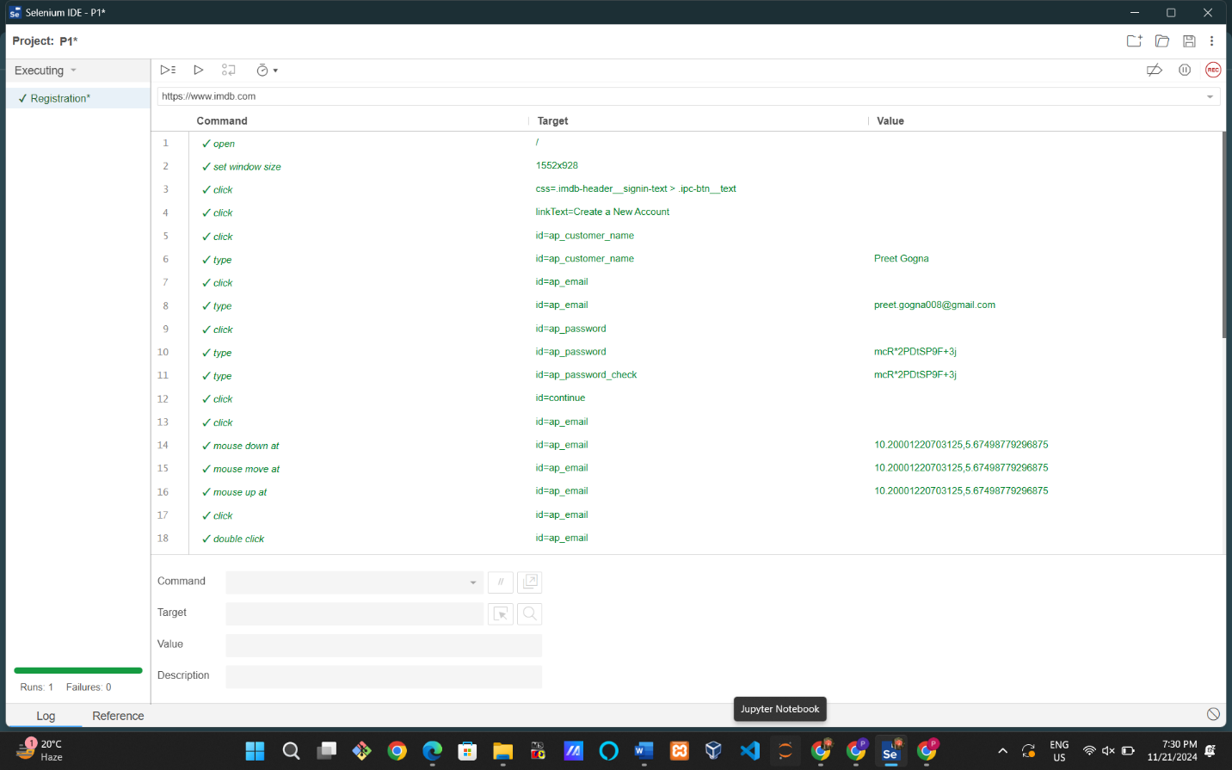

* **Scroll test**

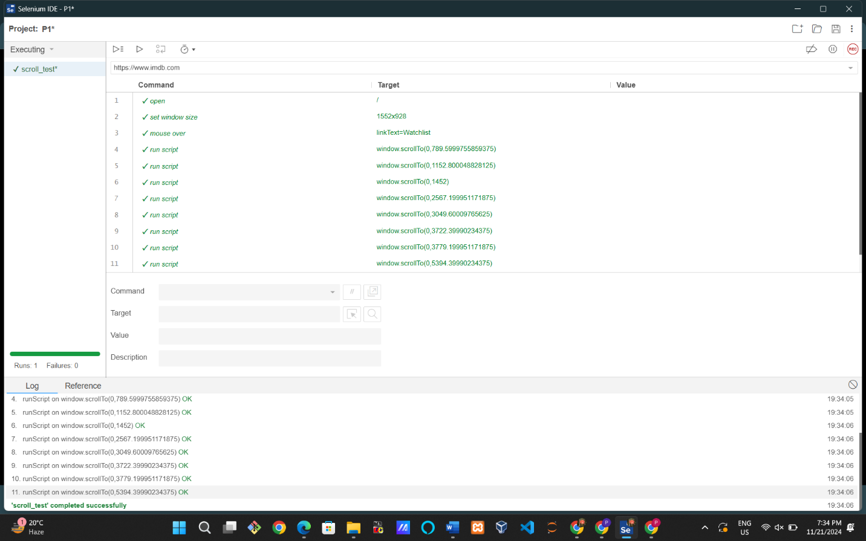

* **Login test**

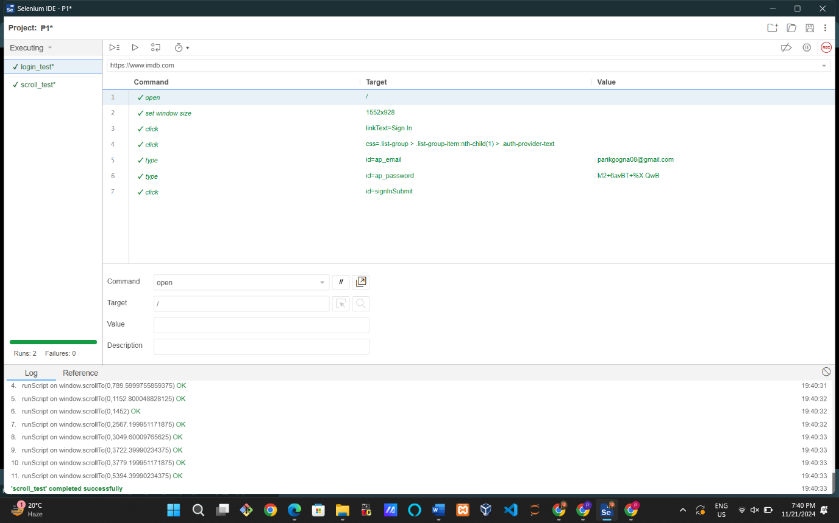

* **Search Bar**

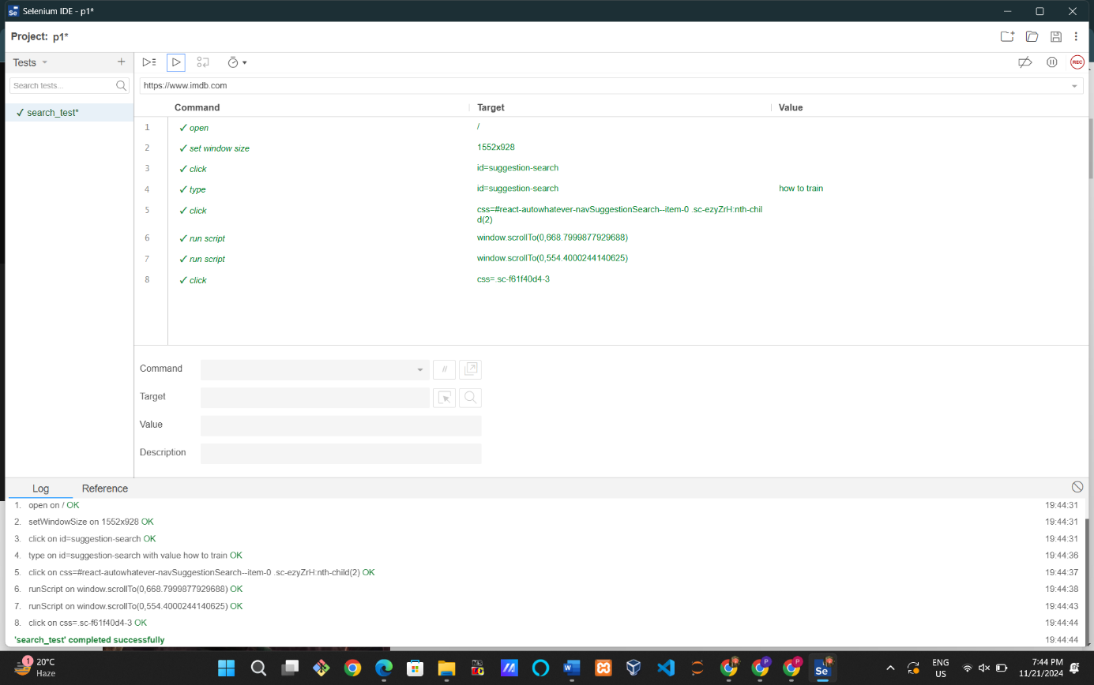

* **LOGOUT TEST**