Unified Context Engine: An On-Premise, Policy- and Requirement-Aware LLM Assistant
CS 540 Final Project Report
Preet Patel
May 6, 2026
This report follows the CS 540 final project outline and summarizes the motivation, research, approach, implementation, empirical results, deliverables, and future work for the Unified Context Engine (UCE).

1. Introduction
The original proposal for this project was titled "An On-Premise, Organization-Bound LLM Assistant for Context-Aware Software Engineering." The central idea was to build a local LLM assistant that could answer software engineering questions using private organizational context rather than relying only on public training data. The project began from a practical gap in current developer assistants: tools such as ChatGPT, Claude, and Copilot can reason over general programming knowledge, but they usually do not know a company's private codebase, policies, data models, architecture decisions, internal documentation, or access-control rules unless that information is manually pasted into a prompt or sent to an external provider.
During implementation, the project evolved from a general context-aware assistant into a more focused system: the Unified Context Engine, or UCE. UCE builds a deterministic graph over code, schema, requirements, policies, and RBAC authority rules, then exposes graph-backed reasoning and gated mutation tools through an MCP server. This modified direction preserved the original privacy and organization-bound motivation, but made the technical problem sharper: the goal became not merely to retrieve useful context, but to make LLM-assisted software engineering accountable to requirements, policies, and role-based authority constraints.

A. Original goals of the project
The original goal was to create an on-premise, organization-bound LLM assistant for software engineering. The assistant was intended to run locally, ingest a representative internal software project, and answer developer questions that a generic cloud LLM could not answer because the required information lived in private source code, internal documentation, logs, or local tools. The proposal emphasized three layers: a local LLM core, a knowledge retrieval layer using RAG and GraphRAG-style structured retrieval, and an MCP-style integration layer for accessing tools and repositories through standardized interfaces.
The original expected outcome was a proof-of-concept assistant that could answer internal development questions with citations to code or documentation. Example target questions included locating API ownership, explaining build failures in the context of a local CI/CD setup, and finding internal usage rules for custom libraries. In short, the original project asked: can a local assistant become useful by grounding answers in an organization-specific context while keeping private data on-premise?

B. Modified goals, why modified
The goals changed because context-aware assistance alone does not solve the more important software-engineering risk: LLMs can produce plausible but policy-violating, requirement-incomplete, or authorization-bypassing suggestions. In practice, a developer assistant needs to know not only where code lives, but also what requirements the code satisfies, what policies govern those requirements, and who is allowed to make particular changes. A longer prompt can help in simple cases, but prompt curation remains non-deterministic. It can miss constraints, overfit to keywords, or produce inconsistent answers across runs.
The modified goal was therefore to build a local, policy- and requirement-aware context engine. Instead of relying on keyword matching or prompt-only reasoning, UCE represents governance facts as graph nodes and edges. Requirements govern tables and columns; policies enforce requirements; files reference schema entities; imports create transitive impact; and RBAC rules define which roles may read, write, or delete protected paths. This made the project more research-oriented: the final system compares a no-tool local LLM baseline against MCP-UCE, measuring whether a model catches policy/requirement violations and whether it breaches RBAC constraints.
The privacy motivation also became stronger. Current cloud LLMs are powerful, but sending proprietary code, schemas, policies, and access rules to external systems raises data privacy and intellectual-property concerns. Because this project targets organization-bound software engineering, I chose to evaluate with a local, small LLM, `llama3:instruct`, rather than framing the system around large hosted models. This choice matches the original on-premise goal and also reflects hardware constraints typical of student and small-team environments.

C. Assumptions you made
The implementation and experiments were conducted on a Windows development machine using PowerShell. The UCE implementation is primarily Python, with the target project written largely in TypeScript/Next.js using a Drizzle database schema. The graph backend is Neo4j, authentication and role-token minting are represented through Keycloak, and the tool interface follows the Model Context Protocol pattern. The local LLM baseline used `llama3:instruct` through a local OpenAI-compatible endpoint. The evaluated target repository was a representative software project with source files, database schema files, requirement Markdown documents, policy Markdown documents, and RBAC Markdown rules.
- Programming languages used: Python for UCE, TypeScript/JavaScript for the target application, Markdown for governance artifacts.
- Operating environment: Windows with PowerShell, local Python 3.12 tooling, local graph/service processes, and local LLM inference.
- Primary datastore assumption: Neo4j can store a deterministic knowledge graph over code, schema, requirements, policies, functions, imports, identifiers, and RBAC rules.
- Security assumption: the assistant should connect to UCE MCP rather than directly to the raw graph backend, because direct graph access can bypass policy and RBAC checks.
- Evaluation assumption: exact requirement IDs, policy IDs, file paths, and RBAC allow/deny decisions are appropriate measurable outputs for comparing no-tool LLM behavior against MCP-UCE behavior.

D. Definitions of terms specific to your project
UCE: Unified Context Engine, the system built in this project. It creates and serves a governance-aware graph over code and software artifacts.
MCP: Model Context Protocol, a standardized pattern for exposing data sources and tools to AI assistants through structured interfaces.
GraphRAG: A retrieval approach that uses graph structure, not only flat text chunks, to retrieve connected context for LLM reasoning.
Requirement: A project-level rule describing what the software must preserve, such as required schema fields or audit properties.
Policy: A governance artifact that enforces one or more requirements.
RBAC: Role-Based Access Control. In UCE, RBAC rules define whether viewer, editor, or admin roles may perform read, write, or delete operations on paths.
No-tool LLM baseline: A local LLM that receives pasted static context only and cannot query UCE, Neo4j, files, grep, or MCP tools.
MCP-UCE: The graph-backed, MCP-exposed UCE system that performs deterministic impact analysis and RBAC-gated mutations.

E. Summary of approach that you followed
The final approach was to turn software context and governance context into a single graph. Code ingestion parses files, imports, functions, classes, method declarations, and identifiers. Schema ingestion parses tables and columns. Requirement ingestion links requirement IDs to tables and columns through deterministic evidence. Policy ingestion links policies to the requirements they enforce. RBAC ingestion converts authority rules into enforceable role/path/operation constraints. The resulting graph supports queries such as: if a table or column changes, which files, requirements, and policies are implicated? If a user with a given role tries to mutate a path, should the system allow the action?
This strategy separates two jobs that are often blurred together in LLM applications. The LLM can still explain, summarize, and interact conversationally, but UCE handles the source-of-truth reasoning for impact, requirements, policies, and authority. This is the main design contribution: use the LLM as an interface and reasoning partner, but use deterministic graph relationships and RBAC gates for decisions that must be auditable.

F. Project deliverables
- A Python-based UCE ingestion pipeline for code, schema, requirement, policy, and RBAC artifacts.
- A Neo4j graph schema covering files, tables, columns, requirements, policies, functions, classes, methods, identifiers, roles, and authority rules.
- MCP-exposed reasoning tools such as impact analysis, explanation, risk assessment, identifier usage, and function counting.
- RBAC-gated mutation tools including authorize_change, write_file, and delete_file.
- Keycloak-based role-token bootstrap support for viewer, editor, and admin roles.
- A benchmark comparing a real no-tool local LLM baseline using llama3:instruct against MCP-UCE on requirement/policy capture and RBAC breach behavior.
- Architecture diagrams, evaluation graphs, tables, and this final report.

G. Contribution of individual team members
This was an individual project. I, Preet Patel, was responsible for the proposal, literature review, system design, implementation, debugging, evaluation, benchmark design, results analysis, documentation, diagrams, and final report.

2. Background research that you did
The background research combined primary research from an industry practitioner with secondary research on LLMs, retrieval-augmented generation, graph-based retrieval, tool use, MCP, and AI governance. The most important takeaway was that most deployed LLM workflows rely heavily on prompt curation and human review, while this project needed a more auditable mechanism for software-governance constraints.

A. Primary research
For primary research, I discussed the problem with a senior program manager working at Discord. I asked how teams make sure LLM-driven or AI-assisted engineering workflows do not violate policies and requirements. The answer was practical and realistic: teams curate prompts, enhance prompts with more context, rely on manual verification and human-in-the-loop review, and sometimes use an LLM-as-judge to evaluate outputs. However, the LLM-as-judge pattern is not always accurate, and manual review does not scale cleanly when the number of requirements, policies, and code paths grows.
This conversation shaped the project direction. If the standard answer is better prompts plus manual checking, then there is room for a system that represents requirements and policies as first-class artifacts. Instead of asking an LLM to remember all constraints from a prompt, UCE gives the assistant a governed context engine that can compute affected files, requirements, policies, and authorization decisions deterministically.

B. Secondary research
The secondary research began with general LLM capability papers. Brown et al. showed that large language models can perform many tasks through few-shot prompting, but this also highlights a limitation: prompt-based behavior is flexible but not inherently grounded in private organizational state [1]. Chen et al.'s Codex work showed the promise of models trained on code, motivating the software-engineering assistant direction, but such models still rely on public training data and do not automatically know a private codebase [2].
RAG research was directly relevant because the original proposal focused on local context retrieval. Lewis et al. introduced retrieval-augmented generation as a way to combine parametric language models with non-parametric retrieved documents [3]. GraphRAG extended that idea by using graph structure to represent entities and relationships rather than retrieving isolated text chunks only [4]. For this project, that insight became central: software systems are not flat documents. They are networks of files, imports, functions, schemas, requirements, and policies.
MCP research and documentation were also important. Anthropic describes MCP as an open protocol for connecting AI assistants to the systems where data lives, replacing fragmented custom integrations with a consistent tool/data interface [5]. This matched the project goal of exposing UCE as a controlled gateway rather than giving an assistant direct database or filesystem access. Related tool-use papers such as ReAct and Toolformer also support the broader idea that models become more useful when they can call external tools, but the tool layer must be constrained and auditable [6], [7].
Finally, AI governance work such as NIST AI RMF reinforced the need to treat AI system behavior as a risk-management problem, not merely a model-quality problem [8]. For UCE, this translated into measurable governance outcomes: did the assistant catch implicated requirements, did it identify enforced policies, and did it avoid RBAC breaches?

C. What was most helpful to your goals?
The most helpful input was the combination of MCP and the Discord primary research discussion. MCP suggested the architectural boundary: the assistant should interact through a controlled tool server. The primary research showed why prompts and human review are not sufficient as the only guardrail. GraphRAG and RAG literature helped explain why structured retrieval is better than flat keyword matching for connected software systems. Together, these sources motivated the final strategy: keep the LLM local and small for privacy and hardware reasons, but compensate for model limitations with deterministic graph context, explicit requirements, policy edges, and RBAC gates.

3. Approach to your goals

A. The strategy you followed
The main strategy was to make context explicit, structured, and queryable before asking an LLM to reason about it. A common failure mode in LLM-based development tools is that they rely on long prompts containing fragments of source code and rules. This is fragile because the model may ignore a rule, over-focus on a keyword, or fail to combine two distant facts. UCE instead builds a graph where important software and governance entities are represented as nodes, and evidence-backed relationships are represented as edges.
The UCE strategy has five parts. First, parse the codebase and schema into deterministic graph nodes. Second, ingest requirements and policies as first-class governance artifacts. Third, connect files to schema objects and requirements to schema objects so impact analysis can move from a code or schema change to the requirements it may violate. Fourth, expose reasoning through MCP tools, not direct graph access. Fifth, enforce RBAC on mutation tools so users cannot bypass governance by writing directly to protected policy or requirement paths.
- Ingest code, schema, requirements, policies, and RBAC documents into a deterministic graph.
- Expose graph-backed reasoning tools through UCE MCP.
- Prevent direct Neo4j-MCP access from acting as an authorization bypass.
- Evaluate a no-tool local LLM baseline against MCP-UCE using exact IDs and RBAC probes.
- Use results to measure not only relevance, but policy/requirement capture and RBAC safety.

B. Motivation for your strategy
The motivation was that policy and requirement compliance needs stronger guarantees than a prompt can provide. A model can be told to follow rules, but if those rules are embedded as prose inside a long prompt, the system has no durable record of why a decision was made. A graph provides inspectability. If UCE reports that a change to `meetings.created_at` implicates `RQ-001` and `P-001`, that result can be traced through schema, requirement, and policy relationships. If an editor attempts to modify `src/rbac/*.md`, RBAC rules can deny the operation before any LLM-generated text touches the filesystem.
The strategy was also motivated by privacy. The original proposal argued that private code and internal artifacts should not leave the organization. The final implementation keeps that assumption and evaluates with a local small LLM, `llama3:instruct`. This is not intended to beat the largest hosted models in open-ended language ability. Instead, the research question is whether a local model plus a deterministic MCP context engine can perform safer organization-bound software reasoning than a local model alone.

C. How you divided the work among team members
Because this was an individual project, the work was divided by project phase rather than by team member. I first wrote the proposal and researched RAG, GraphRAG, MCP, and local LLM deployment. I then implemented ingestion and graph schema support, followed by MCP reasoning tools and RBAC-gated mutation tools. After that, I built the benchmark, corrected the baseline to use actual no-tool LLM responses, generated evaluation figures and tables, and prepared the final report.

4. Implementation

A. Design of your software, if any
UCE is designed as a guarded middle layer between an AI assistant and internal software-engineering knowledge. The assistant connects to UCE MCP, not directly to the raw graph backend. UCE then performs impact analysis, risk assessment, explanation, file mutation, and RBAC authorization using graph-backed context. This boundary is important because direct database access would allow an assistant to bypass the policies that UCE is supposed to enforce.
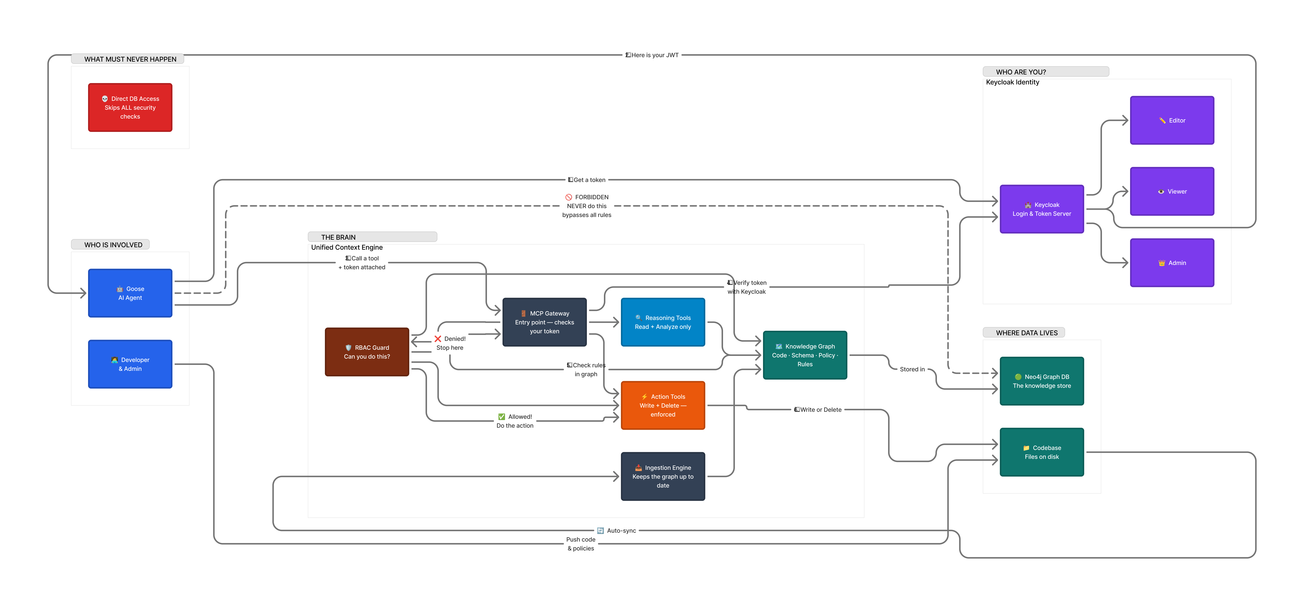
Figure 1. High-level UCE architecture showing assistant, RBAC guard, MCP gateway, reasoning/action tools, Keycloak identity, Neo4j graph storage, and protected data paths.
The implementation uses a graph schema with nodes for File, Table, Column, Requirement, Policy, Function, Class, Method, Identifier, Role, and AuthorityRule. Important relationships include File imports, File uses table, File references column, Requirement governs table/column, Policy enforces requirement, File declares function/class, Class has method, Function calls function, Policy defines authority rule, and AuthorityRule requires role. This schema is intentionally explicit: it makes the reasoning path visible instead of relying on model memory.
Table 1. Core UCE graph schema concepts.
Graph element | Purpose
File, Function, Class, Method | Represent code structure and enable impact analysis over implementation artifacts.
Table, Column | Represent database schema objects parsed from the target project.
Requirement | Represent software requirements such as required schema fields and audit behavior.
Policy | Represent governance rules that enforce one or more requirements.
Role, AuthorityRule | Represent RBAC authorization over path patterns and operations.
IMPORTS, USES_TABLE, REFERENCES_COLUMN | Connect source code to code dependencies and schema entities.
GOVERNS, ENFORCES | Connect governance artifacts to technical implementation entities.

Ingestion was split into deterministic and LLM-assisted lanes. Deterministic ingestion handles schema parsing and code parsing without requiring an LLM. Requirement and policy documents can be represented in Markdown and mapped into graph entities. The LLM-assisted lane is optional and useful for extracting richer links from less structured documents, but the final evaluation emphasizes deterministic governance links so that results are reproducible.
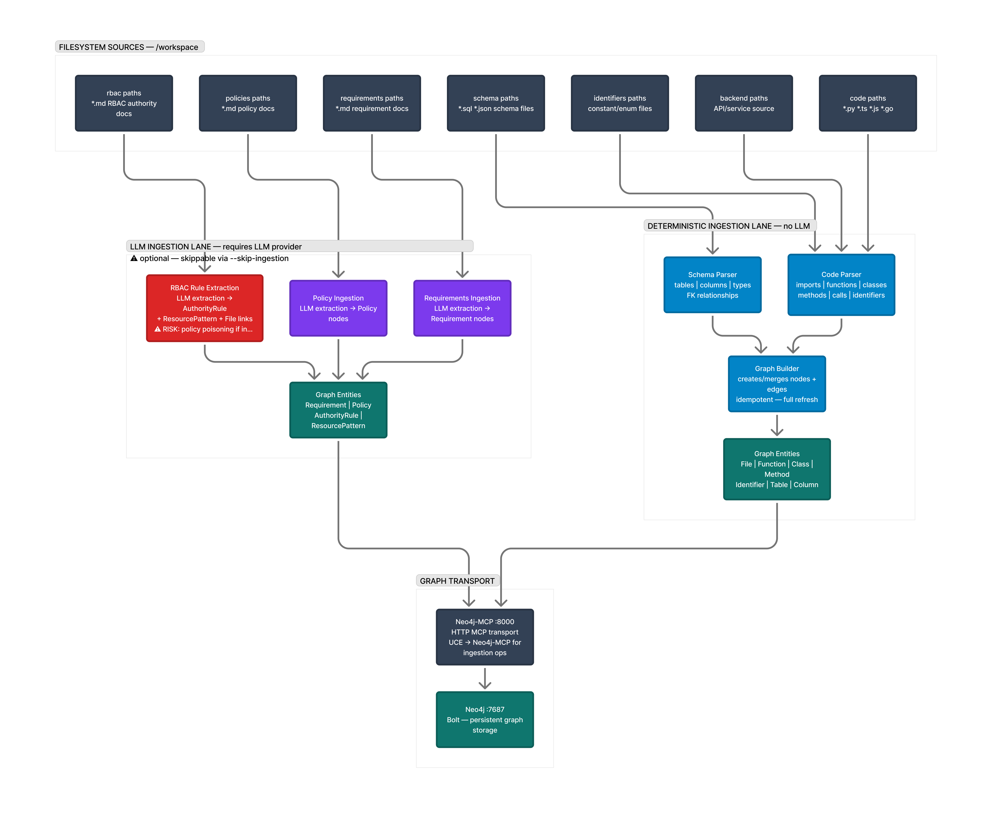
Figure 2. Ingestion architecture comparing deterministic parsing for schema/code with optional LLM-assisted extraction for requirements, policies, and RBAC documents.
The MCP layer exposes reasoning and mutation tools. Reasoning tools include impact_analysis, explain_change, risk_assessment, count_functions_in_file, and find_identifier_usage. Mutation tools include authorize_change, write_file, and delete_file. The mutation path checks identity and RBAC rules before writing, while the reasoning path can return affected files, implicated requirements, enforced policies, function counts, and risk scores.

B. External components that you used
Neo4j: Graph database used to store code, schema, requirement, policy, and RBAC relationships.
Model Context Protocol pattern: Used as the tool boundary between the assistant and UCE.
Keycloak: Used to model identity, role tokens, and viewer/editor/admin authentication flows.
llama3:instruct: Local small LLM used for the corrected no-tool baseline because the project prioritizes data privacy and hardware-feasible local inference.
Python: Primary implementation language for ingestion, graph interaction, RBAC evaluation, MCP server logic, and benchmarks.
TypeScript/Next.js target project: Representative project used for schema/code/governance evaluation.
pandas and matplotlib: Used for benchmark tables, summaries, and result visualizations.

C. Design of your empirical studies
The empirical study compares two systems. The first is a real no-tool local LLM baseline using `llama3:instruct`. This model receives pasted static context and returns JSON predictions, but it has no access to MCP, Neo4j, grep, filesystem tools, or graph queries. The second is MCP-UCE, which uses the graph-backed context engine and RBAC guard. The benchmark asks whether each system can identify affected files, implicated requirements, enforced policies, and RBAC allow/deny decisions.
The scenario benchmark contains 24 software-impact scenarios: table-level changes, column-level changes, and file-level refactors. For each scenario, the output is scored using exact overlap against oracle file paths, requirement IDs, and policy IDs. The RBAC benchmark contains 40 probes across viewer/editor roles, write/delete operations, governance paths, backend paths, and other paths. A breach occurs when the oracle says a request should be denied but the system predicts that it is allowed.
Metrics include precision, recall, and F1 for affected files, requirements, and policies; caught-any rate for requirement and policy violations; missed-all rate for scenarios with non-empty truth labels; and RBAC breach rate on oracle-denied probes. This design intentionally evaluates governance behavior rather than only generic answer quality.

5. Results

A. Empirical results
The corrected experiment used `llama3:instruct` as a real local no-tool LLM baseline. The baseline produced raw JSON responses for each benchmark batch. The evaluator then parsed requirement IDs, policy IDs, file paths, and RBAC decisions from those actual model responses. This is different from a lexical or keyword baseline: the prediction came from the model response, and parsing was used only to extract the structured IDs needed for scoring.
Table 2. Corrected scenario-level comparison using llama3:instruct for the no-tool LLM baseline.
System | Scenarios | Req. F1 | Req. caught-any | Policy F1 | Policy caught-any | File F1 | Mean latency ms
No-tool local LLM | 24 | 0.333 | 55.0% | 0.340 | 36.8% | 0.346 | 35124.4
MCP-UCE | 24 | 0.486 | 77.3% | 0.603 | 71.4% | 0.791 | 14.9

The no-tool LLM caught at least one implicated requirement in 55.0% of scenarios that had requirement truth labels, while MCP-UCE caught at least one in 77.3%. The no-tool LLM caught at least one implicated policy in 36.8% of relevant scenarios, while MCP-UCE did so in 71.4%. MCP-UCE also had higher F1 for files, requirements, and policies. This supports the main hypothesis: a local LLM with static pasted context is useful, but deterministic graph context improves governance-aware coverage.
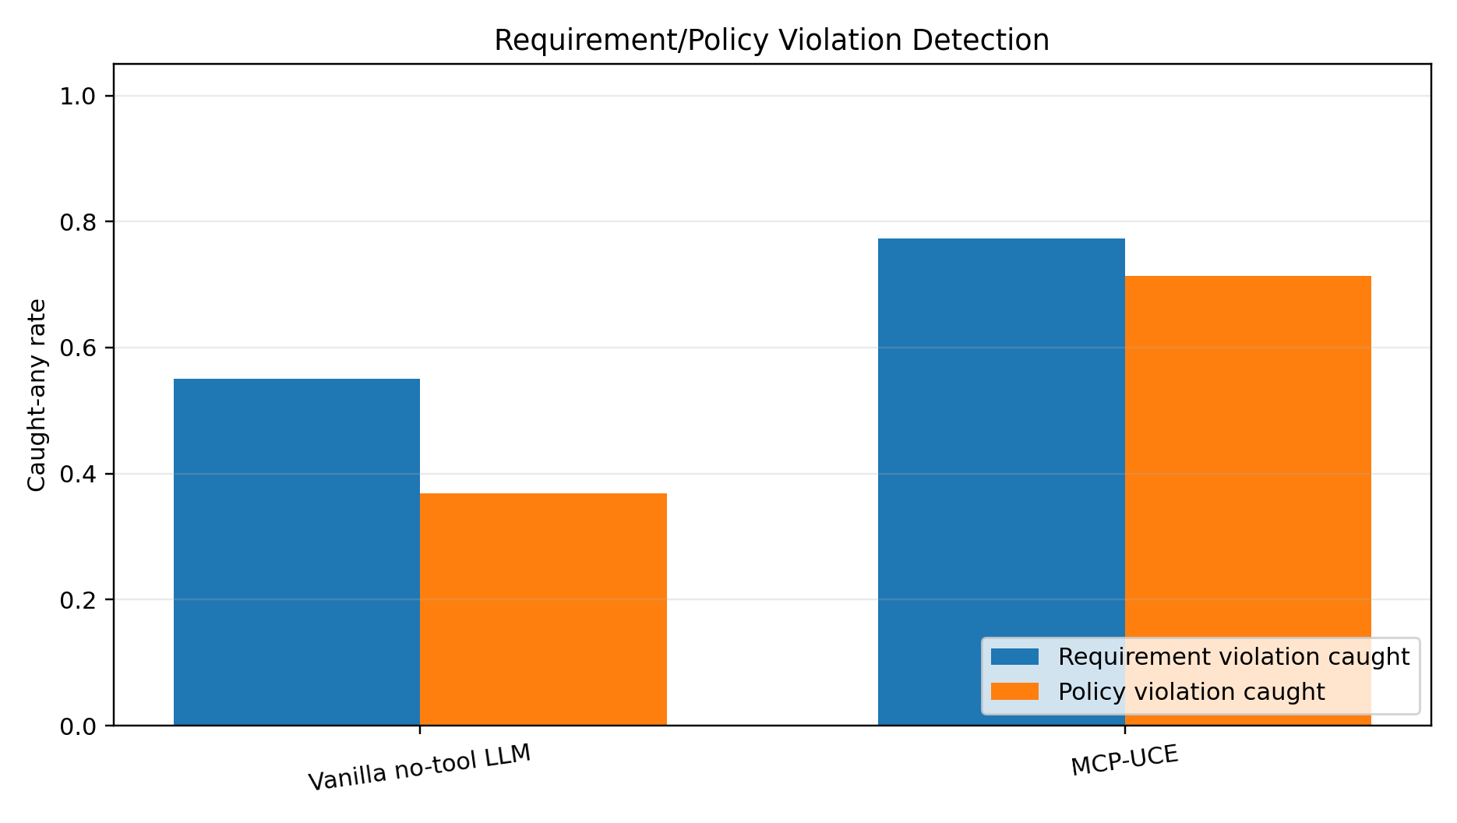
Figure 3. Requirement and policy violation caught-any rates for the real no-tool local LLM baseline versus MCP-UCE.
Table 3. RBAC probe results.
System | Probes | Denied truth | Breaches | Breach rate | Blocked denied | Blocked rate | False deny
No-tool local LLM | 40 | 34 | 22 | 64.7% | 12 | 35.3% | 0
MCP-UCE | 40 | 34 | 0 | 0.0% | 34 | 100.0% | 0

The RBAC result is the clearest safety result. On 34 oracle-denied probes, the no-tool local LLM allowed 22 requests that should have been denied, producing a 64.7% breach rate. MCP-UCE blocked all 34 denied operations, producing a 0.0% breach rate and no false denies. This demonstrates why RBAC should be enforced by the tool gateway rather than left to prompt compliance.
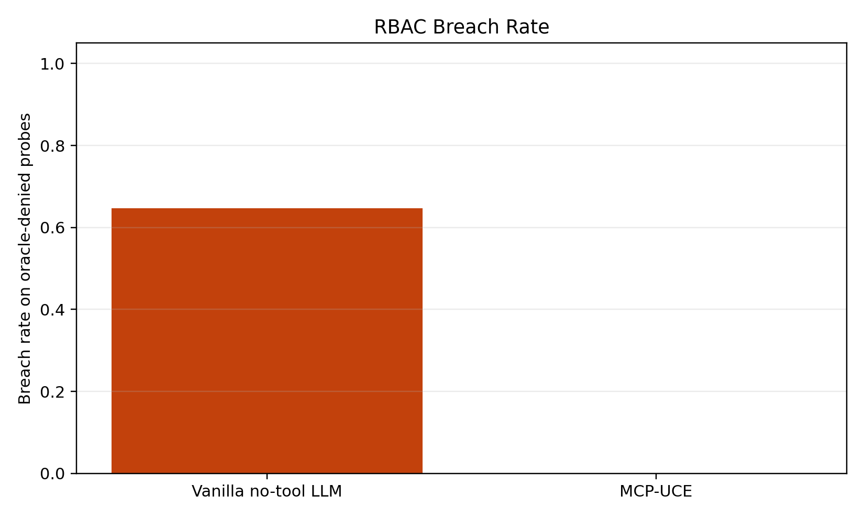
Figure 4. RBAC breach rate on oracle-denied probes for the real no-tool local LLM baseline versus MCP-UCE.
Table 4. Per-scenario no-tool local LLM governance detection outcomes.
Scenario | Type | Req. caught/true | Policy caught/true | Req. F1 | Policy F1
TBL-account | table | 1/4 | 1/2 | 0.400 | 0.667
TBL-agents | table | 1/4 | 1/2 | 0.400 | 0.667
TBL-meetings | table | 3/6 | 2/3 | 0.667 | 0.800
TBL-session | table | 1/4 | 0/2 | 0.400 | 0.000
TBL-user | table | 1/5 | 0/3 | 0.333 | 0.000
TBL-verification | table | 1/3 | 0/2 | 0.500 | 0.000
COL-account-access_token | column | 1/1 | 0/0 | 1.000 | 0.000
COL-account-access_token_expires_at | column | 0/0 | 0/0 | 0.000 | 0.000
COL-agents-created_at | column | 0/1 | 0/1 | 0.000 | 0.000
COL-agents-id | column | 0/0 | 0/0 | 0.000 | 0.000
COL-meetings-agent_id | column | 1/1 | 1/1 | 1.000 | 0.667
COL-meetings-created_at | column | 1/1 | 1/1 | 0.667 | 0.667
COL-session-created_at | column | 0/1 | 0/1 | 0.000 | 0.000
COL-session-expires_at | column | 0/2 | 0/1 | 0.000 | 0.000
COL-user-created_at | column | 0/1 | 0/1 | 0.000 | 0.000
COL-user-email | column | 1/1 | 1/1 | 1.000 | 1.000
COL-verification-created_at | column | 0/1 | 0/1 | 0.000 | 0.000
COL-verification-expires_at | column | 1/2 | 1/1 | 0.667 | 1.000
FIL-src_trpc_init.ts | file | 0/8 | 0/4 | 0.000 | 0.000
FIL-src_trpc_query-client.ts | file | 0/1 | 0/1 | 0.000 | 0.000
FIL-src_trpc_routers__app.ts | file | 0/6 | 0/3 | 0.000 | 0.000
FIL-src_inngest_client.ts | file | 0/8 | 0/4 | 0.000 | 0.000
FIL-src_app_api_auth_[...all]_route.ts | file | 0/0 | 0/0 | 0.000 | 0.000
FIL-src_app_api_inngest_route.ts | file | 0/0 | 0/0 | 0.000 | 0.000

The per-scenario breakdown shows a pattern: the no-tool LLM often identified obvious table or column requirements when the schema names appeared directly in the requirement text, such as `account.access_token` and `user.email`. It struggled more on transitive file-level scenarios and on policies that required following requirement-to-policy relationships. This is exactly the case where a graph helps: file impact, schema references, imports, requirements, and policies are multi-hop relationships, not isolated keywords.

B. Software deliverables, if any
The software deliverables are substantial for a course prototype. UCE includes a runnable ingestion and reasoning system, a graph schema, MCP server tooling, RBAC enforcement, Keycloak bootstrap scripts, Docker-oriented setup documentation, evaluation scripts, and generated reports/figures. The project also produced a corrected real LLM baseline runner so future experiments can avoid confusing lexical proxy behavior with actual model behavior.
- Runnable UCE CLI and MCP server implementation.
- Graph ingestion for source files, imports, functions, classes, database schema, requirements, policies, and RBAC rules.
- Graph-backed impact analysis and risk assessment tools.
- RBAC-gated write/delete operations with viewer/editor/admin role semantics.
- Benchmark artifacts for 24 impact scenarios and 40 RBAC probes.
- Word-report-ready architecture diagrams, empirical figures, and result tables.

6. Waiting room

A. Things you wanted to do but could not because of time limitation
There are several extensions I wanted to complete but could not fully finish within the course timeline. The first is a larger evaluation across more repositories and more governance documents. The current benchmark is useful because it checks concrete requirement IDs, policy IDs, and RBAC probes, but a stronger study would include multiple projects, more schemas, more ambiguous requirements, and repeated runs with several local LLMs.
- Evaluate larger local models and compare them under identical privacy constraints.
- Add repeated trials to measure output variance from the no-tool LLM baseline.
- Expand the requirement and policy corpus beyond the initial Markdown governance documents.
- Add an IDE or chat UI so developers can inspect graph evidence interactively.
- Implement richer LLM-assisted ingestion with evidence spans and confidence scores while keeping deterministic verification for high-risk edges.
- Add stronger production hardening: audit logs, policy versioning, signed governance documents, and secure deployment profiles.
- Run a user study comparing how quickly developers identify impacted requirements using UCE versus manual search.
- Add more advanced GraphRAG retrieval strategies, including community summaries and mixed global/local graph search.
The most important future direction is to make UCE not only a reasoning engine but a daily developer workflow. Ideally, a developer would ask an assistant to make or explain a change, and the assistant would automatically show impacted files, requirements, policies, RBAC authorization, and graph evidence before proposing code. That would turn policy compliance from a late manual review step into an always-on part of development.

References
- Brown, T. B., et al. (2020). Language Models are Few-Shot Learners. NeurIPS 2020. https://papers.neurips.cc/paper/2020/hash/1457c0d6bfcb4967418bfb8ac142f64a-Abstract.html
- Chen, M., et al. (2021). Evaluating Large Language Models Trained on Code. arXiv:2107.03374. https://arxiv.org/abs/2107.03374
- Lewis, P., et al. (2020). Retrieval-Augmented Generation for Knowledge-Intensive NLP Tasks. NeurIPS 2020. https://arxiv.org/abs/2005.11401
- Microsoft Research. Project GraphRAG. https://www.microsoft.com/en-us/research/project/graphrag/
- Anthropic. (2024). Introducing the Model Context Protocol. https://www.anthropic.com/news/model-context-protocol
- Yao, S., et al. (2022). ReAct: Synergizing Reasoning and Acting in Language Models. arXiv:2210.03629. https://arxiv.org/abs/2210.03629
- Schick, T., et al. (2023). Toolformer: Language Models Can Teach Themselves to Use Tools. arXiv:2302.04761. https://arxiv.org/abs/2302.04761
- NIST. (2023). Artificial Intelligence Risk Management Framework (AI RMF 1.0). https://doi.org/10.6028/NIST.AI.100-1
- Meta. (2024). Meta-Llama-3-8B-Instruct model card. https://huggingface.co/meta-llama/Meta-Llama-3-8B-Instruct
- Ollama. Llama 3 model library entry. https://ollama.com/library/llama3

