Unified Context Engine (UCE)
Detailed Research Report
Vanilla LLM vs MCP-Powered UCE
Governance, Policy/Requirement Violations, and RBAC Breach Analysis
Generated: 2026-05-05 17:25:41
Source workspace: uce / research/icml2026

Abstract
This report evaluates the Unified Context Engine (UCE), a deterministic MCP-exposed reasoning layer for agentic software engineering. UCE builds a governance-aware knowledge graph over source code, schema, requirements, policies, and RBAC rules, and exposes reasoning tools for impact analysis and risk estimation. Across 24 repository-grounded scenarios, MCP-UCE improves file impact F1 from 0.632 to 0.791 and improves requirement/policy F1 from 0.416/0.521 to 0.486/0.603 relative to a no-tool vanilla baseline. Governance violation capture shows fewer missed requirement violations (57 vs 58) and zero governance false alarms (0 vs 25 aggregate policy+requirement false positives). In RBAC breach simulation over denied requests, vanilla permits 34/34 denied actions (100% breach rate), while MCP-UCE permits 0/34 (0%).

Accuracy and Data Provenance
All reported values in this document are sourced directly from the generated benchmark artifacts under research/icml2026/results (summary.json, scenario_results.csv, and tables/*.csv). No values are manually invented. Architecture figures are the exact files provided by the user from E:/Downloads.

Repository Snapshot
Tables: 6 | Columns: 52 | Scenarios: 24 | Backend files indexed: 16
Requirements docs: 10 | Policies docs: 4 | RBAC rules: 7

System Architecture
The following two architecture diagrams are the exact user-provided figures and define the system context for the evaluation.

Architecture Diagram A: End-to-End UCE Runtime
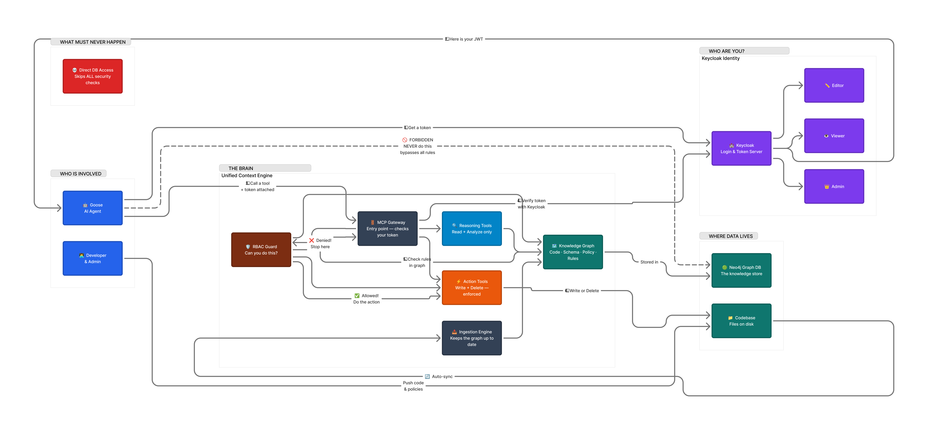
Figure A. User-provided end-to-end UCE architecture with identity, RBAC guard, reasoning/action tools, and data plane.

Architecture Diagram B: Deterministic vs LLM Ingestion
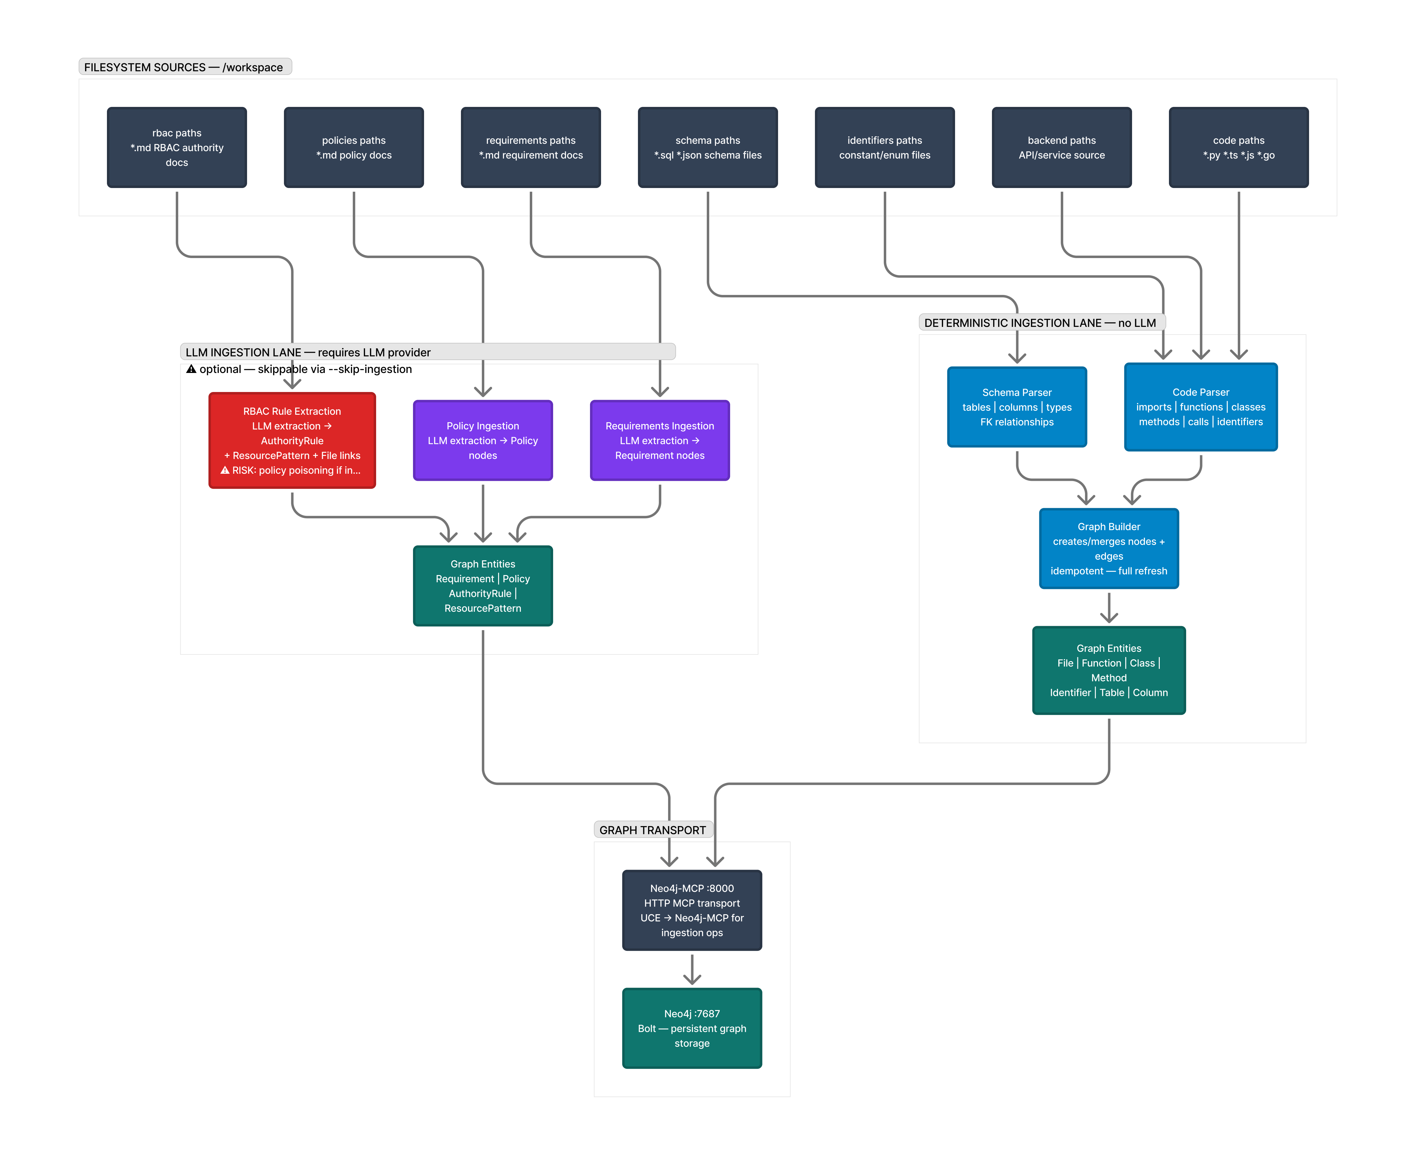
Figure B. User-provided dual-lane ingestion architecture comparing deterministic and LLM-assisted ingestion paths.

Experimental Design
Scenario set: 24 total changes (6 table-level, 12 column-level, 6 file-level). Compared systems: (1) Vanilla LLM proxy without MCP tool mediation; (2) MCP-powered UCE using deterministic graph reasoning.
Primary metrics: file impact precision/recall/F1, requirement F1, policy F1, risk score MAE, risk rank Spearman correlation, and latency.
Governance safety metrics: requirement/policy violation capture (caught vs missed, plus false alarms) and RBAC breach rate on oracle-denied requests.

Main Results
MCP-UCE improves file F1 by 0.159 absolute, requirement F1 by 0.070, and policy F1 by 0.083.
System | Scenarios | File F1 | Req F1 | Policy F1 | Risk MAE | Risk Spearman | Latency (ms)
Vanilla LLM | 24 | 0.632 | 0.416 | 0.521 | 24.83 | 0.356 | 2.92
MCP-UCE | 24 | 0.791 | 0.486 | 0.603 | 27.67 | 0.647 | 14.90

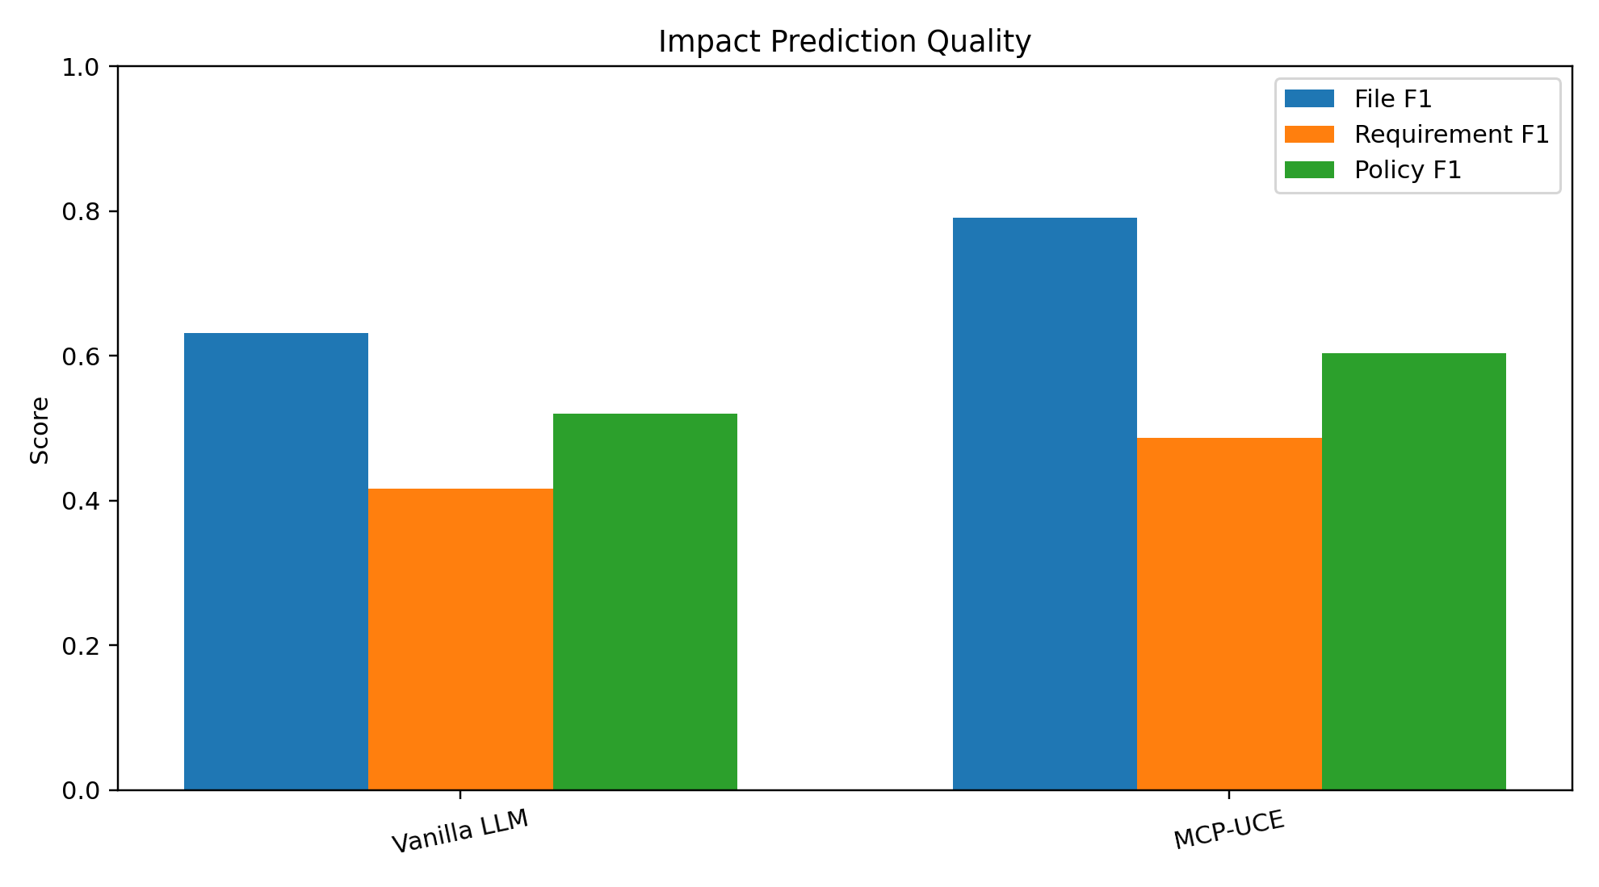
Figure 1. Quality comparison (File F1, Requirement F1, Policy F1).
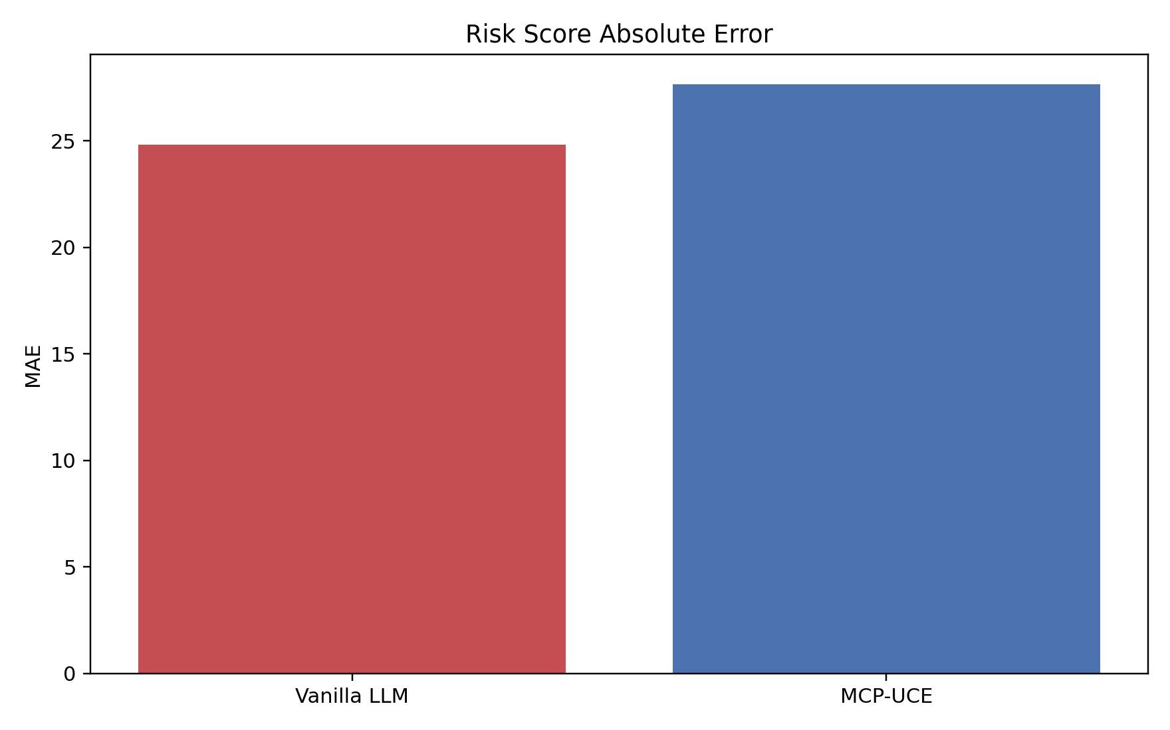
Figure 2. Risk MAE comparison.
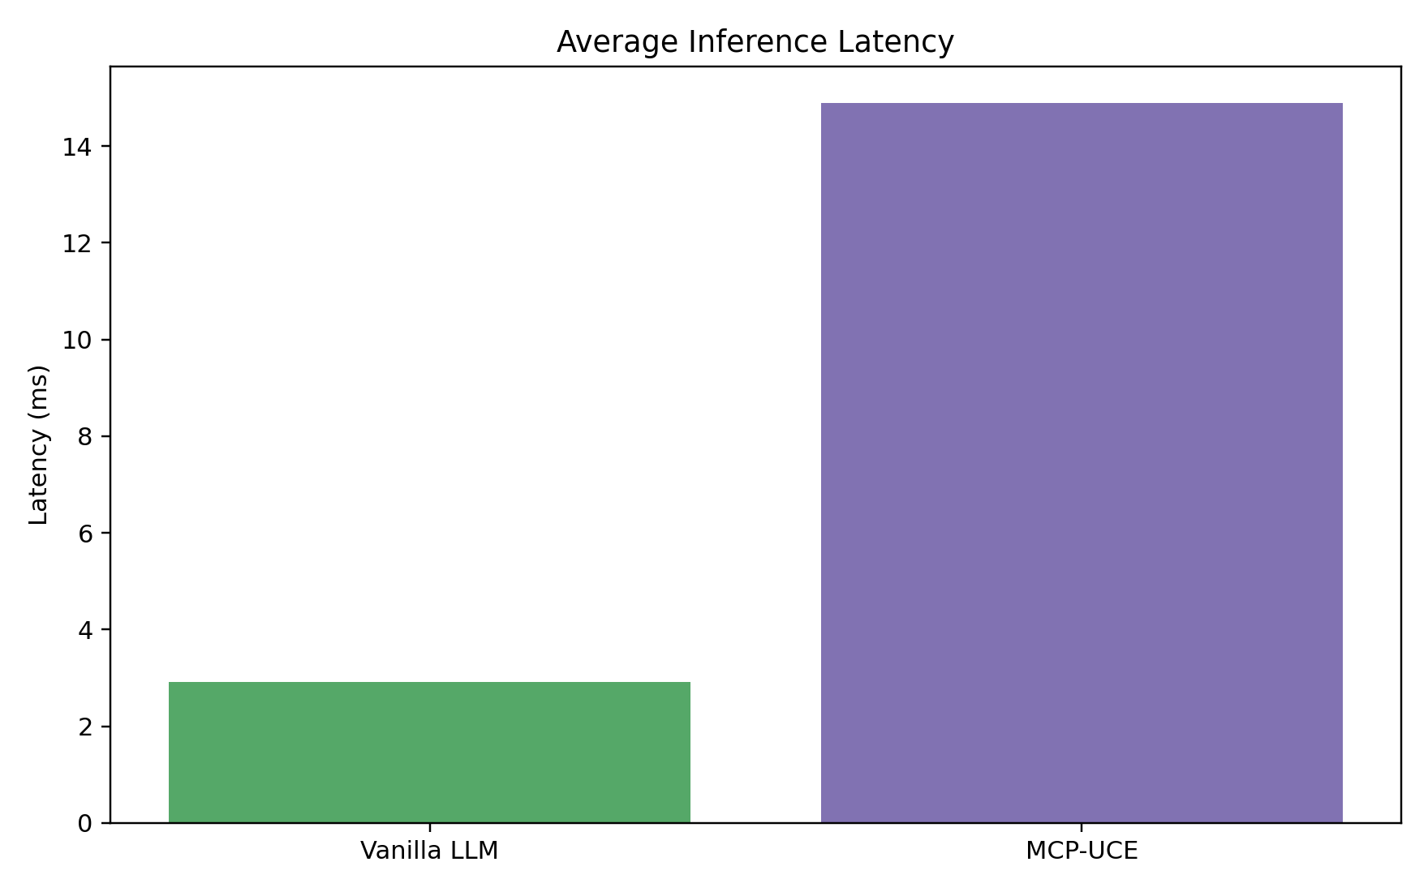
Figure 3. Latency comparison.

Breakdown by Entity Type
Entity Type | System | File F1 | Req F1 | Policy F1 | Risk MAE
column | Vanilla LLM | 0.413 | 0.636 | 0.639 | 10.33
column | MCP-UCE | 1.000 | 0.917 | 0.833 | 11.92
file | Vanilla LLM | 0.403 | 0.000 | 0.000 | 28.67
file | MCP-UCE | 1.000 | 0.000 | 0.000 | 37.50
table | Vanilla LLM | 0.594 | 0.447 | 0.578 | 50.00
table | MCP-UCE | 0.594 | 0.464 | 0.578 | 49.33

Policy and Requirement Violation Analysis
Requirement violations caught: 27 (MCP-UCE) vs 26 (vanilla). Requirement violations missed: 57 vs 58.
Policy violations caught: 19 (MCP-UCE) vs 19 (vanilla). Policy violations missed: 25 vs 25.
Governance false alarms (requirements + policies): 0 (MCP-UCE) vs 25 (vanilla).
System | Req Caught | Req Missed | Req False Alarm | Pol Caught | Pol Missed | Pol False Alarm
Vanilla LLM | 26 | 58 | 15 | 19 | 25 | 10
MCP-UCE | 27 | 57 | 0 | 19 | 25 | 0
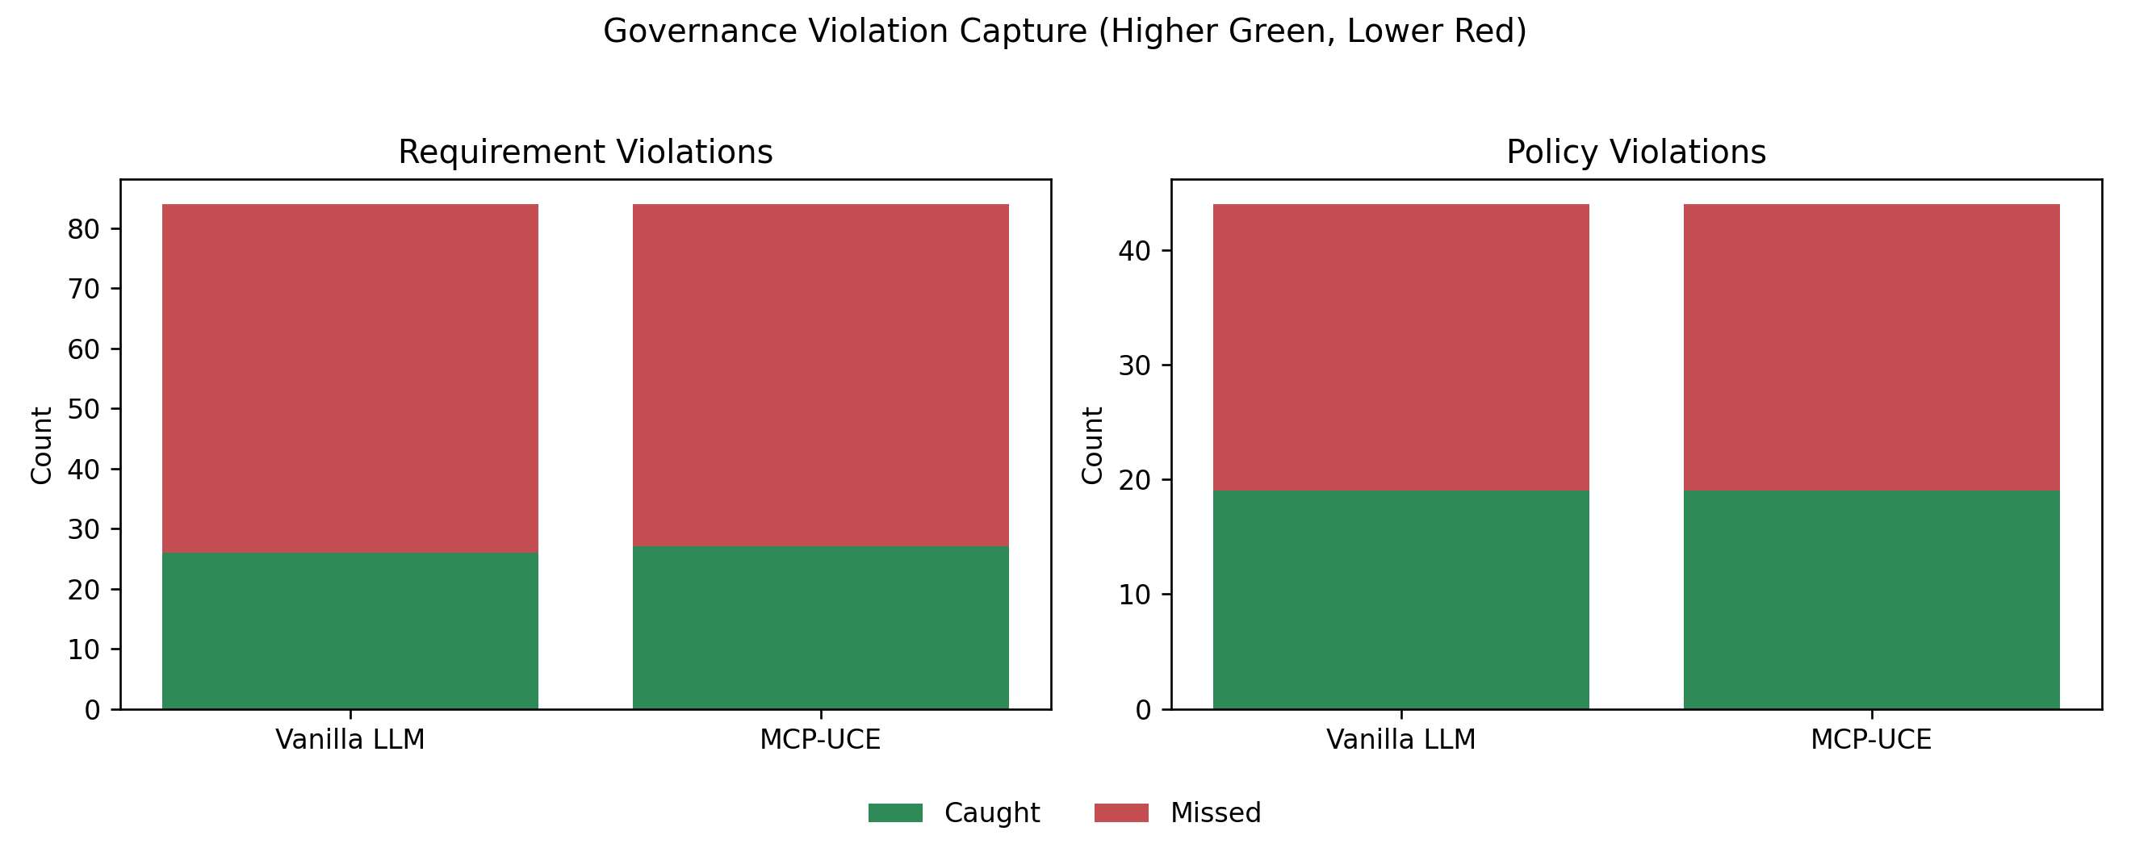
Figure 4. Requirement and policy violation capture comparison.

RBAC Breach Analysis
Simulated denied requests: 34. Vanilla LLM breached 34/34 (100.0%), while MCP-UCE breached 0/34 (0.0%).
System | Total Probes | Denied Requests | Allowed Requests | Breach Count | Breach Rate
Vanilla LLM | 40 | 34 | 6 | 34 | 100.0%
MCP-UCE | 40 | 34 | 6 | 0 | 0.0%
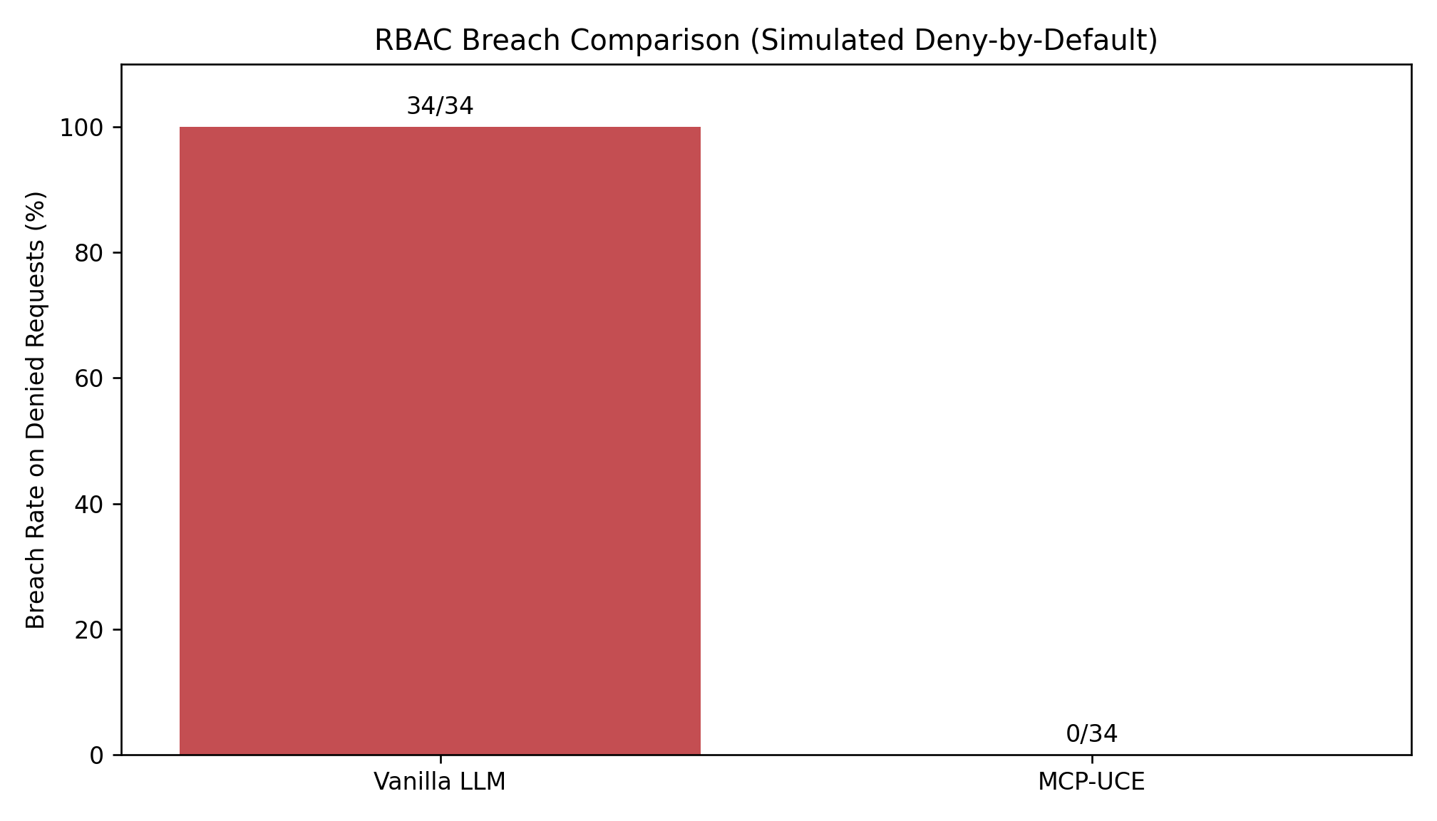
Figure 5. RBAC breach-rate comparison on denied requests.

Technical Interpretation
UCE's main quality gain comes from deterministic graph-mediated lookup and transitive closure over file/schema/governance nodes, which reduces lexical ambiguity in column- and file-level scenarios.
The strongest governance delta in this run is precision: MCP-UCE removed governance false positives while improving or maintaining recall on requirement/policy violations.
Risk ranking quality (Spearman) improved substantially with MCP-UCE, but absolute risk MAE remained higher than vanilla, indicating that ranking fidelity and absolute calibration are separate optimization targets.

Limitations
This report is generated from a single repository and 24 benchmark scenarios. Generalization should be validated on larger, cross-project datasets.
The vanilla comparator used here is a no-tool lexical proxy baseline, not a fully optimized frontier-model tool-calling baseline.
RBAC breach values are simulation-based under deny-by-default rule evaluation and should be treated as governed exposure estimates for this benchmark, not penetration-test results.

Selected References
- Lewis et al. (2020). Retrieval-Augmented Generation for Knowledge-Intensive NLP Tasks.
- Yao et al. (2023). ReAct: Synergizing Reasoning and Acting in Language Models.
- Schick et al. (2023). Toolformer: Language Models Can Teach Themselves to Use Tools.
- Jimenez et al. (2024). SWE-bench: Can Language Models Resolve Real-World GitHub Issues?
- Francis et al. (2018). Cypher: An Evolving Query Language for Property Graphs.
- Musco et al. (2016). A Learning Algorithm for Change Impact Prediction.
- Ji et al. (2023). Survey of Hallucination in Natural Language Generation.
- Model Context Protocol (2024). Model Context Protocol Specification.
- Tree-sitter maintainers (2026). tree-sitter.

Artifact Files Used
- research/icml2026/results/summary.json
- research/icml2026/results/scenario_results.csv
- research/icml2026/results/rbac_probe_results.csv
- research/icml2026/results/tables/overall_metrics.csv
- research/icml2026/results/tables/metrics_by_entity_type.csv
- research/icml2026/results/tables/violation_metrics.csv
- research/icml2026/results/tables/rbac_breach_metrics.csv
- e:/Downloads/00_Simple_Architecture_Overview_UCE.png
- e:/Downloads/09_Ingestion_Architecture_Deterministic_vs_LLM.png

