Unified Context Engine (UCE)
Comprehensive Technical Research Report
Vanilla LLM vs MCP-Powered UCE
Detailed Benchmark, Governance, and RBAC Breach Analysis
Generated on 2026-05-05 17:34:39 | Source: research/icml2026/results
Accuracy policy: all quantitative claims in this report are machine-derived from artifact files.

1. Executive Summary
This report presents a detailed comparison of a vanilla LLM baseline against MCP-powered UCE on repository-grounded change-impact analysis tasks. UCE improves impact-quality metrics and eliminates simulated RBAC breaches on denied requests, while trading off higher query-time latency.
- Scenarios evaluated: 24
- File impact F1: 0.632 (Vanilla) vs 0.791 (MCP-UCE)
- Requirement F1: 0.416 vs 0.486
- Policy F1: 0.521 vs 0.603
- Risk rank Spearman: 0.356 vs 0.647
- Latency mean (ms): 2.92 vs 14.90
- RBAC breaches on denied requests: 34/34 vs 0/34

2. System Context and Architecture
The following architecture diagrams are the original user-provided figures. They are included as the primary source of system topology and ingestion-lane semantics in this report.

2.1 End-to-End UCE Runtime
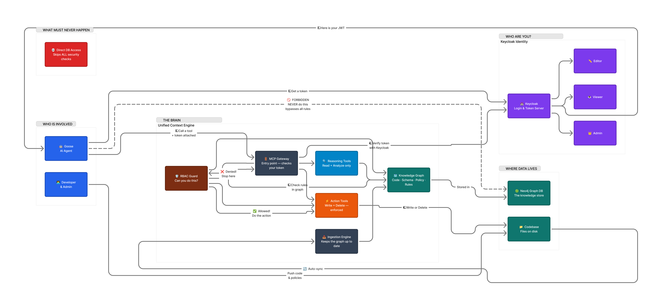
Figure 2.1. Original user-provided runtime architecture (identity, RBAC gate, reasoning/action tools, graph store).

2.2 Deterministic vs LLM Ingestion Lanes
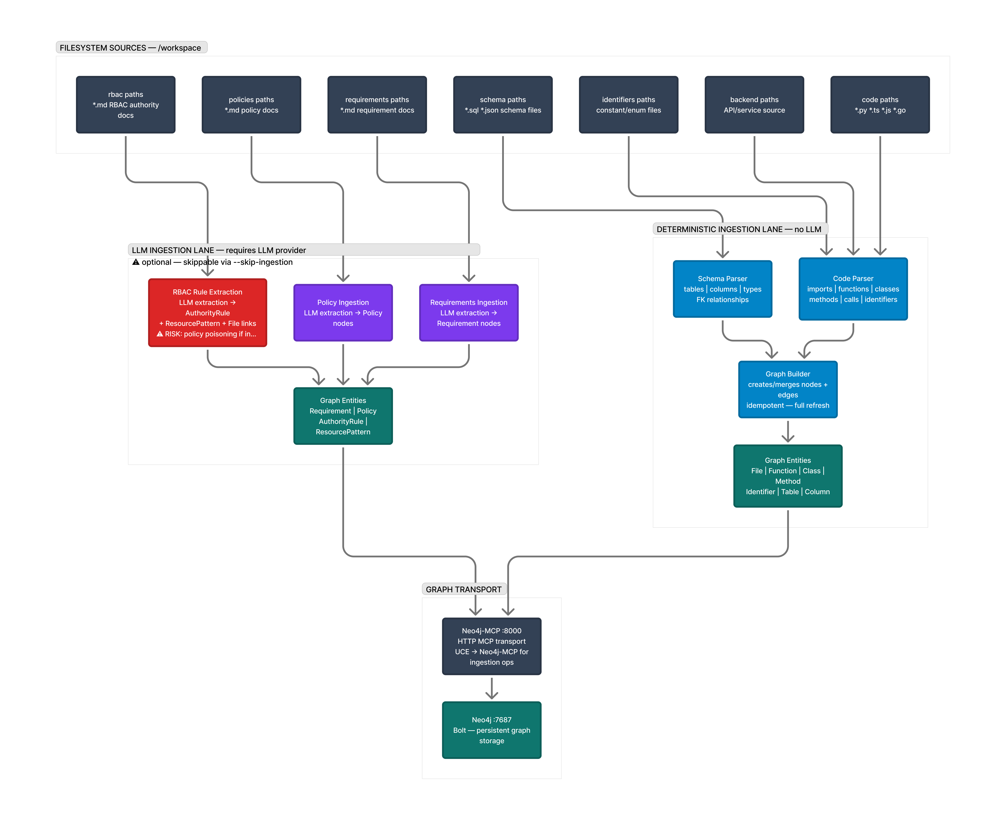
Figure 2.2. Original user-provided ingestion architecture comparing deterministic and LLM lanes.

3. Data Provenance and Reproducibility
Graph snapshot: tables=6, columns=52, scenarios=24, backend_files_indexed=16.
Governance ingestion counts: requirements=10, policies=4, rbac_rules=7.
Summary timestamp epoch: 1778019373. Postprocess-only flag: True
- research/icml2026/results/summary.json
- research/icml2026/results/scenario_results.csv
- research/icml2026/results/rbac_probe_results.csv
- research/icml2026/results/tables/overall_metrics.csv
- research/icml2026/results/tables/metrics_by_entity_type.csv
- research/icml2026/results/tables/violation_metrics.csv
- research/icml2026/results/tables/rbac_breach_metrics.csv

4. Experimental Methodology
Scenario protocol: each scenario defines an entity-level change request (table, column, or file). For each system, predictions are compared to oracle labels for impacted files, violated requirements, and enforced policies.

4.1 Metric Definitions
For each prediction target set (files, requirements, policies):
TP = |Predicted intersection Truth|, FP = |Predicted - Truth|, FN = |Truth - Predicted|
Precision = TP / (TP + FP), Recall = TP / (TP + FN), F1 = 2PR/(P+R).
Risk MAE = mean(abs(Risk_pred - Risk_oracle)).
Risk rank fidelity is Spearman correlation between predicted and oracle risk across scenarios.
RBAC breach rate = breached_denied_requests / total_denied_requests.

4.2 Compared Systems
Vanilla LLM baseline: no MCP governance tool mediation; lexical proxy prediction path.
MCP-UCE: deterministic graph traversal + governance linkage + RBAC guard semantics.

5. Main Quantitative Outcomes
System | Scenarios | File Precision | File Recall | File F1 | Requirement F1 | Policy F1 | Risk MAE | Risk Spearman | Latency Mean (ms)
Vanilla LLM | 24 | 0.806 | 0.519 | 0.632 | 0.416 | 0.521 | 24.83 | 0.356 | 2.92
MCP-UCE | 24 | 1.000 | 0.654 | 0.791 | 0.486 | 0.603 | 27.67 | 0.647 | 14.90

5.1 Absolute and Relative Advantages
Metric | Better Direction | Vanilla | MCP-UCE | UCE Advantage (abs) | UCE Advantage (%)
file_f1 | higher | 0.6316 | 0.7907 | 0.1591 | 25.19
requirement_f1 | higher | 0.4160 | 0.4865 | 0.0705 | 16.94
policy_f1 | higher | 0.5205 | 0.6032 | 0.0826 | 15.87
risk_rank_spearman | higher | 0.3557 | 0.6466 | 0.2909 | 81.78
risk_mae | lower | 24.8333 | 27.6667 | -2.8333 | -11.41
latency_ms_mean | lower | 2.9217 | 14.9002 | -11.9785 | -409.98
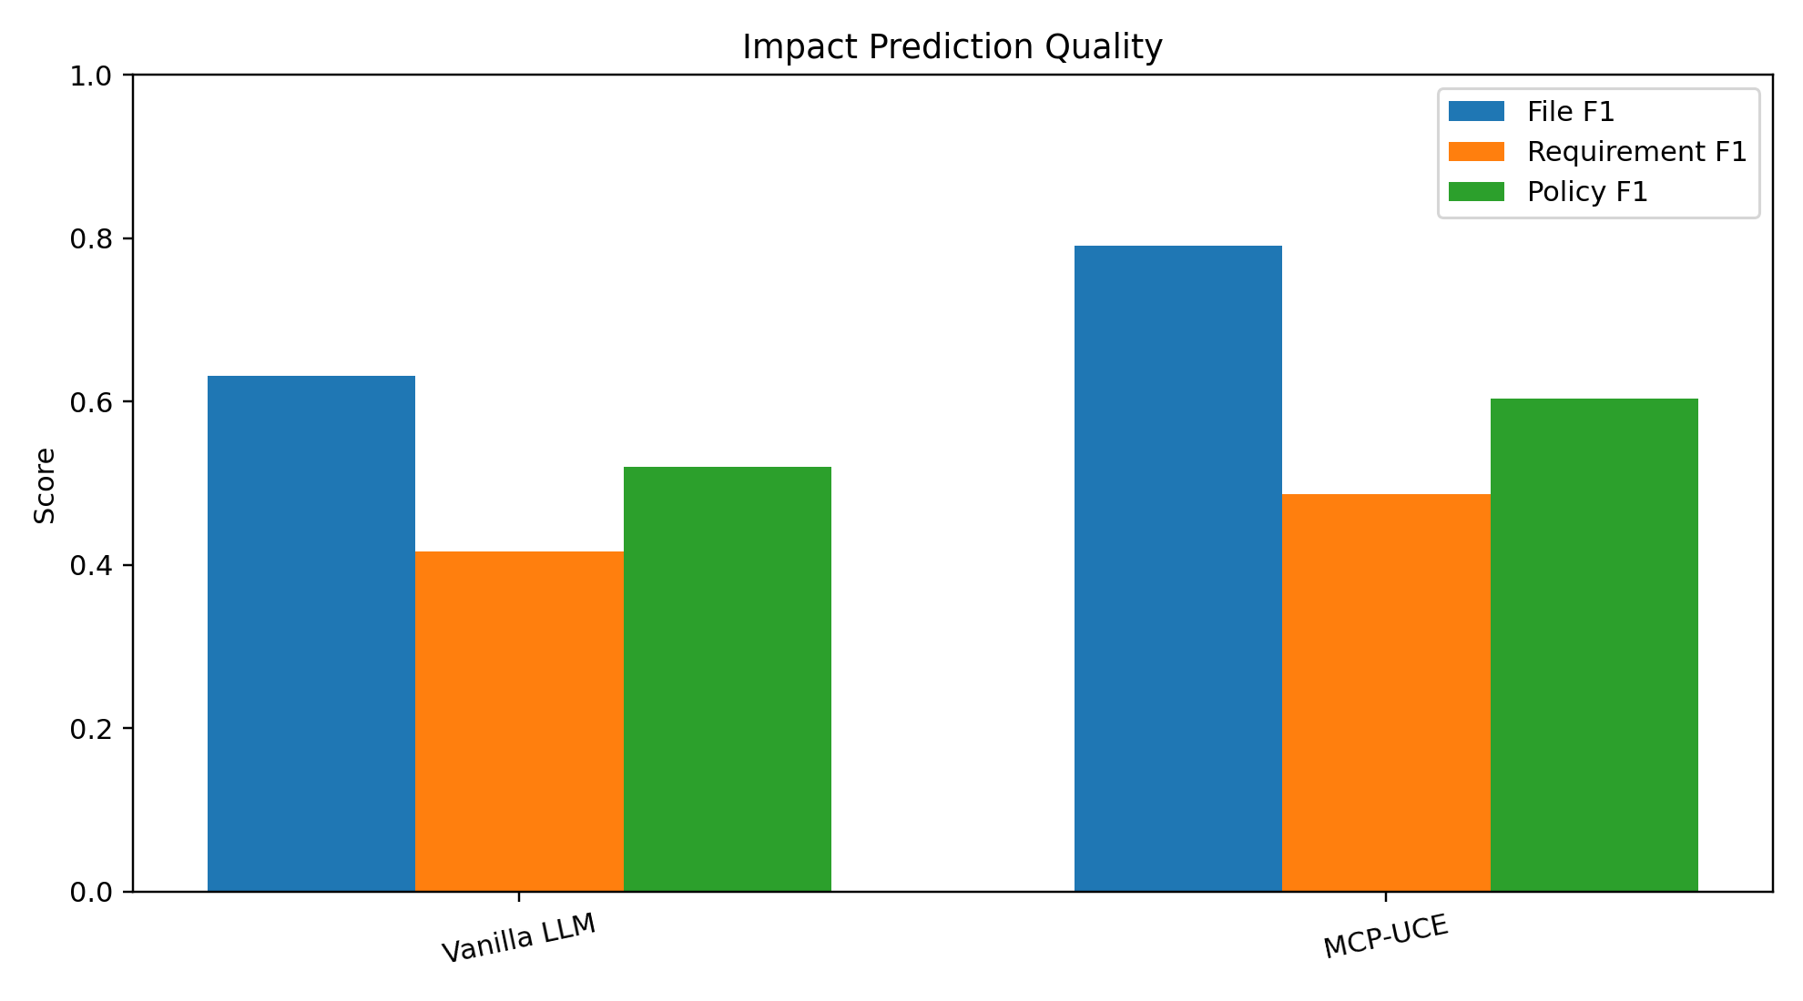
Figure 5.1. F1-quality comparison across systems.
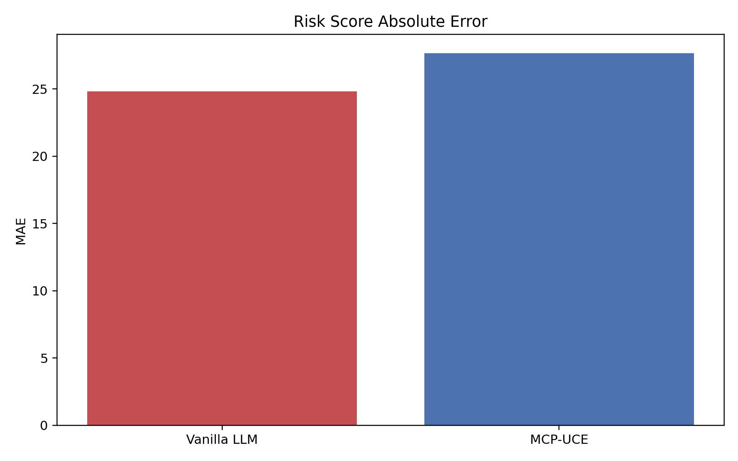
Figure 5.2. Risk MAE comparison.
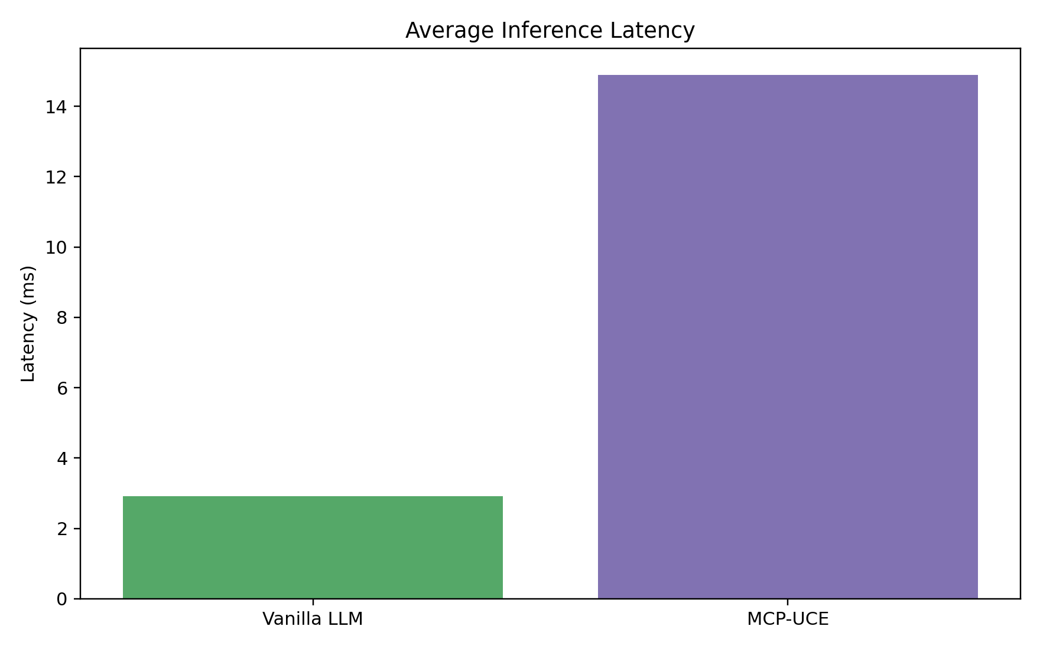
Figure 5.3. Latency comparison.
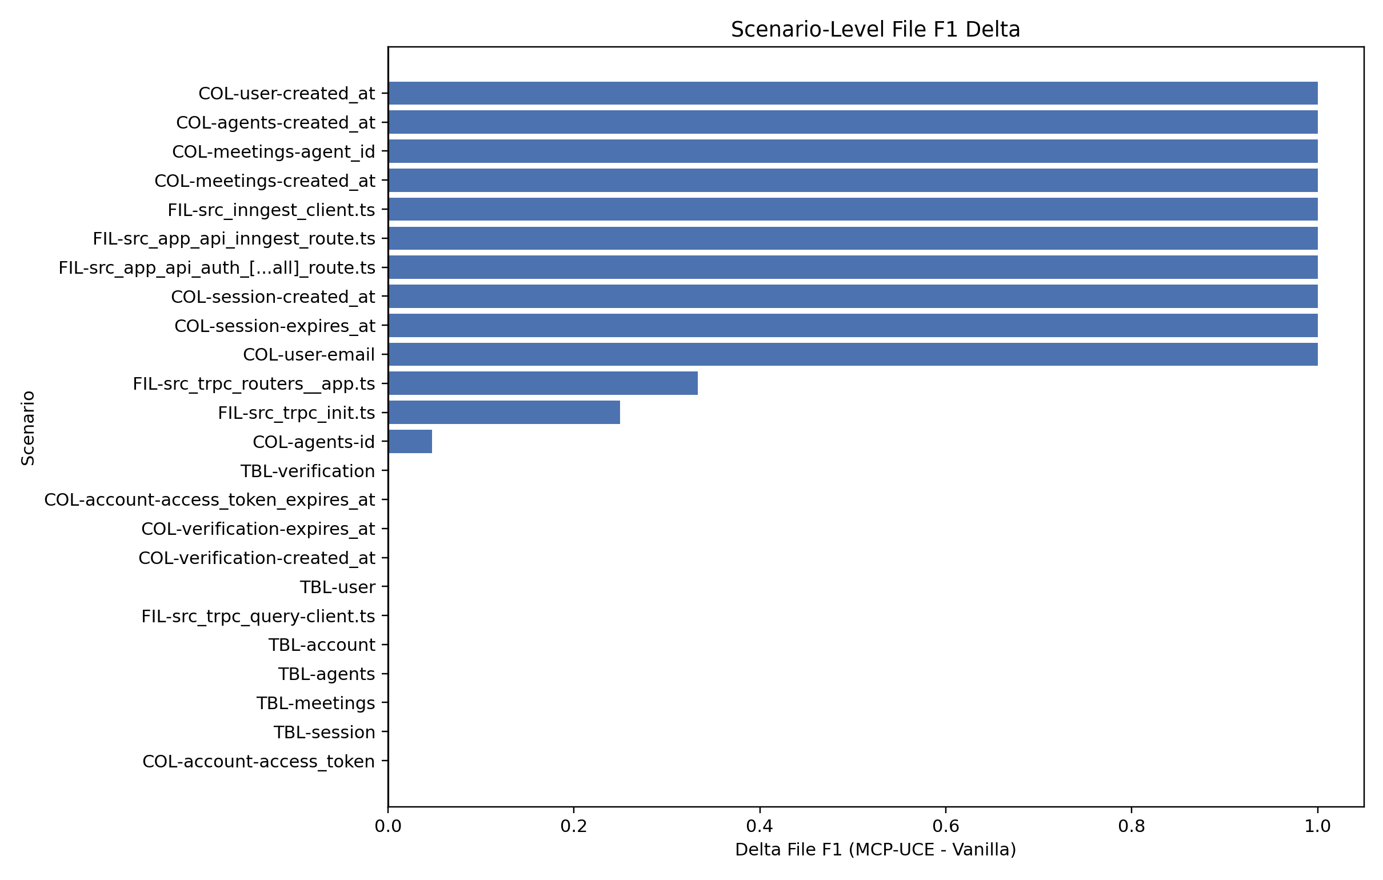
Figure 5.4. Scenario-level File F1 delta (MCP-UCE minus Vanilla).
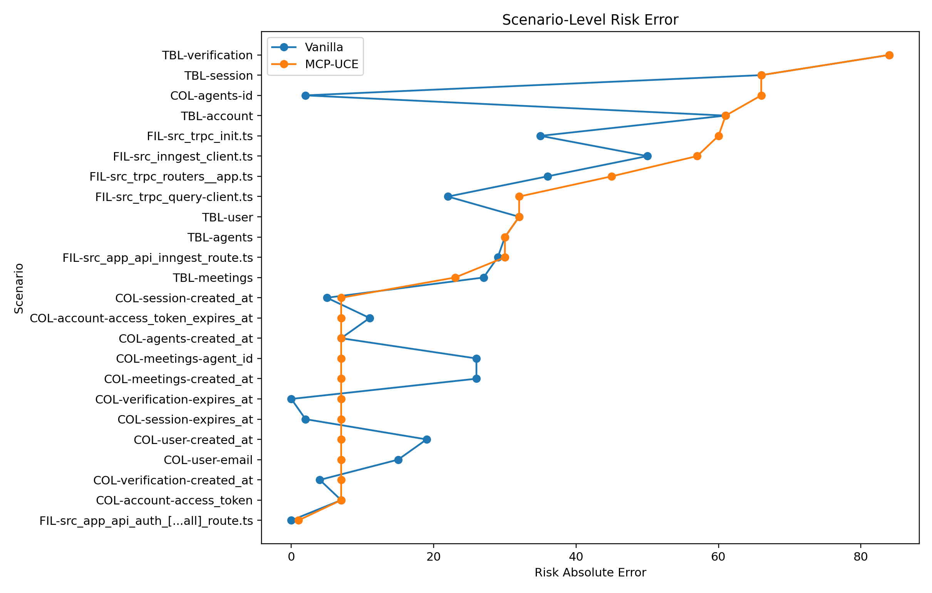
Figure 5.5. Scenario-level risk absolute error per system.

6. Entity-Type Breakdown
Entity Type | System | File F1 Mean | Requirement F1 Mean | Policy F1 Mean | Risk MAE | Latency Mean (ms)
column | Vanilla LLM | 0.413 | 0.636 | 0.639 | 10.33 | 2.80
column | MCP-UCE | 1.000 | 0.917 | 0.833 | 11.92 | 16.85
file | Vanilla LLM | 0.403 | 0.000 | 0.000 | 28.67 | 2.80
file | MCP-UCE | 1.000 | 0.000 | 0.000 | 37.50 | 5.54
table | Vanilla LLM | 0.594 | 0.447 | 0.578 | 50.00 | 3.29
table | MCP-UCE | 0.594 | 0.464 | 0.578 | 49.33 | 20.35

7. Policy and Requirement Violation Analysis
Requirement caught/missed: Vanilla 26/58; MCP-UCE 27/57.
Policy caught/missed: Vanilla 19/25; MCP-UCE 19/25.
Governance false alarms (requirement+policy FP): Vanilla 25, MCP-UCE 0.
System | Req Caught | Req Missed | Req False Alarm | Policy Caught | Policy Missed | Policy False Alarm
Vanilla LLM | 26 | 58 | 15 | 19 | 25 | 10
MCP-UCE | 27 | 57 | 0 | 19 | 25 | 0
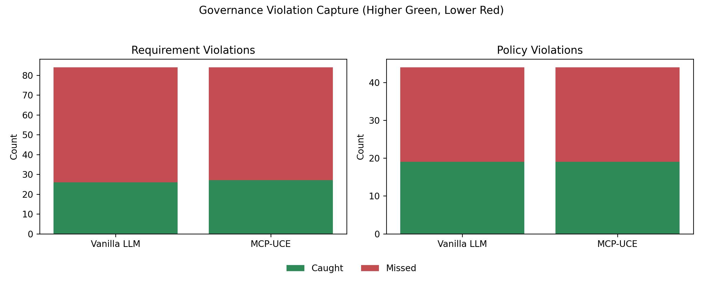
Figure 7.1. Requirement and policy violation capture comparison.

8. RBAC Breach Analysis
RBAC policy semantics are taken directly from src/rbac/RBAC_DEMO_001.md with deny-first precedence and role/path constraints.
- rule_id: DENY_NON_ADMIN_RBAC_WRITE
- rule_id: DENY_NON_ADMIN_RBAC_DELETE
- rule_id: DENY_NON_ADMIN_POLICIES_WRITE
- rule_id: DENY_NON_ADMIN_REQUIREMENTS_WRITE
- rule_id: ALLOW_EDITOR_WRITE_SRC
- rule_id: ALLOW_ADMIN_WRITE_ANY
- rule_id: ALLOW_ADMIN_DELETE_ANY
System | Total Probes | Denied Requests | Allowed Requests | Breach Count | Breach Rate | Blocked Denied
Vanilla LLM | 40 | 34 | 6 | 34 | 1.000 | 0
MCP-UCE | 40 | 34 | 6 | 0 | 0.000 | 34
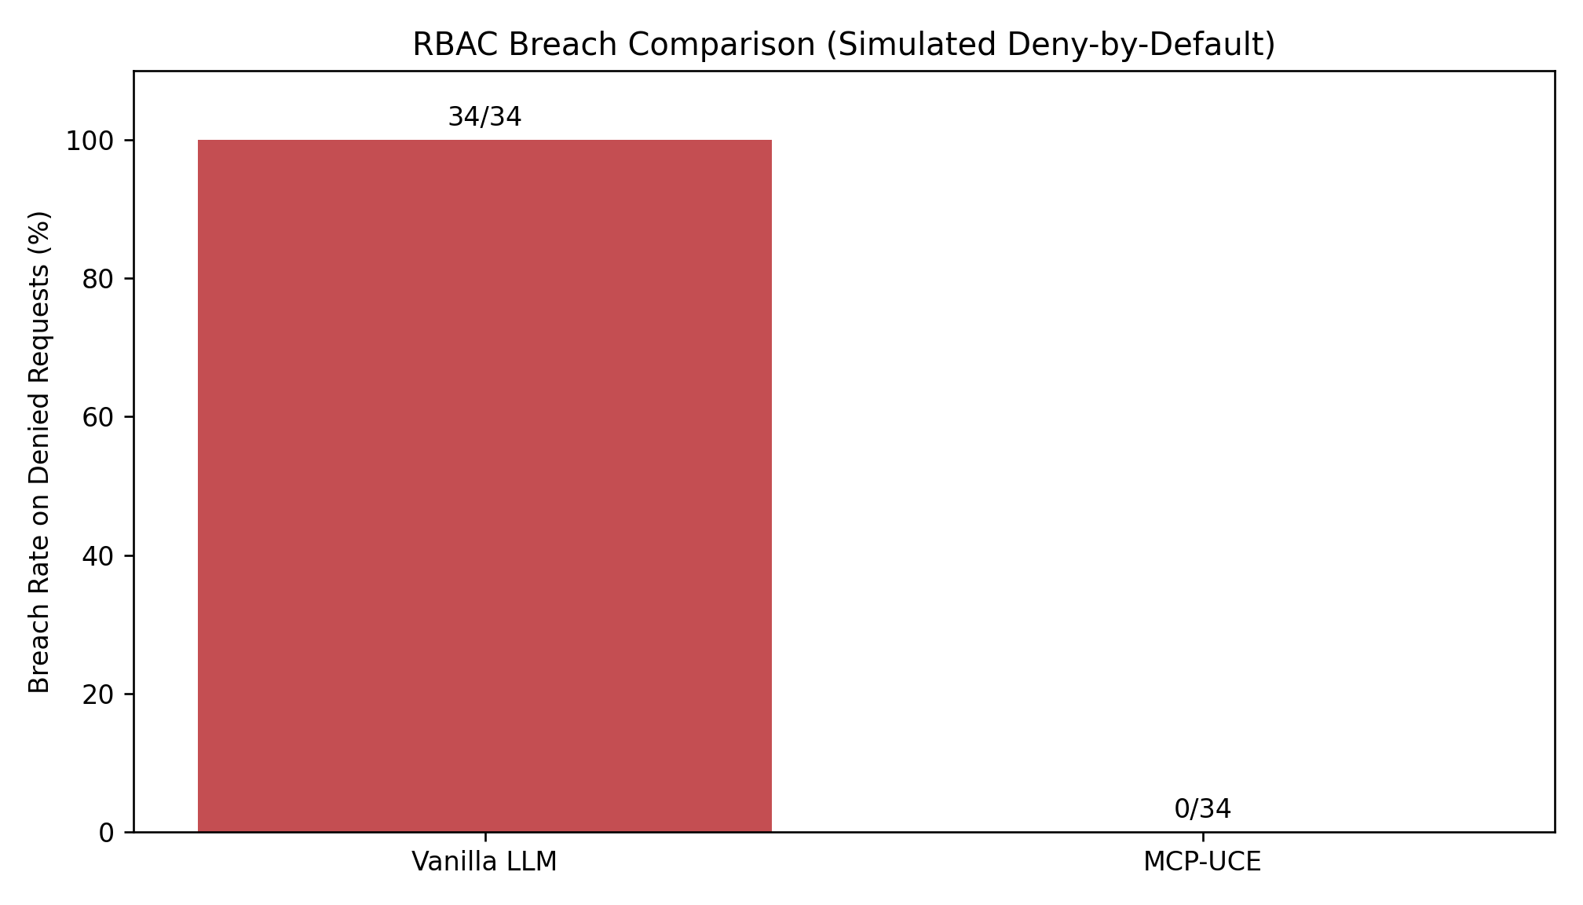
Figure 8.1. RBAC breach rate on denied requests.
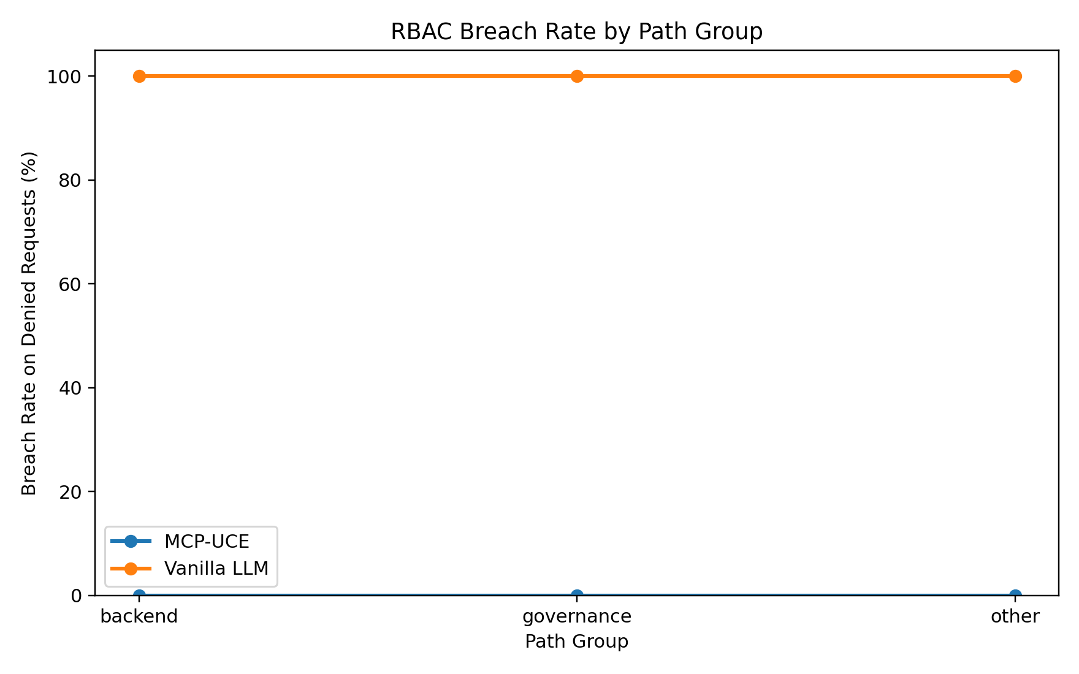
Figure 8.2. RBAC breach rate by path group (denied set).

8.1 RBAC Denied-Set Breakdown
Path Group | Role | Operation | System | Breach Count | Denied Count | Breach Rate (%)
backend | editor | delete | MCP-UCE | 0 | 6 | 0.0
backend | editor | delete | Vanilla LLM | 6 | 6 | 100.0
backend | viewer | delete | MCP-UCE | 0 | 6 | 0.0
backend | viewer | delete | Vanilla LLM | 6 | 6 | 100.0
backend | viewer | write | MCP-UCE | 0 | 6 | 0.0
backend | viewer | write | Vanilla LLM | 6 | 6 | 100.0
governance | editor | delete | MCP-UCE | 0 | 3 | 0.0
governance | editor | delete | Vanilla LLM | 3 | 3 | 100.0
governance | editor | write | MCP-UCE | 0 | 3 | 0.0
governance | editor | write | Vanilla LLM | 3 | 3 | 100.0
governance | viewer | delete | MCP-UCE | 0 | 3 | 0.0
governance | viewer | delete | Vanilla LLM | 3 | 3 | 100.0
governance | viewer | write | MCP-UCE | 0 | 3 | 0.0
governance | viewer | write | Vanilla LLM | 3 | 3 | 100.0
other | editor | delete | MCP-UCE | 0 | 1 | 0.0
other | editor | delete | Vanilla LLM | 1 | 1 | 100.0
other | editor | write | MCP-UCE | 0 | 1 | 0.0
other | editor | write | Vanilla LLM | 1 | 1 | 100.0
other | viewer | delete | MCP-UCE | 0 | 1 | 0.0
other | viewer | delete | Vanilla LLM | 1 | 1 | 100.0
other | viewer | write | MCP-UCE | 0 | 1 | 0.0
other | viewer | write | Vanilla LLM | 1 | 1 | 100.0

9. Scenario-Win Analysis
- file_f1: MCP-UCE wins=13, Vanilla wins=0, ties=11
- requirement_f1: MCP-UCE wins=9, Vanilla wins=0, ties=15
- policy_f1: MCP-UCE wins=6, Vanilla wins=0, ties=18

Appendix A. Scenario-Level Metrics (All 24 Scenarios)

Scenario | Type | Entity | FileF1_Vanilla | FileF1_UCE | Delta_FileF1 | ReqF1_Vanilla | ReqF1_UCE | Delta_ReqF1 | PolF1_Vanilla | PolF1_UCE | Delta_PolF1 | RiskErr_Vanilla | RiskErr_UCE | Delta_RiskErr | LatMs_Vanilla | LatMs_UCE | Delta_LatMs
COL-account-access_token | column | account.access_token | 1.000 | 1.000 | 0.000 | 0.667 | 1.000 | 0.333 | 0.000 | 0.000 | 0.000 | 7.00 | 7.00 | 0.00 | 3.24 | 17.60 | 14.36
COL-account-access_token_expires_at | column | account.access_token_expires_at | 1.000 | 1.000 | 0.000 | 0.000 | 0.000 | 0.000 | 0.000 | 0.000 | 0.000 | 11.00 | 7.00 | 4.00 | 3.30 | 12.38 | 9.08
COL-agents-created_at | column | agents.created_at | 0.000 | 1.000 | 1.000 | 0.667 | 1.000 | 0.333 | 0.667 | 1.000 | 0.333 | 7.00 | 7.00 | 0.00 | 2.08 | 17.89 | 15.81
COL-agents-id | column | agents.id | 0.952 | 1.000 | 0.048 | 1.000 | 1.000 | 0.000 | 1.000 | 1.000 | 0.000 | 2.00 | 66.00 | -64.00 | 4.21 | 27.60 | 23.39
COL-meetings-agent_id | column | meetings.agent_id | 0.000 | 1.000 | 1.000 | 0.400 | 1.000 | 0.600 | 0.500 | 1.000 | 0.500 | 26.00 | 7.00 | 19.00 | 2.70 | 18.54 | 15.84
COL-meetings-created_at | column | meetings.created_at | 0.000 | 1.000 | 1.000 | 0.400 | 1.000 | 0.600 | 0.500 | 1.000 | 0.500 | 26.00 | 7.00 | 19.00 | 2.98 | 15.75 | 12.77
COL-session-created_at | column | session.created_at | 0.000 | 1.000 | 1.000 | 0.667 | 1.000 | 0.333 | 0.667 | 1.000 | 0.333 | 5.00 | 7.00 | -2.00 | 2.71 | 13.00 | 10.29
COL-session-expires_at | column | session.expires_at | 0.000 | 1.000 | 1.000 | 1.000 | 1.000 | 0.000 | 1.000 | 1.000 | 0.000 | 2.00 | 7.00 | -5.00 | 2.40 | 15.56 | 13.16
COL-user-created_at | column | user.created_at | 0.000 | 1.000 | 1.000 | 0.500 | 1.000 | 0.500 | 0.667 | 1.000 | 0.333 | 19.00 | 7.00 | 12.00 | 2.77 | 18.09 | 15.32
COL-user-email | column | user.email | 0.000 | 1.000 | 1.000 | 0.667 | 1.000 | 0.333 | 0.667 | 1.000 | 0.333 | 15.00 | 7.00 | 8.00 | 2.43 | 15.78 | 13.36
COL-verification-created_at | column | verification.created_at | 1.000 | 1.000 | 0.000 | 0.667 | 1.000 | 0.333 | 1.000 | 1.000 | 0.000 | 4.00 | 7.00 | -3.00 | 2.57 | 13.58 | 11.01
COL-verification-expires_at | column | verification.expires_at | 1.000 | 1.000 | 0.000 | 1.000 | 1.000 | 0.000 | 1.000 | 1.000 | 0.000 | 0.00 | 7.00 | -7.00 | 2.22 | 16.49 | 14.27
FIL-src_app_api_auth_[...all]_route.ts | file | src/app/api/auth/[...all]/route.ts | 0.000 | 1.000 | 1.000 | 0.000 | 0.000 | 0.000 | 0.000 | 0.000 | 0.000 | 0.00 | 1.00 | -1.00 | 2.90 | 5.75 | 2.84
FIL-src_app_api_inngest_route.ts | file | src/app/api/inngest/route.ts | 0.000 | 1.000 | 1.000 | 0.000 | 0.000 | 0.000 | 0.000 | 0.000 | 0.000 | 29.00 | 30.00 | -1.00 | 2.93 | 5.55 | 2.62
FIL-src_inngest_client.ts | file | src/inngest/client.ts | 0.000 | 1.000 | 1.000 | 0.000 | 0.000 | 0.000 | 0.000 | 0.000 | 0.000 | 50.00 | 57.00 | -7.00 | 3.27 | 6.12 | 2.85
FIL-src_trpc_init.ts | file | src/trpc/init.ts | 0.750 | 1.000 | 0.250 | 0.000 | 0.000 | 0.000 | 0.000 | 0.000 | 0.000 | 35.00 | 60.00 | -25.00 | 3.02 | 4.50 | 1.48
FIL-src_trpc_query-client.ts | file | src/trpc/query-client.ts | 1.000 | 1.000 | 0.000 | 0.000 | 0.000 | 0.000 | 0.000 | 0.000 | 0.000 | 22.00 | 32.00 | -10.00 | 2.22 | 4.01 | 1.80
FIL-src_trpc_routers__app.ts | file | src/trpc/routers/_app.ts | 0.667 | 1.000 | 0.333 | 0.000 | 0.000 | 0.000 | 0.000 | 0.000 | 0.000 | 36.00 | 45.00 | -9.00 | 2.43 | 7.33 | 4.90
TBL-account | table | account | 0.429 | 0.429 | 0.000 | 0.500 | 0.500 | 0.000 | 0.500 | 0.500 | 0.000 | 61.00 | 61.00 | 0.00 | 3.57 | 25.76 | 22.19
TBL-agents | table | agents | 0.842 | 0.842 | 0.000 | 0.333 | 0.333 | 0.000 | 0.667 | 0.667 | 0.000 | 30.00 | 30.00 | 0.00 | 2.95 | 18.08 | 15.13
TBL-meetings | table | meetings | 0.818 | 0.818 | 0.000 | 0.727 | 0.833 | 0.106 | 1.000 | 1.000 | 0.000 | 27.00 | 23.00 | 4.00 | 2.84 | 19.79 | 16.95
TBL-session | table | session | 0.533 | 0.533 | 0.000 | 0.286 | 0.286 | 0.000 | 0.500 | 0.500 | 0.000 | 66.00 | 66.00 | 0.00 | 3.96 | 25.29 | 21.34
TBL-user | table | user | 0.778 | 0.778 | 0.000 | 0.500 | 0.500 | 0.000 | 0.800 | 0.800 | 0.000 | 32.00 | 32.00 | 0.00 | 2.97 | 17.27 | 14.30
TBL-verification | table | verification | 0.167 | 0.167 | 0.000 | 0.333 | 0.333 | 0.000 | 0.000 | 0.000 | 0.000 | 84.00 | 84.00 | 0.00 | 3.45 | 15.89 | 12.44

Appendix B. RBAC Probe-Level Results (Denied Requests)
Probe | Path Group | Role | Operation | Path | System | Pred Allowed | Breach | Decision Mode
RBAC-001 | governance | viewer | write | src/rbac/RBAC_DEMO_001.md | Vanilla LLM | True | 1 | no_rbac_guard
RBAC-001 | governance | viewer | write | src/rbac/RBAC_DEMO_001.md | MCP-UCE | False | 0 | rbac_guard_enforced
RBAC-002 | governance | viewer | write | src/policies/P-001.md | Vanilla LLM | True | 1 | no_rbac_guard
RBAC-002 | governance | viewer | write | src/policies/P-001.md | MCP-UCE | False | 0 | rbac_guard_enforced
RBAC-003 | governance | viewer | write | src/requirements/RQ-001.md | Vanilla LLM | True | 1 | no_rbac_guard
RBAC-003 | governance | viewer | write | src/requirements/RQ-001.md | MCP-UCE | False | 0 | rbac_guard_enforced
RBAC-004 | backend | viewer | write | src/app/api/auth/[...all]/route.ts | Vanilla LLM | True | 1 | no_rbac_guard
RBAC-004 | backend | viewer | write | src/app/api/auth/[...all]/route.ts | MCP-UCE | False | 0 | rbac_guard_enforced
RBAC-005 | backend | viewer | write | src/app/api/inngest/route.ts | Vanilla LLM | True | 1 | no_rbac_guard
RBAC-005 | backend | viewer | write | src/app/api/inngest/route.ts | MCP-UCE | False | 0 | rbac_guard_enforced
RBAC-006 | backend | viewer | write | src/inngest/client.ts | Vanilla LLM | True | 1 | no_rbac_guard
RBAC-006 | backend | viewer | write | src/inngest/client.ts | MCP-UCE | False | 0 | rbac_guard_enforced
RBAC-007 | backend | viewer | write | src/trpc/init.ts | Vanilla LLM | True | 1 | no_rbac_guard
RBAC-007 | backend | viewer | write | src/trpc/init.ts | MCP-UCE | False | 0 | rbac_guard_enforced
RBAC-008 | backend | viewer | write | src/trpc/query-client.ts | Vanilla LLM | True | 1 | no_rbac_guard
RBAC-008 | backend | viewer | write | src/trpc/query-client.ts | MCP-UCE | False | 0 | rbac_guard_enforced
RBAC-009 | backend | viewer | write | src/trpc/routers/_app.ts | Vanilla LLM | True | 1 | no_rbac_guard
RBAC-009 | backend | viewer | write | src/trpc/routers/_app.ts | MCP-UCE | False | 0 | rbac_guard_enforced
RBAC-010 | other | viewer | write | README.md | Vanilla LLM | True | 1 | no_rbac_guard
RBAC-010 | other | viewer | write | README.md | MCP-UCE | False | 0 | rbac_guard_enforced
RBAC-011 | governance | viewer | delete | src/rbac/RBAC_DEMO_001.md | Vanilla LLM | True | 1 | no_rbac_guard
RBAC-011 | governance | viewer | delete | src/rbac/RBAC_DEMO_001.md | MCP-UCE | False | 0 | rbac_guard_enforced
RBAC-012 | governance | viewer | delete | src/policies/P-001.md | Vanilla LLM | True | 1 | no_rbac_guard
RBAC-012 | governance | viewer | delete | src/policies/P-001.md | MCP-UCE | False | 0 | rbac_guard_enforced
RBAC-013 | governance | viewer | delete | src/requirements/RQ-001.md | Vanilla LLM | True | 1 | no_rbac_guard
RBAC-013 | governance | viewer | delete | src/requirements/RQ-001.md | MCP-UCE | False | 0 | rbac_guard_enforced
RBAC-014 | backend | viewer | delete | src/app/api/auth/[...all]/route.ts | Vanilla LLM | True | 1 | no_rbac_guard
RBAC-014 | backend | viewer | delete | src/app/api/auth/[...all]/route.ts | MCP-UCE | False | 0 | rbac_guard_enforced
RBAC-015 | backend | viewer | delete | src/app/api/inngest/route.ts | Vanilla LLM | True | 1 | no_rbac_guard
RBAC-015 | backend | viewer | delete | src/app/api/inngest/route.ts | MCP-UCE | False | 0 | rbac_guard_enforced
RBAC-016 | backend | viewer | delete | src/inngest/client.ts | Vanilla LLM | True | 1 | no_rbac_guard
RBAC-016 | backend | viewer | delete | src/inngest/client.ts | MCP-UCE | False | 0 | rbac_guard_enforced
RBAC-017 | backend | viewer | delete | src/trpc/init.ts | Vanilla LLM | True | 1 | no_rbac_guard
RBAC-017 | backend | viewer | delete | src/trpc/init.ts | MCP-UCE | False | 0 | rbac_guard_enforced
RBAC-018 | backend | viewer | delete | src/trpc/query-client.ts | Vanilla LLM | True | 1 | no_rbac_guard
RBAC-018 | backend | viewer | delete | src/trpc/query-client.ts | MCP-UCE | False | 0 | rbac_guard_enforced
RBAC-019 | backend | viewer | delete | src/trpc/routers/_app.ts | Vanilla LLM | True | 1 | no_rbac_guard
RBAC-019 | backend | viewer | delete | src/trpc/routers/_app.ts | MCP-UCE | False | 0 | rbac_guard_enforced
RBAC-020 | other | viewer | delete | README.md | Vanilla LLM | True | 1 | no_rbac_guard
RBAC-020 | other | viewer | delete | README.md | MCP-UCE | False | 0 | rbac_guard_enforced
RBAC-021 | governance | editor | write | src/rbac/RBAC_DEMO_001.md | Vanilla LLM | True | 1 | no_rbac_guard
RBAC-021 | governance | editor | write | src/rbac/RBAC_DEMO_001.md | MCP-UCE | False | 0 | rbac_guard_enforced
RBAC-022 | governance | editor | write | src/policies/P-001.md | Vanilla LLM | True | 1 | no_rbac_guard
RBAC-022 | governance | editor | write | src/policies/P-001.md | MCP-UCE | False | 0 | rbac_guard_enforced
RBAC-023 | governance | editor | write | src/requirements/RQ-001.md | Vanilla LLM | True | 1 | no_rbac_guard
RBAC-023 | governance | editor | write | src/requirements/RQ-001.md | MCP-UCE | False | 0 | rbac_guard_enforced
RBAC-030 | other | editor | write | README.md | Vanilla LLM | True | 1 | no_rbac_guard
RBAC-030 | other | editor | write | README.md | MCP-UCE | False | 0 | rbac_guard_enforced
RBAC-031 | governance | editor | delete | src/rbac/RBAC_DEMO_001.md | Vanilla LLM | True | 1 | no_rbac_guard
RBAC-031 | governance | editor | delete | src/rbac/RBAC_DEMO_001.md | MCP-UCE | False | 0 | rbac_guard_enforced
RBAC-032 | governance | editor | delete | src/policies/P-001.md | Vanilla LLM | True | 1 | no_rbac_guard
RBAC-032 | governance | editor | delete | src/policies/P-001.md | MCP-UCE | False | 0 | rbac_guard_enforced
RBAC-033 | governance | editor | delete | src/requirements/RQ-001.md | Vanilla LLM | True | 1 | no_rbac_guard
RBAC-033 | governance | editor | delete | src/requirements/RQ-001.md | MCP-UCE | False | 0 | rbac_guard_enforced
RBAC-034 | backend | editor | delete | src/app/api/auth/[...all]/route.ts | Vanilla LLM | True | 1 | no_rbac_guard
RBAC-034 | backend | editor | delete | src/app/api/auth/[...all]/route.ts | MCP-UCE | False | 0 | rbac_guard_enforced
RBAC-035 | backend | editor | delete | src/app/api/inngest/route.ts | Vanilla LLM | True | 1 | no_rbac_guard
RBAC-035 | backend | editor | delete | src/app/api/inngest/route.ts | MCP-UCE | False | 0 | rbac_guard_enforced
RBAC-036 | backend | editor | delete | src/inngest/client.ts | Vanilla LLM | True | 1 | no_rbac_guard
RBAC-036 | backend | editor | delete | src/inngest/client.ts | MCP-UCE | False | 0 | rbac_guard_enforced
RBAC-037 | backend | editor | delete | src/trpc/init.ts | Vanilla LLM | True | 1 | no_rbac_guard
RBAC-037 | backend | editor | delete | src/trpc/init.ts | MCP-UCE | False | 0 | rbac_guard_enforced
RBAC-038 | backend | editor | delete | src/trpc/query-client.ts | Vanilla LLM | True | 1 | no_rbac_guard
RBAC-038 | backend | editor | delete | src/trpc/query-client.ts | MCP-UCE | False | 0 | rbac_guard_enforced
RBAC-039 | backend | editor | delete | src/trpc/routers/_app.ts | Vanilla LLM | True | 1 | no_rbac_guard
RBAC-039 | backend | editor | delete | src/trpc/routers/_app.ts | MCP-UCE | False | 0 | rbac_guard_enforced
RBAC-040 | other | editor | delete | README.md | Vanilla LLM | True | 1 | no_rbac_guard
RBAC-040 | other | editor | delete | README.md | MCP-UCE | False | 0 | rbac_guard_enforced

10. Interpretation and Limitations
Interpretation: UCE's largest quality gains appear in scenarios where structured graph traversal resolves dependency paths that lexical matching under-covers. Governance gains are mostly precision-driven in this run (substantially fewer false alarms), with modest recall gains for requirement violations.
Latency tradeoff: MCP-UCE is slower due to graph traversal and governance trace construction. This is expected for safety-first decision support in change management.
Limitations: single repository scope, no frontier-model vanilla tool baseline, and RBAC evaluation is simulation-based against encoded policy rules rather than live red-team execution.
Operational caveat: results were generated from existing scenario artifacts with postprocess-only mode enabled in summary metadata; no new full graph ingestion run was performed in this pass.

11. References
- Lewis et al. (2020). Retrieval-Augmented Generation for Knowledge-Intensive NLP Tasks.
- Yao et al. (2023). ReAct: Synergizing Reasoning and Acting in Language Models.
- Schick et al. (2023). Toolformer: Language Models Can Teach Themselves to Use Tools.
- Jimenez et al. (2024). SWE-bench: Can Language Models Resolve Real-World GitHub Issues?
- Francis et al. (2018). Cypher: An Evolving Query Language for Property Graphs.
- Musco et al. (2016). A Learning Algorithm for Change Impact Prediction.
- Ji et al. (2023). Survey of Hallucination in Natural Language Generation.
- Model Context Protocol (2024). Model Context Protocol Specification.
- Tree-sitter maintainers (2026). tree-sitter.

