Experiment 3
AIM: Develop Expense Tracking Module with Exception Handling
Source: Program.cs
Code:
using System;
using System.Collections.Generic;
class Expense
{
public string Category { get; set; }
public double Amount { get; set; }
public Expense(string category, double amount)
{
Category = category;
Amount = amount;
}
public void Display()
{
Console.WriteLine($"Category: {Category}, Amount: ₹{Amount}");
}
}
class ExpenseTracker
{
static List<Expense> expenses = new List<Expense>();
static void Main(string[] args)
{
while (true)
{
Console.WriteLine("\n===== Expense Tracking System =====");
Console.WriteLine("1. Add Expense");
Console.WriteLine("2. View Expenses");
Console.WriteLine("3. Calculate Total Expense");
Console.WriteLine("4. Exit");
Console.Write("Enter your choice: ");
try
{
int choice = Convert.ToInt32(Console.ReadLine());
switch (choice)
{
case 1:
AddExpense();
break;
case 2:
ViewExpenses();
break;
case 3:
CalculateTotal();
break;
case 4:
Console.WriteLine("Exiting...");
return;
default:
Console.WriteLine("Invalid choice! Please select 1-4.");
break;
}
}
catch (FormatException)
{
Console.WriteLine("Error: Please enter a valid number.");
}
catch (Exception ex)
{
Console.WriteLine("Unexpected Error: " + ex.Message);
}
}
}
static void AddExpense()
{
try
{
Console.Write("Enter Expense Category: ");
string category = Console.ReadLine();
Console.Write("Enter Expense Amount: ");
double amount = Convert.ToDouble(Console.ReadLine());
if (amount < 0)
throw new ArgumentException("Expense amount cannot be negative.");
expenses.Add(new Expense(category, amount));
Console.WriteLine("Expense added successfully.");
}
catch (FormatException)
{
Console.WriteLine("Error: Amount must be a numeric value.");
}
catch (ArgumentException ex)
{
Console.WriteLine("Error: " + ex.Message);
}
}
static void ViewExpenses()
{
if (expenses.Count == 0)
{
Console.WriteLine("No expenses found.");
return;
}
Console.WriteLine("\n----- Expense List -----");
foreach (Expense expense in expenses)
{
expense.Display();
}
}
static void CalculateTotal()
{
double total = 0;
foreach (Expense expense in expenses)
{
total += expense.Amount;
}
Console.WriteLine($"Total Expense: ₹{total}");
}
}
Output: Screenshot:

===== Expense Tracking System =====
1. Add Expense
2. View Expenses
3. Calculate Total Expense
4. Exit
Enter your choice: 1

Enter Expense Category: Food
Enter Expense Amount: 500
Expense added successfully.

===== Expense Tracking System =====
1. Add Expense
2. View Expenses
3. Calculate Total Expense
4. Exit
Enter your choice: 1

Enter Expense Category: Transport
Enter Expense Amount: 250
Expense added successfully.

===== Expense Tracking System =====
1. Add Expense
2. View Expenses
3. Calculate Total Expense
4. Exit
Enter your choice: 2

----- Expense List -----
Category: Food, Amount: ₹500
Category: Transport, Amount: ₹250

===== Expense Tracking System =====
1. Add Expense
2. View Expenses
3. Calculate Total Expense
4. Exit
Enter your choice: 3

Total Expense: ₹750

===== Expense Tracking System =====
1. Add Expense
2. View Expenses
3. Calculate Total Expense
4. Exit
Enter your choice: 4

Exiting...
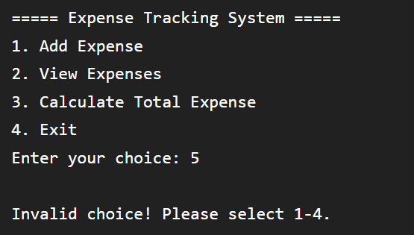

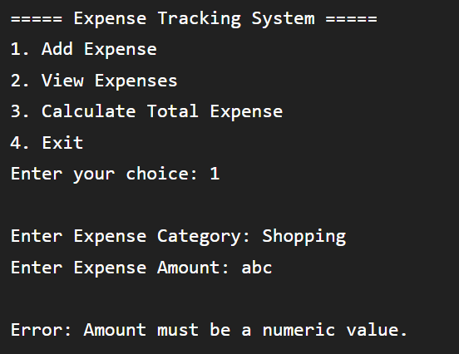

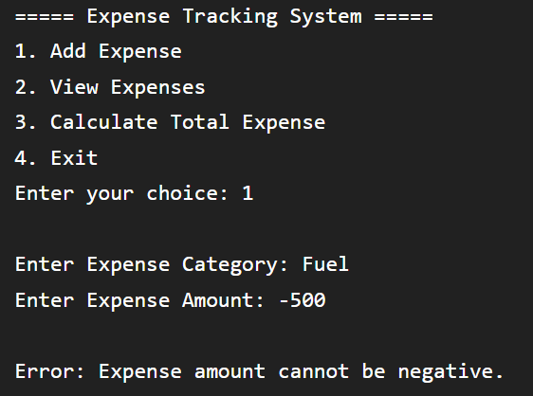
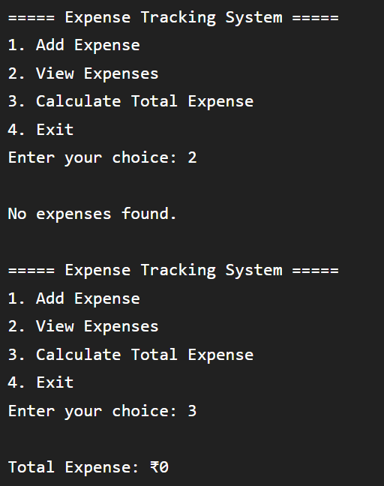
GitHub URL:
https://github.com/Preet1926/Practical-3

