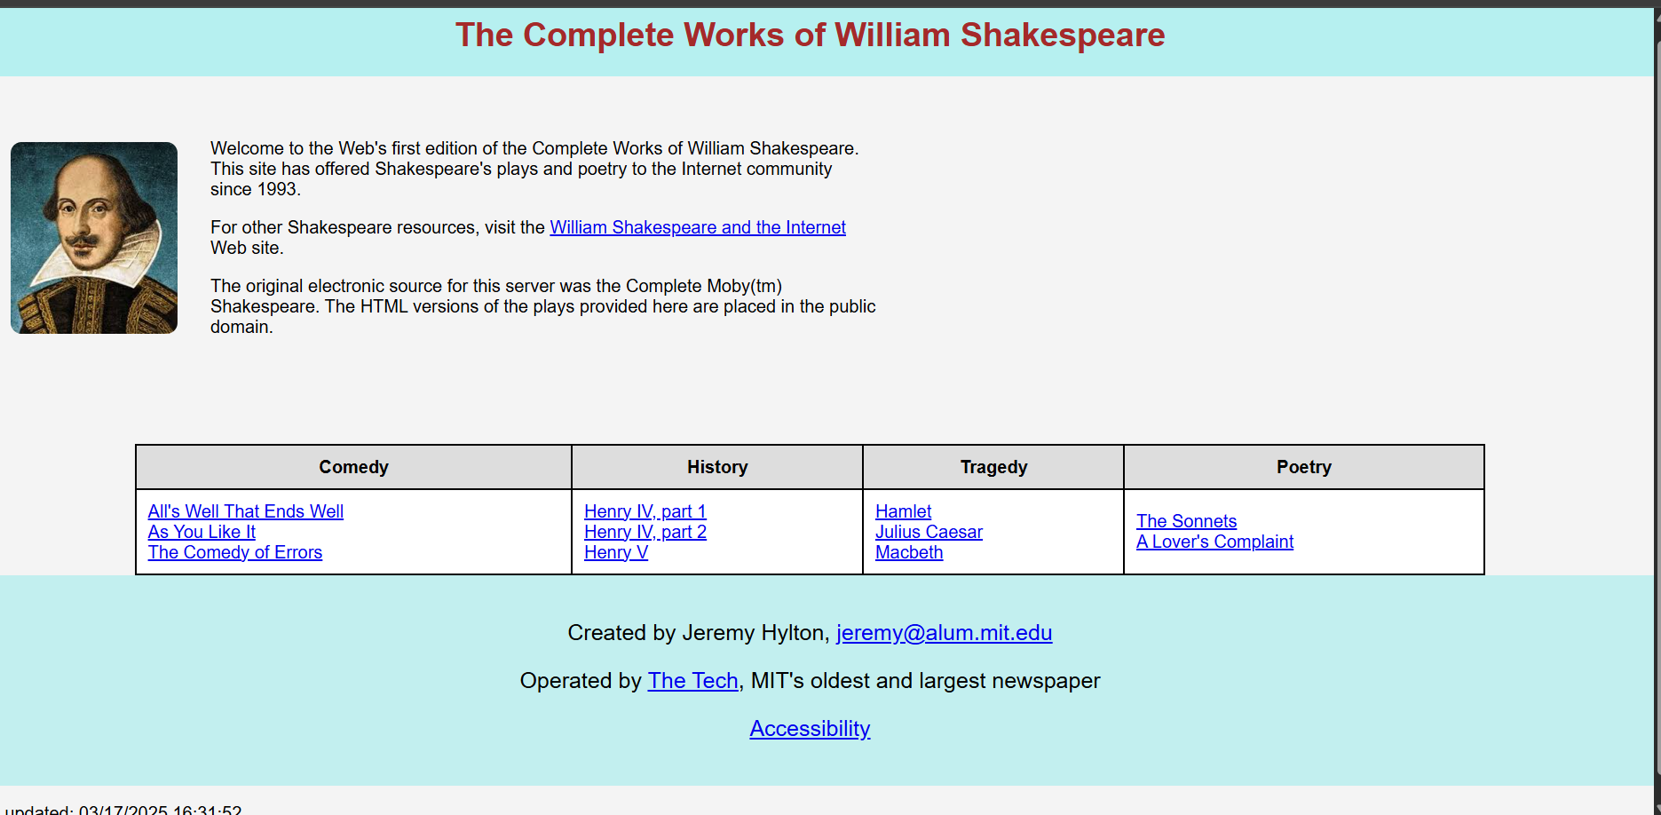

**Addendum:**

• **Enhanced Styling:**

* Applied a soft background color for better readability.
* Used a more modern font (Arial).
* Added padding and margins for better spacing.
* Styled the table for a cleaner look.
* Made links visually appealing with hover effects.

• **Structural Improvements:**

* Used a .container class with display: flex; for better content alignment.
* The image now has proper margins and a border-radius.
* The table is centered and has a more professional design.

• **Fixed Errors:**

* Corrected a misplaced double quote ("") in the image tag.
* Fixed an incorrect HTML tag (<a href="">Antony and Cleopatra></a> → <a href="#">Antony and Cleopatra</a>).
* Removed extra spaces and cleaned up the formatting.

• **Footer Adjustments:**

* Wrapped the email inside a proper mailto: link.
* Improved text alignment and spacing.