| **SOEN 6471**  **ADVANCED SOFTWARE ARCHITECTURES**  **SUMMER 2023**  Deliverable 1  ECLIPSE  Declaration  We, the members of the team, have read and understood the Fairness Protocol and the Communal Work Protocol, and agree to abide by the policies therein, without any exception, under any circumstances, whatsoever.  Team K Preet Angad Singh Nanda  Priyanshi Yogeshkumar Patel  Jimil Suchitkumar Prajapati  Yash Nareshbhai Radadiya  Kevin Rao |
| --- |

# Table of Contents

**Table of Contents** **i**

1. **Problem 1 1**

1.1 Introduction 1

1.2 Uniquely defining characteristic 1

1.3 Software activities 1

1.4 Summary 2

1. **Problem 2 2**

2.1Model for Context of Use 2

2.2 Entity Definitions 3

1. **Problem 3 4**

3.1Stakeholder Model – Mind Map 4

3.2 Stakeholder Definitions:- 5

1. **Github****5**
2. **Responsibilities on Deliverable 1** **6**
3. **Contributions** **on Deliverable 1** **6**
4. **References** **6**

This deliverable submission follows the template provided by [1].

OPENARCH is an open source software system that our team must choose among several candidates. Our chosen OPENARCH is Eclipse.

# **1. Problem 1**

## **1.1 Introduction**

Eclipse is a widely used open-source integrated development environment (IDE) that provides a comprehensive set of tools and functionalities for software developers. It is designed to be highly extensible, customizable, and platform-independent, making it suitable for a wide range of programming languages and development domains.[2]

The prime objective of Eclipse is to enhance developer productivity by providing a unified environment for writing, testing, and debugging code. It offers a rich set of features, including code editors with syntax highlighting and auto-completion, integrated debugging tools, version control system integration, and project management capabilities.[3]

## **1.2 Uniquely defining characteristic**

One of the distinctive features that sets Eclipse apart is its modularity. The IDE is built upon the Eclipse Platform, which offers a collection of essential services and frameworks that can be expanded upon with various plugins. This modular design enables developers to personalize their development environment by adding or removing specific features, making Eclipse highly adaptable to different programming languages and development workflows. [4]

Eclipse has gained popularity in a broad range of software development fields, encompassing Java, C/C++, Python, PHP, and more. It provides dedicated tools and frameworks tailored to specific languages and platforms, such as the Eclipse Java Development Tools (JDT) for Java development and the Eclipse C/C++ Development Tools (CDT) for C/C++ programming. Moreover, Eclipse supports web and mobile application development through frameworks like the Eclipse Web Tools Platform (WTP) and Eclipse Mobile Tools for Java (MTJ). [4]

## **1.3 Software activities**

The development of Eclipse involves a collaborative effort by a large community of contributors and is overseen by the Eclipse Foundation, a non-profit organization. The Foundation ensures transparent and open development processes, encouraging active participation from the community. This has led to a diverse collection of plugins and extensions contributed by individuals, organizations, and companies, expanding the capabilities of the IDE. [3]

Another significant aspect of Eclipse is its contribution to software modeling and model-driven development. The Eclipse Modeling Framework (EMF) [2]. offers a platform for creating domain-specific modeling languages (DSMLs) and generating code from models. This approach allows developers to focus on higher-level abstractions and automate repetitive tasks, resulting in improved productivity and maintainability for complex software systems.

Additionally, Eclipse has played a key role in advancing software testing and quality assurance practices. The Eclipse Testing Framework (ETF) provides a robust infrastructure for testing, including support for unit testing, automated test generation, and test coverage analysis. Eclipse also integrates seamlessly with popular code analysis and static analysis tools, empowering developers to identify potential issues and enhance code quality. [5]

## **1.4 Summary**

To summarize, Eclipse is a flexible and powerful integrated development environment that supports software development in various programming languages and domains. Its modular and extensible nature, along with its strong architecture, makes it a popular choice among developers who value a customizable IDE. With its active community and vast array of plugins, Eclipse [3]remains adaptable and responsive to the evolving demands of the software development industry.

# **2. Problem 2**

Eclipse is intended to be used by people who are programmers and are well versed in Java programming language, looking for an Integrated Development Environment to code Java in, regardless of physical circumstances beyond being capable of interacting with a computer's input interface.

It is intended to allow modifiable and modular behaviour and settings pertaining to visuals and style to accommodate user needs and preferences, and provide aid in coding, debugging, testing, and documenting user code.

It is intended to be used on a multitude of possible hardware (CPU, GPU, RAM, HDD/SSD) combinations and specifications popular and affordable in the current market, as well as macOS, Windows and Linux operating systems.

## **2.1 Model for Context of Use**

The following context diagram is made with [DrawIO](https://app.diagrams.net/). The diagram contains external entities related to the chosen system Eclipse, and their relations to it.

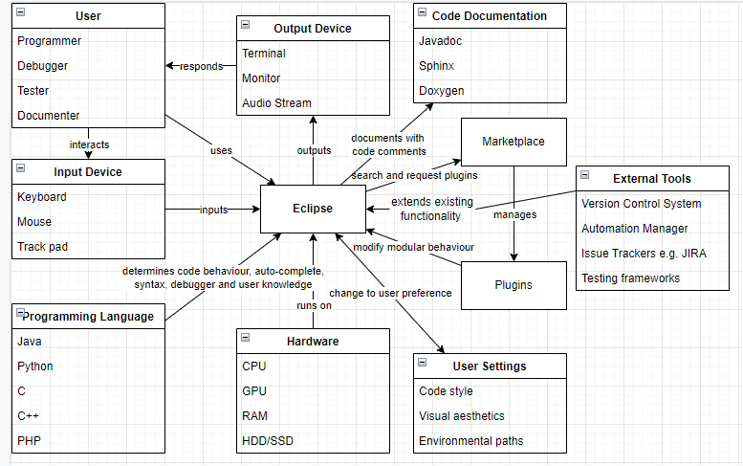

## **2.2 Entity Definitions**

**Eclipse**: The studied system OPENARCH. Refer to Problem 1 for a fuller description.

**User**: The individuals who are interested in using Eclipse and who can effectively do so.

**Input Device**: The interface the users can interact with Eclipse, and with which the user should be capable of interacting with to utilize Eclipse.

**Output Device**: The interface Eclipses has access to with which to respond to the user.

**Programming Language**: The language of the code Eclipse understands, and with which the user should have knowledge of in order to use Eclipse.

**Hardware**: The physical specification under which Eclipse is bound by in its code execution, and provided by the user.

**User Settings**: The idiosyncratic configuration guided by the user’s preference that determines a multitude of behaviour and visual decisions Eclipse can make regarding its built-in functionalities.

**Code Documentation**: The tools that can auto-generate documentation for the code, based on the users code comments.

**Marketplace**: A congregation of user plugins the user can search, select and manage from, as well as where a user can submit his own plugins for the use of the greater community.

**External Tools:** Eclipse supports integration of adding external tools to streamline the development process. These tools are consist of VCS (Version Control System), Testing frameworks, etc, which are essential in maintaining the large codebase.

**Plugins**: The idiosyncratic assembly of user picked, external modifications to Eclipse’s behavioural and visual functionality. These assist in the usage of Eclipse.

# **3. Problem 3**

The potential stakeholders of Eclipse were considered using a mind map model. The mind map helped in defining the roles of the stakeholders.

## **3.1 Stakeholder Model – Mind Map**

The stakeholder mind map was created with the use of Miro.

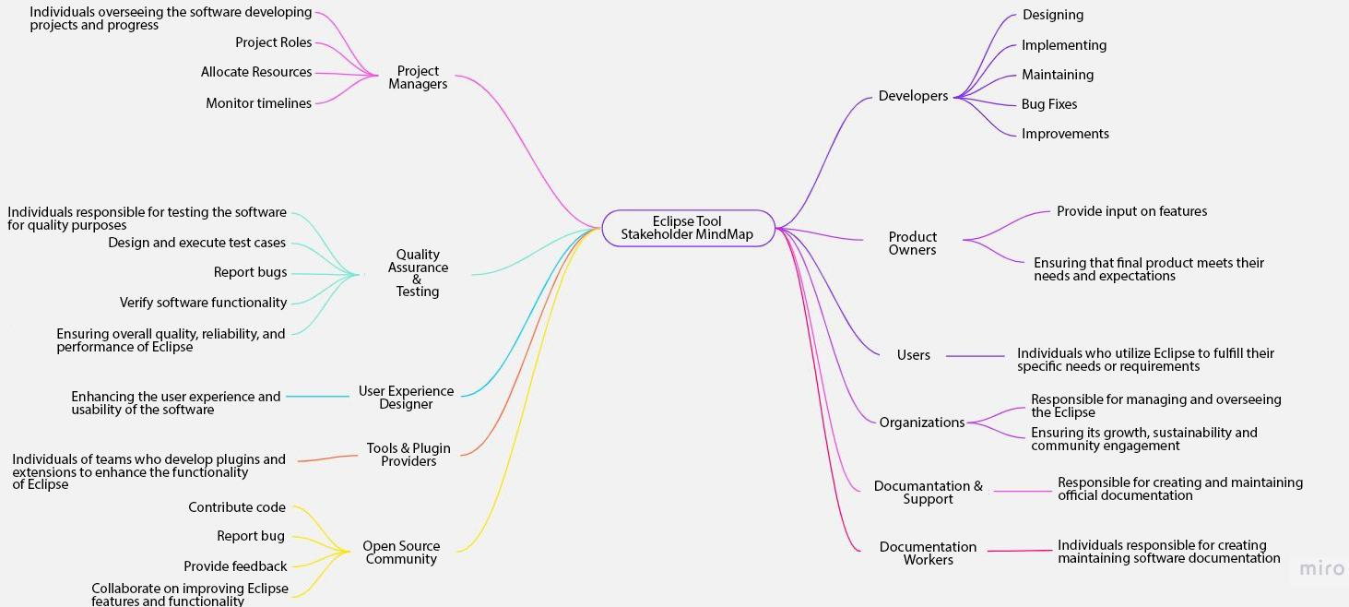

## **3.2 Stakeholder Definitions:**

**Developers:** The primary stakeholders responsible for designing, implementing, and maintaining Eclipse. External individuals or organizations who contribute code, bug fixes, and improvements to Eclipse.

**Product Owners:** Representatives of the end-users or clients who define and prioritize the product requirements.Provide input on features, functionality, and usability, ensuring the final product meets their needs and expectations.

**Users:** Individuals or organizations who utilize Eclipse to fulfill their specific needs or requirements.

**Organizations:** The governing body responsible for managing and overseeing the Eclipse project, ensuring its growth, sustainability, and community engagement.

**Documentation and Support:** Stakeholders responsible for creating and maintaining official documentation, including user guides, manuals, and API references for Eclipse.

**Documentation Writers:** Individuals responsible for creating and maintaining software documentation.

**Project Managers:** Definition: Individuals overseeing the software development project and its progress.

**Quality Assurance and Testing:** Individuals or teams responsible for testing Eclipse releases, reporting bugs, and verifying fixes and stakeholders involved in ensuring the overall quality, reliability, and performance of Eclipse through continuous testing and quality control processes.

**User Experience (UX) Designers:** Professionals focused on enhancing the user experience and usability of the software.

**Tool and Plugin Providers**: Individuals or teams who develop plugins and extensions to enhance the functionality of Eclipse and Organizations offering complementary tools or services that integrate with Eclipse to provide additional features or capabilities.

**Open Source Community:** Developers and contributors from the broader open-source community who engage with Eclipse projects.

**4. Github**

<https://github.com/PreetAngadSingh/SOEN6471-TeamK>

# **5. Responsibilities on Deliverable 1**

| **Team Member** | **Research** | **P1** | **P2** | **P3** | **Documentation** |
| --- | --- | --- | --- | --- | --- |
| Preet Angad Singh Nanda |  |  |  |  |  |
| Priyanshi Yogeshkumar Patel |  |  |  |  |  |
| Jimil Suchitkumar Prajapati |  |  |  |  |  |
| Yash Nareshbhai Radadiya |  |  |  |  |  |
| Kevin Rao |  |  |  |  |  |

# **6. Contributions on Deliverable 1**

Near the beginning of the deliverable, on our first team meeting, we assigned each other and ourselves responsibilities over the deliverable. The following table lists the decided allocation of responsibilities and how team members contributed to these responsibilities.

| **Team Member** | **Contributions** |
| --- | --- |
| Preet Angad Singh Nanda | * Research and Documentation * Mind map for stakeholder model and/or its definitions (Problem 3) |
| Priyanshi Yogeshkumar Patel | * Description of Eclipse (Problem 1) * Research and Documentation |
| Jimil Suchitkumar Prajapati | * Research and Documentation * Model for context of use and/or its definitions. (Problem 2) |
| Yash Nareshbhai Radadiya | * Mind map for stakeholder model and/or its definitions (Problem 3) * Research and Documentation |
| Kevin Rao | * Research and Documentation * Model for context of use and/or its definitions. (Problem 2) |

# **7. References**

1. Kamthan, P. (2023) *Documentation Template* [Word Document]. Course Web Site. <http://users.encs.concordia.ca/~kamthan/courses/soen-6471/documentation_template.docx>

1. "Eclipse IDE 2021-03", Eclipse Foundation, 10 05 2021. [Online]. Available: <https://help.eclipse.org/latest/index.jsp>

1. K. Moir, "The Architecture of Open Source Applications (Volume 1)," [Online]. Available: <https://aosabook.org/en/v1/eclipse.html>

1. "Co-evolution of the Eclipse SDK Framework and Its Third-Party Plug-Ins..," [Online]. Available: <https://doi.org/10.1109/csmr.2013.64>

1. "g-Eclipse – A Contextualised Framework for Grid Users, Grid Resource Providers and Grid Application Developers.," [Online]. Available: <https://doi.org/10.1007/978-3-540-69389-5_46>