Student Name: Harmanpreet Kaur
Student id: 991855668
GitHub link:

Remote Domain Join from a CSV File

Introduction:
The purpose of this assignment is to develop a PowerShell script to remotely join the computers to the Active Directory domain. This script reads computer names or IP addresses out of a CSV file and attempts to join every computer to the domain. It also restarts the computer when necessary and generates a report which indicates which computers were joined to the domain and which ones failed to join. This script has been written with help of Script Template in the course. It utilises functions, parameters, and error handling to improve the readability of the code and its management. Also, it will prompt for the necessary password on execution, and it doesn't need to be saved into the script. I learned valuable things about using PowerShell for computer management in this assignment, and how it can save time and simplify computer management if I have many computers to manage.

Input CSV File
List of computers is stored in a csv file called Computers.csv. There is one column in the file named ComputerName. The name or IP address of each computer that I want to add to the domain is listed in a row.
Example: ComputerName 192.168.1.50
Using the Import-Csv command, the script reads the computer list. I can add more computers to the CSV file without editing the script, if I need to.

PowerShell Script
Script name: Harmanpreet_JoinDomainScript.ps1
<#
.SYNOPSIS
Joins computers from a CSV file to a domain remotely and makes a report.
.DESCRIPTION
This script reads computer names from a CSV file (column name: ComputerName).
For each computer it checks the connection, joins it to the domain and restarts it.
At the end it shows a report and saves it to a CSV file so I can see which computers
were joined and which ones failed.
The passwords are asked when the script runs so they are not saved in the script.
.PARAMETER CsvPath
Path of the CSV file with the computer names. Default is C:\Scripts\Computers.csv
.PARAMETER Domain
The domain to join. Default is Harman.powershell.com
.PARAMETER AdminUser
The domain admin account name. Default is Harman
.PARAMETER ReportPath
Where the report is saved. Default is C:\Scripts\JoinReport.csv
.EXAMPLE
PS> .\Harmanpreet_JoinDomainScript.ps1
.NOTES
Author: Harmanpreet Kaur
Created: 2026-10-17
Version: 1.0
Last Modified: 2026-10-17
Change Log:
1.0 - Initial release
.LINK
https://learn.microsoft.com/powershell/module/microsoft.powershell.management/add-computer
#>

#Parameters
param(
[string]$CsvPath = "C:\Scripts\Computers.csv",
[string]$Domain = "Harman.powershell.com",
[string]$AdminUser = "Harman",
[string]$ReportPath = "C:\Scripts\JoinReport.csv"
)

#Functions

# Reads the CSV file and gives back the list of computer names
function Get-ComputerList($path) {
if (-not (Test-Path $path)) {
throw "CSV file not found: $path"
}
$rows = Import-Csv -Path $path
$names = @()
foreach ($row in $rows) {
$name = "$($row.ComputerName)".Trim()
if ($name -ne "") {
$names += $name
}
}
if ($names.Count -eq 0) {
throw "No computer names found. The CSV needs a column called ComputerName."
}
return $names
}

# Joins one remote computer to the domain and restarts it
# It gives back one line for the report
function Join-OneComputer($pc, $localCred, $domainCred) {

$status = ""
$restarted = "No"
$message = ""

# check if the computer answers first
if (-not (Test-Connection -ComputerName $pc -Count 1 -Quiet)) {
$status = "Failed"
$message = "Computer is not reachable"
}
else {
try {
Add-Computer -ComputerName $pc -LocalCredential $localCred -DomainName $Domain `
-Credential $domainCred -Restart -Force -ErrorAction Stop
$status = "Joined"
$restarted = "Yes"
$message = "Joined to $Domain"
}
catch {
$status = "Failed"
$message = $_.Exception.Message
}
}

return [PSCustomObject]@{
ComputerName = $pc
Status = $status
Restarted = $restarted
Message = $message
Time = Get-Date -Format "yyyy-MM-dd HH:mm:ss"
}
}

#Execution Code

# Read the computer names
try {
$computers = Get-ComputerList $CsvPath
}
catch {
Write-Host "Error: $($_.Exception.Message)"
return
}
Write-Host "Found $($computers.Count) computer(s) in the CSV file"

# Ask for the passwords
$domainCred = Get-Credential -UserName "$Domain\$AdminUser" -Message "Enter DOMAIN admin password"
$localCred = Get-Credential -Message "Enter LOCAL admin of the remote PCs (example: PC\Administrator)"

# Join each computer and keep the result for the report
$report = @()
foreach ($pc in $computers) {
Write-Host "Joining $pc ..."
$report += Join-OneComputer $pc $localCred $domainCred
}

# Show the report on the screen
Write-Host ""
Write-Host "===== Join Report ====="
$report | Format-Table ComputerName, Status, Restarted, Message -AutoSize

$joined = @($report | Where-Object { $_.Status -eq "Joined" }).Count
$failed = @($report | Where-Object { $_.Status -eq "Failed" }).Count
Write-Host "Joined: $joined Failed: $failed"

# Save the report to a CSV file
$report | Export-Csv -Path $ReportPath -NoTypeInformation
Write-Host "Report saved to $ReportPath"

Screenshots of Execution

Screenshot 1: Running the Script and the Join Report

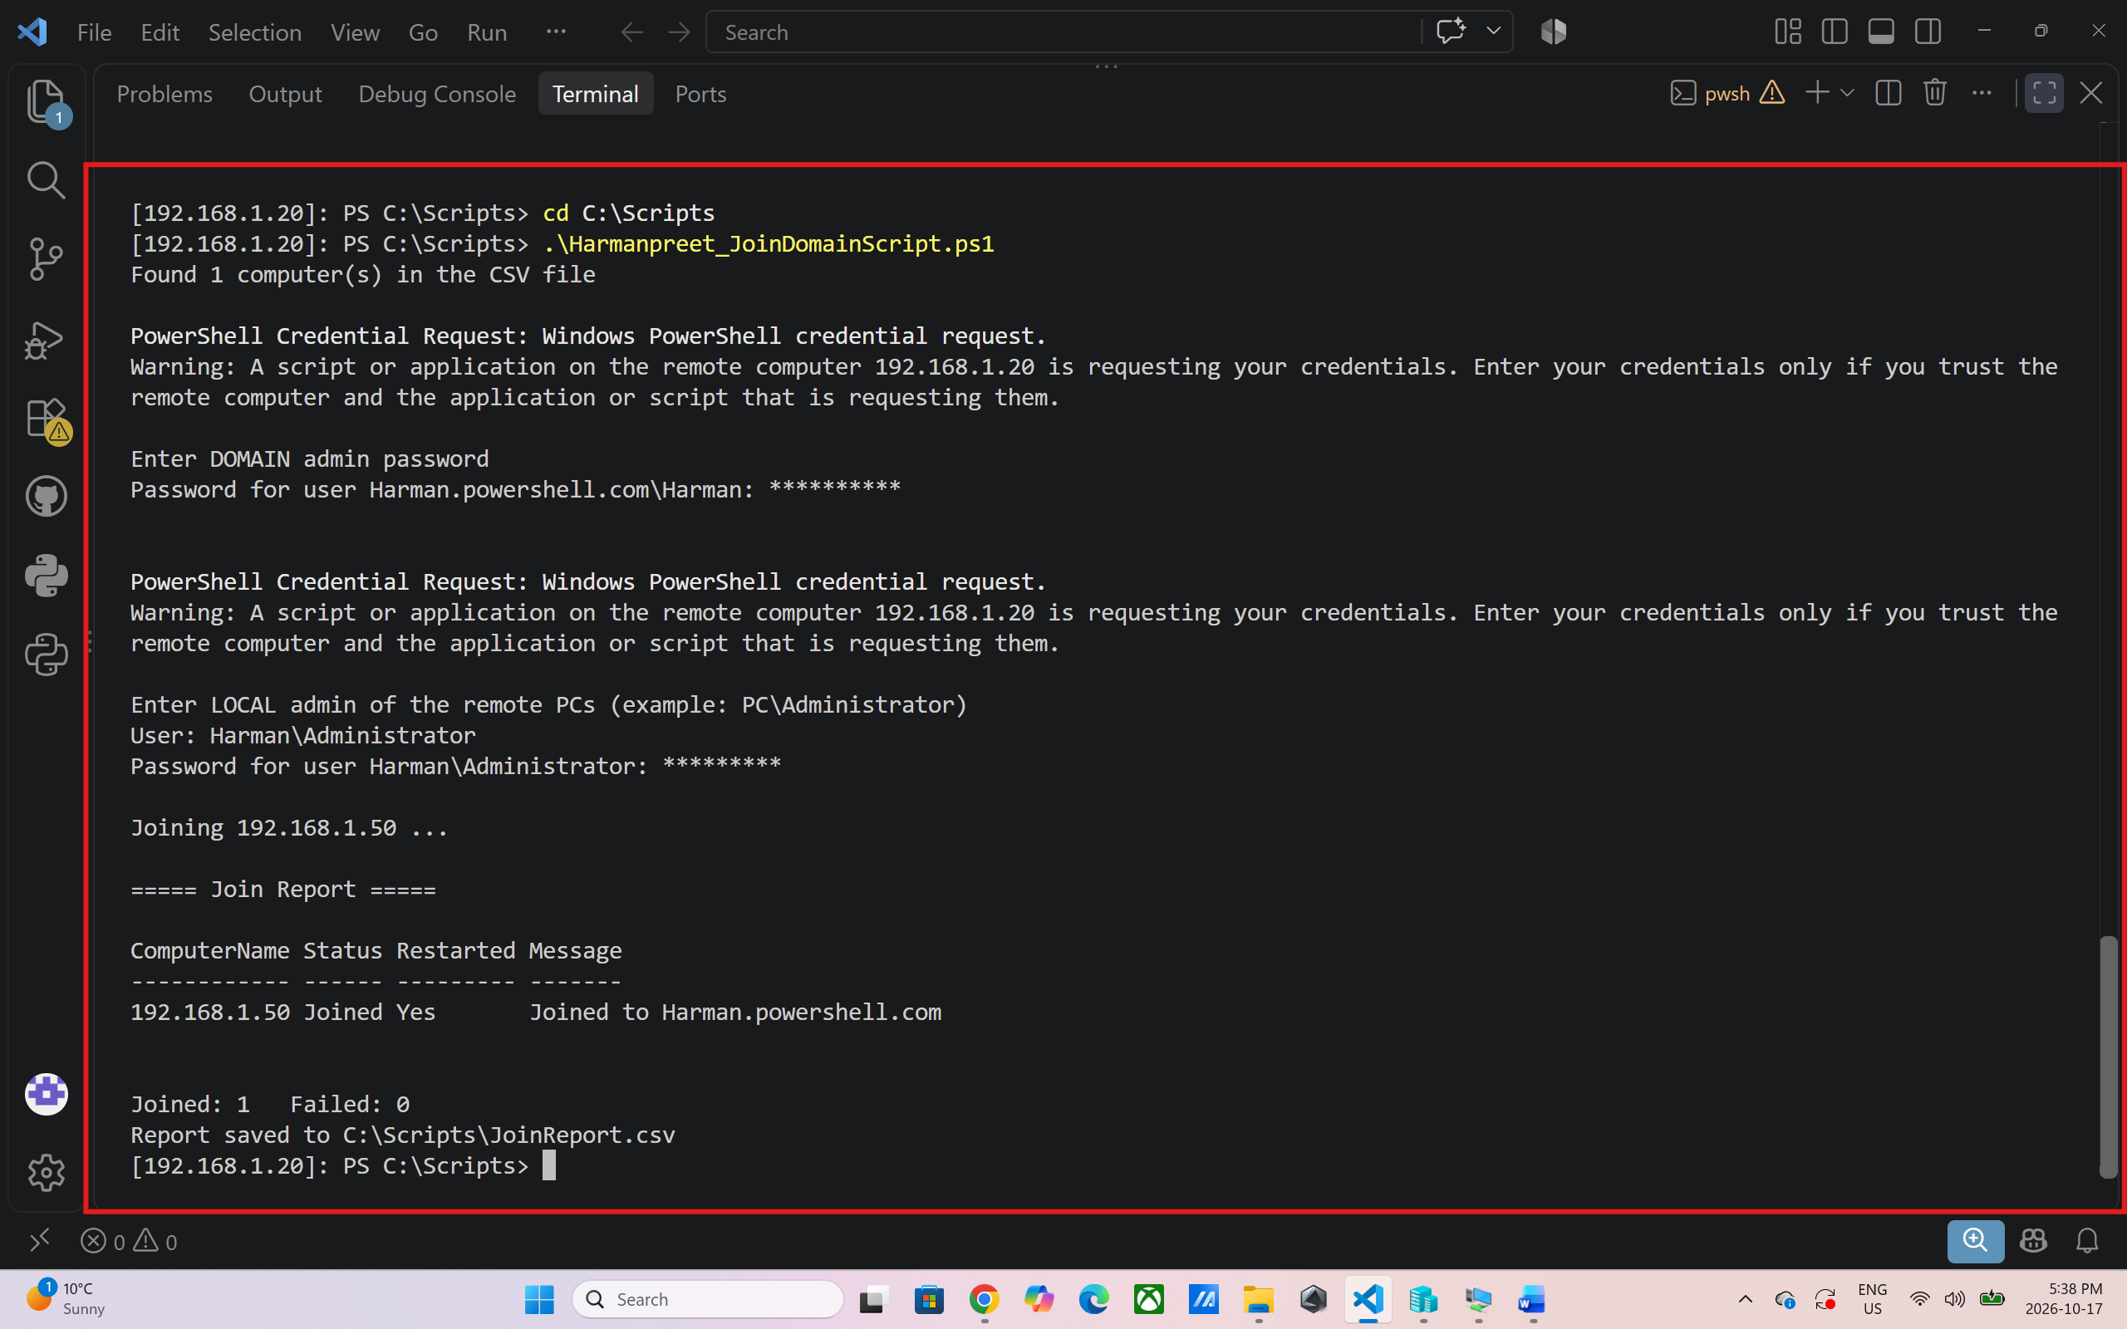

Output: I ran the script from 192.168.1.20 in `C:\Scripts`. It could find 1 computer in the CSV file and request the password of the domain admin and the local admin. It joined **192.168.1.50** to **Harman.powershell.com** and restarted it. Report Status: “Joined” / Restarted: “Yes”. Joined: 1, Failed: 0. The report file JoinReport.csv is saved to C:\Scripts\JoinReport.csv.
Screenshot 2: Server3 Joined to the Domain

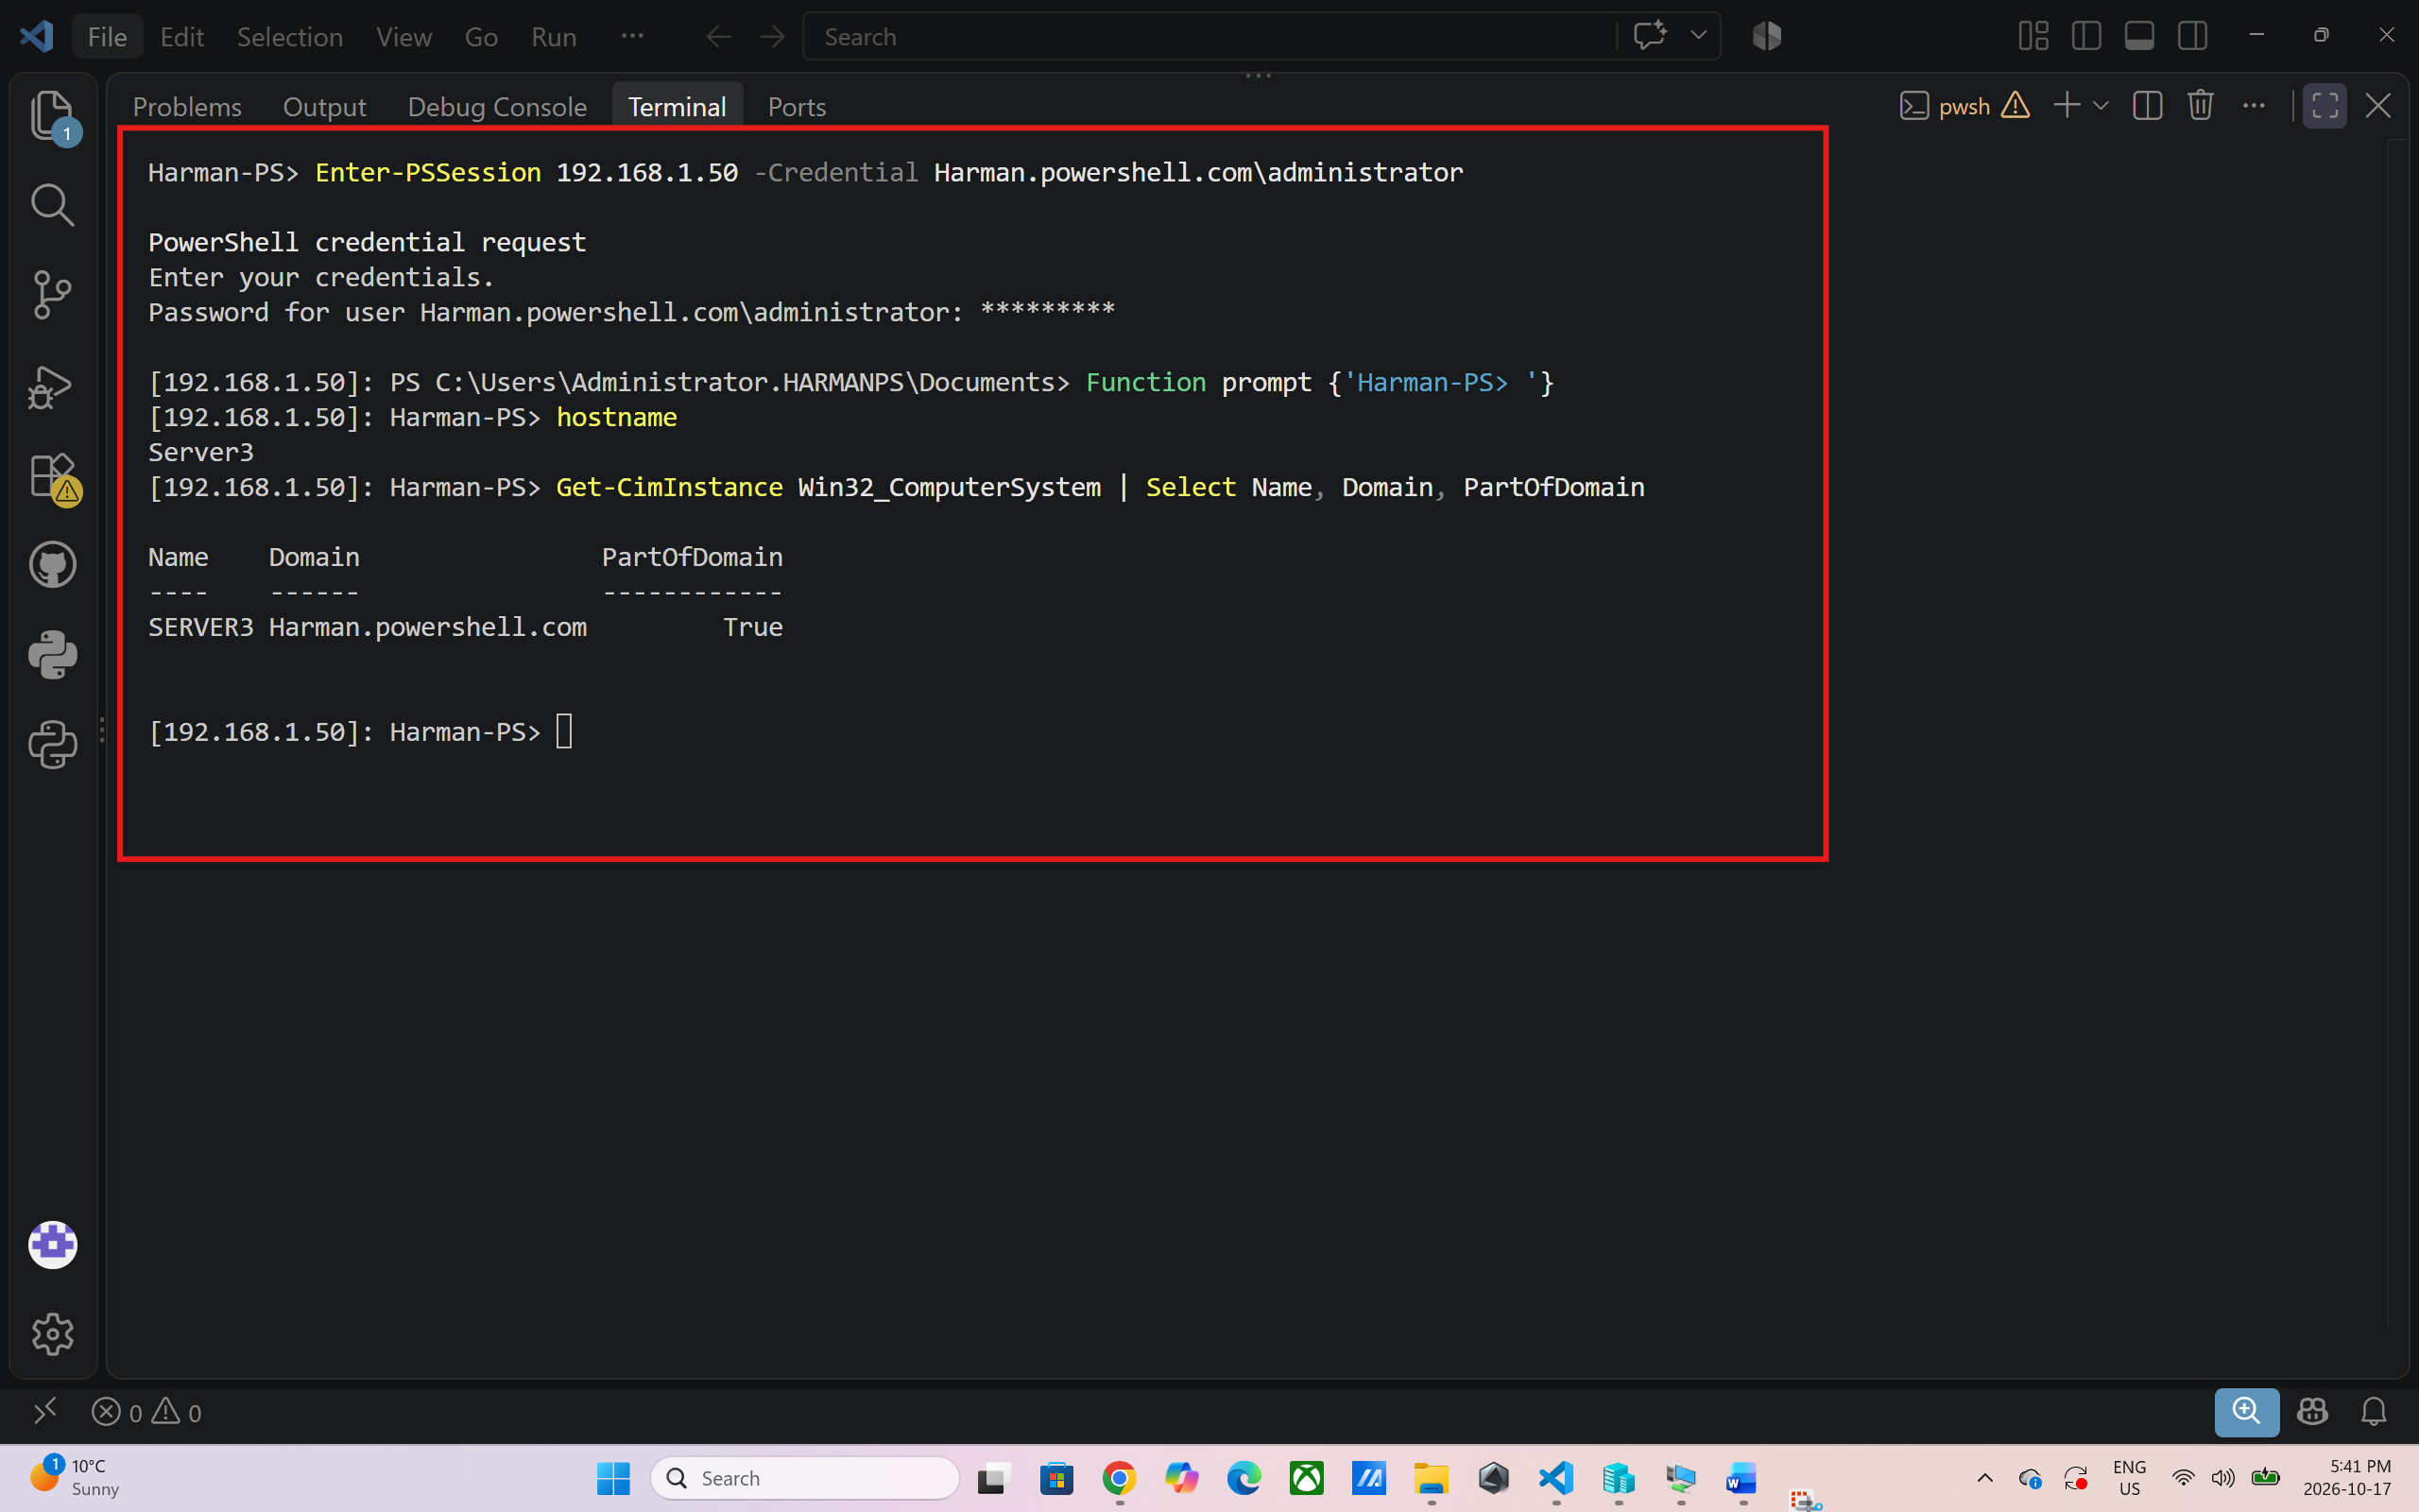
Output: I verified the join using Enter-PSSession and running hostname and Get-CimInstance Win32_ComputerSystem on 192.168.1.50. The computer name is SERVER3, the domain is Harman.powershell.com and PartOfDomain is True. This should validate that the join was successful and not merely reported by my script.

Screenshot 3: Error Handling When the Computer Is Already in the Domain
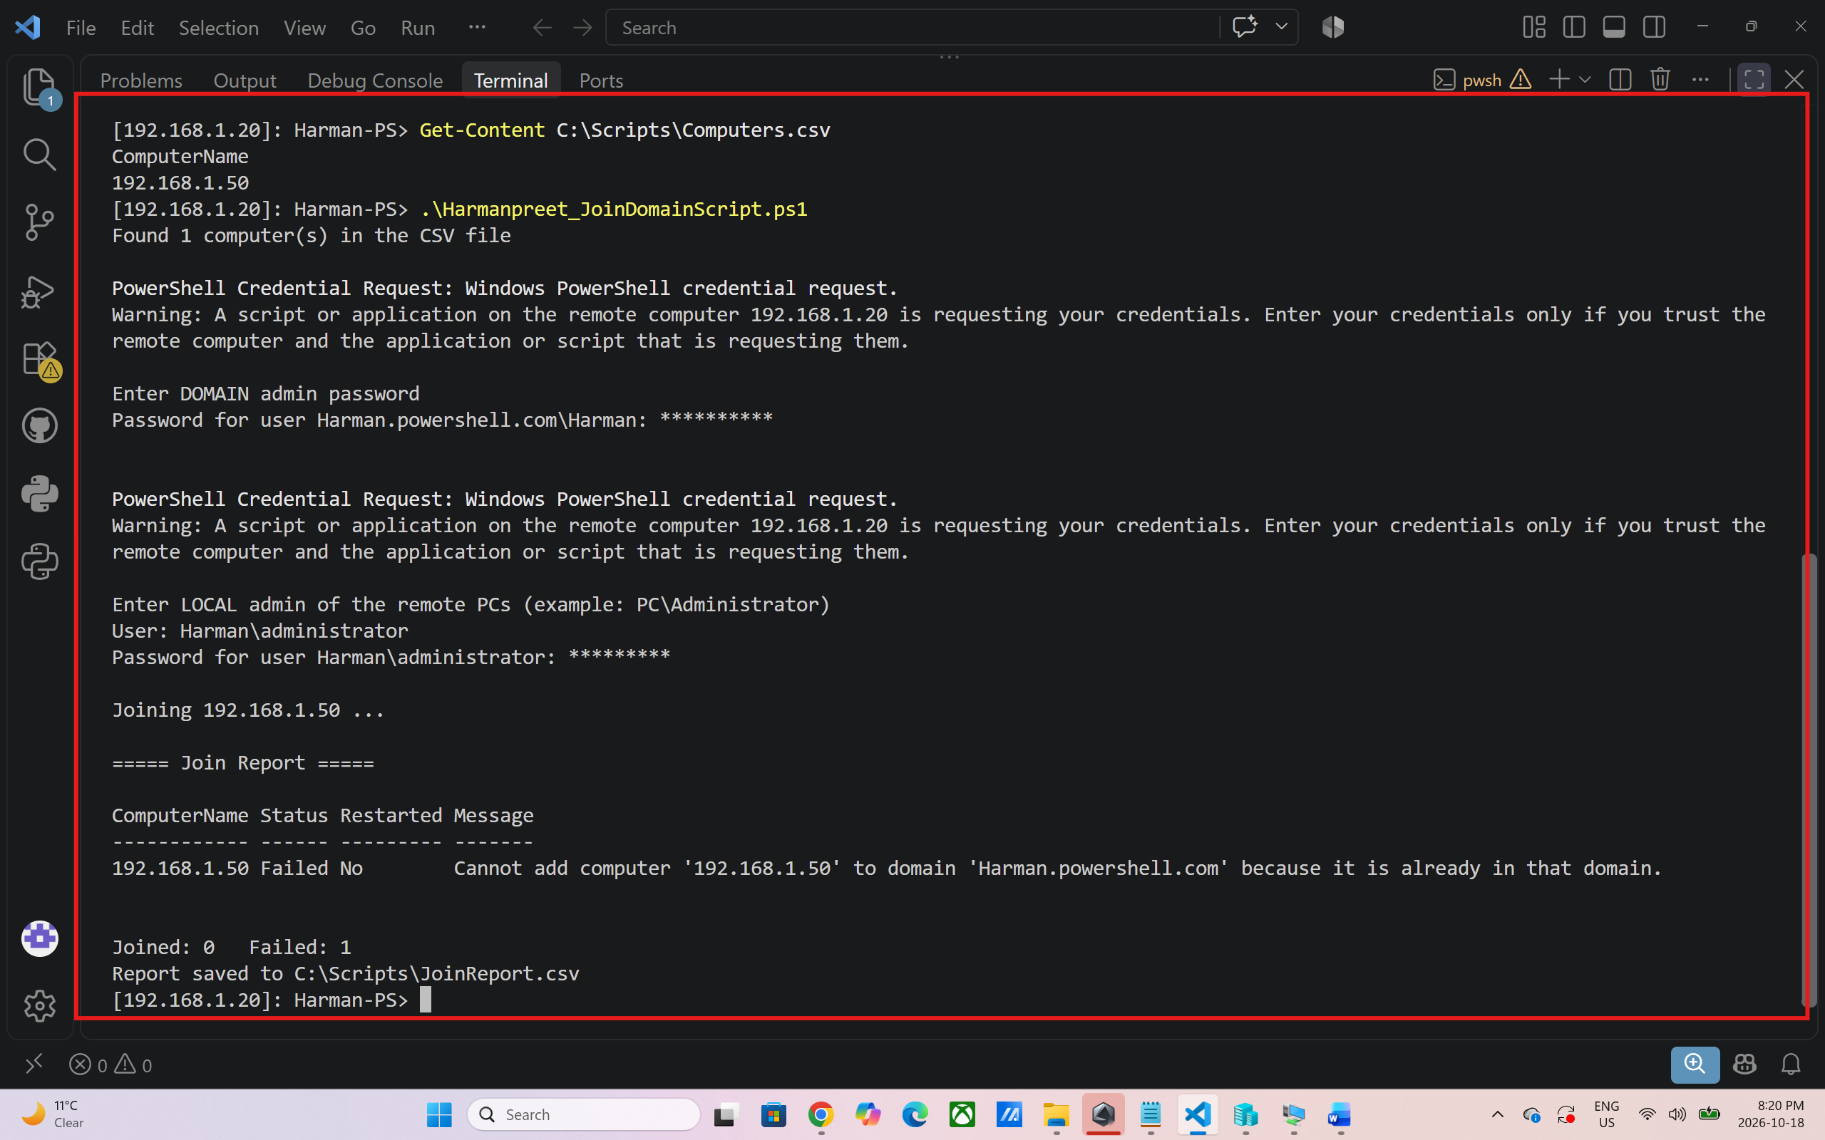
Output: I Ran the script again on the same computer. Server3 was already in the domain, so Add-Computer returned an error. The script did not cause any crashes. The try/catch block caught the error, and the Join Report shows Status “Failed”, Restarted “No”, and the message that the computer is already in that domain. The summary displays Joined: 0 Failed: 1 and the report is saved once again.
Screenshot 4: Saved JoinReport.csv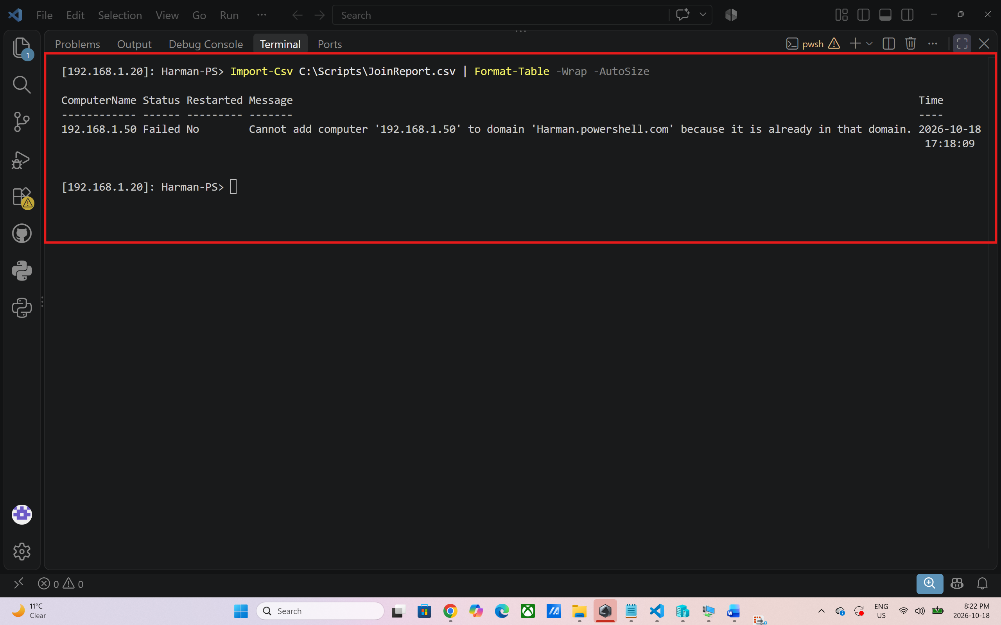
Output: I imported a report file and displayed it using Import-Csv. It has one row for 192.168.1.50 with ComputerName, Status, Restarted, Message and Time. This information about the Time column is not displayed in the on screen table, but it is saved in the file. The time is from the remote machine (192.168.1.20), so that means that the time can vary from my computer's clock.

How the Script Works

- The parameter block defines the location of the CSV file, domain name, administrator account and report file.
- Get-ComputerList is a function that will read the computer names from the CSV file.
- When running it asks for the required passwords rather than storing them in the script. The Join-OneComputer function determines if each computer is reachable and attempts to join the computer to the domain.
- To join the computer to the domain and to restart the computer if necessary, use the Add-Computer command.
- Errors are caught in a try/catch to ensure that if one computer fails, the script does not fail.
- Last, it prints the output in a table and writes the output to a CSV report with Export-Csv.
- A restart is always required to complete a domain join, so the script uses -Restart

Reflection Summary
For this assignment, I wrote a script in PowerShell to perform a remote computer join to an Active Directory domain, using a CSV file containing a list of the computers to join. The script reads the file using Import-Csv, verifies every computer, then adds the computer to the file and generates the report at the end. I learned to use domain and local credentials together, I learned how parameters, functions and Get-Credential make a script more flexible and secure as there are no passwords stored in it. The biggest take-away I had was error handling. Running the script on Server3, the already domain joined server, did not cause the script to crash. The error was caught by the try/catch block, and the error message was written to the report with a clear message (see Screenshots 3 and 4). That was a good example as to how a script can continue to run and inform the administrator what actually occurred.
During testing, I experienced a couple of issues as well. Firstly the PowerShell execution policy was blocking the script and so was changed to allow scripts for the one session. In addition, I discovered that the CSV file needs to have the header ComputerName and the extension .csv, otherwise it's impossible to read it using the script. such as being in a remote session on the wrong computer, so PowerShell could not find my script. These problems taught me to check the environment, the folder and the input file before running a script.
Overall, this assignment was an indicator to me that PowerShell is a tool which makes system administration faster and more reliable. Future enhancements to the script would include adding an OU column to the CSV file, assigning each computer to the appropriate OU, and checking to see if a computer is already joined to the domain prior to joining the computer.
Conclusion
This assignment was a learning curve for me to learn how to automate joining computers to an Active Directory domain via PowerShell. I learned to read computer names from a CSV file and using administrative credentials, catching errors, and saving the results to a report file. This script will save an administrator time if he/she needs to add more than one computer to a domain.

