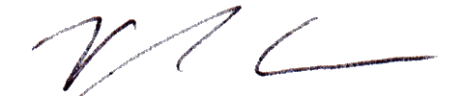
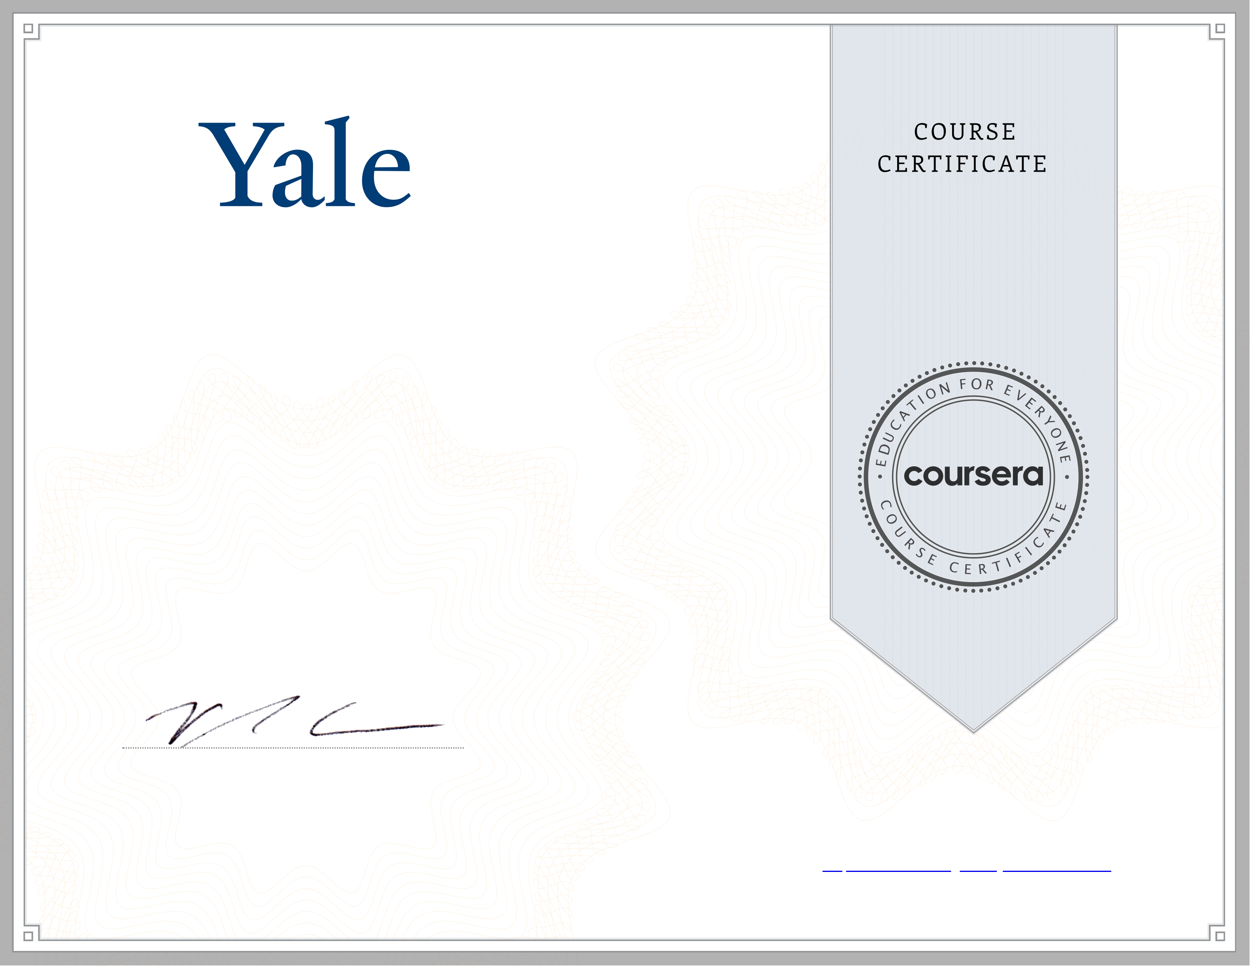
Mar 2, 2024
Preet Jawla
has successfully completed
Introduction to Psychology
an online non-credit course authorized by Yale University and offered through Coursera
Paul Bloom
Brooks and Suzanne Ragen Professor of Psychology
Yale University
Cour ser a has confir med the identity of this individual and their
par ticipation in the cour se.

