**Experiment -1.1**

Install Git and creating repository.

**Student Name: Preet UID: 22BDO10062**

**Branch: CSE(DevOps) Section/Group**- **22BCD-1/B**

**Semester: 4th Date of Performance: 15/01/2024**

**Subject Name**: Git and hub **Subject Code: 22CSH-293**

**1. Aim/Overview of the practical:** Install Git and creating repository.

**2. Software Used:** Git Bash, GitHub.

**3. Steps for experiment/practical:**

1. Download Git for windows.

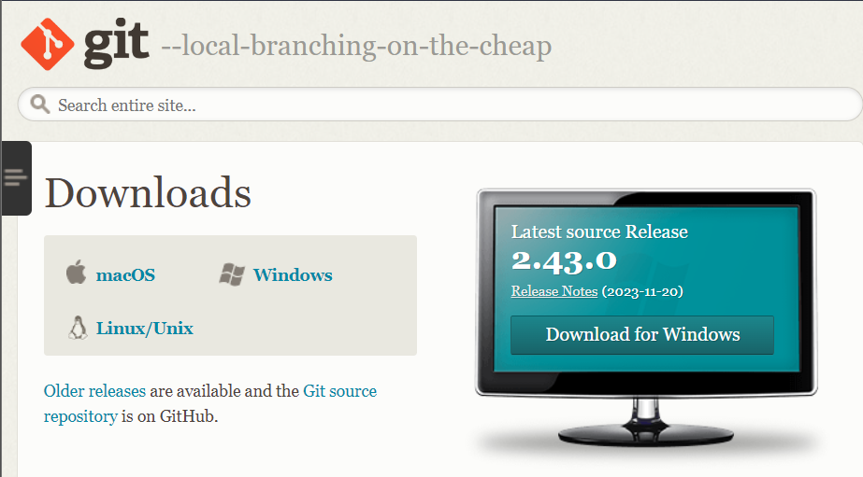

1. Install using git installer 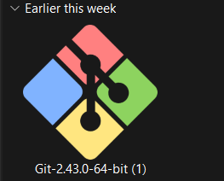
2. Click on ‘next’. 4. Click next after selecting following.

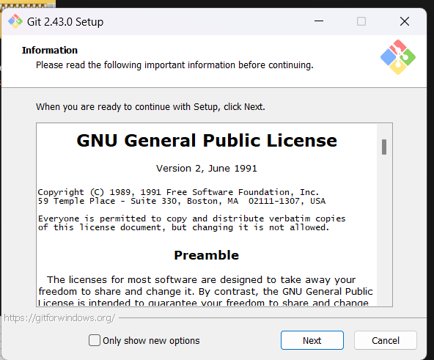 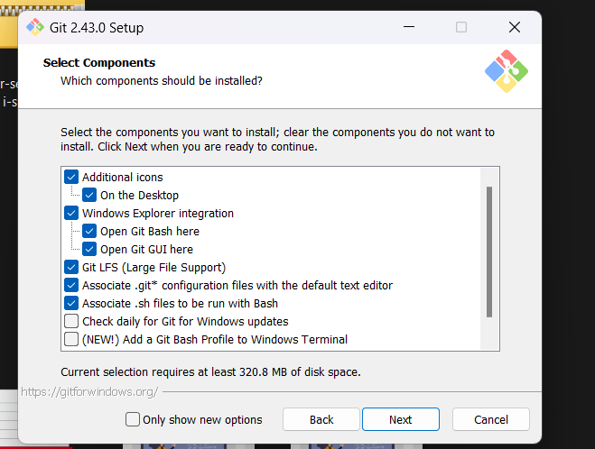

5. Click on next -next by keeping all settings as shown.

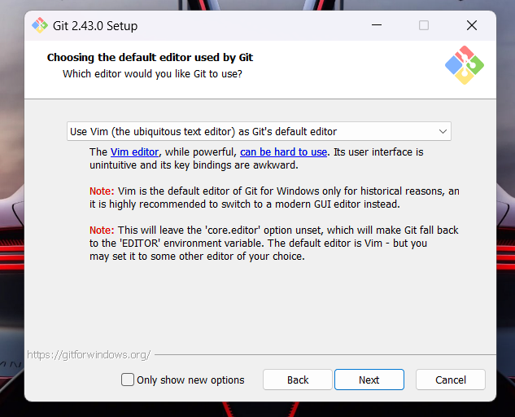 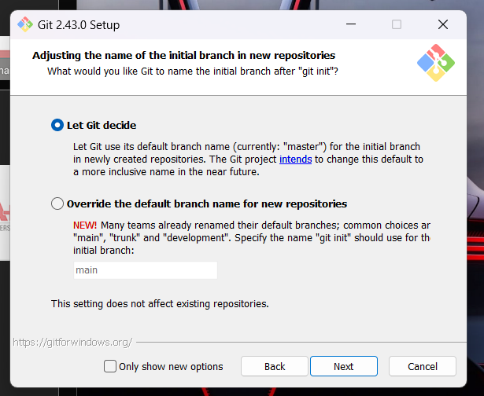

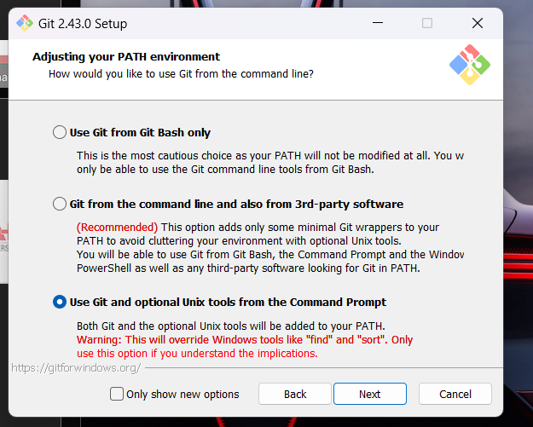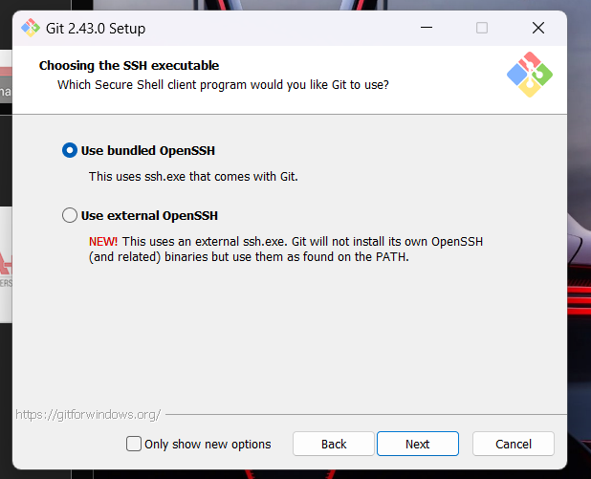

6. Can select first(beginners), or both.

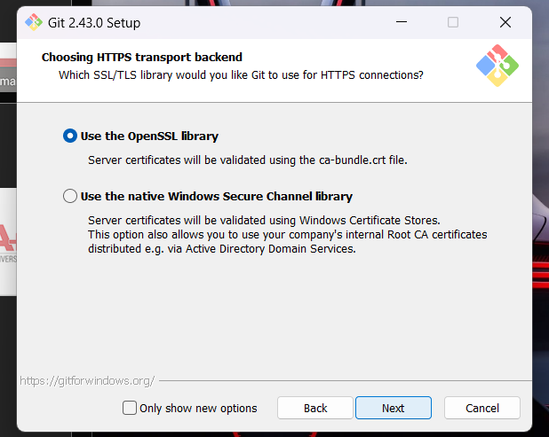 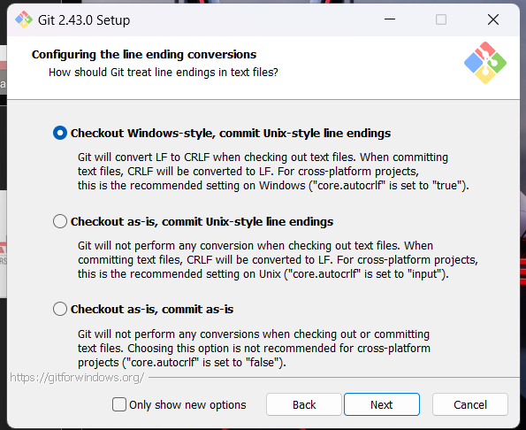

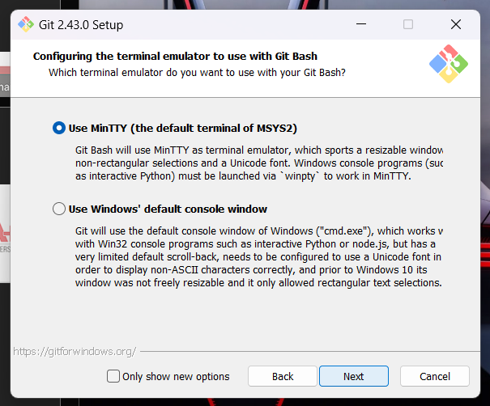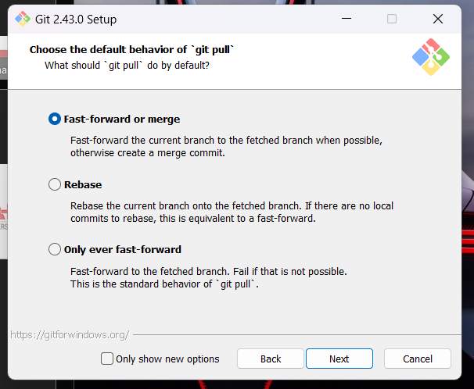

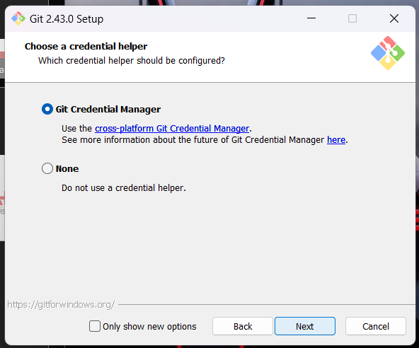 

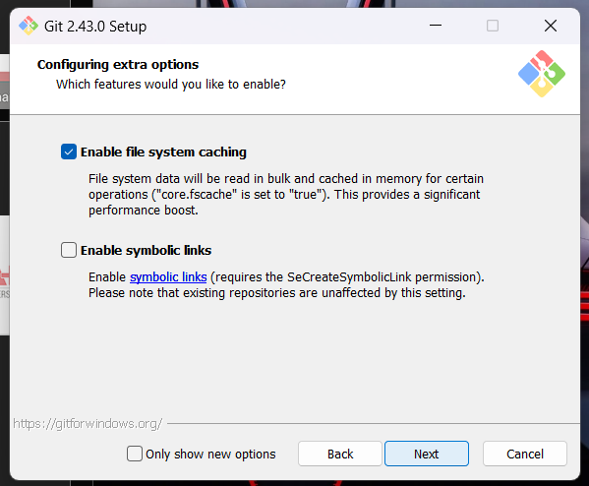 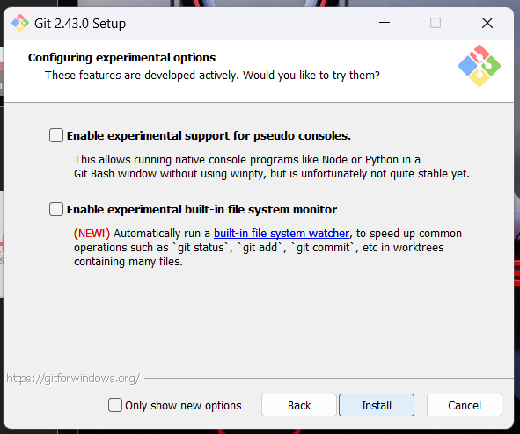

**7.** Now, Git will be installed successfully.

8. We can see the two applications as follows.

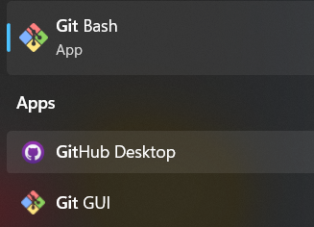 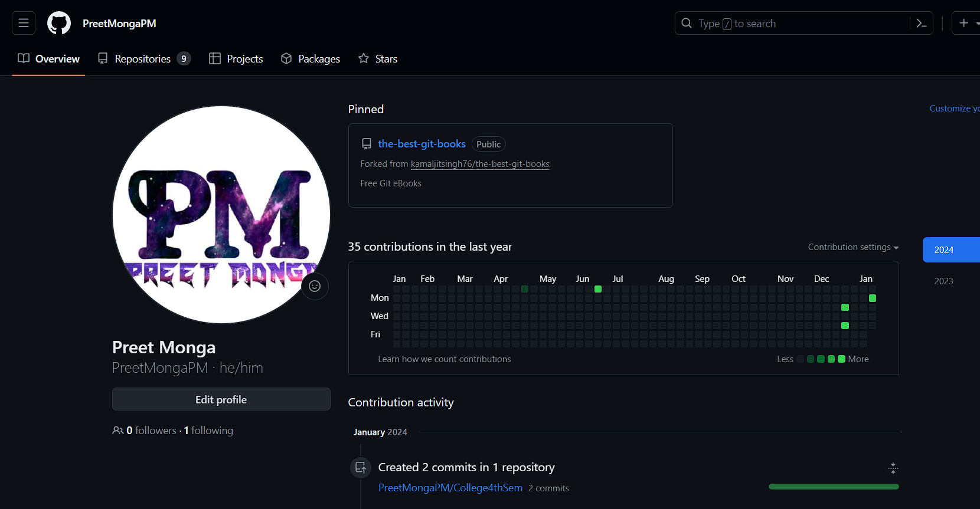

9. Now create account on GitHub.

10. Let’s create a repository on Github.

Github.com -> Repositories -> New -> Name the Repository ->write Description(optional) -> Public(to access openly) ->Add a README file(Details of Project) -> add .gitignore(to ignore changes someone else wanna do) - > License(none)

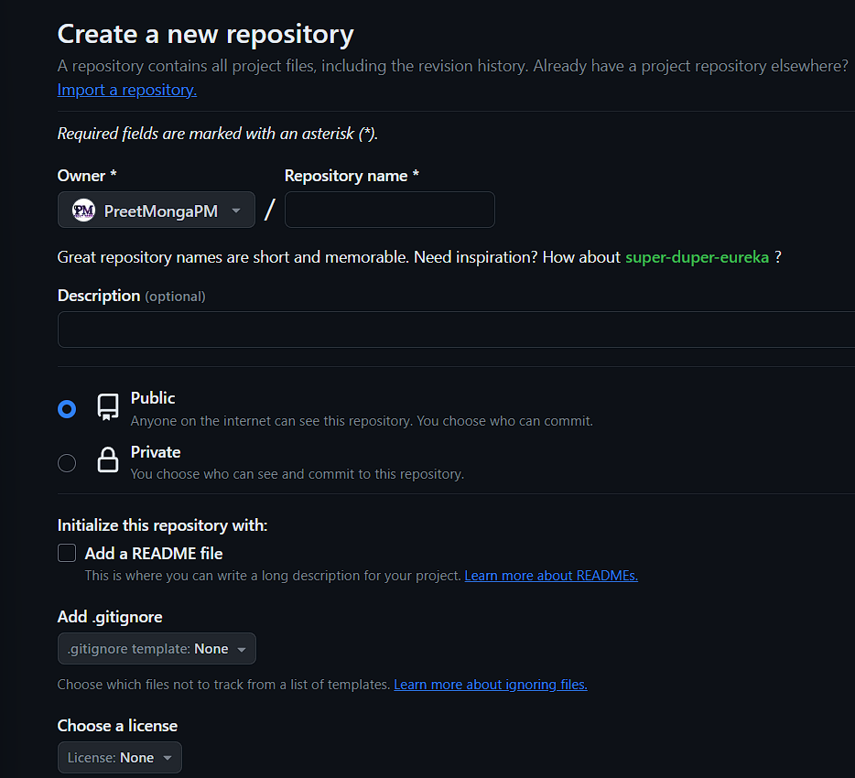

**11. Configuring Git with Github**

Open Git Bash-> write following commands whilst using username and email id used on the GitHub

*git config --global user.name “PreetMongaPM”*

press enter

*git config --global user.email “preetmongapm1@gmail.com”*

press enter

Use following command to check whether its configured or not ->

*git config --list*

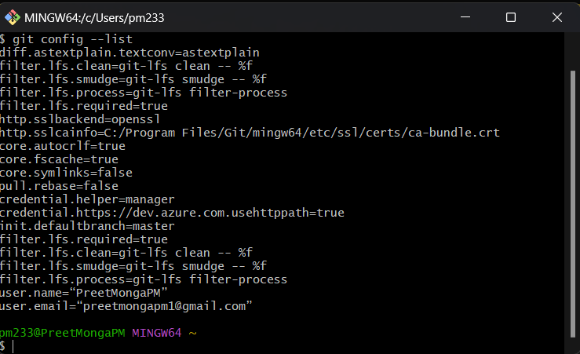 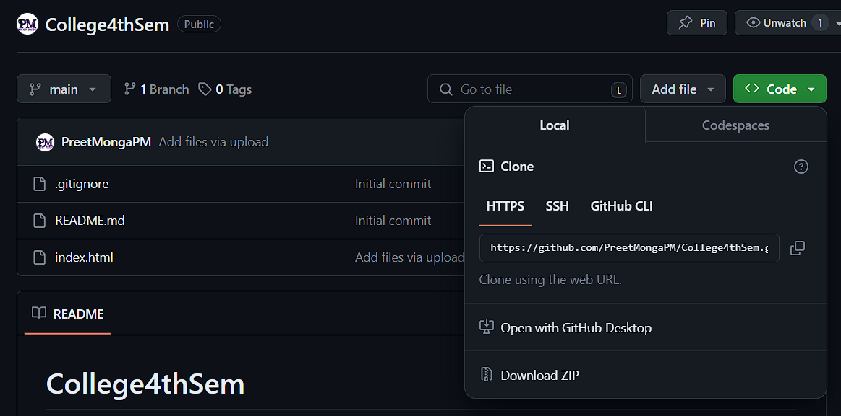

**12. Let’s clone that remote repository over our git.**

Write and copy the https link of repostitory from GitHub

*git clone “* [*https://github.com/PreetMongaPM/College4thSem.git*](https://github.com/PreetMongaPM/College4thSem.git)*”*

**13. Now, open the same repository on our Git Bash**

Write-

cd – means change directory

*cd repository_name*

*cd College4thSem*

**14. Now we are in the repository that we cloned on our local machine.**

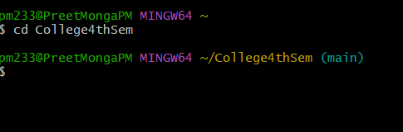

**15. Let’s create a file on our local and push it on to remote server.**

Write –

*cat>file_name*

*Hello Preet*

And press ctrl + d to save the file and close it

*(write inside file)*

To see content inside it:

*cat index.html*

To see status off our repository use:

*git status*

Add the untracked file and commit it writing a commit message.

*git add index.html*

*git commit -m “index.html added”*

File now available to GitHub.

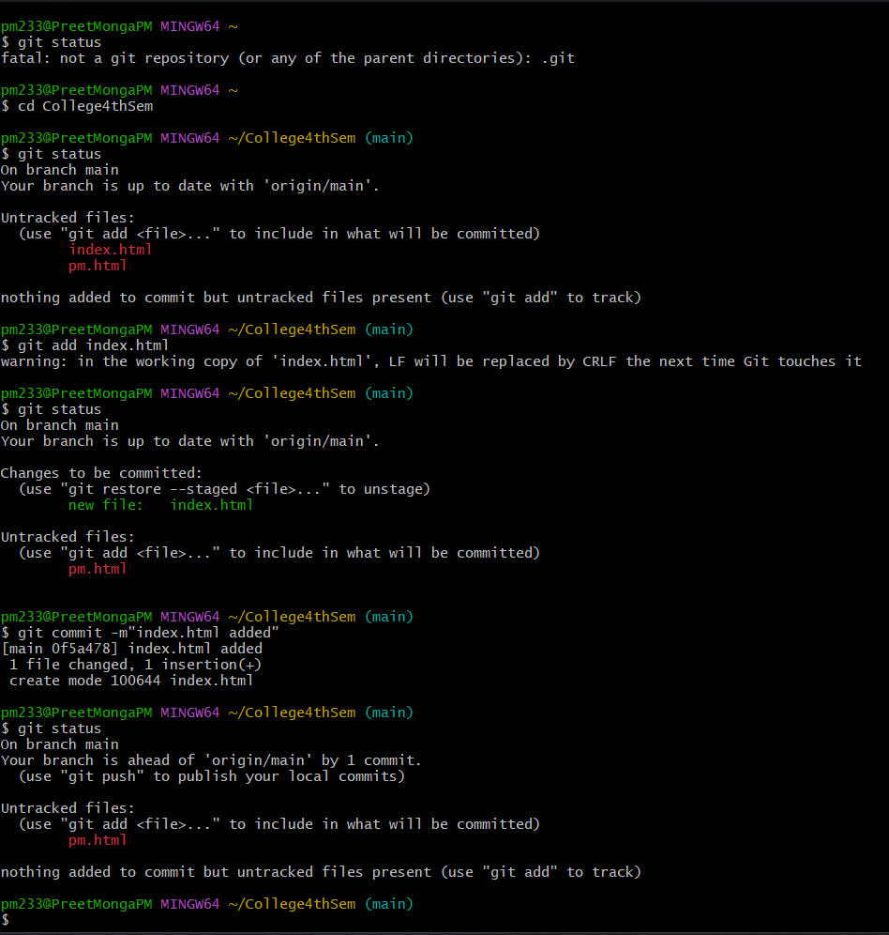 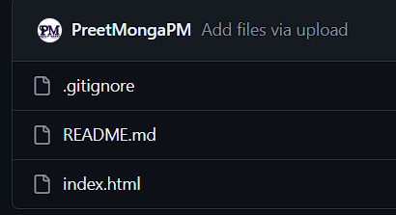

1. **Result/Output/Writing Summary:**

In this experiment we installed git, configured it with our GitHub account and write some commands such as clone to pull remote repository to our local machine, cd, cat, then add and commit to update changes to our remote repositories.

**Learning outcomes (What I have learnt):**

**1.** Learnt how to install git.

**2.** Learnt how to configure git with GitHub account.

**3.** Learnt about some basic commands such as cd and cat.

**4.** Learnt using git clone command.

**5.** Also learnt how to add and commit updates to the GitHub account.

**Evaluation Grid (To be created as per the SOP and Assessment guidelines by the faculty):**

|  |  |  |  |
| --- | --- | --- | --- |
| Sr. No. | Parameters | Marks Obtained | Maximum Marks |
| 1. |  |  |  |
| 2. |  |  |  |
| 3. |  |  |  |
|  |  |  |  |