**Experiment -1.3**

**Student Name: Preet UID: 22BDO10062**

**Branch: CSE(DevOps) Section/Group**- **22BCD-1/B**

**Semester: 4th Date of Performance: 02/02/2024**

**Subject Name**: Git and hub **Subject Code: 22CSH-293**

**1. Aim/Overview of the practical:** To create and explore Pull request.

**2. Software Used:** Git bash, GitHub.

**3. Steps for experiment/practical:**

1. Go to GitHub.com and create repository named “exp3”.

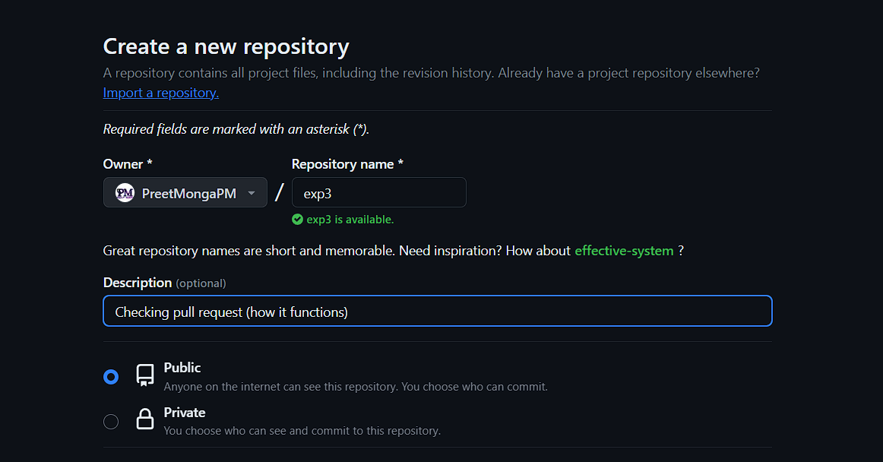 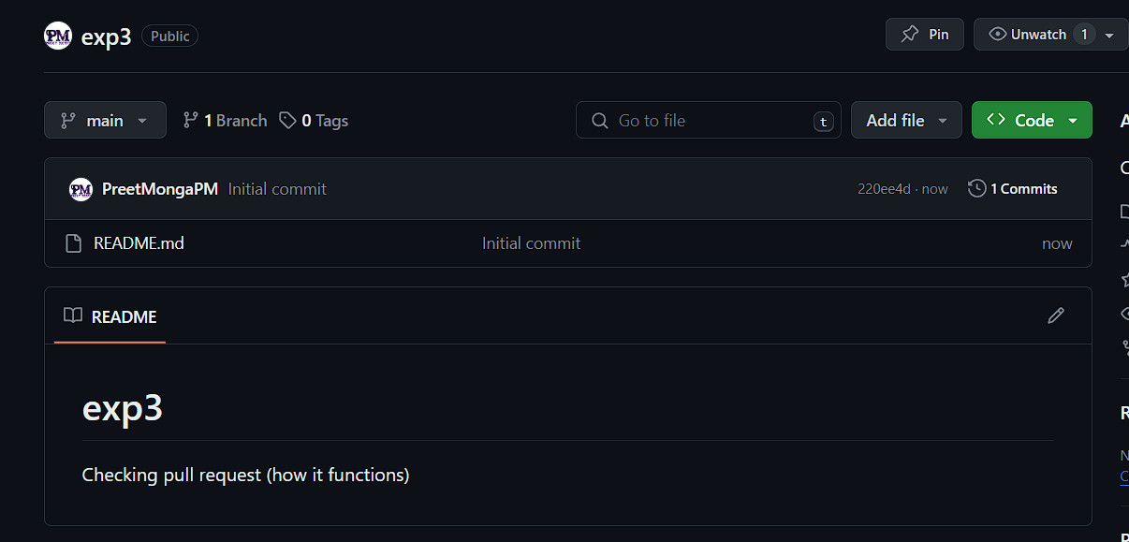

1. Now, we have to clone that repository over local machine using the link over code section in repository over GitHub

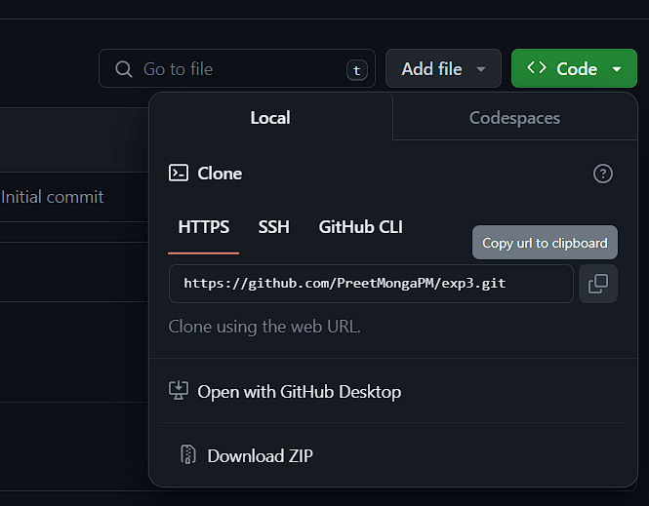

1. Copy the HTTPS link and paste with the command:

*git clone “link”*

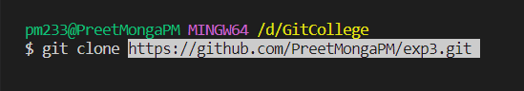

1. Now, our repository is cloned over our local machine.
2. Change the directory using ***cd***

Using *cd directory_name*

*cd exp3*



1. Create and add a file in our local repository using the *cat* command

*cat > file_name*

*cat > index.html*

* Using this our file will be created and opened, so that we can write in the file.
* Once we have written in our file, press ctrl+d to save and close the file.

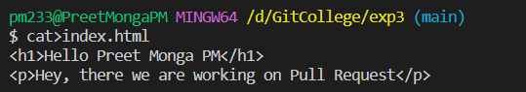

1. Now, let’s add and commit the file

Using *git add file_name*

Using *git commit -m“commit message”*

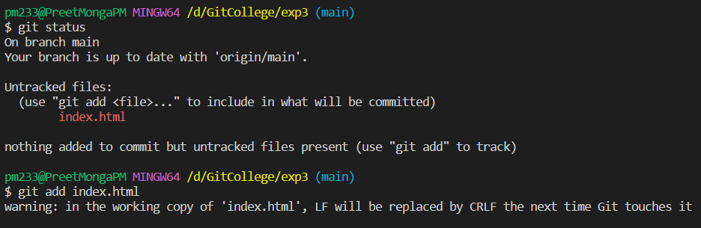

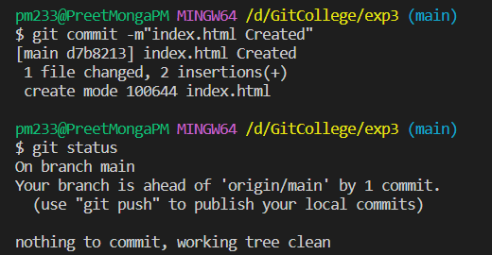

1. Let’s create a new branch named “second”

Using:

*git checkout -b branch_name*

*git checkout -b second*

This command will create a new branch and move us to that branch. If we just want to create a branch then just used the following:

*git branch brach_name*

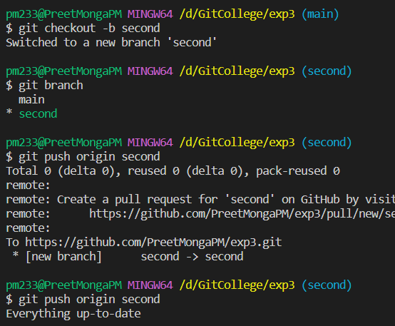

1. Now, we have to push the changes over to our GitHub, first time will ask for password.

Using:

Origin means from where we cloned the file, at the same location we are pushing it:

***git push origin main***

***git push -u origin main***

We can also use **-u**  to save the default location so that with just

*git push,* we can do it afterwards.

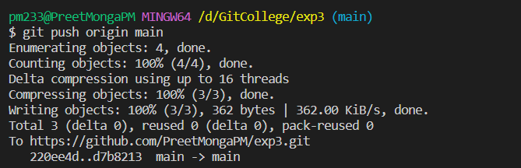

1. Go to GitHub.com and open the second branch, go to index.html and make changes.

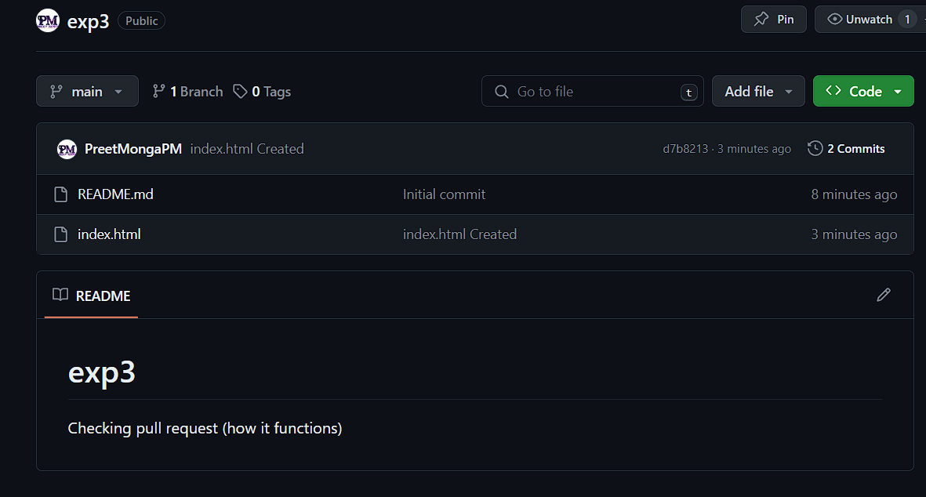

1. Made a little changes over the index.html.

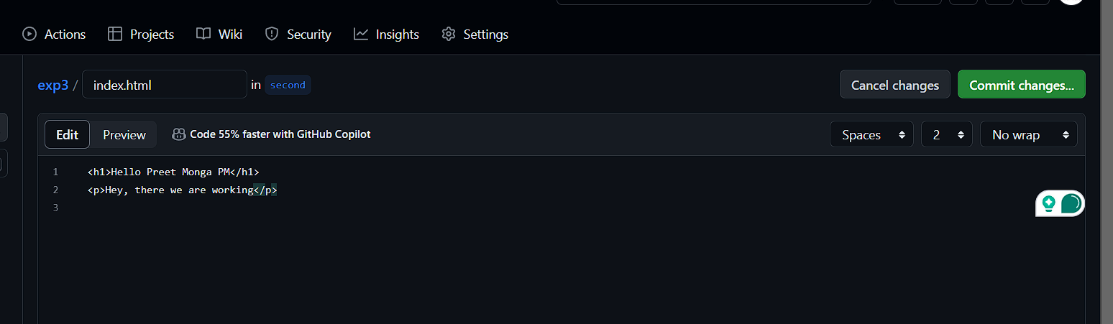

1. Once, we go over the main branch, it shows that the second branch is ahead and had recent pushes, so click on “compare & pull request”.

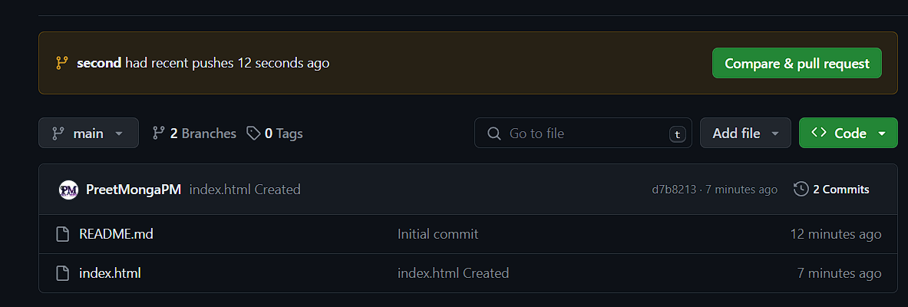

1. Click on create pull request and then click on merge pull request.

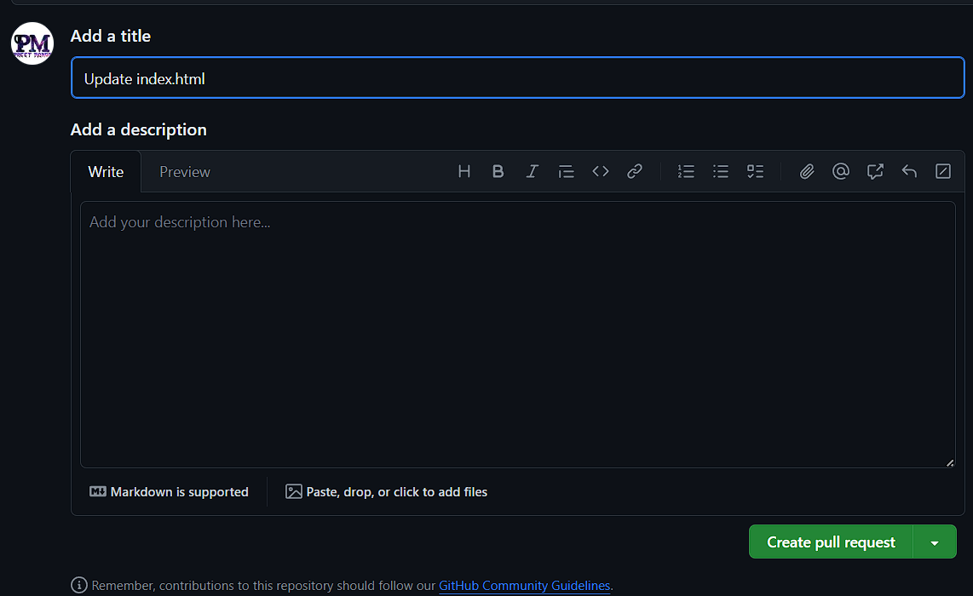 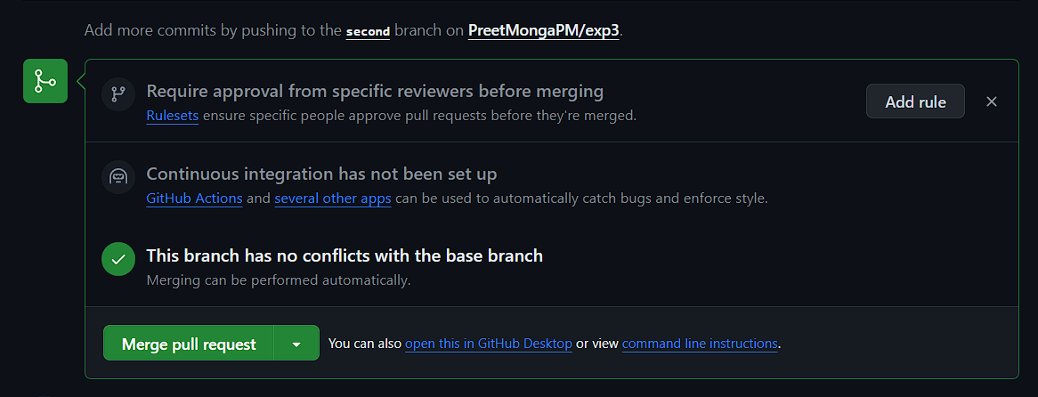

1. Now, our branches are merged properly.

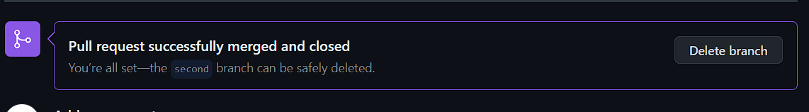

1. Let’s fetch the updates over our local machine, but it will not change the local repository.

*git fetch*

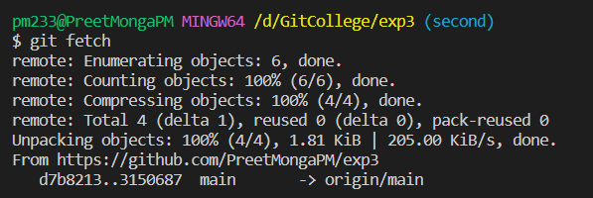

As we can see, there are no changes done using **fetch** command.

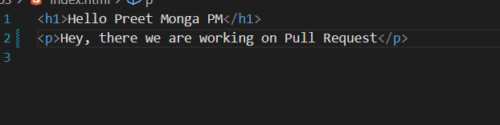

1. We will use pull command file to update the changes over our local repository.

*git pull origin main*

This will reflect the changes over our local workspace.

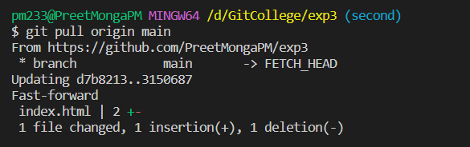

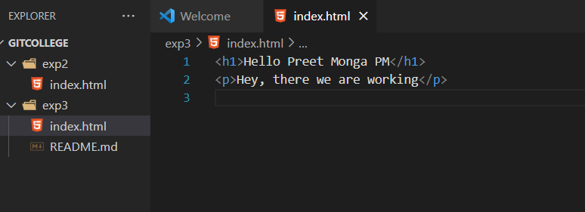

**OTHER WAY:**

1. Let’s edit the local branch and then push it over to remote repo, here I created a branch named sub of main.

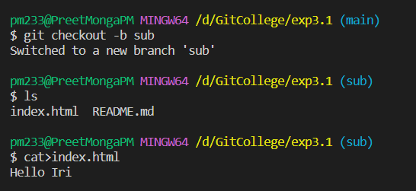

1. Now, I will update the file in sub branch, then push it over to GitHub and merge it over their.

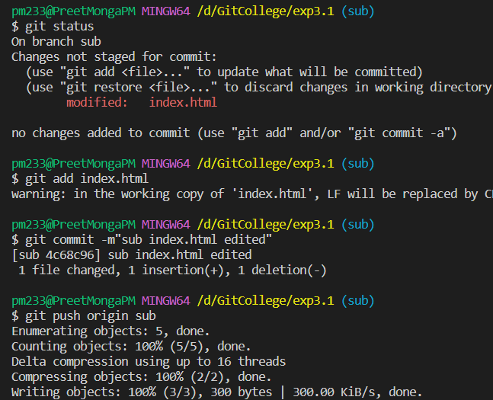 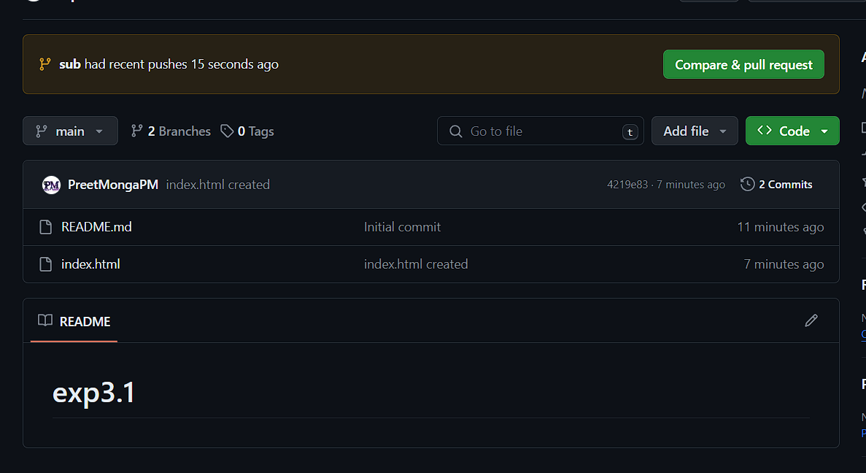

Rest of the process is same.

1. **Result/Output/Writing Summary:**

In this experiment, I made a repository over our GitHub then cloned in over to our local machine then made a file in it. We created a branch of it then pushed both branches over to GitHub and made some changes in that branch over GitHub then merged with the main branch using compare and pull request. We updated main branch over GitHub and then pulled it over local machine, we tried fetching but it didn’t change the local version. So, pull is used.

I also tried other way of merging over GitHub rather than git.

**Learning outcomes (What I have learnt):**

**1.** Learnt about the difference between fetch and pull commands.

**2.** Learnt about creating branches over both git and GitHub.

**3.** Learnt about compare and pull requests.

**4.** Learnt about difference between cloning and pulling.

**5.** Learnt about the merging over branches over both git and GitHub.

**Evaluation Grid (To be created as per the SOP and Assessment guidelines by the faculty):**

|  |  |  |  |
| --- | --- | --- | --- |
| Sr. No. | Parameters | Marks Obtained | Maximum Marks |
| 1. |  |  |  |
| 2. |  |  |  |
| 3. |  |  |  |
|  |  |  |  |