**Experiment -2.1**

Install Git and creating repository.

**Student Name: Preet UID: 22BDO10062**

**Branch: CSE (DevOps) Section/Group**- **22BCD-1/B**

**Semester: 4th Date of Performance: 09/02/2024**

**Subject Name**: Git and hub **Subject Code: 22CSH-293**

## Aim/Overview of the practical: Editing a File and committing changes on GitHub.

1. **Software Used:** GitHub and Git Bash.
2. **Steps for experiment/practical:**
3. Create a repository on GitHub named pract4 with ReadMe file, public and click create repository.

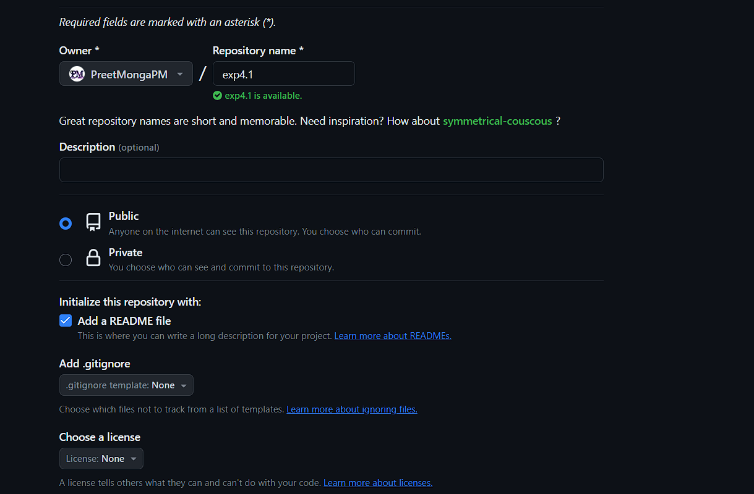

1. Go to Git Bash and clone the repository to your local machine using:

*git clone <-link->*

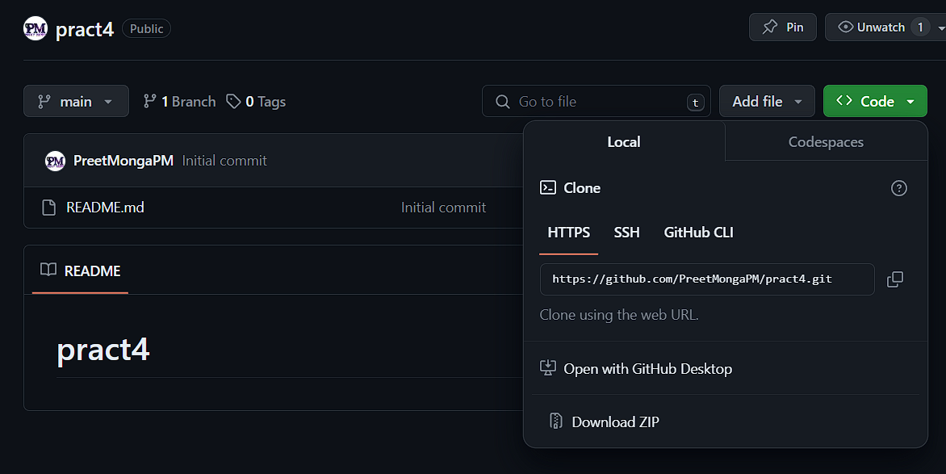

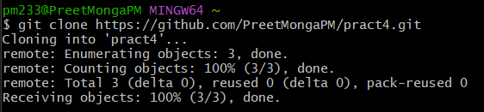

1. Go to pract4 repository using cd:

*cd directory_name*

**

1. Now, create a file index.html using vim editor and

*vim file_name*

Press *I* key for inserting

Write:

*<h1> Hello P M </h1>*

after writing press *esc* key to escape the insert mode and press *:wq* to save and quit.

1. Add and commit changes using:

*git add file_name*

*git add index.html or git add .*

*git commit -m“commit message”*

*git commit-m“index.html created”*

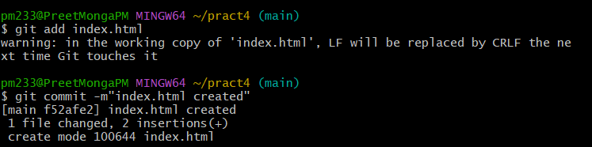

1. Let’s push these changes over to our GitHub.

Before push:

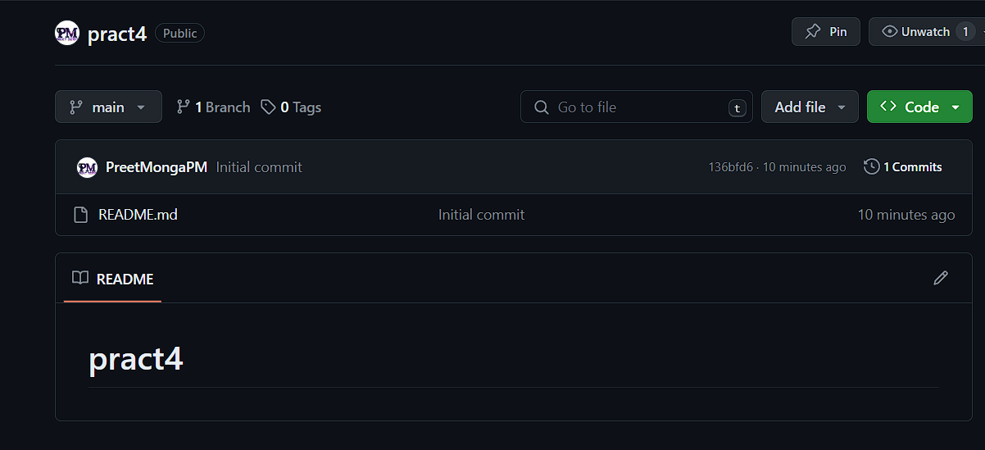

After push:

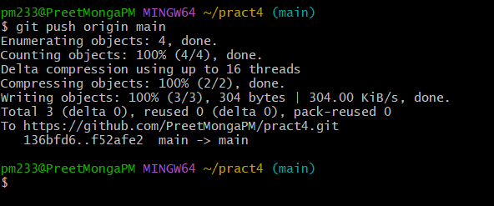

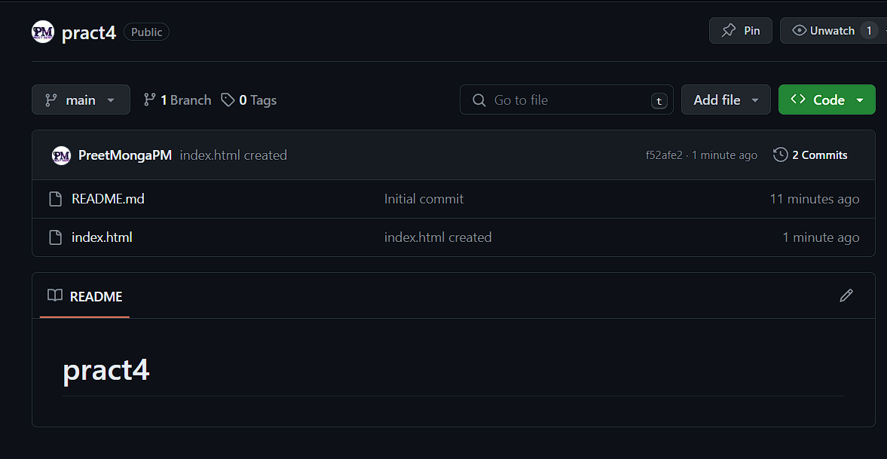

1. Now, let’s make changes over our GitHub index.html and pull it over to local.
2. Open index.html and press pencil icon in top-right corner.
3. Commit the changes.

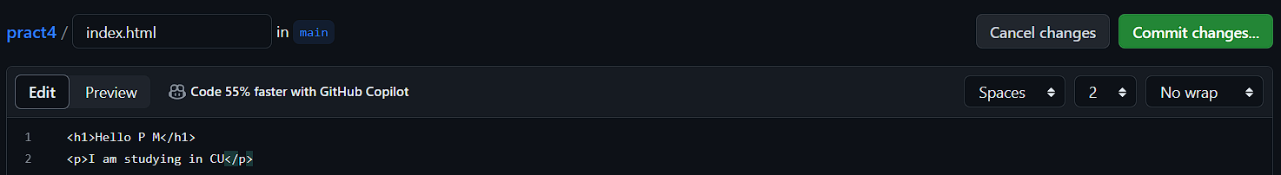

1. Also, let’s see the differences before and after pull to local machine.

Before Pull:

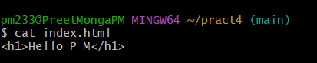

After Pull:

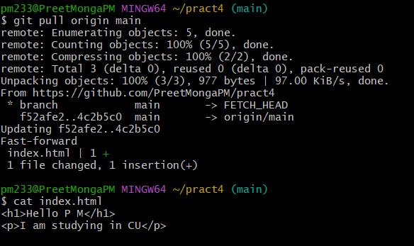

We can see that our local file also changed.

Fetch will not change the local data as saw in last experiment so pull for the win.

1. **Result/Output/Writing Summary:**

In this experiment, I basically created a remote repository over GitHub and cloned it over to local machine. Then I created a file index.html locally , added, commited and pushed it over to the remote repository. Then made some changes over remote file and pulled it over to my local machine.

**Learning outcomes (What I have learnt):**

**1.** Learnt about cloning of repository.

**2.** Learnt about two stage commit – add and then commit.

**3.** Learnt about using vim editor to create and add data to file.

**4.** Learnt about pushing the changes over to the remote repository.

**5.** Learnt about pulling the changes to the local repository.

**Evaluation Grid (To be created as per the SOP and Assessment guidelines by the faculty):**

|  |  |  |  |
| --- | --- | --- | --- |
| Sr. No. | Parameters | Marks Obtained | Maximum Marks |
| 1. |  |  |  |
| 2. |  |  |  |
| 3. |  |  |  |
|  |  |  |  |