
a markerless augmented reality
system for mobile devices

april 20, 2017

Mythri Manjunath ramanpreet kaur
Matriculation No: 344560 Matriculation No: 746930

Table of Contents
1 Introduction 2
2 System Architecture 3
3 Client Applications 4
3.1 Jet Fighter and 3D Augmentation Overlays 4
3.2 Screenshots 4
4 Summary 5
Bibliography 6

List of Tables:

Table 3-1: Risk Impact Analysis Table 6
Table 3-2: Optimize Decision Table 9
Table 4-1: Test Case Results 13

List of Figures:

No table of figures entries found.

Introduction
This project is based on the paper “A markerless augmented reality system for mobile devices”. In this paper an end to end markerless AR pipeline is developed.

Marker-based implementation utilizes some type of image such as a QR/2D code to produce a result when it is sensed by a reader, typically a camera on a cell phone. Fiducial marker which is traditional marker in which the camera recognizes the image and augments respect to that image. Markerless AR is often more reliant on the capabilities of the device being used such as the GPS location, velocity meter, etc. It may also be referred to as Location-based or Position-based AR
In this project, we will go without traditional marker and build using Markerless Augmented Reality(AR). The markerless augmented reality app is built using the Unity 3D game engine. The app will work for Android devices. The application for augmented reality uses phone’s gyroscope to find phone’s orientation and augment based on its orientation.

System Architecture
Natural Feature Tracking is an image-based tracking technique that detects and tracks the features that are naturally found in the image itself. These could be corners, edges, blobs, etc., without using specifically designed ID markers. The tracking pipeline can be sketched as shown in Figure 1. For instant, “Keypoint detection” is usually accomplished with a ORB (Oriented FAST and Rotated BRIEF) descriptor to calculate feature points in the camera image [4].

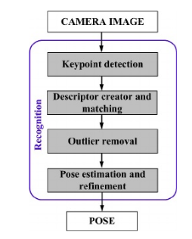
Figure 1: Natural Feature Detection AR Pipeline [4]

Feature Detection and Description
The system uses the OpenCV implementation of the ORB feature detector.

Feature Matching

Client Applications

Jet Fighter and 3D Augmentation Overlays
In this project, we will go without traditional marker and build using Markerless Augmented Reality(AR). The markerless augmented reality app is built using the Unity 3D game engine. The app will work for Android devices. The application for augmented reality uses the orientation of your mobile’s gyroscope to orientate the camera in the virtual world to line up the virtual over the top of a live video feed.

Screenshots
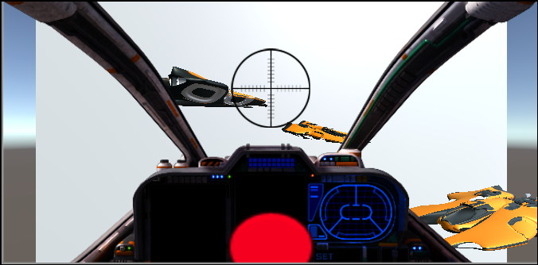
Figure 2: Jet Fighter

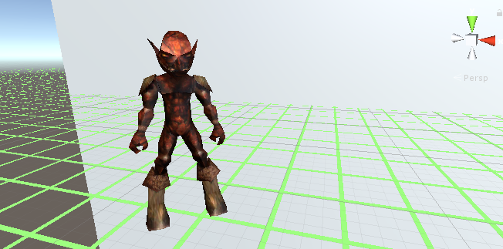
Figure 3: 3D Augmented Overlay

Summary
Two markerless augmented reality applications were developed to operate in real time on current generation mobile devices. The application was tested on two mobile devices. A part of the Markerless AR pipeline is also implemented as part of the project.

Bibliography
[1] Alex Ufkes, Mark Fiala. “A Markerless Augmented Reality System for Mobile Devices” 2013 International Conference on Computer and Robot Vision DOI: 10.1109/CRV.2013.51
[2] http://www.marxentlabs.com/what-is-markerless-augmented-reality-dead-reckoning/
[3] Augmented Reality: About AR http://researchguides.dartmouth.edu/c.php?g=59732&p=382858
[4]http://www.academia.edu/10351349/Marker_Based_vs._Natural_Feature_Tracking_Augmented _Reality_Visualization_of_the_3D_Foot_Phantom
[5] http://opencv-python tutroals.readthedocs.io/en/latest/py_tutorials/py_feature2d/py_orb/py_orb.html

