# Project Requirement and Specification

On

***House Price Prediction System***

## CSE V Semester Mini Project 2022-2023



***Submitted to: Submitted by:***

Mr. Sameer Rana Preetam Rawat

CC-CSE-C-V Sem Roll No.:2018571

CSE-C-V Sem

Session:2022-2023

DEPARTMENT OF COMPUTER SCIENCE AND ENGINEERING

**GRAPHIC ERA HILL UNIVERSITY**

# CERTIFICATE

Certified that **Preetam Rawat** (Roll No.- 2018571) has developed mini project on “**House Price Prediction System**” for the CS V Semester Mini Project in Graphic Era Hill University, Dehradun. The project carried out by Student is their own work as best of my knowledge.

Date: 20th Jan 2023

**Mr.Sameer Rana**

Class Co-ordinator

CSE-C-V Sem (CSE Department) GEHU Dehradun

# ACKNOWLEDGEMENT

We would like to express our gratitude to The Almighty Shiva Baba, the most Beneficient and the most Merciful, for completion of project.

We wish to thank our parents for their continuing support and encouragement. We also wish to thank them for providing us with the opportunity to reach this fair in our studies.

We would like to thank particularly our project Co-ordinator for his patience, support and encourgement throughout the completion of this project and having faith in us.

We also acknowledge them who help us in developing the project.

At last but not the least We greatly indebted to all other persons who directly or indirectly helped us during this work.

CSE-C-Sem-V Preetam Rawat

GEHU,Dehradun Roll No. – 2018571

Session 2022-2023

**TABLE OF CONTENTS**

1. **INTRODUCTION** 
   * ABOUT PROJECT

1. **REQUIREMENTS OF PROJECT** 
   * SOFTWARE REQUIRMENTS
   * MACHINE LEARNING
   * PYTHON LANGUAGE
   * JUPYTER NOTEBOOK

1. **WORKING**

1. **CONCLUSION**

1. **REFERENCES**

## INTRODUCTION

Development of civilization is the foundation of the increase in demand for houses day by day. Accurate prediction of house prices has been always a fascination for buyers, sellers, and bankers also. Many researchers have already worked to unravel the mysteries of the prediction of house prices. Many theories have been given birth as a consequence of the research work contributed by various researchers all over the world. Some of these theories believe that the geographical location and culture of a particular area determine how the home prices will increase or decrease whereas other schools of thought emphasize the socio-economic conditions that largely play behind these house price rises.

We all know that a house price is a number from some defined assortment, so obviously prediction of prices of houses is a regression task. To forecast house prices one person usually tries to locate similar properties in his or her neighborhood and based on collected data that person will try to predict the house price.

All these indicate that house price prediction is an emerging research area of regression that requires the knowledge of machine learning. This has motivated me to work in this domain.

Realestate appraisal is an integral part of the property buying process. Traditionally, the appraisal is performed by professional appraisers specially trained for real estate valuation. For the buyers of real estate properties, an automated price estimation system can be useful to estimate the prices of properties currently on the market. Such a system can be particularly helpful for novice buyers who are buying a property for the first time, with little to no experience.

**WHAT IS MACHINE LEARNIN?**

Development of civilization is the foundation of the increase in demand for houses day by day. Accurate prediction of house prices has been always a fascination for buyers, sellers, and bankers also. Many researchers have already worked to unravel the mysteries of the prediction of house prices. Many theories have been given birth as a consequence of the research work contributed by various researchers all over the world. Some of these theories believe that the geographical location and culture of a particular area determine how the home prices will increase or decrease whereas other schools of thought emphasize the socio-economic conditions that largely play behind these house price rises.

We all know that a house price is a number from some defined assortment, so obviously prediction of prices of houses is a regression task. To forecast house prices one person usually tries to locate similar properties in his or her neighborhood and based on collected data that person will try to predict the house price.

All these indicate that house price prediction is an emerging research area of regression that requires the knowledge of machine learning. This has motivated me to work in this domain.

Realestate appraisal is an integral part of the property buying process. Traditionally, the appraisal is performed by professional appraisers specially trained for real estate valuation. For the buyers of real estate properties, an automated price estimation system can be useful to estimate the prices of properties currently on the market. Such a system can be particularly helpful for novice buyers who are buying a property for the first time, with little to no experience.

.

## Software and Tools Requirements

### PYTHON

Python is a programming language that supports the creation of a wide range of applications. Developers regard it as a great choice for Artificial Intelligence (AI), Machine Learning, and Deep Learning projects.

This article explains why Python is a popular language among developers working in Machine Learning and Deep Learning fields. It also justifies why you should use Python when building AI projects.

AI refers to [any intelligence](https://www.section.io/engineering-education/why-python-is-good-for-machine-learning/engineering-education/differences-between-artificial-intelligence-machine-learning-and-deep-learning/) shown by a machine that can lead to a feasible solution to a problem. Machine learning expands on AI methods further by using [algorithms](https://www.thinkautomation.com/eli5/what-is-an-algorithm-an-in-a-nutshell-explanation/) to analyze data, learn, and make better decisions.

Deep learning works similarly but has different capabilities, like drawing conclusions that resemble human decision-making. It is made possible by using well-structured layers of algorithms inspired by the human brain’s neural network

**JUPYTER NOTEBOOK**

The Jupyter Notebook is an open source web application that you can use to create and share documents that contain live code, equations, visualizations, and text. Jupyter Notebook is maintained by the people at [Project Jupyter](http://jupyter.org/).

Jupyter Notebooks are a spin-off project from the IPython project, which used to have an IPython Notebook project itself. The name, Jupyter, comes from the core supported programming languages that it supports: Julia, Python, and R. Jupyter ships with the IPython kernel, which allows you to write your programs in Python, but there are currently over 100 other kernels that you can also use.

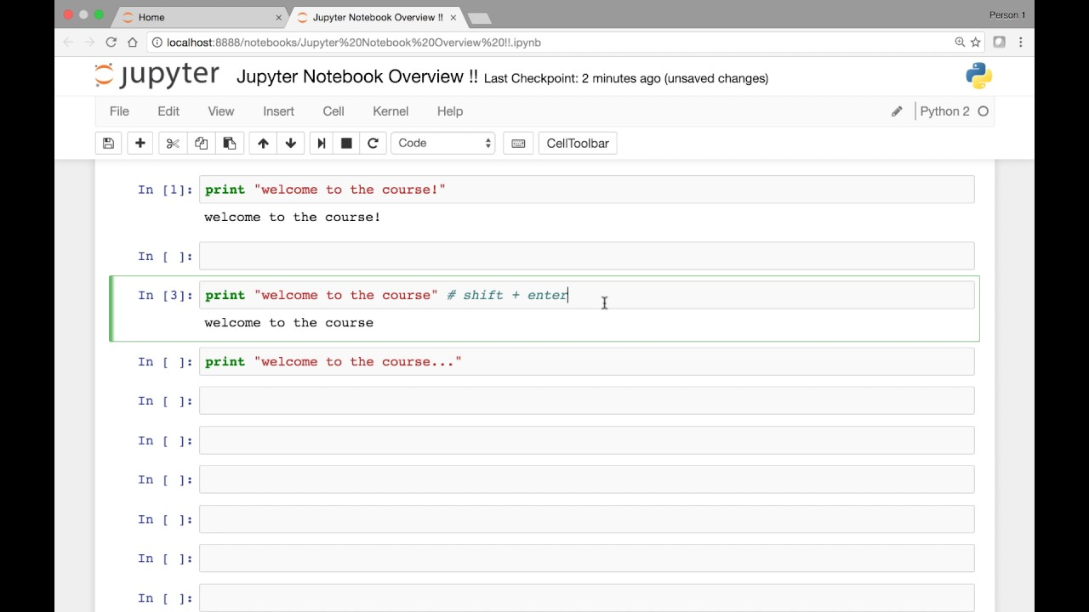

## Working

The first task is to get a dataset. A dataset is required for two main things, the first one is that the model is needed to be trained and the second is to test the model. For this that dataset is divided into two parts : 1. Training set 2. Test set

The dataset is then cleaned, which means that it is not always necessary that the dataset will be In the format that we want it to be in.

Sometimes there is data redundancy, missing of data values , etc. This can cause our model to not get trained properly, hence hindereing the accuracy o the model.

Then we choose a desired algorithms for our project. Different algorithms are tested and the best one is chosen. This model is trained and final our project is ready to predict the prices of houses.

## CONCLUSION

Nowadays technology has been a good assistance to mankind in almost all the fields. This project too focuses on one of the such uses of AI technology.

This project uses machine learning to predict the prices of the houses. This has made it very convenient for the people to get a house of their choice within their budget limit. We all know that a house price is a number from some defined assortment, so obviously prediction of prices of houses is a regression task. To forecast house prices one person usually tries to locate similar properties in his or her neighborhood and based on collected data that person will try to predict the house price.

All these indicate that house price prediction is an emerging research area of regression that requires the knowledge of machine learning. This has motivated me to work in this domain.

### Refrences

* https://www.investopedia.com/
* <https://docs.soliditylang.org/en/v0.8.15/>
* https://google.com/
* <https://youtube.com/>
* <https://geeksforgeeks.com/>