Week-01
EEE Makers Hub : Task 1
Date: 24-06-2026
Name : Preetam Kumar Ghosh
Roll : 2303066
Batch : 2023
Dept. : EEE
Submission Date: 25 May 2026

Table of Contents
Chapter 1: IoT, Embedded System, and Robotics 3
Section 1.01: IoT(Internet of Things) 3
(a) Basic Definition: 3
(b) Applications: 3
Section 1.02: Embedded System 3
(a) Basic Definition: 3
(b) Applications: 3
Section 1.03: Robotics 4
(a) Basic Definition: 4
(b) Applications: 4
Section 1.04: Difference between IoT, Embedded System, and Robotics 5
Chapter 2: CNC Machines & G-code 5
(a) What is CNC? 5
(b) Role of CNC Machines in PCB Fabrication 6
(c) Basic Idea of G-code 6
(d) What do (G00, G01, G02, G03, G90, G91, G92, F, M03, M04, M05, T, M06, M08, M09, M00, M30) these mean in G-code?) 7
Chapter 3: Microcontrollers 7
(a) What is a Microcontroller? 7
(b) Why microcontrollers are used? 8
(c) A list of available microcontrollers in Bangladesh 8
Chapter 4: Sensors & Actuators 10
(a) What are sensors and actuators? 10
(b) Functionalities of common sensors and their applications 10
Chapter 5: Real-Life System Example 12
Section 5.05: Advance Traffic Light System 12
Section 5.06: Smart Farm Automation 13
References: 15

IoT, Embedded System, and Robotics

IoT(Internet of Things)

Basic Definition:
The Internet of Things (IoT) is a network of physical objects embedded with sensors, software, and connectivity that allow them to collect and exchange data over the internet. [1]

Applications:
- Smart Home
Used for comfort, security, and saving energy.
Examples: smart lights, smart AC/thermostat, CCTV cameras, smart locks, Alexa/Siri.
- Industrial IoT (IIoT)
Used in factories for automation and monitoring.
Examples: machine fault detection, automatic production systems, quality control.
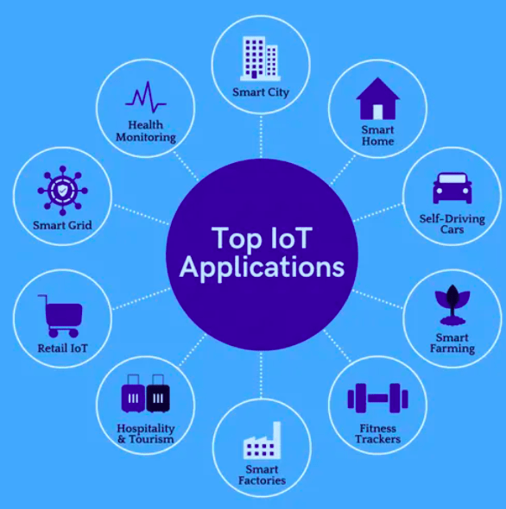
- Healthcare
Used to monitor patients and medical equipment.
Examples: smartwatches for heart rate monitoring, medicine reminders, equipment tracking.
- Smart Agriculture
Used to improve farming efficiency.
Examples: soil moisture sensors, smart irrigation, livestock tracking, autonomous tractors.
- Smart Cities
Used to improve city services and management.
Examples: smart traffic lights, smart waste bins, air quality monitoring, water leak detection.
- Retail & Supply Chain
Used for inventory and product tracking.
Examples: smart shelves, GPS tracking of goods, temperature monitoring during transport. [1]
Figure 1: Applications of IoT

Embedded System

Basic Definition:
An embedded system is a small computer system designed to perform a specific task inside a larger system. It consists of a processor, memory, and input/output units. Embedded systems are used in devices with size, cost, power, or weight limitations. [2]

Applications:
- GPS Systems
Used in vehicles and phones for navigation and location tracking.
- Medical Devices
Used for patient monitoring such as heart rate, pulse, and health data collection.
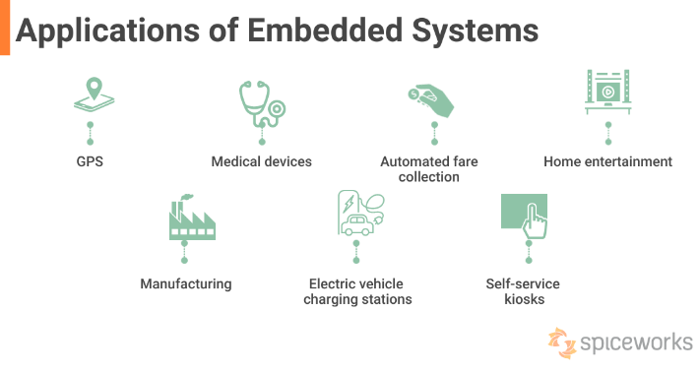
- Automotive Systems
Used in airbags, ABS braking, speed control, parking assistance, and car entertainment systems.
- Automated Fare Collection
Used in ticket machines, smart cards, and automatic gates in public transport systems.
- Fitness Trackers
Used to monitor steps, heart rate, sleep, and body temperature.
Figure 2: Applications of Embedded System

- Home Entertainment
Used in smart TVs, remote controls, streaming systems, and gaming devices.
- ATM Machines
Used to process banking transactions and communicate with bank servers.
- Manufacturing & Robotics
Used in factory robots for automation, quality control, and safety monitoring.
- EV Charging Stations
Used to monitor charging, display information, and detect maintenance issues.
- Self-Service Kiosks
Used in vending machines, airport kiosks, ticket counters, and self-checkout systems. [2]

Robotics

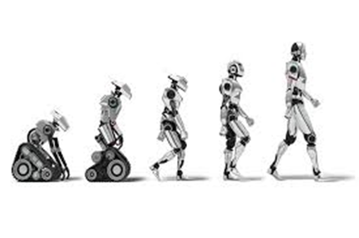
Basic Definition:
Robotics is a branch of engineering and science that combines electronics, mechanical engineering, and computer science to design, build, and control robots. Robots are machines designed to perform specific tasks automatically, especially in dangerous, repetitive, or heavy-duty work. [3]
Figure 3: Advancement of Robotics

Applications:
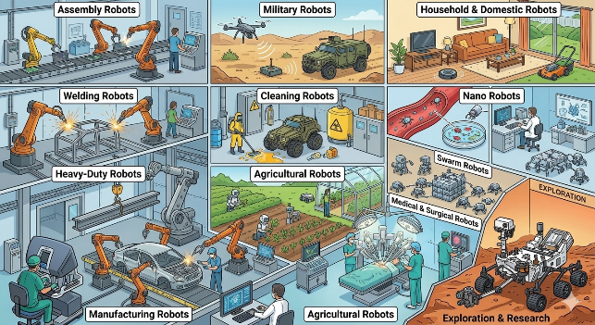
- Assembly Robots
Used in industries for assembling products automatically.
- Welding Robots
Used for seam welding and other industrial welding tasks.
- Heavy-Duty Robots
Used for lifting heavy materials and industrial operations.
Figure 4: Applications of Robotics
- Manufacturing Robots
Used in factories and automobile industries for fast and accurate production.
- Military Robots
Used for bomb detection, surveillance, and dangerous military operations.
- Cleaning Robots
Used for cleaning toxic waste and hazardous industrial areas.
- Agricultural Robots
Used for farming, planting, harvesting, and monitoring crops.
- Household & Domestic Robots
Used for home cleaning and daily household tasks.
- Nano Robots
Tiny robots used in medical and scientific applications.
- Swarm Robots
Groups of robots working together to complete tasks efficiently. [3]

Difference between IoT, Embedded System, and Robotics
Feature | IoT | Embedded System | Robotics
Definition | Network of connected smart devices that share data through the internet. | Small computer system designed for a specific task inside a larger system. | Branch of engineering that deals with designing and controlling robots.
Main Purpose | Communication and automation using internet connectivity. | Perform a dedicated function efficiently. | Perform physical tasks automatically.
Internet Connection | Usually required. | Not always required. | May or may not require internet.
Components | Sensors, network, cloud, software. | Processor, memory, input/output devices. | Sensors, actuators, controller, mechanical parts.
Human Interaction | Mostly remote monitoring and control. | Limited user interaction. | Can directly interact with environment and humans.
Examples | Smart home, smart city, fitness tracker. | ATM, microwave oven, washing machine. | Industrial robot, military robot, cleaning robot.
Application Area | Smart devices and communication systems. | Electronic devices and control systems. | Automation, manufacturing, healthcare, military.

CNC Machines & G-code

What is CNC?
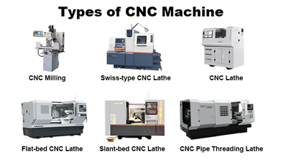
CNC stands for Computer Numerical Control, which refers to the computerized operation of machining tools used in manufacturing. CNC machines operate using pre-programmed software and codes, which tell each machine the exact movements and tasks to complete. For example, a CNC machine may cut, drill, or shape materials like metal or plastic based on computer instructions, achieving high accuracy without manual control.
Figure 5: Types of CNC Machines
CNC is used to operate different machines such as lathes, mills, grinders, routers, and laser cutters. These machines follow coded instructions (G-code and M-code) to perform precise manufacturing operations. The program is usually created from CAD/CAM designs and loaded into the machine’s control unit. [4]

Role of CNC Machines in PCB Fabrication
CNC machines play an important role in PCB (Printed Circuit Board) fabrication by providing high precision and automation.
- CNC machines are used to cut PCB boards into exact required shapes and sizes.
- They are used for drilling holes for components like resistors, capacitors, and IC pins with very high accuracy.
- CNC routers help in removing unwanted copper layers to form circuit paths.
- They ensure consistent and repeatable production, which is important for mass manufacturing of PCBs.
- CNC-based PCB fabrication reduces human error and increases production speed and quality. [4]
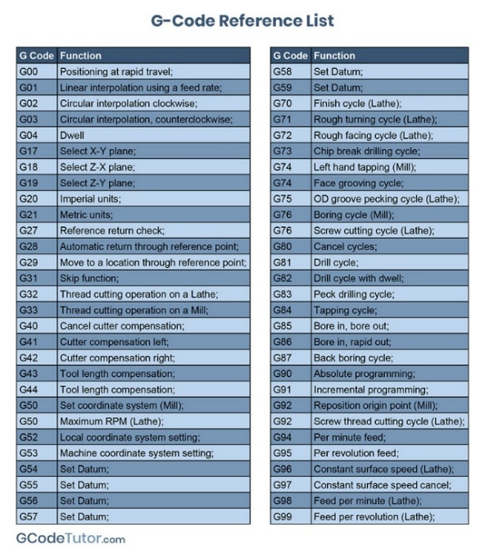
Overall, CNC machines make PCB manufacturing faster, more accurate, and reliable compared to manual methods. [4]

Basic Idea of G-code
G-code is a programming language used for CNC (Computer Numerical Control) machines. It is used to tell a machine what to do and how to do it. The G-code commands instruct the machine where to move, how fast to move, and what path to follow.
In machining tools like lathes or mills, the cutting tool follows these commands to move along a specific path and remove material to create the desired shape.
In 3D printing or additive manufacturing, G-code commands instruct the machine to deposit material layer by layer to form a precise object. [4] [5]
Figure 6: G-Code

What do (G00, G01, G02, G03, G90, G91, G92, F, M03, M04, M05, T, M06, M08, M09, M00, M30) these mean in G-code?)
- G00 – Rapid positioning (fast movement without cutting)
- G01 – Linear interpolation (straight line cutting movement at set feed rate)
- G02 – Circular interpolation clockwise (arc movement in clockwise direction)
- G03 – Circular interpolation counterclockwise (arc movement in counterclockwise direction)
- G90 – Absolute positioning (coordinates measured from fixed origin)
- G91 – Incremental/relative positioning (coordinates measured from current position)
- G92 – Set current position as a new reference zero point (temporary coordinate system reset)
- F – Feed rate (sets the speed of cutting movement)
- M03 – Spindle ON clockwise
- M04 – Spindle ON counterclockwise
- M05 – Spindle STOP
- T – Tool selection (chooses a specific tool number)
- M06 – Tool change command
- M08 – Coolant ON (flood coolant)
- M09 – Coolant OFF
- M00 – Program stop (pauses machine completely)
- M30 – End of program and reset to beginning [6]

Microcontrollers

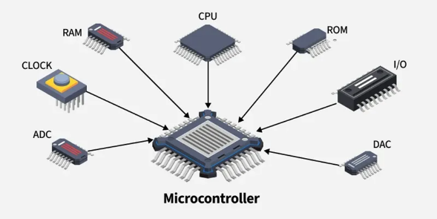
What is a Microcontroller?
A microcontroller unit (MCU) is a small computer on a single chip. It is designed to perform specific tasks within an embedded system without needing a complex operating system.
These compact integrated circuits (ICs) contain a processor core, random-access memory (RAM), and electrically erasable programmable read-only memory (EEPROM) for storing programs, even when the power is off.
Figure 7: Microcontrollers
Unlike general-purpose microprocessors, microcontrollers combine processing, memory, and input/output (I/O) peripherals such as timers, counters, and analog-to-digital converters (ADCs) into one efficient unit. This makes them suitable for real-time applications like controlling motors, servos, and reading sensor data. [7]

Why microcontrollers are used?
- Consumer Electronics
Microcontrollers are used in microwaves, washing machines, and air conditioners for controlling operations, temperature, speed, and user inputs.
- Automotive Industry
Used in engine control systems, airbag deployment, ABS braking systems, and infotainment systems to improve vehicle performance and safety.
- Medical Devices
Used in pacemakers, blood pressure monitors, and insulin pumps for accurate monitoring and control of patient health.
- Industrial Automation
Used in machinery control systems, robotics, and process control for automation and improved productivity.
- Communication Systems
Used in mobile phones, routers, and modems for data processing, communication control, and network management. [8]

A list of available microcontrollers in Bangladesh
Microcontroller / Development Board | Approximate Price (BDT)
Arduino Boards
Arduino Uno R3 | 949
Arduino Nano (ATmega328) | 363
Arduino Pro Mini 328 (5V/16MHz) | 430
Arduino UNO R4 Minima 32bit 48MHz | 1,650
Arduino Pro Micro Atmega32U4 5V/16MHz | 680
ESP & Wireless Microcontrollers
ESP32 NodeMCU Development Board Wireless Wifi | 427
ESP8266 NodeMCU Lua V3 | 350
ESP32-CAM (with Camera Module) | 940
ESP32-S3 Microcontroller 2.4 GHz Wi-Fi Development Board | 1,590
ESP32 C6 DevKit-C N16R8 | 950
Wemos D1 Mini ESP8266 | 320
STM32 & Advanced ARM Boards
STM32F103C8T6 "Blue Pill" Board | 480
STM32G431CBU6 Mini Core Development Board | 1,550
STM32F401RCT6 MicroPython Compatible | 974
STM32F411CEU6 Black Pill Development Board | 874
STM8S103F3P6 STM8 Blue Core | 350
Raspberry Pi & Teensy
Raspberry Pi Pico 2 (RP2350) | 1,250
Raspberry RP2040 Core Board 16MB | 1,450
Teensy 4.1 Development Board | 8,945
Bare AVR, PIC & RISC-V Chips
ATmega32A | 430
ATtiny15L | 270
PIC18F4550 | 762
PIC16F877A | 2,250
PIC16F628 | 135
CH32V003 Development Board 48Mhz RISC-V | 390
[11] [12] [13] [14]

Sensors & Actuators

What are sensors and actuators?
A sensor is an apparatus that recognizes occurrences or modifications in its surroundings and then generates a corresponding signal. Usually, this output is presented as an optical or electrical signal. But in order to start this process, there must be an initial input, which is often some kind of energy like heat, light, or mechanical force. [9]
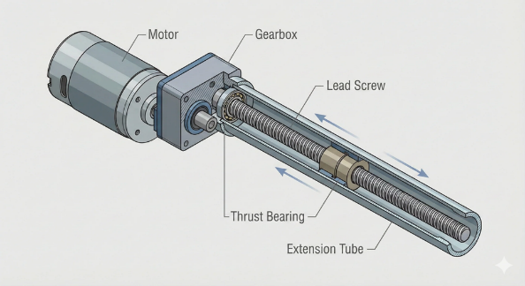
An actuator is a machine component or system that moves or controls the mechanism of the system. Sensors in the device sense the environment, then control signals are generated for the actuators according to the actions needed to perform. [10]
The control system acts upon an environment through the actuator. It requires a source of energy and a control signal. When it receives a control signal, it converts the source of energy to a mechanical operation. [10]
Figure 8: Actuator Structure

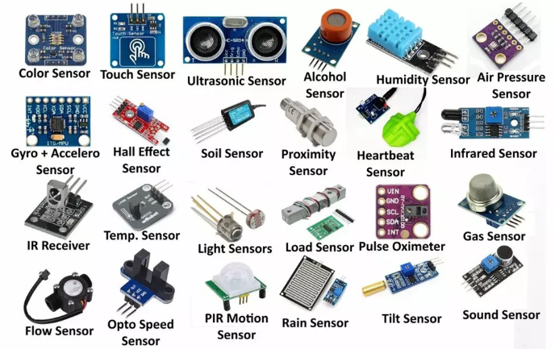
Functionalities of common sensors and their applications
Sensors act as the bridge between the physical environment and digital systems. They allow embedded systems and microcontrollers to collect real-world data and make intelligent decisions based on that information. Different types of sensors are used depending on the required functionality and application area.
Figure 9: Different Types of Sensors
Sensor Type | Function | Typical Applications
DHT11 / DHT22 | Measures temperature and humidity from the surrounding environment. | Smart home automation, greenhouse monitoring, and weather stations.
HC-SR04 | Uses ultrasonic waves to calculate the distance between the sensor and an object. | Obstacle avoidance robots, parking systems, and automatic dispensers.
MQ Series Gas Sensors | Detects gases such as smoke, LPG, CO, and alcohol in the air. | Gas leakage detection, fire safety systems, and environmental monitoring.
LDR (Light Dependent Resistor) | Changes resistance according to light intensity. | Automatic street lights, smart lighting systems, and display brightness control.
BMP280 / BME280 | Measures atmospheric pressure, temperature, and humidity (BME280). | Weather monitoring systems, drones, and altitude measurement devices.
MPU6050 | Combines a 3-axis accelerometer and gyroscope to detect motion and orientation. | Drone stabilization, robotics, gesture control, and balancing systems.
Soil Moisture Sensor | Measures the water content present in soil. | Smart irrigation, precision agriculture, and greenhouse automation.
PIR Sensor | Detects motion using infrared radiation changes. | Security alarms, motion-activated lights, and occupancy detection systems.
Potentiometer | Works as a variable resistor to provide adjustable analog input. | Volume control circuits, dimmers, calibration systems, and user input control.
4x4 Keypad | Provides multiple button inputs through a matrix arrangement. | Password-based security systems, ATM interfaces, and digital control panels.
[15]
Architectural Role of Sensors in Embedded Systems
In embedded system design, sensors play a very important role in making systems intelligent and automated. Their functionalities can generally be divided into several major areas:
- Data Acquisition: Sensors collect physical information such as temperature, pressure, light, motion, or gas concentration and convert them into electrical signals that can be processed digitally.
- Automation and Control: Sensor outputs are used to automatically control actuators such as motors, relays, pumps, alarms, or LEDs without requiring human intervention.
- Safety and Threshold Detection: Many sensors are used in protection systems where alarms or safety actions are triggered when a parameter exceeds a predefined limit.
- Decision-Making Systems: Multiple sensors can work together to help autonomous systems make complex decisions, such as in robotics, drones, industrial automation, and smart traffic systems.
Overall, sensors are one of the most important components in modern embedded systems because they provide the real-time information necessary for monitoring, automation, and intelligent control.

Real-Life System Example
Understanding individual sensors and microcontrollers is only the first step in embedded systems design. The true power of these technologies is realized when components are integrated into cohesive, automated systems that solve real-world problems. This chapter explores two comprehensive project examples that demonstrate the integration of multiple sensors, user interfaces, actuators, and complex control logic.

Advance Traffic Light System
The Advance Traffic Light System moves beyond standard timed loops by introducing dynamic user configuration, security protocols, and real-time state management. It serves as an excellent model for municipal traffic control systems where administrators require the ability to safely and securely alter operation parameters on the fly.

Project Repository:
https://github.com/preetam21022/tinkercad-projects/tree/main/Advance%20Traffic%20Light%20System

System Overview
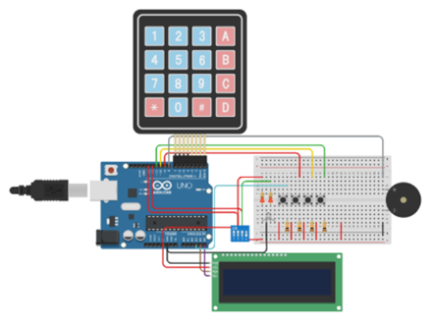
This project simulates an advanced intersection control unit. It features an administrator editing mode protected by a numeric passcode, allowing authorized personnel to adjust the duration of the Red, Yellow, and Green signals. The system provides real-time feedback via an I2C LCD screen, including current operational modes and countdown timers, while a piezo buzzer offers auditory confirmation for inputs.

Core Hardware Components
Figure 10: Advance Traffic Light System
- Microcontroller: Arduino Uno R3 serves as the central processing unit.
- User Input: A 4x4 Keypad for passcode entry and delay configuration, alongside a 4-position SPST DIP switch and pushbuttons for mode selection and manual testing.
- Outputs: An RGB LED simulates the traffic signal, while an I2C 16x2 LCD displays status prompts and countdowns.

Operational Modes
The system relies on a state-machine architecture that dictates how the traffic lights operate based on the hardware switch positions:
- Configuration Mode (Password Protected): Activated by pressing * on the keypad, the system prompts the user for a 4-digit password (default: 6556). Upon successful authentication, the administrator can press R, Y, or G to reconfigure the respective light's delay in seconds, confirming the entry with C.
- Automatic Traffic Cycle: When the DIP switch is set to the OFF position, the system runs autonomously. It cycles through the configured Red → Yellow → Green phases, outputting a real-time countdown to the LCD.
- Manual Test Mode: When the DIP switch is toggled ON, the system enters a diagnostic state. Operators can manually trigger and test individual lights (using buttons R, Y, G) or initiate a single test cycle (button A).

Technical Challenges & Future Scope
A notable challenge in this advanced loop is handling blocking delays. Currently, exiting the automated cycle requires specific timing to interrupt the loop. Future iterations of this system could implement hardware interrupts or non-blocking timers (millis()) to allow instantaneous mode switching. Additionally, writing the administrator's custom delays to EEPROM would ensure the settings survive power cycles, and integrating an RTC (Real-Time Clock) could allow the system to switch to "night mode" automatically. [16]

Smart Farm Automation
While many smart agricultural systems focus purely on crop health, this project takes a holistic approach by combining environmental automation with field-level security. It is designed to be a self-contained, low-cost solution tailored for rural or small-scale farms where both resource optimization and asset protection are priorities.

Project Repository:

https://github.com/Preetam21022/TinkerCAD-Projects/tree/main/Smart%20Farm%20Automation

System Overview
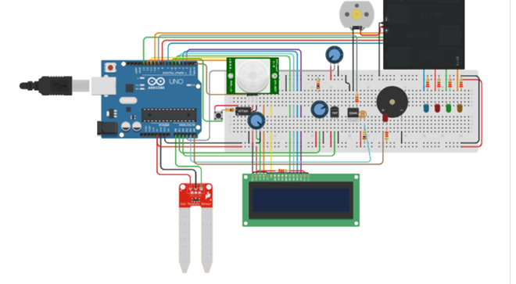
The Smart Farm Automation controller continuously monitors environmental parameters critical to plant health—such as soil moisture, temperature, light intensity, and humidity. Based on this data, it autonomously operates water pumps, heat sources, and grow lights. Simultaneously, it acts as a security sentry; if motion is detected in the field, it pauses farming operations, triggers an alarm, and logs the intrusion event for later review.
Figure 11: Smart Farm Automation

Core Hardware Components
- Microcontrollers: An Arduino Uno handles the main automation and logging loop, while an ATtiny85 acts as a dedicated coprocessor to handle PIR motion signal processing.
- Sensors: An analog Soil Moisture Sensor, a TMP36 Temperature sensor, an LDR for light intensity, and a PIR motion sensor.
- Actuators & Interface: DC Motors (simulating a water pump and curtain motor driven via an n-MOSFET), LEDs representing mist sprayers and grow lights, a piezo buzzer for the security alarm, and a 16x2 parallel LCD for real-time data display.

Dual-Loop Operational Logic
The system's firmware is designed to prioritize security without neglecting crop health, dividing its tasks into two conceptual loops:
- The Farm Automation Loop: If no intrusion is detected, the system reads analog data. If the soil value drops below a specific threshold (e.g., < 400), it activates the irrigation pump. If the LDR detects low ambient light (< 50%), it engages the grow lights and opens motorized curtains. The LCD continuously updates with live temperature, humidity, and light percentage. If environmental parameters exceed safe bounds, a continuous warning buzzer sounds.
- The Security Loop: The PIR sensor actively scans for movement. If an intruder (human or animal) is detected, the system immediately pulls a hardware pin HIGH. The farm automation pauses, an active buzzer alarm pulses, and the exact timestamps of when the motion started and ended are logged into an array.

Data Logging and System Recovery
The system can store up to 20 motion start/end timestamps. An operator can hold down a dedicated hardware Reset button for more than one second to dump this security log to the Serial monitor. Once the log is reviewed, the system clears the stored arrays and resumes normal farming operations. Future upgrades for this system include adding a Wi-Fi/Bluetooth module for remote monitoring and implementing I2C displays to free up digital I/O pins for additional sensors.

Technical Challenges & Future Scope
Developing a dual-purpose system on a constrained microcontroller presented several technical hurdles. A primary challenge was managing timing conflicts; the system had to balance standard farming automation delays with the need for instantaneous, interrupt-like responsiveness for intruder logging. Furthermore, managing numerous analog and digital sensors alongside multiple actuators quickly exhausted the available I/O pins on the Arduino Uno, and continuous loop updates caused noticeable LCD flicker.
Future iterations aim to resolve these I/O bottlenecks by migrating to an I2C-based LCD (PCF8574), freeing up digital pins for additional capabilities. Other planned upgrades include:
- Persistent Storage: Utilizing EEPROM to save farm settings and motion logs so data survives power cycles.
- Enhanced Security & Safety: Integrating a gas sensor for fire detection and adding a servo-based automated door lock that engages during a security breach.
- Remote Connectivity: Extending the system with Wi-Fi or Bluetooth modules (like the ESP8266 or HC-05) to allow for remote telemetry monitoring and wireless control overrides. [17]

References:
- https://www.ibm.com/think/topics/internet-of-things
- https://www.spiceworks.com/it-hardware/what-is-refs-2/
- https://www.geeksforgeeks.org/software-engineering/robotics-introduction/
- https://www.goodwin.edu/enews/what-is-cnc/
- https://gcodetutor.com/cnc-machine-training/cnc-g-codes.html
- https://howtomechatronics.com/tutorials/g-code-explained-list-of-most-important-g-code-commands/#h-what-is-g-code
- https://www.ibm.com/think/topics/microcontroller
- https://www.geeksforgeeks.org/electronics-engineering/applications-of-microcontroller/
- https://www.monolithicpower.com/en/learning/mpscholar/sensors/intro-to-sensors/what-is-a-sensor?srsltid=AfmBOor4VdumKYHR0TerUGZGJI2qS0t5JJOKHtRhP88X3MQaJ5AsUZhO
- https://www.geeksforgeeks.org/machine-learning/actuators-in-iot/
- https://store.roboticsbd.com/
- https://techshopbd.com/
- https://www.bdtronics.com/?srsltid=AfmBOorovUNM9yZK-sqJLqWVLYfISc2j0Tyh48oJtFr2ztzRsn04s2FY
- https://www.robotechbd.com/?srsltid=AfmBOor13I_dkOgHyxhMSZRSWED4M-Ay52Dtu5_db-BqTo5euA5BcOEv
- https://github.com/Preetam21022/TinkerCAD-Projects/tree/main
- https://github.com/Preetam21022/TinkerCAD-Projects/tree/main/Advance%20Traffic%20Light%20System
- https://github.com/Preetam21022/TinkerCAD-Projects/tree/main/Smart%20Farm%20Automation

