**STEPS FOR CONFIGURING BLUETOOTH IN AT COMMAND MODE**

**Step 1:**

Take an USB to Serial converter, connect RX pin of Bluetooth to TX pin of Serial adapter and connect TX pin of Bluetooth to RX pin of Serial adapter.

**Step 2:**

Connect the Serial adapter to the PC through a USB cable. To establish communication through serial software’s like TERA TERM. The Serial software must have an option to include a CR+LF at end of every line command.

Link to download Tera Term: http://logmett.com/index.php?/download/tera-term-483-freeware.html

**Step 3:**

To configure in AT mode first enable key pin with 3.3 volts. Then connect the ground and VCC (3.6-6V) pins of the Bluetooth module.

Note: If we follow this in sequence then the Red LED will glow once in two seconds. This indicates it is in AT command mode. If not repeat the step 3 again

**Step 3:**

Now Open the Tera Term software and open a new connection. Select Serial connection and the respective com port of USB attached in above steps. We can check the USB com port from device manager.

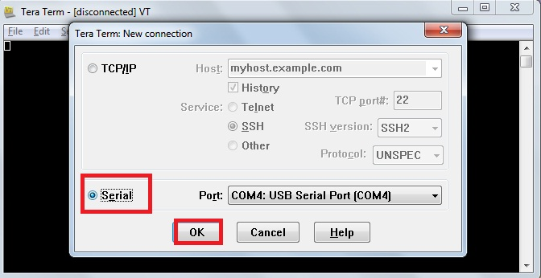

**Step 4:**

Then open setup menu and terminal window in it. Set new line transmit as CR+LF. And enable Local Echo. Press OK.

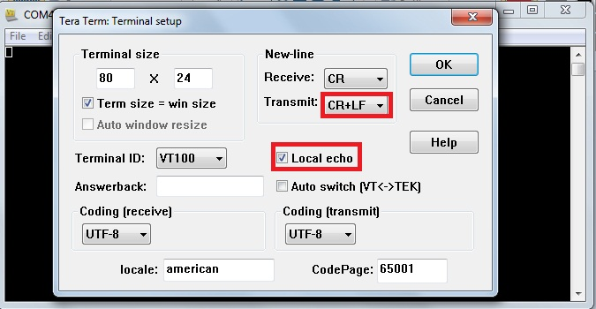

**Note:**

* Local echo is to display the transmit character on screen.
* CR+LF is carriage return + line feed necessary to send AT commands

**Step 5:**

Open the setup menu and Serial Port window in it. And set Baud rate to 38400. Press OK.

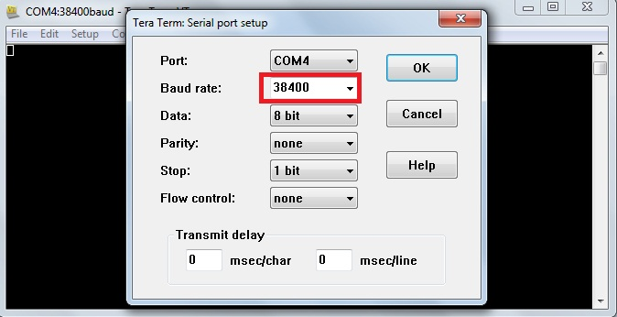

**Note:**

* The default Baud rate for AT command mode is 38400.

**Step 6:**

Now type the AT commands from the Datasheet into the workspace and verify the outputs.

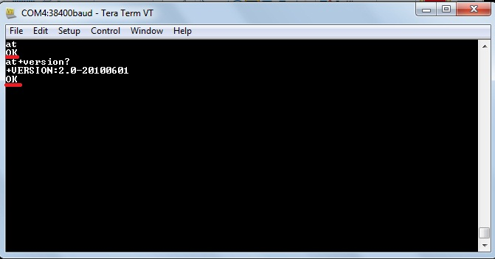

**Note:**

* If you get an error resend the AT command and if the error still persists check the connections.

**STEPS FOR CONFIGURING BLUETOOTH IN TRANSPARENT MODE**

**Step 1:**

Take an USB to Serial converter, connect RX pin of Bluetooth to TX pin of Serial adapter and connect TX pin of Bluetooth to RX pin of Serial adapter.

**Step 2:**

Connect the Serial adapter to the PC through a USB cable. To establish communication through serial software’s like TERA TERM. The Serial software must have an option to include a CR+LF at end of every line command.

Link to download Tera Term: http://logmett.com/index.php?/download/tera-term-483-freeware.html

**Step 3:**

To configure in Transparent mode connect the ground and VCC (3.6-6V) pins of the Bluetooth module and connect the key pin to ground.

**Step 3:**

Now Open the Tera Term software and open a new connection. Select Serial connection and the respective com port of USB attached in above steps. We can check the USB com port from device manager.



**Step 4:**

Then open setup menu and terminal window in it. Set new line transmit as CR+LF. And enable Local Echo. Press OK.



**Note:**

* Local echo is to display the transmit character on screen.
* CR+LF is carriage return + line feed necessary to send AT commands
* In new line receive can be made carriage return or carriage return + line feed or auto

**Step 5:**

Open the setup menu and Serial Port window in it. And set Baud rate to 9600. Press OK.

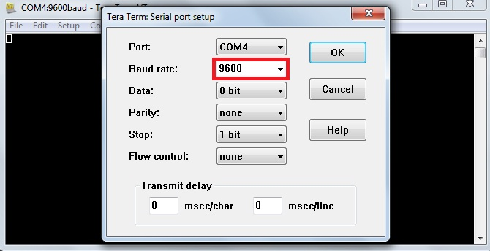

**Note:**

* The default baud rate for transparent command mode is 9600.

**Step 6:**

Now if you pair the Bluetooth with a mobile and connect in any Bluetooth terminal software in mobile, you can communicate between the mobile and the PC.

In PC

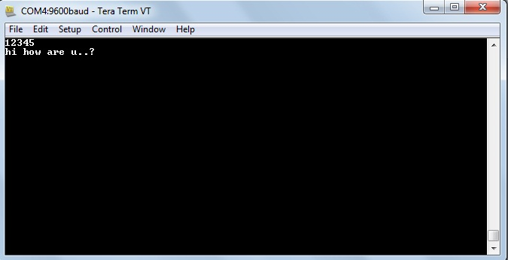

In mobile

