Configuring a RN XV module in AT command mode

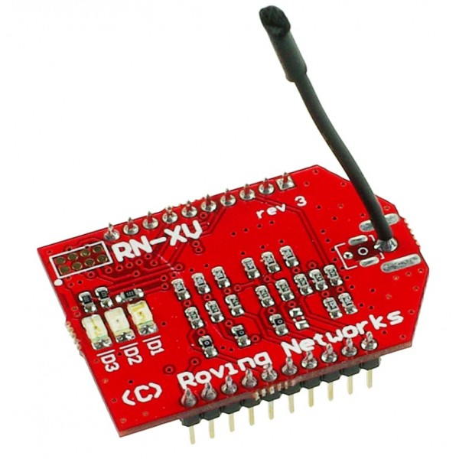

**Fig. 1 RN XV module**

**Step 1:**

Mount this module on a Zigbee adapter and connect it to a PC using USB cable.

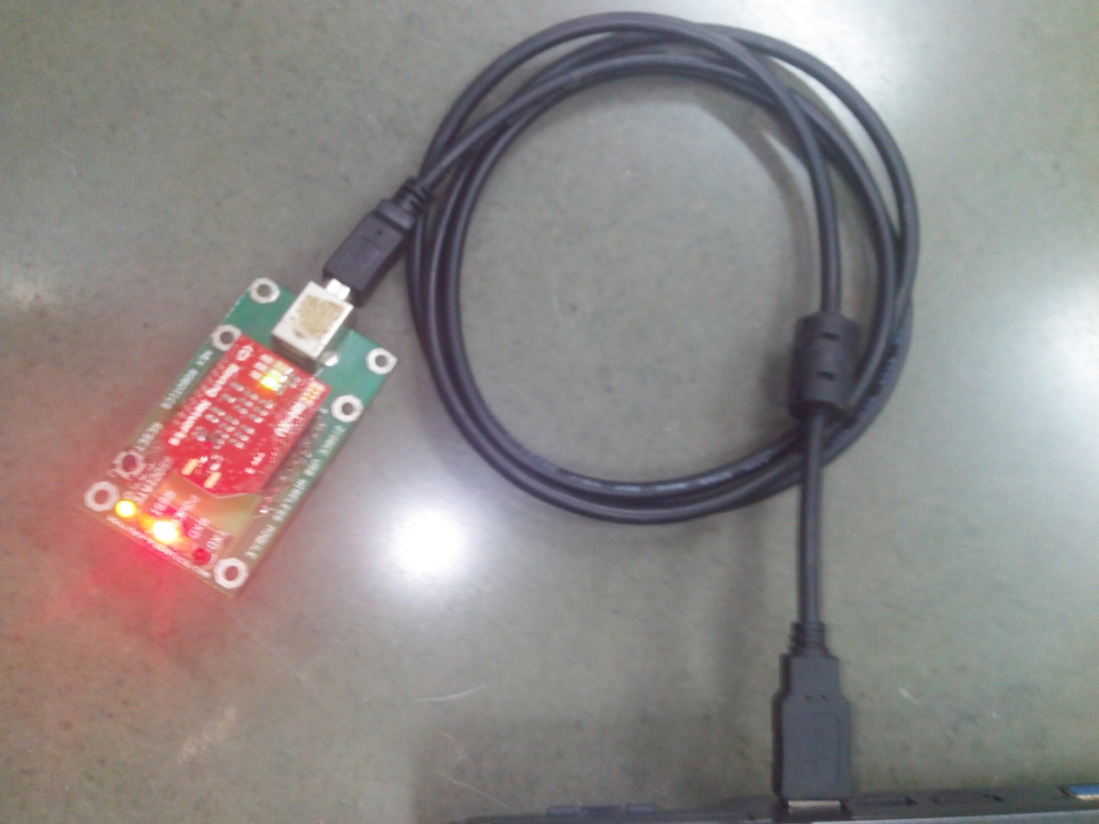

**Fig 2 USB connection**

**Step 2:**

Open a terminal software preferable not a hyperterminal. Tera term or coolterm is adviced. Here we have used Tera term. You can download it from following link.

<http://logmett.com/index.php?/download/tera-term-483-freeware.html>

**Step 3:**

Start a new connection in Tera term select serial connection and respective USB com port. The com port number can be derived from device manager.

Press ok.

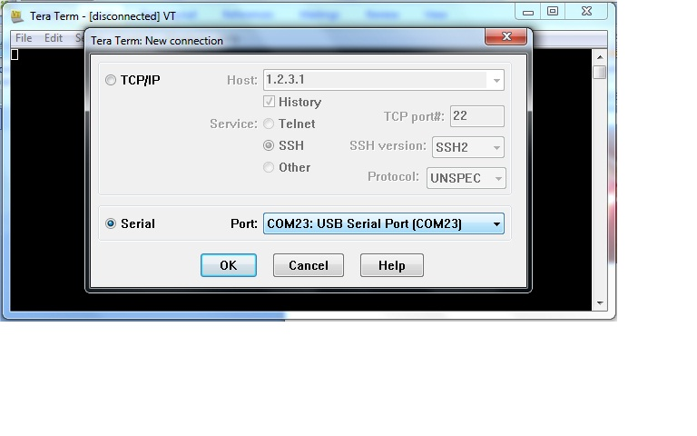

**Fig. 3 New connection**

**Step 4:**

Open serial port setup window under setup menu and verify the following settings

|  |  |
| --- | --- |
| Port | “Your USB com port” |
| Baud Rate | 9600 |
| Data | 8 bit |
| Parity | None |
| Stop | 1 bit |

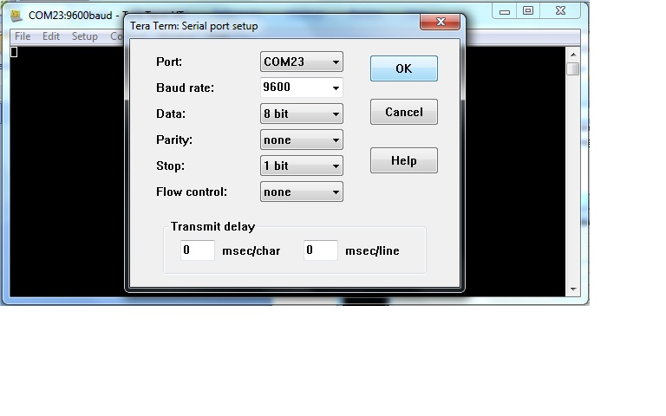

**Fig. 4 Serial port Setup**

Press ok.

**Step 5:**

Under terminal window in setup menu set the following settings.

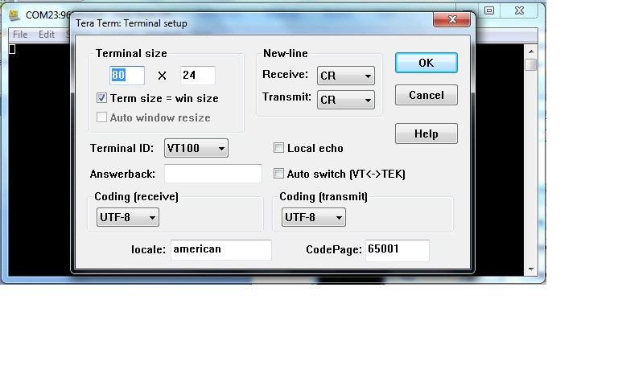

**Fig. 5 Terminal Setup**

**Step 6:**

Now in the workspace of Tera term type the commands from the data sheet.

First type $$$ without any enter to enter command mode. The module will reply with a “cmd” to indicate that it has entered command mode.

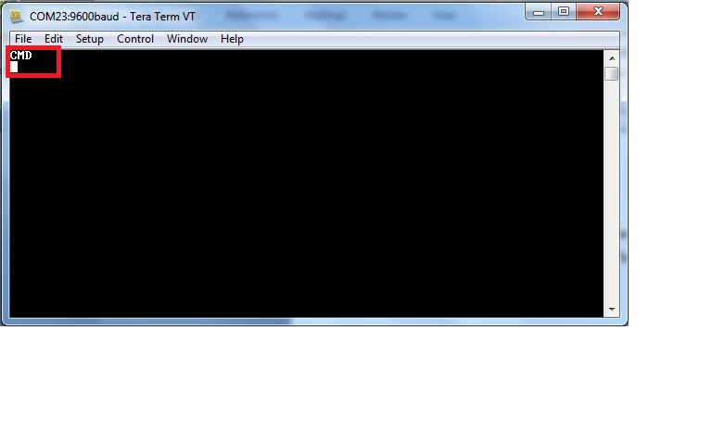

**Fig. 6 Entering command mode**

**Note:** After entering the command you need to press enter and if command is correct the module replies with a AOK and if there is error it replies ERROR.