 [Traduit de Anglais vers Français - www.onlinedoctranslator.com](https://www.onlinedoctranslator.com/fr/?utm_source=onlinedoctranslator&utm_medium=docx&utm_campaign=attribution)

1. 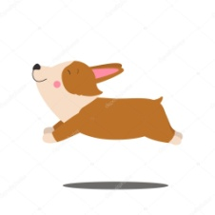 Which animal is this?
   1. Chien
   2. Chat
   3. Léopard
   4. tigre

Ans: a) Chien

1. 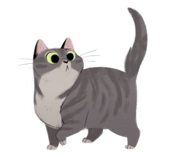 Which animal is this ?
   1. Chien
   2. Chat
   3. Léopard
   4. Lion

Ans: b) Chat

1. 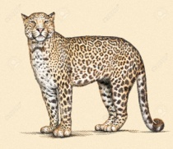 Which animal is this?
   1. Léopard
   2. Lion
   3. tigre
   4. Baleine

Ans: a) Léopard

1. 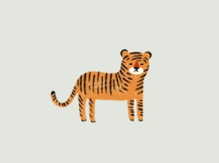 Which animal is this?
   1. Léopard
   2. Baleine
   3. tigre
   4. Perroquet

Ans: c) Tigre

1. 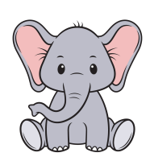 Which animal is this?
   1. Lion
   2. Léopard
   3. l'éléphant
   4. Chien

Ans: c) Éléphant

1. 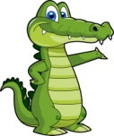 Which animal is this?
   1. Crocodile
   2. Léopard
   3. tigre
   4. Chat

Hint: This animal lay eggs

Ans: a) Crocodile

1. 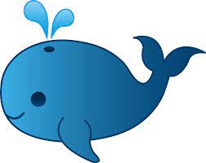 Which animal is this?
   1. Chien
   2. tigre
   3. Lion
   4. Baleine

Hint: Biggest animal in world

Ans: d) Baleine

1. 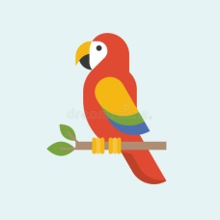Which bird is this?
   1. Perroquet
   2. Léopard
   3. Chat
   4. Chien

Ans: a) Perroquet

1. 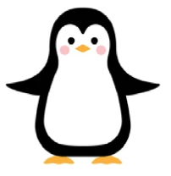Which bird is this?
   1. Perroquet
   2. Canard
   3. manchot
   4. Chien

Ans: c) Pingouin