 [Übersetzt von Englisch nach Deutsch - www.onlinedoctranslator.com](https://www.onlinedoctranslator.com/de/?utm_source=onlinedoctranslator&utm_medium=docx&utm_campaign=attribution)

1. 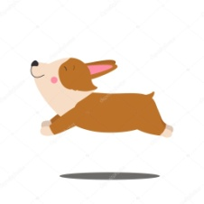 Which animal is this?
   1. Hund
   2. Katze
   3. Leopard
   4. Tiger

Ans: a) Hund

1. 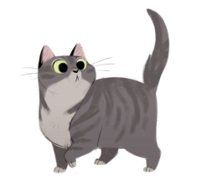 Which animal is this?
   1. Hund
   2. Katze
   3. Leopard
   4. Löwe

Ans: b) Katze

1. 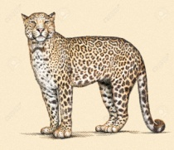 Which animal is this?
   1. Leopard
   2. Löwe
   3. Tiger
   4. Wal

Ans: a) Leopard

1. 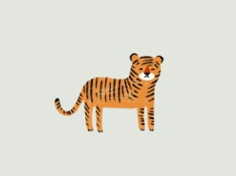 Which animal is this?
   1. Leopard
   2. Wal
   3. Tiger
   4. Papagei

Ans: c) Tiger

1. 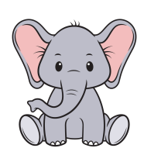 Which animal is this?
   1. Löwe
   2. Leopard
   3. Elefant
   4. Hund

Ans: c) Elefant

1. 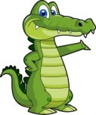 Which animal is this?
   1. Krokodil
   2. Leopard
   3. Tiger
   4. Katze

Hint: This animal lay eggs

Ans: a) Krokodil

1.  Which animal is this?
   1. Hund
   2. Tiger
   3. Löwe
   4. Wal

Hint: Biggest animal in world

Ans: d) Wal

1. 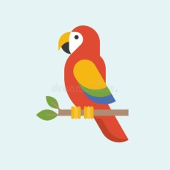Which bird is this?
   1. Papagei
   2. Leopard
   3. Katze
   4. Hund

Ans: a) Papagei

1. Which bird is this?
   1. Papagei
   2. Ente
   3. Pinguin
   4. Hund

Ans: c) Pinguin