 [Traducido del inglés al español - www.onlinedoctranslator.com](https://www.onlinedoctranslator.com/es/?utm_source=onlinedoctranslator&utm_medium=docx&utm_campaign=attribution)

1.  Which animal is this?
   1. Perro
   2. Gato
   3. Leopardo
   4. Tigre

Ans: a) Perro

1. 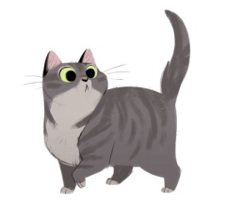 Which animal is this?
   1. Perro
   2. Gato
   3. Leopardo
   4. León

Ans: b) Gato

1. 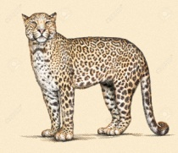 Which animal is this?
   1. Leopardo
   2. León
   3. Tigre
   4. Ballena

Ans: a) Leopardo

1. 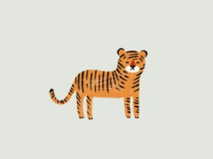 Which animal is this?
   1. Leopardo
   2. Ballena
   3. Tigre
   4. Loro

Ans: c) Tigre

1.  Which animal is this?
   1. León
   2. Leopardo
   3. Elefante
   4. Perro

Ans: c) Elefante

1.  Which animal is this?
   1. Cocodrilo
   2. Leopardo
   3. Tigre
   4. Gato

Hint: This animal lay egg

Ans: a) Cocodrilo

1.  Which animal is this?
   1. Perro
   2. Tigre
   3. León
   4. Ballena

Hint: Biggest animal in world

Ans: d) Ballena

1. 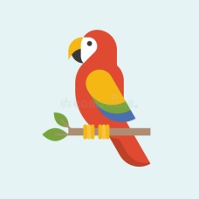 Which bird is this?
   1. Loro
   2. Leopardo
   3. Gato
   4. Perro

Ans: a) Loro

1.  Which bird is this?
   1. Loro
   2. Pato
   3. Pingüino
   4. Perro

Ans: c) Pingüino