1. Which greeting is best for a formal business meeting?
   1. नमस्ते
   2. अरे
   3. आप से मिलकर अच्छा लगा

Ans: c) आप से मिलकर अच्छा लगा

1. If you leaving someone at night, you can greet them by saying
   1. शुभ रात्रि
   2. शुभ प्रभात
   3. सुसंध्या

Ans: a) शुभ रात्रि

1. Synonymous of goodbye
   1. See you later
   2. Goodbye
   3. Nice to meet you

Ans: a) See you later

1. Which one is greeting?
   1. नमस्ते
   2. अलविदा
   3. आप से कल मिलता हूं
   4. बहुत लंबा

Ans: a) नमस्ते

1. 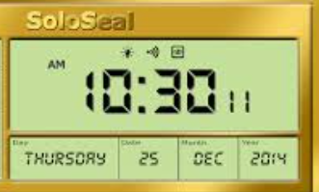Match the correct greetings with the time
   1. शुभ रात्रि
   2. सुसंध्या
   3. शुभ प्रभात

Ans: a) शुभ रात्रि