PhishGuard
Rule-Based Phishing Detection & Data Loss Prevention
Cybersecurity Project Report
2025 - 2026

Abstract
While email is still the leading communication channel used in current organizations, it is also the principal source of cyberattacks and breaches such as phishing attacks and information leakage. As a way of resolving these issues, this work introduces PhishGuard, an email filtering software that utilizes rule-based logic to detect any phishing activity and stop confidential data from leaking. Different from typical approaches, which use machine learning and threat intelligence, PhishGuard works completely offline and uses deterministic algorithms, providing high explainability and predictability.

PhishGuard consists of two engines: a Phishing Detection Engine used for examining incoming emails for any signs of phishing activities and a Data Loss Prevention (DLP) Engine, which scans outgoing emails for any signs of information leakage. Using various methods, such as regular expression matching, checking SPF and DKIM authentication, risk rating, and Luhn checksums, PhishGuard ensures high accuracy and audibility. Moreover, the ability to detect phishing campaigns in batch is included in PhishGuard's capabilities.

Problem

To design and develop an offline, rule-based email security system capable of accurately detecting phishing emails and preventing sensitive data leakage while ensuring transparency, compliance, and operational efficiency without relying on artificial intelligence or external services.

Key Challenges Addressed

- Detection of sophisticated phishing attacks and spoofed emails.
- Prevention of accidental or intentional data leakage via email.
- Verification of sender authenticity using SPF and DKIM.
- Reduction of false positives through deterministic rules.
- Ensuring explainability and auditability in cybersecurity decisions.
- Providing a cost-effective and offline security solution.

1. Introduction

Phishing and social engineering attacks are among the most widespread cyber threats today. Attackers craft fake emails that mimic legitimate senders to trick users into revealing passwords, OTPs, PAN numbers, Aadhaar details, or banking credentials.

PhishGuard is a rule-based email security tool that analyses both incoming and outgoing emails without using any Artificial Intelligence or Machine Learning. Every decision the system makes is driven by explicit, readable, deterministic rules — making it fully transparent and auditable.

The system has two core modules:
- Phishing Detection (Incoming)
- Data Loss Prevention / DLP (Outgoing)

2. System Flow

2.1 Incoming Email — Phishing Detection Flow
- User places .eml files in the sample_emails/ folder.
- main.py reads each file and passes it to the email parser.
- The parser extracts: sender, subject, body, URLs, attachments, and authentication headers
(SPF / DKIM).
- Each extracted field is passed through a set of detector functions (urgency words, brand spoofing, suspicious URLs, etc.).
- Each triggered detector adds to a weighted risk score.
- The risk engine maps the final score to a severity: SAFE / LOW / MEDIUM / HIGH / CRITICAL.
- The report module prints a colour-coded terminal report showing all triggered indicators.
- A batch analysis step detects coordinated campaigns (repeated subjects, reused URLs).

2.2 Outgoing Email — DLP Flow
- User places outgoing draft .eml files in the outgoing_drafts/ folder.
- main.py passes each file to the DLP engine.
- The DLP engine scans the email body using regex patterns for PAN, Aadhaar, credit/debit cards, passwords, IFSC codes, and bank account numbers.
- Attachment filenames are checked against sensitive name patterns (e.g., HR Data, Employee Payroll).
- Credit card numbers are additionally validated using the Luhn algorithm.
- If any CRITICAL pattern is found, the email is flagged as BLOCKED.
- A clear violation report is printed showing the type, count, and sample matches.

3. System Architecture

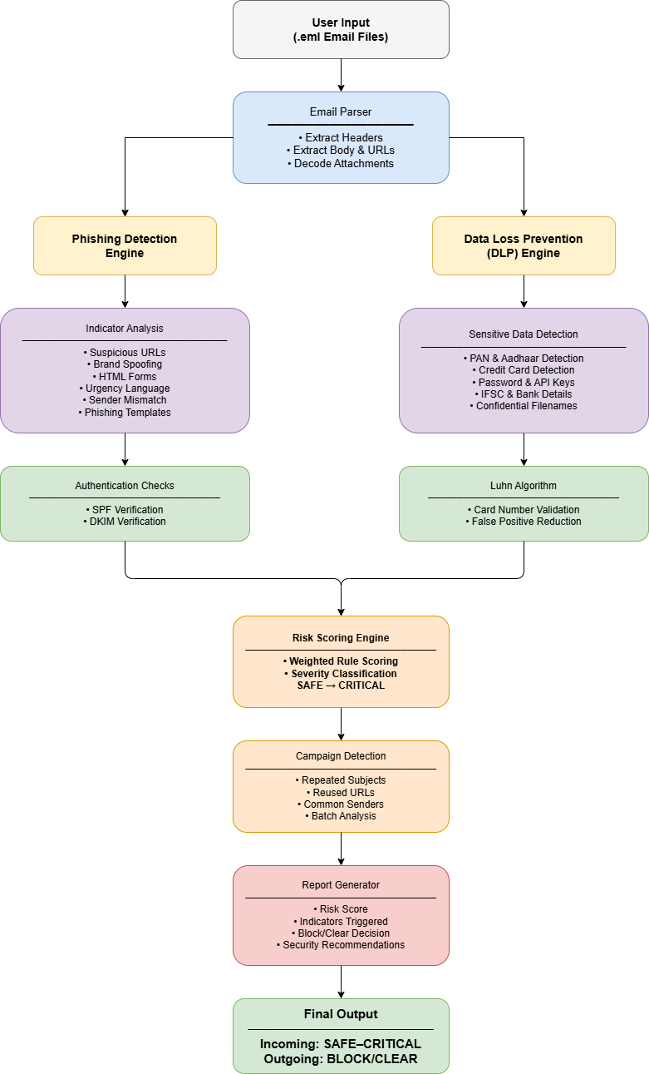

4. Module Descriptions

4.1 main.py

The single-entry point for the entire system. Accepts CLI arguments to control the scan mode:
- python main.py --mode incoming # Phishing scan only
- python main.py --mode outgoing # DLP scan only
- python main.py --mode both # Full scan (default)
- python main.py –email “folder_name\file.ml” # to scan a single email file

4.2 utils/email_parser.py

Responsible for reading a .eml file using Python's built-in email library and running all phishing indicator detectors. Returns a structured dictionary containing every piece of extracted information and all triggered indicators.

Detectors implemented in this module:
Detector | Weight | What It Checks
Urgency Language | 1 | Words: urgent, immediately, act now, account suspended
Suspicious URL | 2 | IP-based URLs, obfuscated subdomains, domain mismatch with sender
Sender Name Mismatch | 2 | Display name claims a brand but the email address domain differs
Free Email Brand Abuse | 2 | Brand name in Gmail/Hotmail/Yahoo address
Crypto Bait | 3 | Keywords: airdrop, Bitcoin, wallet, digital currency, claim crypto
Phishing Template Match | 3 | Regex patterns for known DHL, Tax Refund, Password Reset, 419 scams
HTML Form Detector | 3 | <form>, <input>, <button> tags found inside email HTML body
Language Scoring | 1 | Persuasion vocabulary: verify, confirm, locked, prize, winner

4.3 utils/risk_engine.py

Converts the raw indicator dictionary into a numeric risk score and a human-readable severity label. Logic:
- For each indicator key, if the value is a non-empty list, add its weight to the score.
- Add the pre-computed attachment_score.
- Add +2 for SPF fail, +2 for DKIM fail.
- Map the total score to a severity label:

Score Range | Severity
0 | SAFE
1 | LOW
2 – 4 | MEDIUM
5 – 9 | HIGH
>= 10 | CRITICAL

4.4 utils/dlp_engine.py

Scans outgoing emails for sensitive data patterns. Uses Python's re module for all regex matching. No external library is required.

Data Type | Severity | Pattern / Method
PAN Card | CRITICAL | Regex: 5 uppercase letters + 4 digits + 1 uppercase letter
Aadhaar Number | CRITICAL | Regex: 12 digits starting with 2-9, with optional spaces
Credit / Debit Card | CRITICAL | Regex for 13-19 digit card formats + Luhn algorithm validation
Password / Secret | CRITICAL | Regex: password=xxx, secret: xxx, api_key=xxx patterns
IFSC Code | HIGH | Regex: 4 uppercase letters + 0 + 6 alphanumeric characters
Bank Account Number | HIGH | Regex: 9-18 digit sequences (flagged if 3+ instances found)
Sensitive Filename | HIGH | Name patterns: HR Data, Employee, Payroll, Aadhaar, Confidential
Bulk Data Attachment | HIGH | CSV/XLSX/JSON attachments with more than 10 rows of content

4.5 utils/report.py

Handles all terminal output. Produces colour-coded, icon-annotated reports. Emails are sorted by risk score (highest first). Safe emails are printed last. The DLP report shows each violation with its type, severity, count, and sample matches.

5. Algorithm

5.1 Luhn Algorithm — Credit Card Validation

The Luhn algorithm (also called Modulus 10 algorithm) is a simple checksum formula used to validate credit and debit card numbers. It was designed by Hans Peter Luhn at IBM in 1954. It does not encrypt or secure a number; it only verifies that a digit string is a plausible card number, catching accidental transcription errors.

Why It Is Used in PhishGuard
Regex alone matches any 13-19 digit sequence, which produces many false positives (e.g., phone numbers, order IDs). The Luhn check filters out sequences that look like card numbers but fail the checksum — dramatically improving precision without any database lookup.

Step-by-Step Algorithm
- Write out the card number digits from right to left.
- Double every second digit (i.e., the digits at positions 2, 4, 6 … counting from the right).
- If doubling produces a number greater than 9, subtract 9 from it.
- Sum all the resulting digits together.
- If the total modulo 10 equals 0, the number is valid.

Worked Example — Card: 4111 1111 1111 1111
Digits (right to left): 1 1 1 1 1 1 1 1 1 1 1 1 1 1 1 4

Position: 1 2 3 4 5 6 7 8 9 10 11 12 13 14 15 16
Digit: 1 1 1 1 1 1 1 1 1 1 1 1 1 1 1 4
Double? N Y N Y N Y N Y N Y N Y N Y N Y
After dbl: 1 2 1 2 1 2 1 2 1 2 1 2 1 2 1 8

Sum = 1+2+1+2+1+2+1+2+1+2+1+2+1+2+1+8 = 30
30 mod 10 = 0 → VALID
Implementation in dlp_engine.py

5.2 Regex Pattern Matching

Target | Regex Pattern | Explanation
PAN Card | [A-Z]{5}[0-9]{4}[A-Z] | 5 uppercase + 4 digits + 1 uppercase. Exact Indian PAN format.
Aadhaar | [2-9]\d{3}[\s-]?\d{4}[\s-]?\d{4} | 12-digit number starting 2-9. Optional spaces/hyphens between groups.
IFSC Code | [A-Z]{4}0[A-Z0-9]{6} | 4-letter bank code + 0 + 6 alphanumeric branch code.
Password | (password|secret|api_key)\s*[=:]\s*\S{6,} | Key=value assignment pattern. Catches password=xxx and secret: xxx.
IP URL | https?://(\d{1,3}\.){3}\d{1,3} | URL using raw IP address instead of domain name.

5.3 Weighted Risk Scoring

PhishGuard assigns a different weight to each phishing indicator based on how strongly it correlates with real phishing. A single triggered indicator of weight 3 (e.g., a known phishing template match) contributes more than three low-weight indicators of weight 1 each.

This is a simple additive scoring model — no machine learning, no training data. The weights were chosen based on the relative danger of each indicator:
- Weight 3 (High confidence):
- Weight 2 (Moderate confidence):
- Weight 1 (Supporting evidence):

5.4 Batch Pattern Analysis

After all emails are individually scanned, PhishGuard performs a cross-email analysis using Python's collections. Counter to detect coordinated phishing campaigns. If the same subject line, URL, or sender address appears in multiple emails, it is flagged — a strong signal of a mass phishing attack rather than an isolated incident.

6. Scan Results

6.1 Phishing Detection — Incoming Emails

Email File | Key Indicators | Score | Severity
paypal_spoof.eml | HTML form, banned domain, name spoof, SPF/DKIM fail | 23 | CRITICAL
crypto_urgent.eml | IP URL, crypto keywords, urgency language, SPF/DKIM fail | 15 | CRITICAL
advance_fee_scam.eml | Advance fee keywords, 419 template, SPF/DKIM fail | 13 | CRITICAL
safe_hr_email.eml | None | 0 | SAFE

6.2 DLP — Outgoing Emails

Email File | DLP Violations Found | Action
pan_aadhaar_leak.eml | 4 PAN cards + 4 Aadhaar numbers detected | BLOCKED
credit_card_leak.eml | 3 Luhn-valid card numbers + 1 plaintext password | BLOCKED
safe_meeting.eml | No violations | CLEARED

7. Conclusion

PhishGuard demonstrates that effective email security does not require Artificial Intelligence. By combining deterministic rule-based detection, weighted risk scoring, cryptographic checksum validation (Luhn), and regex-based sensitive data scanning, the system achieves reliable phishing detection and data loss prevention for both incoming and outgoing emails.

Every decision the system makes is fully explainable — each flag points to the exact rule that triggered it. This makes the system transparent, auditable, and easy to extend by adding new rules or patterns without retraining any model.

The India-specific DLP patterns (PAN, Aadhaar, IFSC, RuPay) make PhishGuard directly relevant to the Indian regulatory and compliance context.

