All Experiments

Exp - 2

Aim
multicolumn layout using bootstrap grid system responsive breakpoint for mobile, tablet and the desktop

Output (Screenshot)
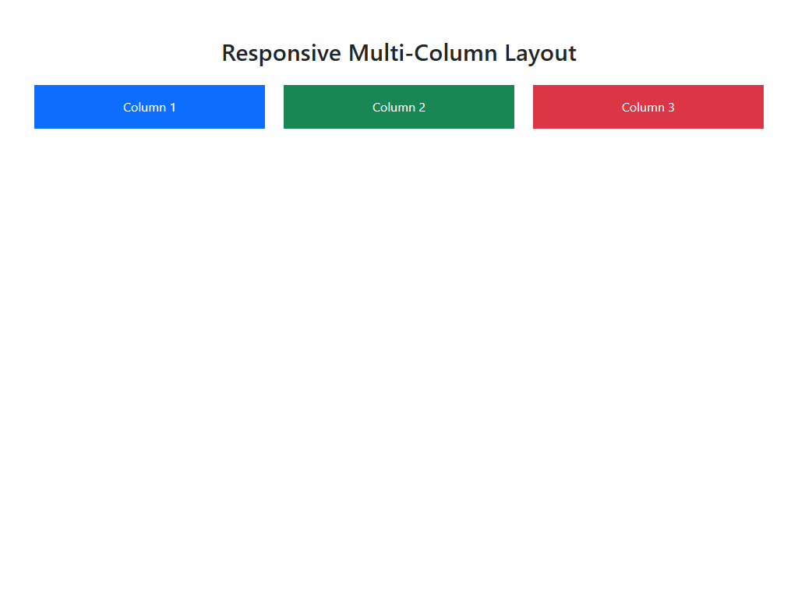

Code
<!DOCTYPE html>
<html lang="en">
<head>
<meta charset="UTF-8">
<meta name="viewport" content="width=device-width, initial-scale=1.0">
<title>Bootstrap Grid</title>
<link href="https://cdn.jsdelivr.net/npm/bootstrap@5.3.0/dist/css/bootstrap.min.css" rel="stylesheet">
</head>
<body>
<div class="container mt-5">
<h2 class="text-center mb-4">Responsive Multi-Column Layout</h2>
<div class="row">
<div class="col-12 col-md-6 col-lg-4 mb-3">
<div class="p-3 bg-primary text-white text-center">Column 1</div>
</div>
<div class="col-12 col-md-6 col-lg-4 mb-3">
<div class="p-3 bg-success text-white text-center">Column 2</div>
</div>
<div class="col-12 col-md-12 col-lg-4 mb-3">
<div class="p-3 bg-danger text-white text-center">Column 3</div>
</div>
</div>
</div>
</body>
</html>

Exp - 3

Aim
form control and validation

Output (Screenshot)
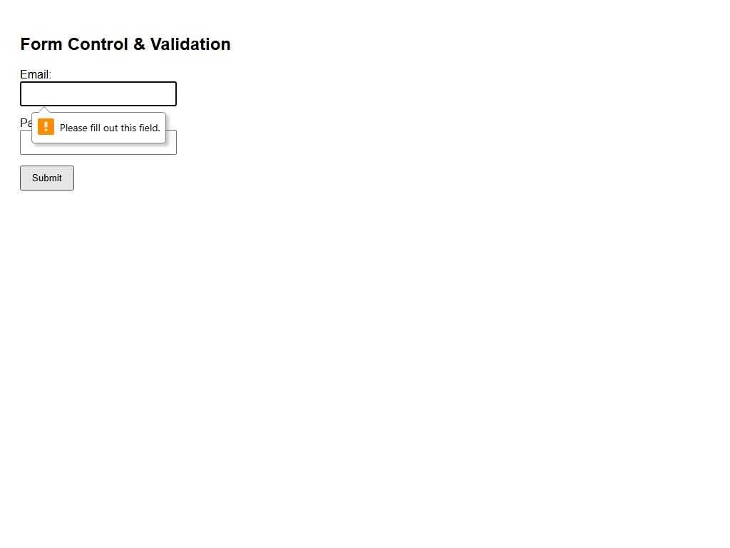

Code
<!DOCTYPE html>
<html>
<head>
<title>Form Validation</title>
<style>
body { font-family: Arial; padding: 20px; }
.error { color: red; font-size: 0.9em; display: none; margin-top: 5px; }
.form-group { margin-bottom: 15px; }
input { padding: 8px; width: 200px; }
button { padding: 8px 15px; }
</style>
</head>
<body>
<h2>Form Control & Validation</h2>
<form id="myForm" onsubmit="return validateForm(event)">
<div class="form-group">
<label for="email">Email:</label><br>
<input type="email" id="email" required>
<div class="error" id="emailError">Please enter a valid email.</div>
</div>
<div class="form-group">
<label for="password">Password:</label><br>
<input type="password" id="password" required minlength="6">
<div class="error" id="pwdError">Password must be at least 6 characters.</div>
</div>
<button type="submit" id="submitBtn">Submit</button>
</form>
<script>
function validateForm(e) {
e.preventDefault();
let isValid = true;
let pwd = document.getElementById('password').value;
if (pwd.length < 6) {
document.getElementById('pwdError').style.display = 'block';
isValid = false;
} else {
document.getElementById('pwdError').style.display = 'none';
}
if (isValid) alert('Form submitted successfully!');
return isValid;
}
</script>
</body>
</html>

Exp - 4

Aim
simple DOM manipulation

Output (Screenshot)
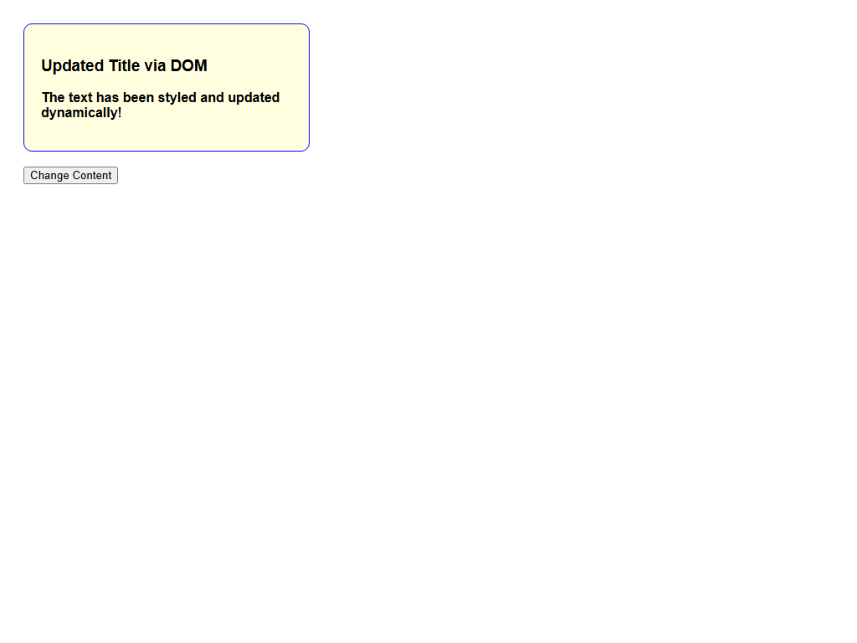

Code
<!DOCTYPE html>
<html>
<head><style>body{font-family:Arial; padding: 20px;}</style></head>
<body>
<div id="contentBox" style="padding: 20px; border: 1px solid black; width: 300px; transition: 0.3s;">
<h3 id="mainTitle">Original Title</h3>
<p id="descText">This is some standard description text.</p>
</div>
<br>
<button id="changeBtn" onclick="manipulateDOM()">Change Content</button>
<script>
function manipulateDOM() {
let title = document.getElementById('mainTitle');
let box = document.getElementById('contentBox');
let p = document.getElementById('descText');
title.innerText = "Updated Title via DOM";
p.innerHTML = "<strong>The text has been styled and updated dynamically!</strong>";
box.style.backgroundColor = "lightyellow";
box.style.borderRadius = "10px";
box.style.borderColor = "blue";
}
</script>
</body>
</html>

Exp - 5

Aim
form validation using string method and type conversion

Output (Screenshot)
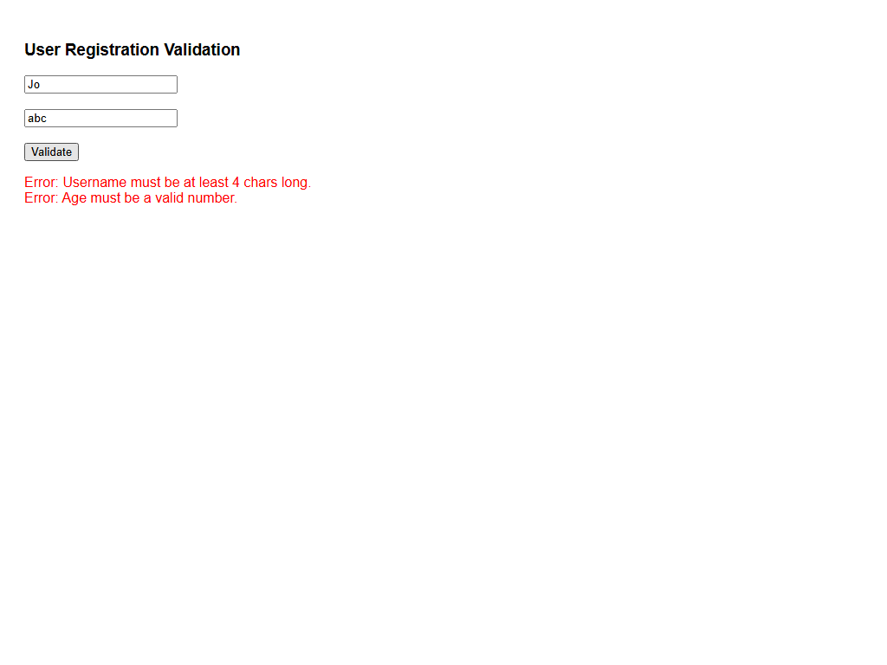

Code
<!DOCTYPE html>
<html>
<head><style>body{font-family:Arial; padding: 20px;}</style></head>
<body>
<h3>User Registration Validation</h3>
<input type="text" id="username" placeholder="Username (Letters only)"><br><br>
<input type="text" id="age" placeholder="Age"><br><br>
<button id="valBtn" onclick="validateData()">Validate</button>
<p id="result"></p>
<script>
function validateData() {
let username = document.getElementById('username').value.trim();
let ageStr = document.getElementById('age').value;
let resultText = "";
let nameRegex = /^[a-zA-Z]+$/;
if (!username.match(nameRegex)) {
resultText += "Error: Username must contain only letters.<br>";
} else if (username.length < 4) {
resultText += "Error: Username must be at least 4 chars long.<br>";
}
let ageNum = parseInt(ageStr);
if (isNaN(ageNum)) {
resultText += "Error: Age must be a valid number.<br>";
} else if (ageNum < 18) {
resultText += "Error: You must be at least 18 years old.<br>";
}
if (resultText === "") {
resultText = "<span style='color:green'>Validation Successful!</span>";
} else {
resultText = "<span style='color:red'>" + resultText + "</span>";
}
document.getElementById('result').innerHTML = resultText;
}
</script>
</body>
</html>

Exp - 6

Aim
demonstrate the functions and variable hoisting

Output (Screenshot)
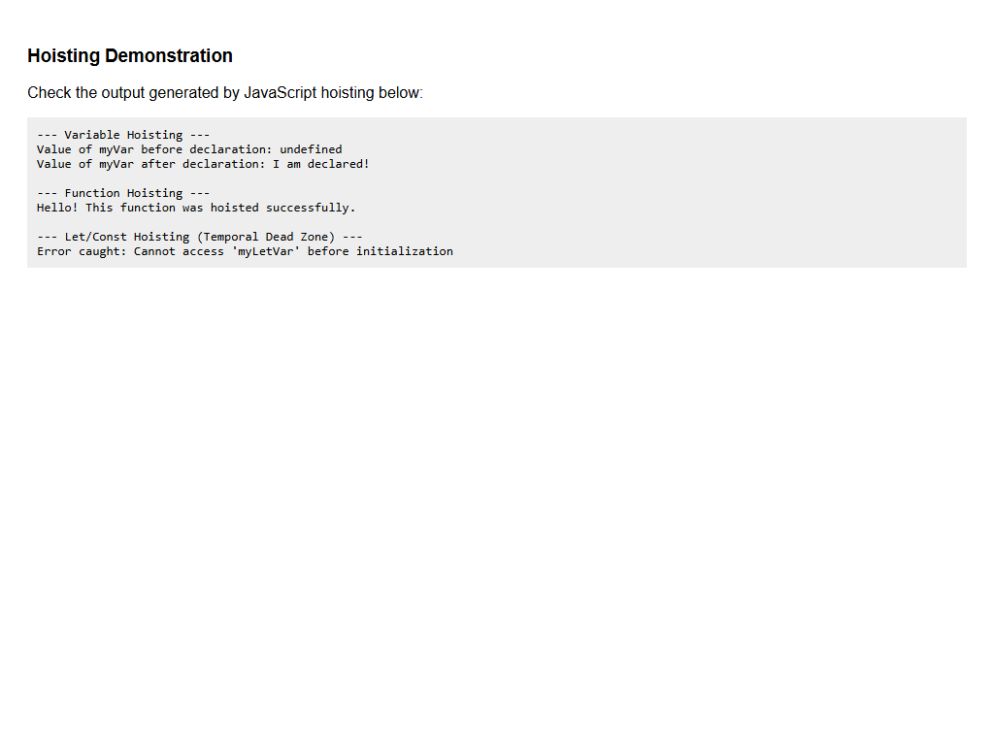

Code
<!DOCTYPE html>
<html>
<head><style>body{font-family:Arial; padding: 20px;} pre{background:#eee; padding:10px;}</style></head>
<body>
<h3>Hoisting Demonstration</h3>
<p>Check the output generated by JavaScript hoisting below:</p>
<pre id="output"></pre>
<script>
let out = "";
out += "--- Variable Hoisting ---\n";
out += "Value of myVar before declaration: " + myVar + "\n";
var myVar = "I am declared!";
out += "Value of myVar after declaration: " + myVar + "\n\n";
out += "--- Function Hoisting ---\n";
out += sayHello() + "\n\n";
function sayHello() { return "Hello! This function was hoisted successfully."; }
out += "--- Let/Const Hoisting (Temporal Dead Zone) ---\n";
try {
console.log(myLetVar);
} catch (error) {
out += "Error caught: Cannot access 'myLetVar' before initialization\n";
}
let myLetVar = "Modern JS";
document.getElementById("output").innerText = out;
</script>
</body>
</html>

Exp - 7

Aim
jquery event listener and animation

Output (Screenshot)
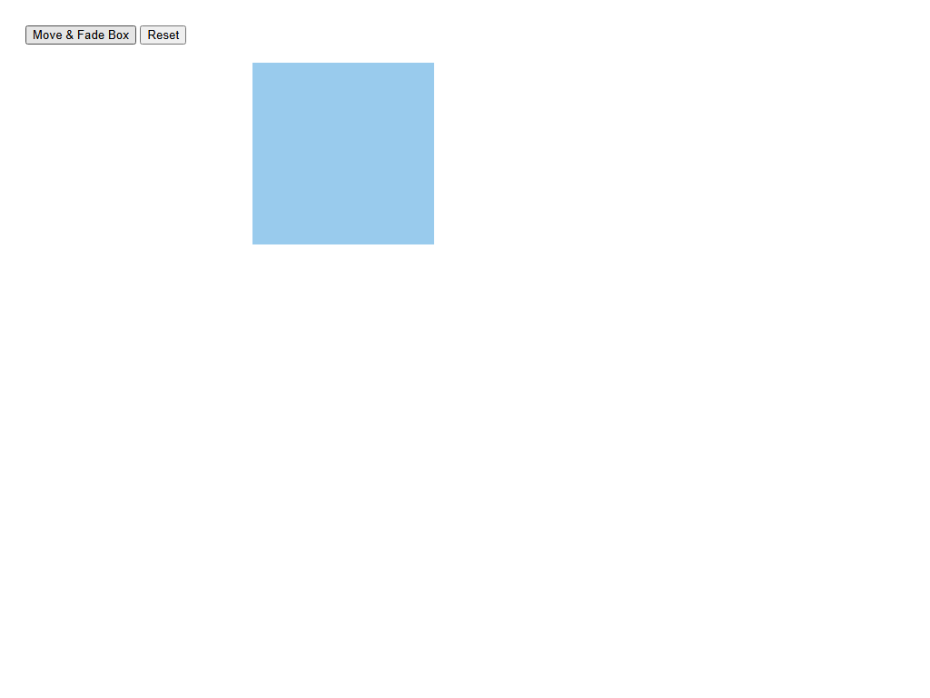

Code
<!DOCTYPE html>
<html>
<head>
<title>jQuery Animation</title>
<script src="https://code.jquery.com/jquery-3.6.0.min.js"></script>
<style>
body{font-family:Arial; padding: 20px;}
#animatedBox { width: 150px; height: 150px; background-color: #3498db; margin-top: 20px; position: relative; }
</style>
</head>
<body>
<button id="moveBtn">Move & Fade Box</button>
<button id="resetBtn">Reset</button>
<div id="animatedBox"></div>
<script>
$(document).ready(function() {
$("#moveBtn").click(function() {
$("#animatedBox").animate({ left: '250px', opacity: '0.5', height: '200px', width: '200px' }, 500);
});
});
</script>
</body>
</html>

Exp - 8

Aim
fetches data asynchronously using jquery

Output (Screenshot)
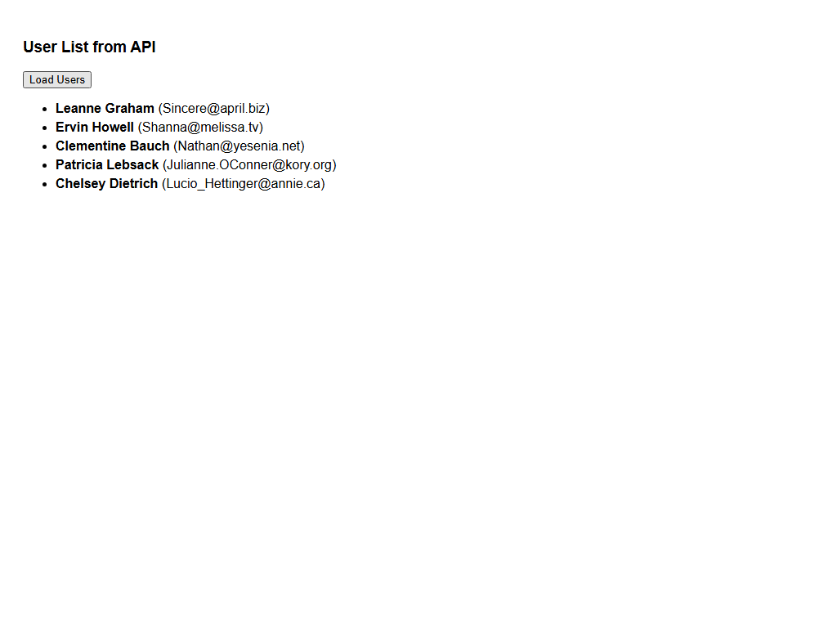

Code
<!DOCTYPE html>
<html>
<head>
<title>jQuery AJAX Fetch</title>
<script src="https://code.jquery.com/jquery-3.6.0.min.js"></script>
<style>body{font-family:Arial; padding: 20px;} li {margin-bottom: 5px;}</style>
</head>
<body>
<h3>User List from API</h3>
<button id="fetchBtn">Load Users</button>
<p id="loading" style="display:none; color:blue;">Loading data...</p>
<ul id="userList"></ul>
<script>
$(document).ready(function() {
$("#fetchBtn").click(function() {
$("#loading").show();
$.ajax({
url: "https://jsonplaceholder.typicode.com/users",
type: "GET",
success: function(data) {
$("#loading").hide();
let listItems = "";
for (let i = 0; i < 5; i++) {
listItems += "<li><strong>" + data[i].name + "</strong> (" + data[i].email + ")</li>";
}
$("#userList").html(listItems);
}
});
});
});
</script>
</body>
</html>

Exp - 9

Aim
php scripts that perform sorting searching and merging

Output (Screenshot)
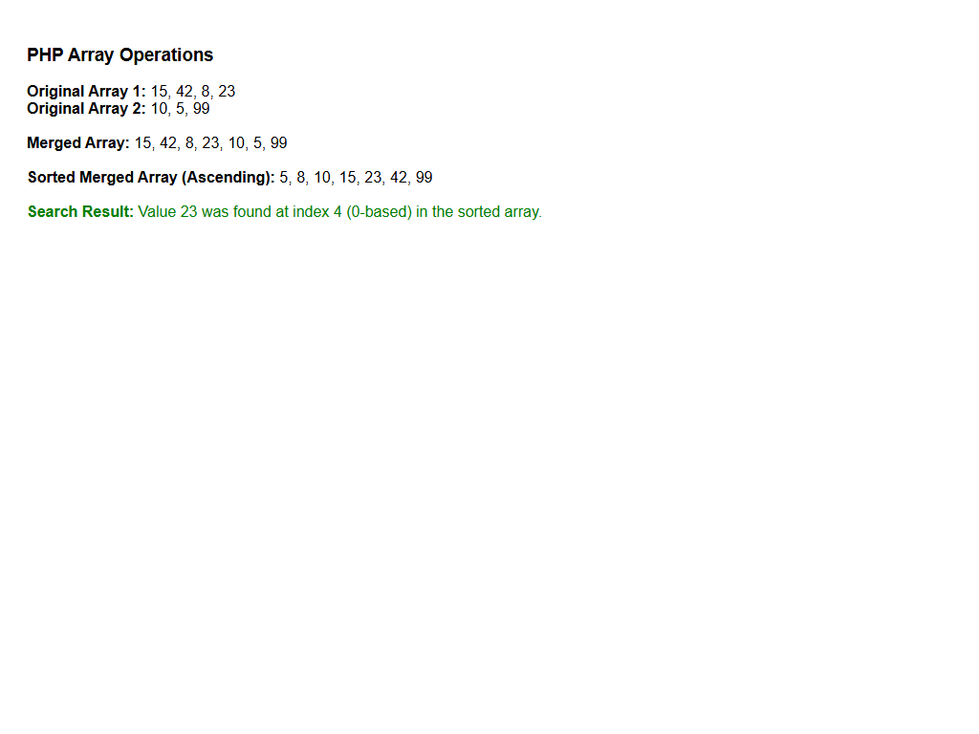

Code
<?php
echo "<div style='font-family:Arial; padding: 20px;'>";
echo "<h3>PHP Array Operations</h3>";
$array1 = array(15, 42, 8, 23);
$array2 = array(10, 5, 99);
echo "<b>Original Array 1:</b> " . implode(", ", $array1) . "<br>";
echo "<b>Original Array 2:</b> " . implode(", ", $array2) . "<br><br>";
$merged_array = array_merge($array1, $array2);
echo "<b>Merged Array:</b> " . implode(", ", $merged_array) . "<br><br>";
sort($merged_array);
echo "<b>Sorted Merged Array (Ascending):</b> " . implode(", ", $merged_array) . "<br><br>";
$search_value = 23;
$index = array_search($search_value, $merged_array);
if ($index !== false) {
echo "<span style='color:green;'><b>Search Result:</b> Value {$search_value} was found at index {$index} (0-based) in the sorted array.</span><br>";
}
echo "</div>";
?>

Exp - 10

Aim
laravel based crud using route controller include the user friendly error manage and bootstrap styling

Output (Screenshot)
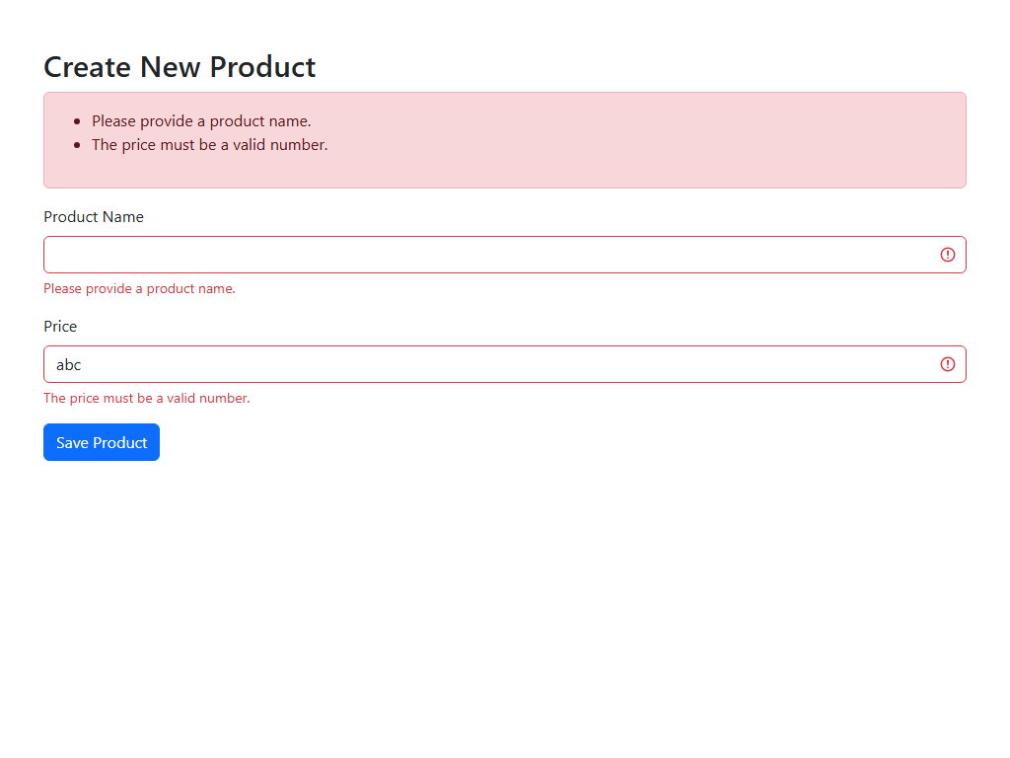

Code
<!DOCTYPE html>
<html lang="en">
<head>
<meta charset="UTF-8">
<title>Laravel CRUD Simulation</title>
<link href="https://cdn.jsdelivr.net/npm/bootstrap@5.3.0/dist/css/bootstrap.min.css" rel="stylesheet">
</head>
<body>
<div class="container mt-5">
<h2>Create New Product</h2>
<div class="alert alert-danger">
<ul>
<li>Please provide a product name.</li>
<li>The price must be a valid number.</li>
</ul>
</div>
<form>
<div class="mb-3">
<label class="form-label">Product Name</label>
<input type="text" name="name" class="form-control is-invalid" value="">
<div class="invalid-feedback">Please provide a product name.</div>
</div>
<div class="mb-3">
<label class="form-label">Price</label>
<input type="text" name="price" class="form-control is-invalid" value="abc">
<div class="invalid-feedback">The price must be a valid number.</div>
</div>
<button type="button" class="btn btn-primary">Save Product</button>
</form>
</div>
</body>
</html>

