Exp - 10

Aim
laravel based crud using route controller include the user friendly error manage and bootstrap styling (Mapped to raw PHP Cart CRUD)

Code (From FoodMart Project)
// File: cart.php & actions/cart_actions.php
// CREATE (Add) -> actions/cart_actions.php
$_SESSION['cart'][$id] = ['name' => $name, 'price' => $price, 'quantity' => $quantity];
// READ (Display) -> cart.php
<?php foreach ($_SESSION['cart'] as $id => $item): ?>
<td><?php echo htmlspecialchars($item['name']); ?></td>
<?php endforeach; ?>
// DELETE (Remove) -> actions/cart_actions.php
unset($_SESSION['cart'][$id]);
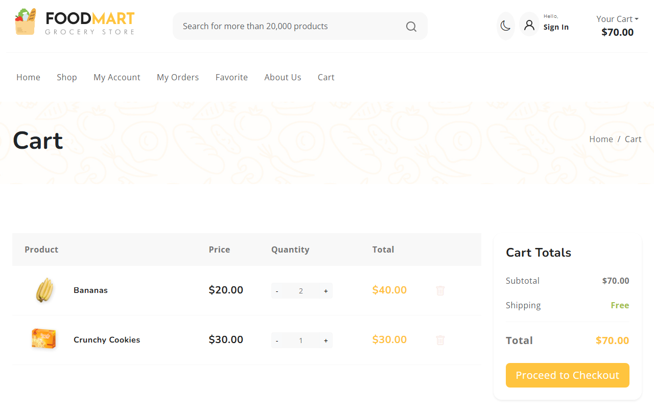
Empty Cart (Initial State)
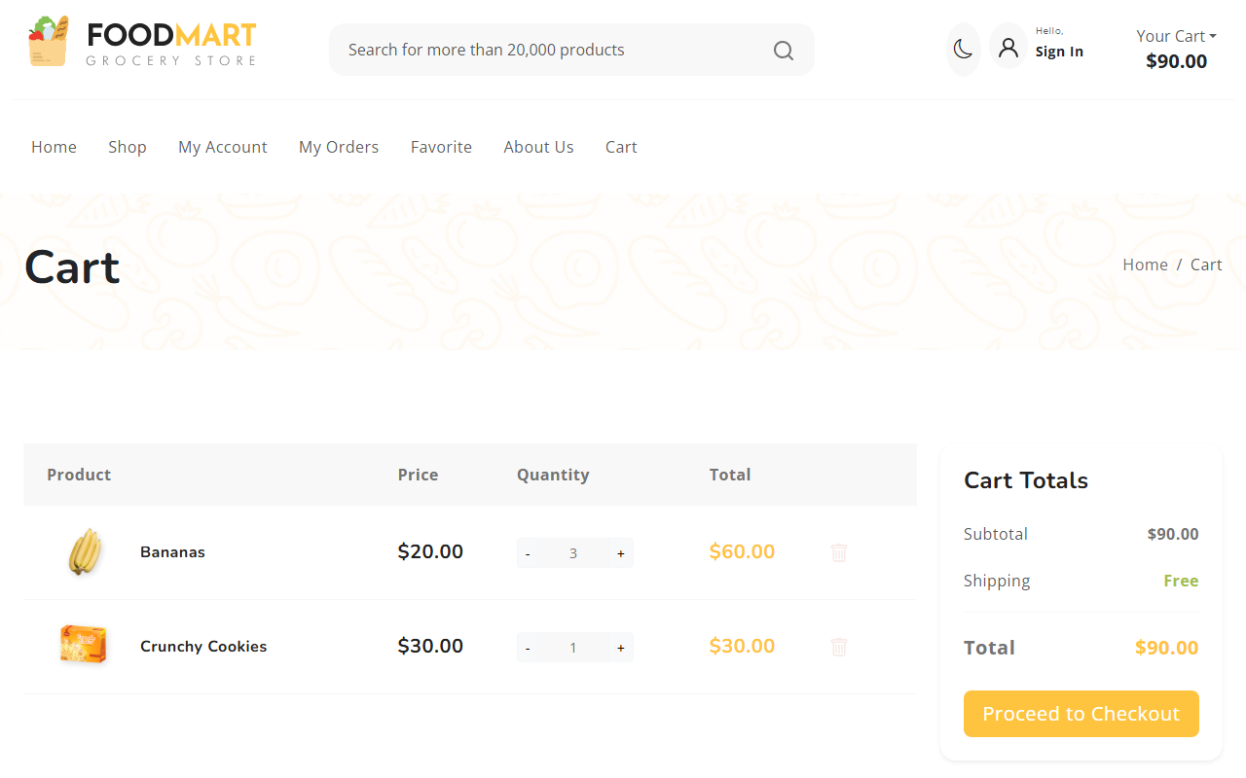
Cart with Items (Create/Read)

