Exp - 3

Aim
form control and validation

Code (From FoodMart Project)
// File: account.php
<form action="actions/change_password.php" method="POST">
<div class="mb-3">
<label for="current_password" class="form-label">Current Password</label>
<input type="password" class="form-control" id="current_password" name="current_password" required>
</div>
<div class="mb-3">
<label for="new_password" class="form-label">New Password</label>
<input type="password" class="form-control" id="new_password" name="new_password" required>
</div>
<div class="d-grid gap-2">
<button type="submit" class="btn btn-danger">Update Password</button>
</div>
</form>
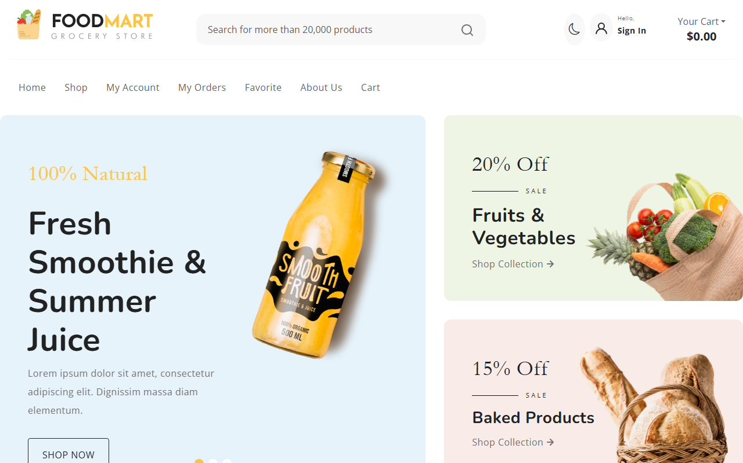
Login Form View

Validation Triggered

