Exp - 4

Aim
simple DOM manipulation

Code (From FoodMart Project)
// File: js/cart.js
// Update Cart Badge dynamically
function updateCartBadge(count) {
$('#offcanvasCart .badge').text(count);
}
// jQuery manipulates the DOM elements to reflect the new count.
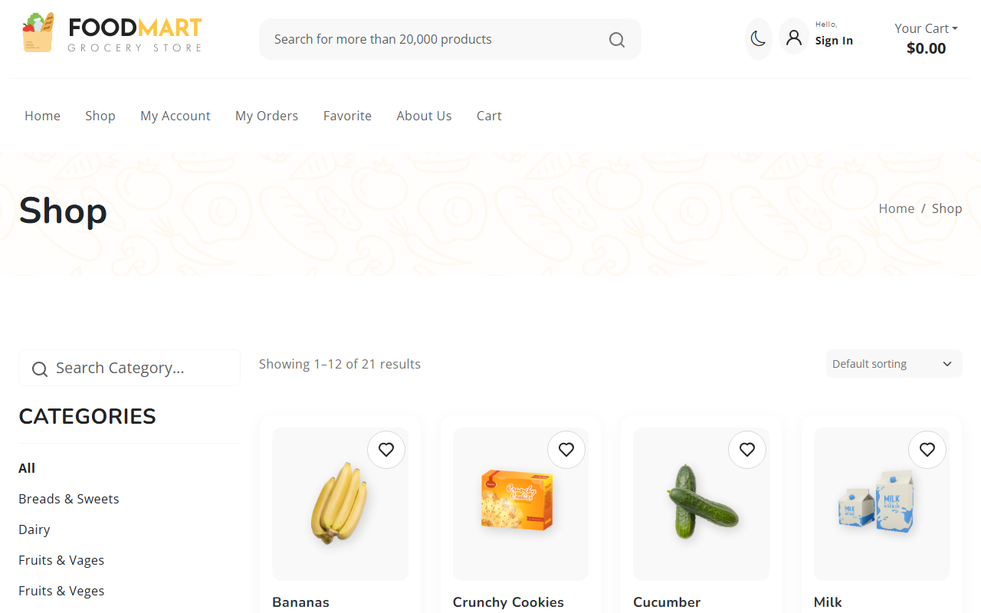
Initial State

DOM Manipulated (Item added to cart)

