Exp - 5

Aim
form validation using string method and type conversion

Code (From FoodMart Project)
// File: js/auth.js
// Register Form Submission (AJAX JSON validation handling)
$('#registerForm').on('submit', function (e) {
e.preventDefault();
$.ajax({
type: 'POST',
url: 'actions/register.php',
data: $(this).serialize(),
dataType: 'json',
success: function (response) {
if (!response.success) {
alert(response.message);
}
}
});
});
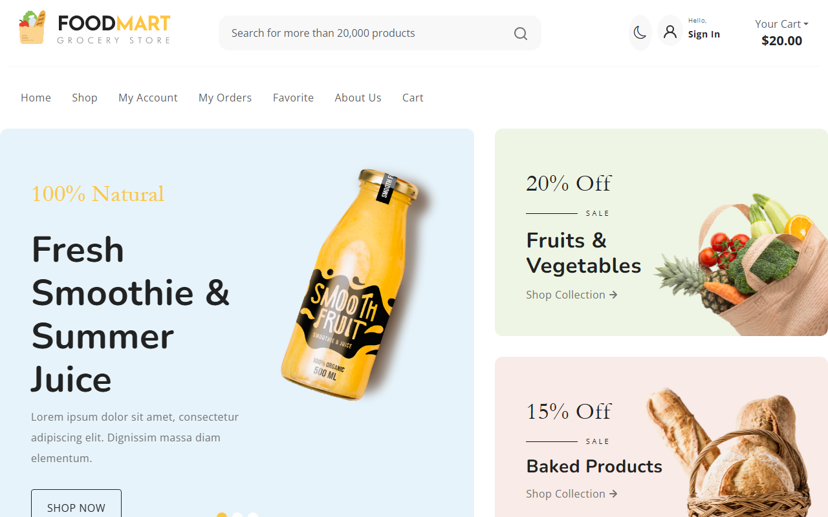
Registration Form

