Exp - 6

Aim
demonstrate the functions and variable hoisting

Code (From FoodMart Project)
// File: js/cart.js
$(document).ready(function () {
// Hoisting in action - calling function before declaration
updateCartBadge(0);
function updateCartBadge(count) {
$('#offcanvasCart .badge').text(count);
}
});
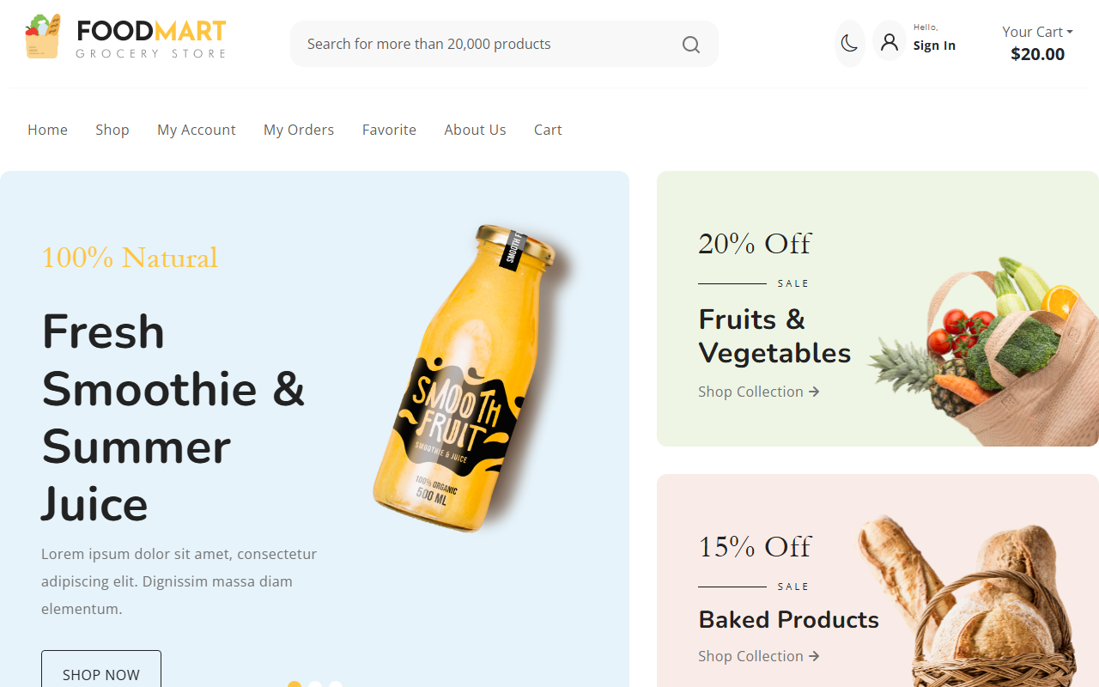
Cart Icon initialized via Hoisted function

