Exp - 7

Aim
jquery event listener and animation

Code (From FoodMart Project)
// File: js/cart.js
// jQuery event listener and icon animation
$(document).on('click', '.btn-add-to-cart', function (e) {
e.preventDefault();
var $btn = $(this);
var originalIcon = $btn.html();
$btn.html('<i class="bi bi-check-lg"></i>'); // UI feedback animation
setTimeout(function () {
$btn.html(originalIcon);
}, 1500);
});
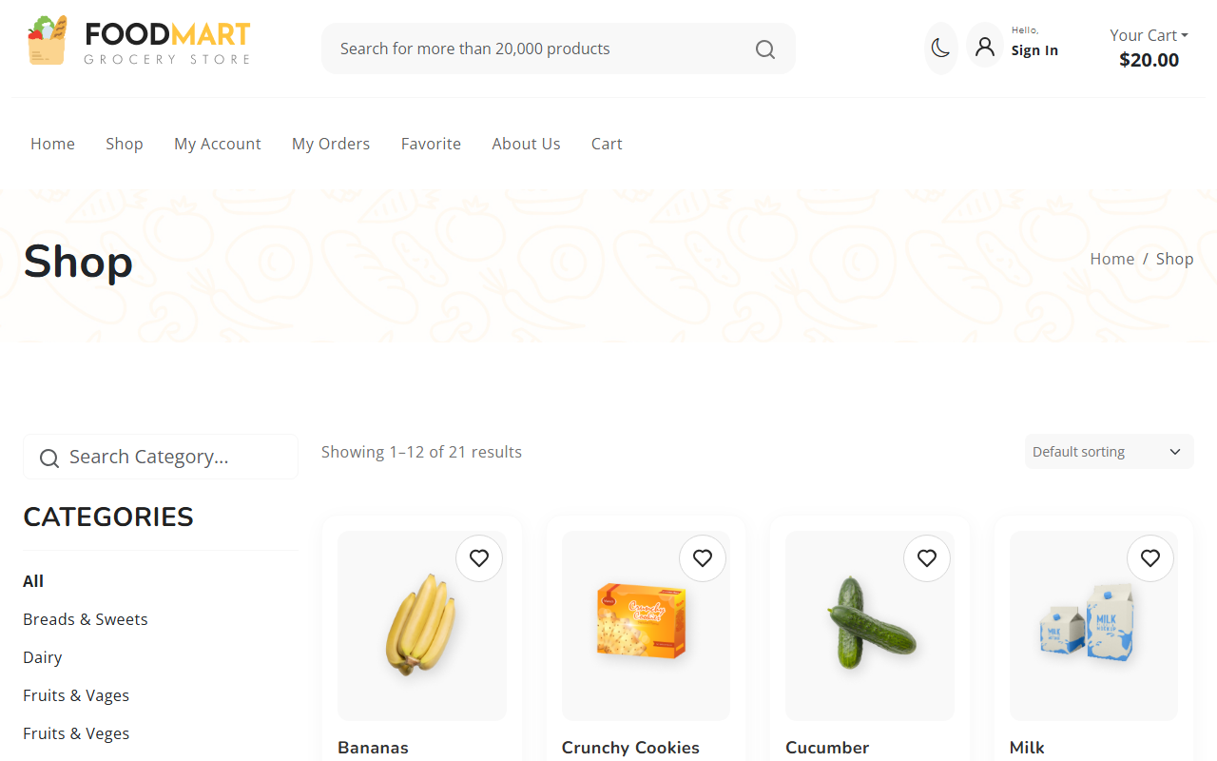
Animation triggered on click

