Exp - 8

Aim
fetches data asynchronously using jquery

Code (From FoodMart Project)
// File: js/cart.js
$.ajax({
url: 'actions/cart_actions.php',
type: 'POST',
dataType: 'json',
data: { action: 'add', id: id, quantity: quantity },
success: function (response) {
if (response.success) {
updateCartBadge(response.cart_count);
}
}
});
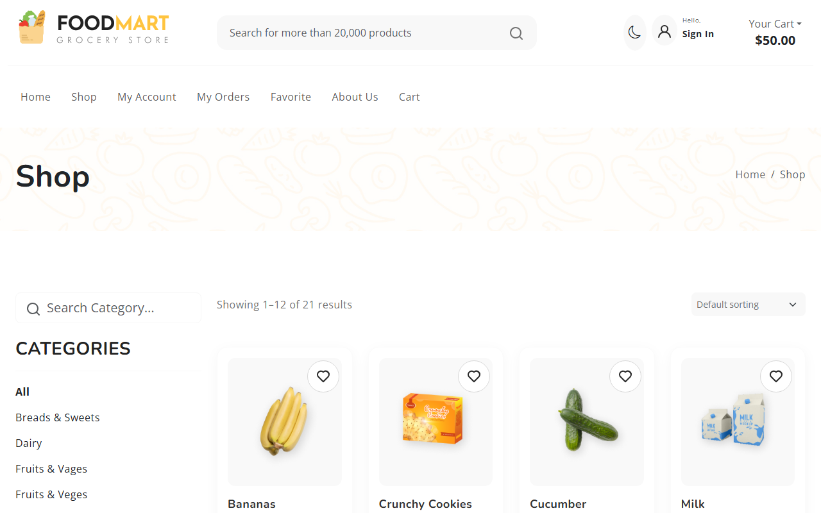
Sending Async Request
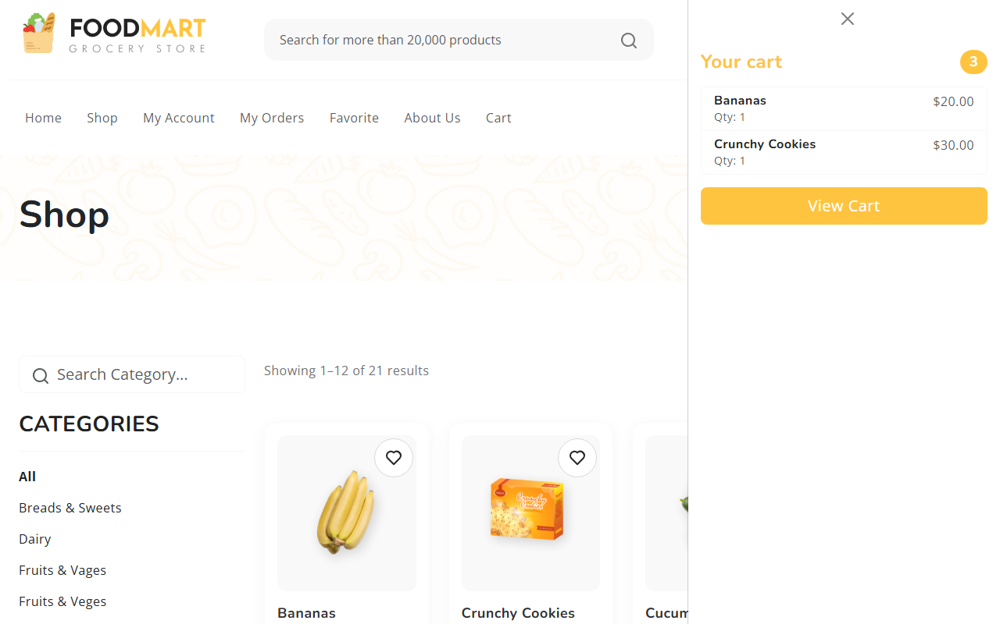
Async Result Displayed

