Exp - 9

Aim
php scripts that perform sorting searching and merging

Code (From FoodMart Project)
// File: shop.php
$category_filter = isset($_GET['category']) ? $_GET['category'] : 'all';
$sql = "SELECT * FROM products";
if ($category_filter != 'all') {
$sql .= " WHERE category = ?";
$params[] = $category_filter;
}
$stmt = $conn->prepare($sql);
$stmt->execute();
$result = $stmt->get_result();

All Products
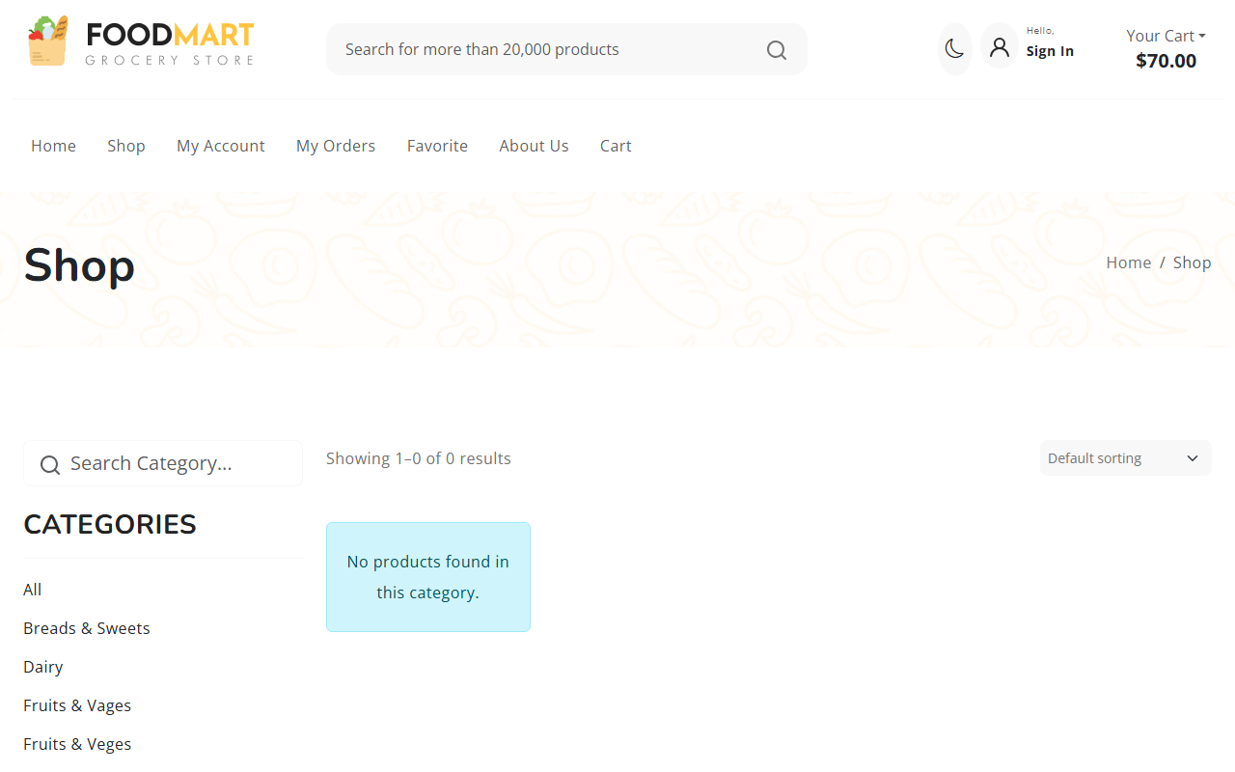
Filtered Products

