FoodMart Code Experiments

Exp - 2

Aim
multicolumn layout using bootstrap grid system responsive breakpoint for mobile, tablet and the desktop

Code (From FoodMart Project)
// File: shop.php
<div class="product-grid row row-cols-1 row-cols-sm-2 row-cols-md-3 row-cols-lg-3 row-cols-xl-4">
<?php if ($result->num_rows > 0): ?>
<?php while($row = $result->fetch_assoc()): ?>
<div class="col">
<div class="product-item">
<!-- Product Display -->
<img src="<?php echo htmlspecialchars($row['image']); ?>">
<h3><?php echo htmlspecialchars($row['title']); ?></h3>
<span class="price"><?php echo htmlspecialchars($row['price']); ?></span>
</div>
</div>
<?php endwhile; ?>
<?php endif; ?>
</div>
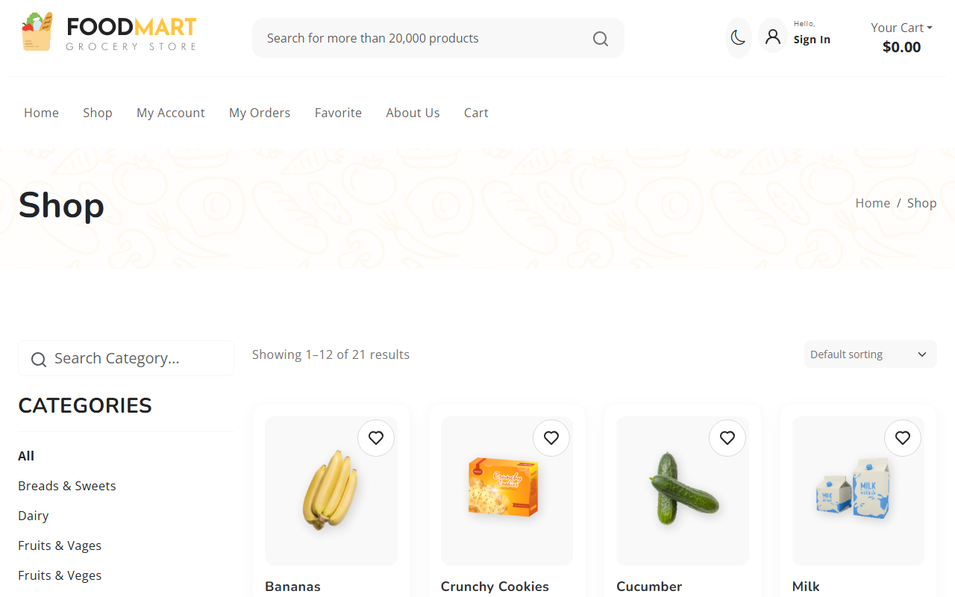
Desktop Layout
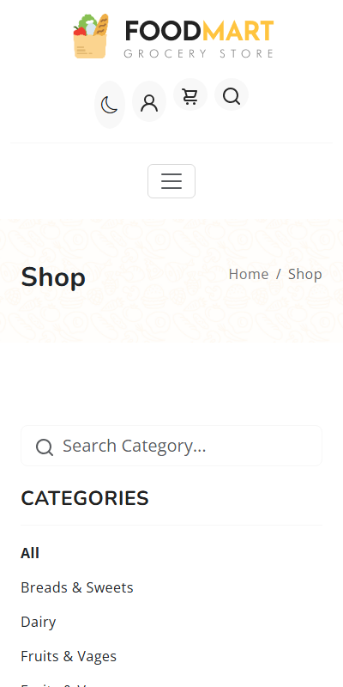
Mobile Layout (Grid stacked)

Exp - 3

Aim
form control and validation

Code (From FoodMart Project)
// File: account.php
<form action="actions/change_password.php" method="POST">
<div class="mb-3">
<label for="current_password" class="form-label">Current Password</label>
<input type="password" class="form-control" id="current_password" name="current_password" required>
</div>
<div class="mb-3">
<label for="new_password" class="form-label">New Password</label>
<input type="password" class="form-control" id="new_password" name="new_password" required>
</div>
<div class="d-grid gap-2">
<button type="submit" class="btn btn-danger">Update Password</button>
</div>
</form>
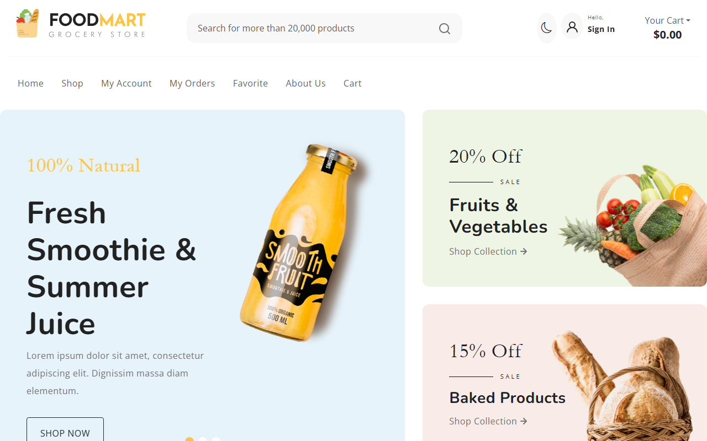
Login Form View

Validation Triggered

Exp - 4

Aim
simple DOM manipulation

Code (From FoodMart Project)
// File: js/cart.js
// Update Cart Badge dynamically
function updateCartBadge(count) {
$('#offcanvasCart .badge').text(count);
}
// jQuery manipulates the DOM elements to reflect the new count.

Initial State

DOM Manipulated (Item added to cart)

Exp - 5

Aim
form validation using string method and type conversion

Code (From FoodMart Project)
// File: js/auth.js
// Register Form Submission (AJAX JSON validation handling)
$('#registerForm').on('submit', function (e) {
e.preventDefault();
$.ajax({
type: 'POST',
url: 'actions/register.php',
data: $(this).serialize(),
dataType: 'json',
success: function (response) {
if (!response.success) {
alert(response.message);
}
}
});
});
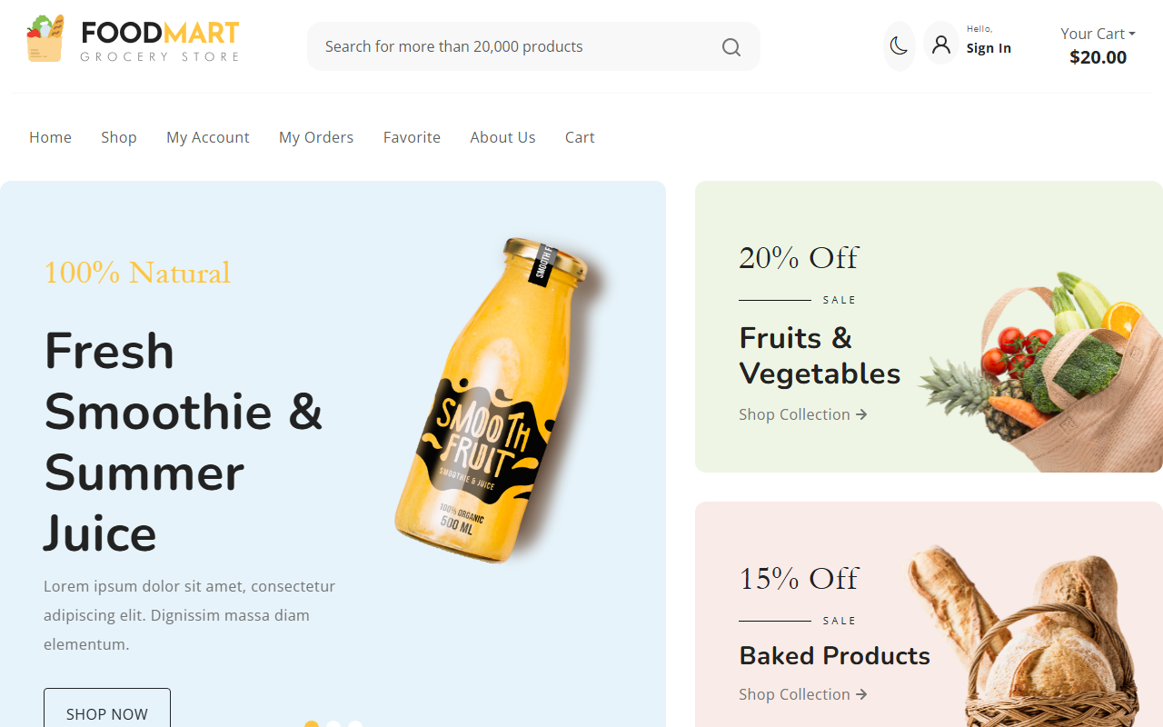
Registration Form

Exp - 6

Aim
demonstrate the functions and variable hoisting

Code (From FoodMart Project)
// File: js/cart.js
$(document).ready(function () {
// Hoisting in action - calling function before declaration
updateCartBadge(0);
function updateCartBadge(count) {
$('#offcanvasCart .badge').text(count);
}
});

Cart Icon initialized via Hoisted function

Exp - 7

Aim
jquery event listener and animation

Code (From FoodMart Project)
// File: js/cart.js
// jQuery event listener and icon animation
$(document).on('click', '.btn-add-to-cart', function (e) {
e.preventDefault();
var $btn = $(this);
var originalIcon = $btn.html();
$btn.html('<i class="bi bi-check-lg"></i>'); // UI feedback animation
setTimeout(function () {
$btn.html(originalIcon);
}, 1500);
});
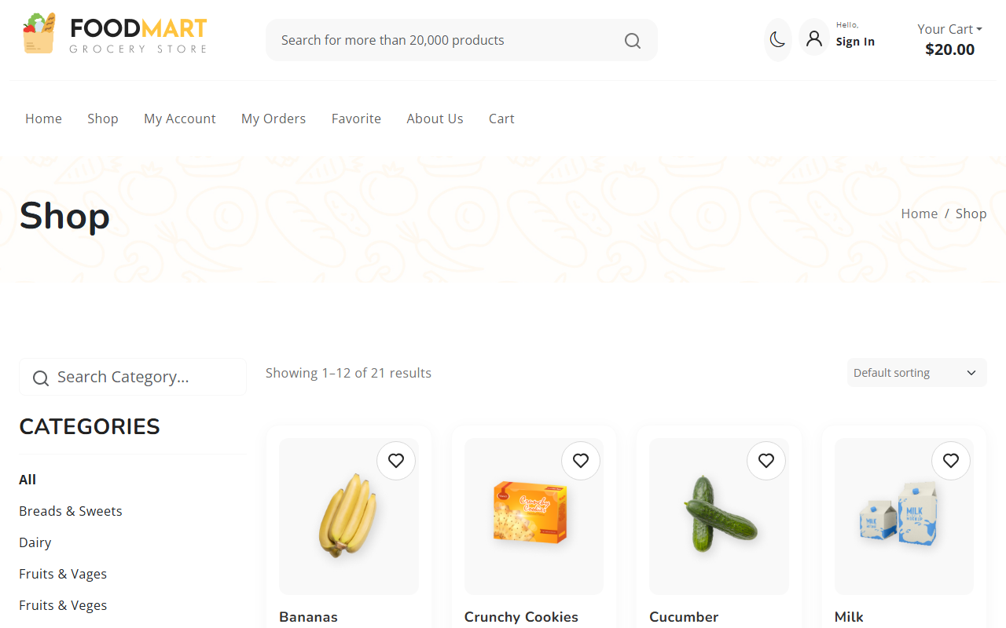
Animation triggered on click

Exp - 8

Aim
fetches data asynchronously using jquery

Code (From FoodMart Project)
// File: js/cart.js
$.ajax({
url: 'actions/cart_actions.php',
type: 'POST',
dataType: 'json',
data: { action: 'add', id: id, quantity: quantity },
success: function (response) {
if (response.success) {
updateCartBadge(response.cart_count);
}
}
});
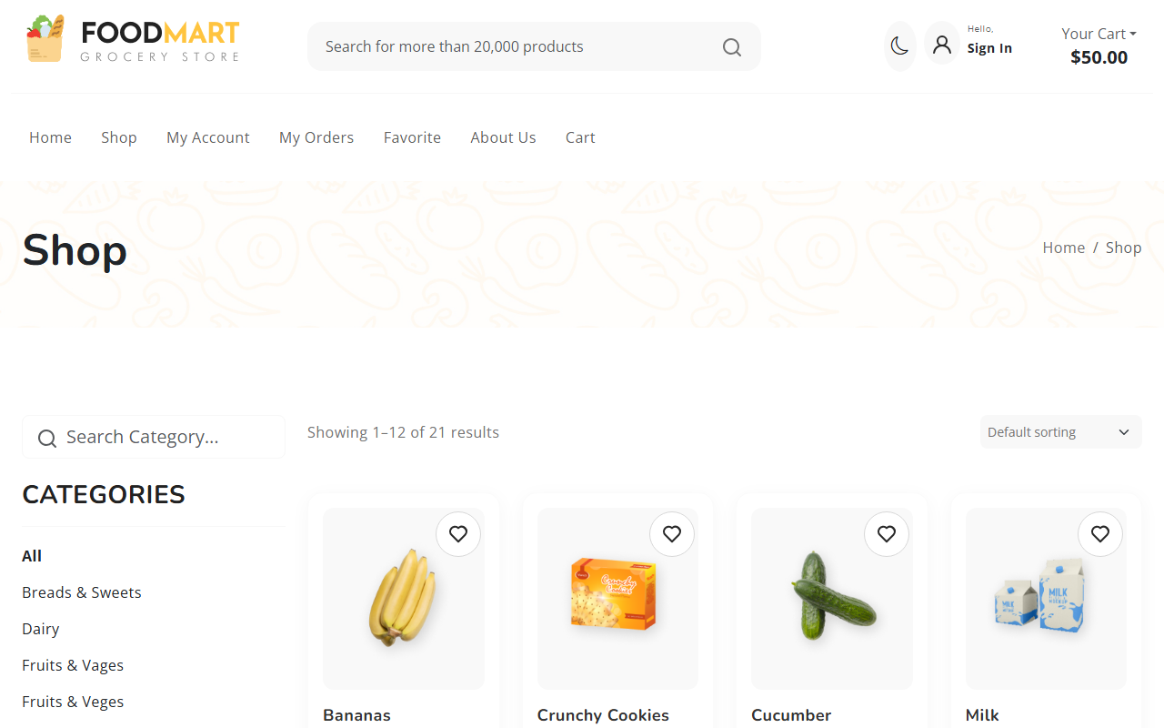
Sending Async Request
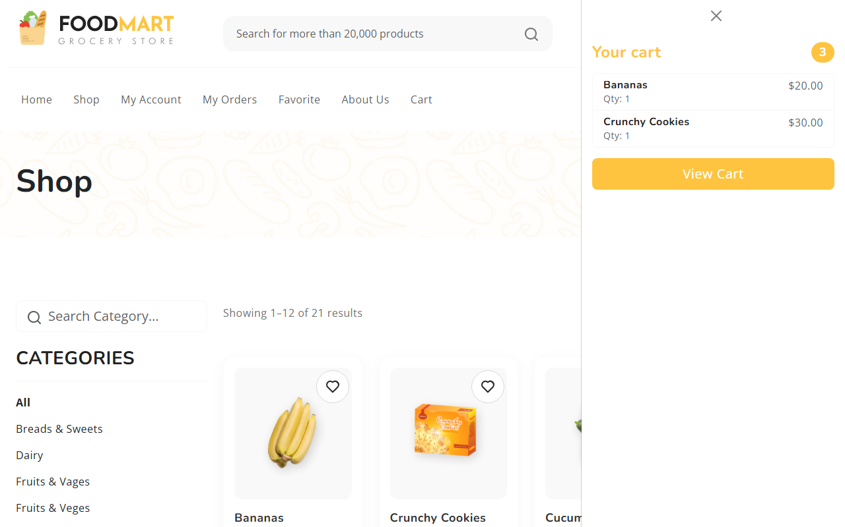
Async Result Displayed

Exp - 9

Aim
php scripts that perform sorting searching and merging

Code (From FoodMart Project)
// File: shop.php
$category_filter = isset($_GET['category']) ? $_GET['category'] : 'all';
$sql = "SELECT * FROM products";
if ($category_filter != 'all') {
$sql .= " WHERE category = ?";
$params[] = $category_filter;
}
$stmt = $conn->prepare($sql);
$stmt->execute();
$result = $stmt->get_result();
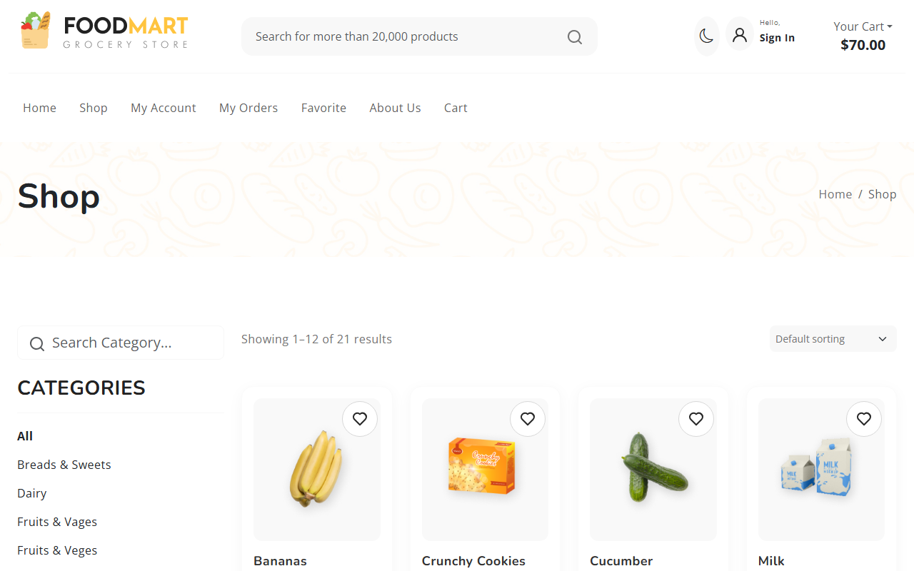
All Products
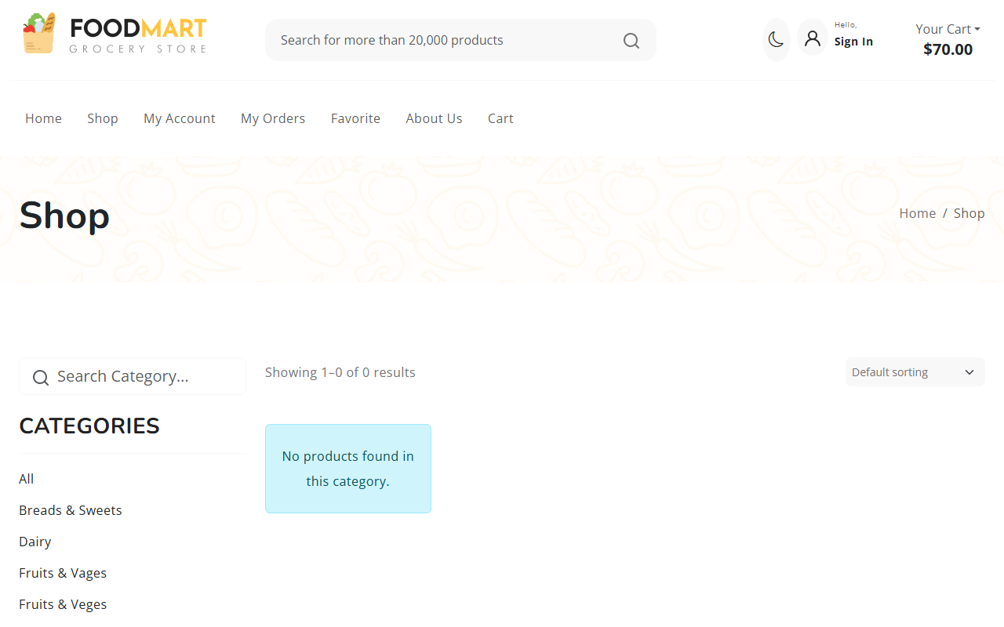
Filtered Products

Exp - 10

Aim
laravel based crud using route controller include the user friendly error manage and bootstrap styling (Mapped to raw PHP Cart CRUD)

Code (From FoodMart Project)
// File: cart.php & actions/cart_actions.php
// CREATE (Add) -> actions/cart_actions.php
$_SESSION['cart'][$id] = ['name' => $name, 'price' => $price, 'quantity' => $quantity];
// READ (Display) -> cart.php
<?php foreach ($_SESSION['cart'] as $id => $item): ?>
<td><?php echo htmlspecialchars($item['name']); ?></td>
<?php endforeach; ?>
// DELETE (Remove) -> actions/cart_actions.php
unset($_SESSION['cart'][$id]);
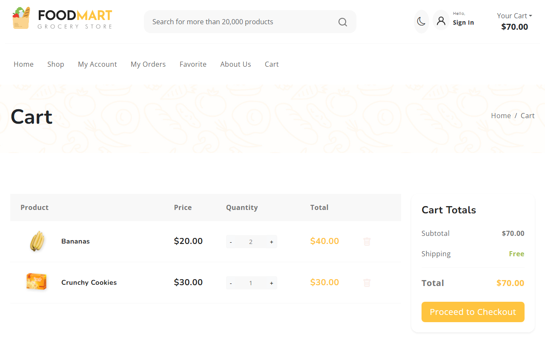
Empty Cart (Initial State)
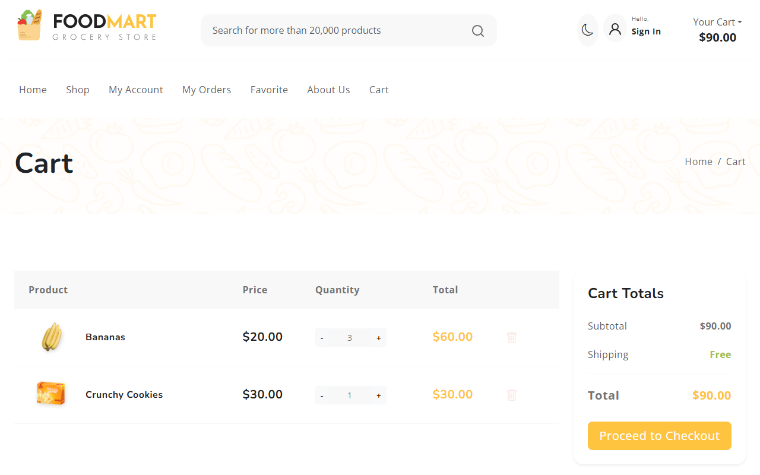
Cart with Items (Create/Read)

