Exp - 10

Aim
laravel based crud using route controller include the user friendly error manage and bootstrap styling (Mapped to raw PHP since FoodMart is raw PHP)

Output (Screenshot from FoodMart)
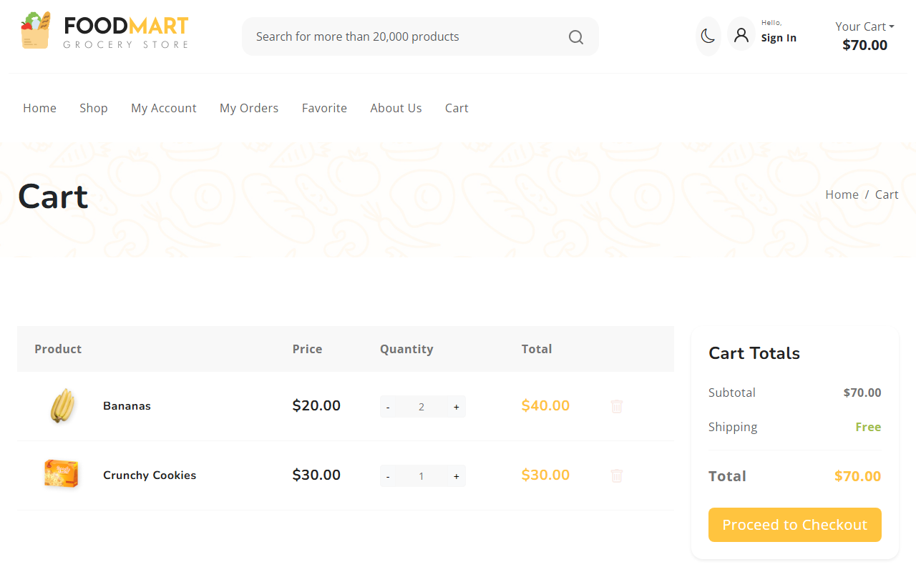

Code (From FoodMart Project)
// File: cart.php & cart_actions.php
// CREATE (Add to Cart)
if ($action == 'add') {
$_SESSION['cart'][$id] = [
'name' => $name,
'price' => $price,
'quantity' => $quantity,
'image' => $image
];
}
// READ (Display Cart in cart.php)
<?php foreach ($_SESSION['cart'] as $id => $item): ?>
<tr>
<td><?php echo htmlspecialchars($item['name']); ?></td>
<td>$<?php echo number_format($item['price'], 2); ?></td>
</tr>
<?php endforeach; ?>
// DELETE (Remove from Cart)
if ($action == 'remove') {
if (isset($_SESSION['cart'][$id])) {
unset($_SESSION['cart'][$id]);
}
}

