Exp - 2

Aim
multicolumn layout using bootstrap grid system responsive breakpoint for mobile, tablet and the desktop

Output (Screenshot from FoodMart)
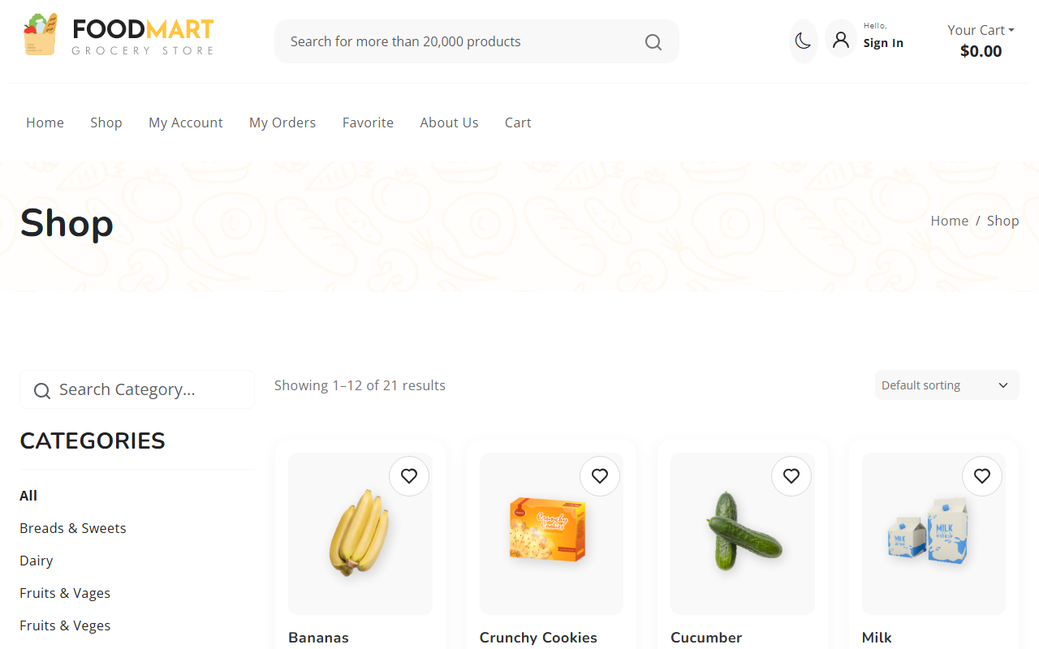

Code (From FoodMart Project)
// File: shop.php
<div class="product-grid row row-cols-1 row-cols-sm-2 row-cols-md-3 row-cols-lg-3 row-cols-xl-4">
<?php if ($result->num_rows > 0): ?>
<?php while($row = $result->fetch_assoc()): ?>
<div class="col">
<div class="product-item">
<!-- Product Display -->
<img src="<?php echo htmlspecialchars($row['image']); ?>">
<h3><?php echo htmlspecialchars($row['title']); ?></h3>
<span class="price"><?php echo htmlspecialchars($row['price']); ?></span>
</div>
</div>
<?php endwhile; ?>
<?php endif; ?>
</div>

