Exp - 5

Aim
form validation using string method and type conversion

Output (Screenshot from FoodMart)
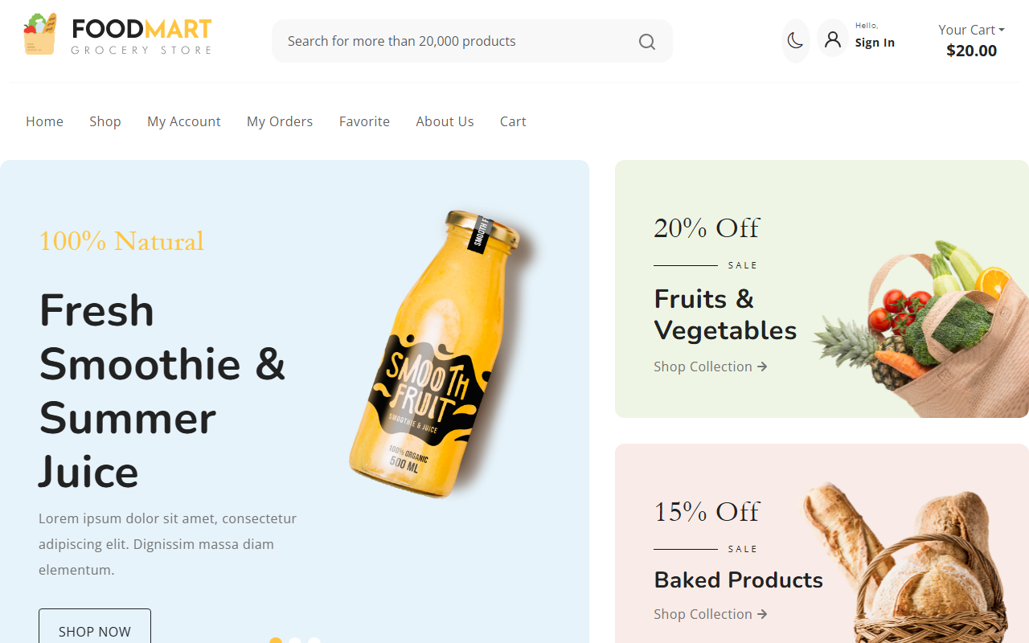

Code (From FoodMart Project)
// File: js/auth.js
// Register Form Submission
$('#registerForm').on('submit', function (e) {
e.preventDefault();
$.ajax({
type: 'POST',
url: 'actions/register.php',
data: $(this).serialize(),
dataType: 'json',
success: function (response) {
if (response.success) {
alert('Registration successful! Please login.');
$('#pills-login-tab').tab('show');
} else {
alert(response.message);
}
}
});
});

