Exp - 6

Aim
demonstrate the functions and variable hoisting

Output (Screenshot from FoodMart)
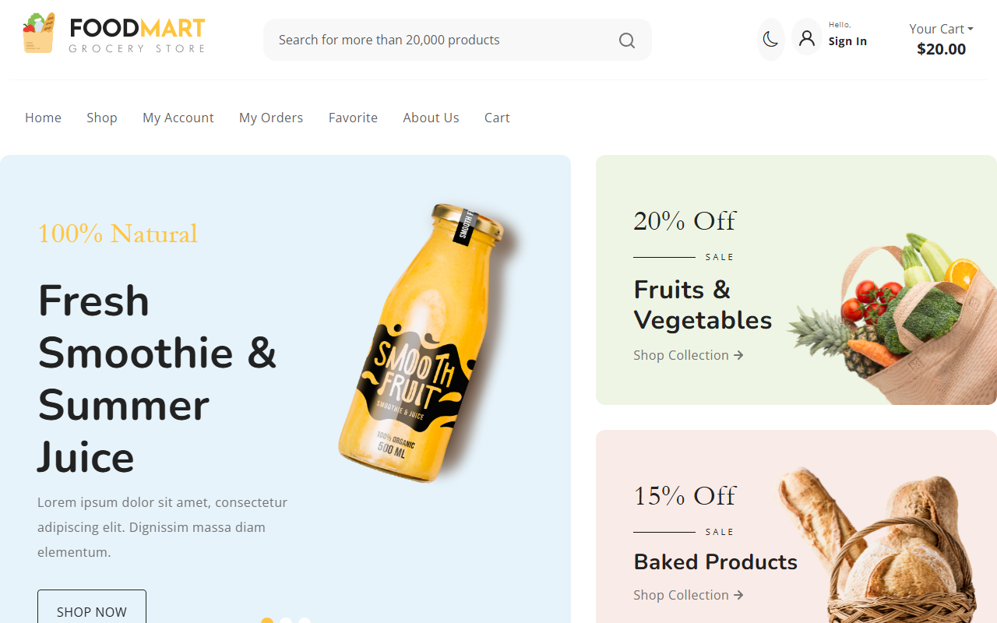

Code (From FoodMart Project)
// File: js/cart.js
$(document).ready(function () {
// Calling function before it's defined (Hoisting)
updateCartBadge(0);
// Add to Cart Click Handler
$(document).on('click', '.btn-add-to-cart', function (e) {
// ...
updateCartBadge(response.cart_count);
});
// Update Cart Badge Function Declaration
function updateCartBadge(count) {
$('#offcanvasCart .badge').text(count);
}
});

