Exp - 8

Aim
fetches data asynchronously using jquery

Output (Screenshot from FoodMart)
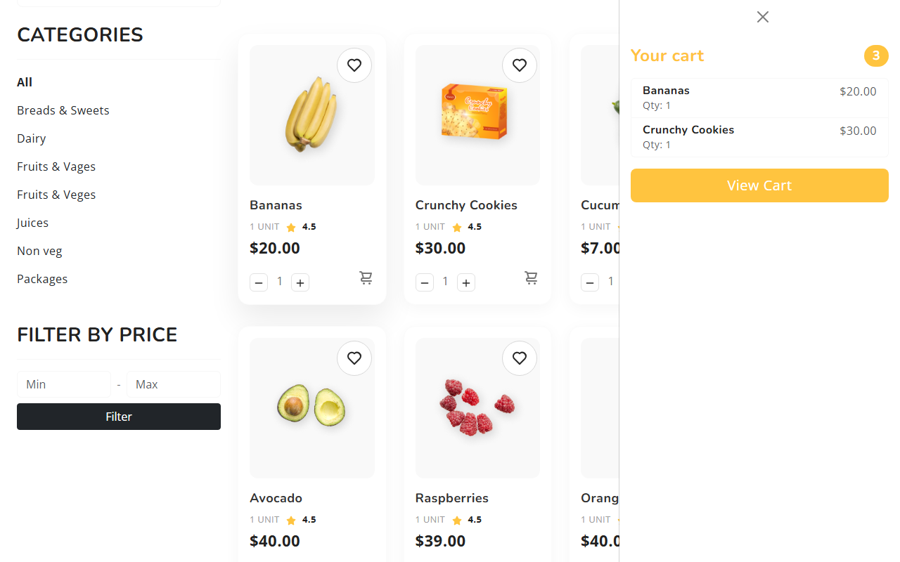

Code (From FoodMart Project)
// File: js/cart.js
$.ajax({
url: 'actions/cart_actions.php',
type: 'POST',
dataType: 'json',
data: {
action: 'add',
id: id,
name: name,
price: price,
image: image,
quantity: quantity
},
success: function (response) {
if (response.success) {
updateCartBadge(response.cart_count);
// Optional: Show toast
}
}
});

