Exp - 9

Aim
php scripts that perform sorting searching and merging

Output (Screenshot from FoodMart)
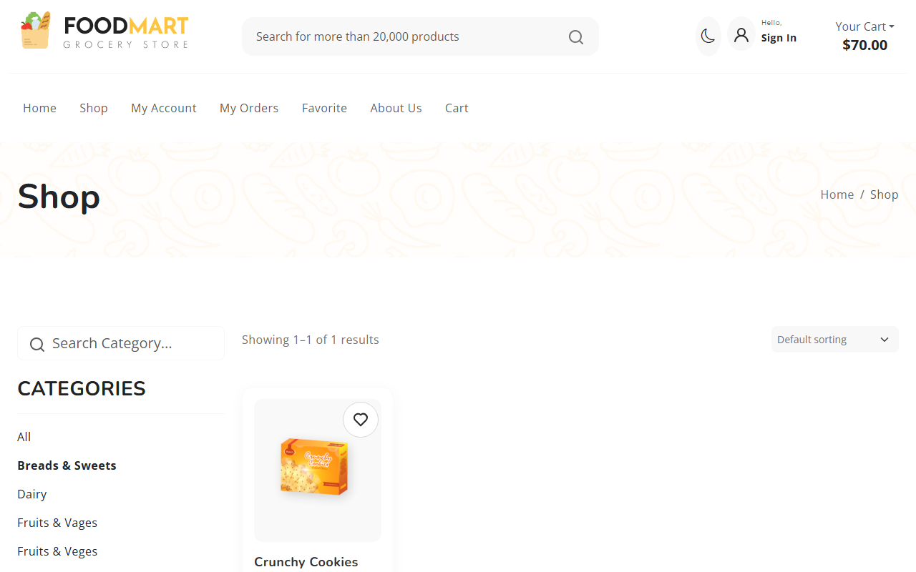

Code (From FoodMart Project)
// File: shop.php
$limit = 12; // Products per page
$page = isset($_GET['page']) ? (int)$_GET['page'] : 1;
$offset = ($page - 1) * $limit;
$category_filter = isset($_GET['category']) ? $_GET['category'] : 'all';
// Build Query for Products
$sql = "SELECT * FROM products";
$params = [];
$types = "";
if ($category_filter != 'all') {
$sql .= " WHERE category = ?";
$params[] = $category_filter;
$types .= "s";
}
$sql .= " LIMIT ? OFFSET ?";
$params[] = $limit;
$params[] = $offset;
$types .= "ii";
$stmt = $conn->prepare($sql);
if (!empty($params)) {
$stmt->bind_param($types, ...$params);
}
$stmt->execute();
$result = $stmt->get_result();

