FoodMart Code Experiments

Exp - 2

Aim
multicolumn layout using bootstrap grid system responsive breakpoint for mobile, tablet and the desktop

Output (Screenshot from FoodMart)
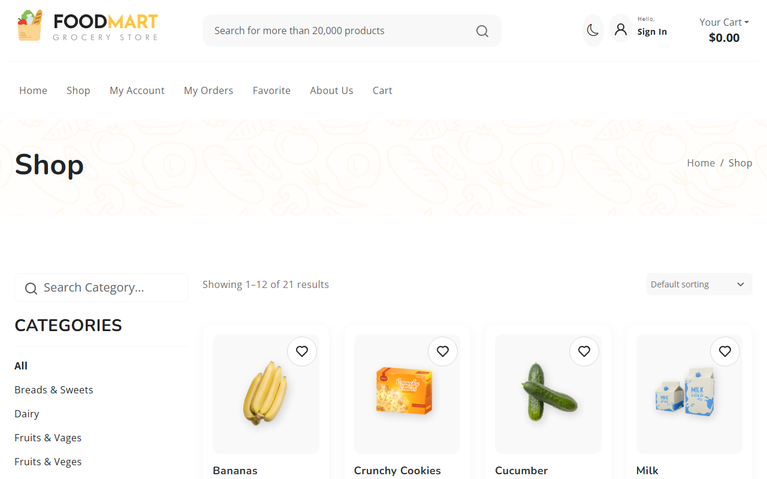

Code (From FoodMart Project)
// File: shop.php
<div class="product-grid row row-cols-1 row-cols-sm-2 row-cols-md-3 row-cols-lg-3 row-cols-xl-4">
<?php if ($result->num_rows > 0): ?>
<?php while($row = $result->fetch_assoc()): ?>
<div class="col">
<div class="product-item">
<!-- Product Display -->
<img src="<?php echo htmlspecialchars($row['image']); ?>">
<h3><?php echo htmlspecialchars($row['title']); ?></h3>
<span class="price"><?php echo htmlspecialchars($row['price']); ?></span>
</div>
</div>
<?php endwhile; ?>
<?php endif; ?>
</div>

Exp - 3

Aim
form control and validation

Output (Screenshot from FoodMart)
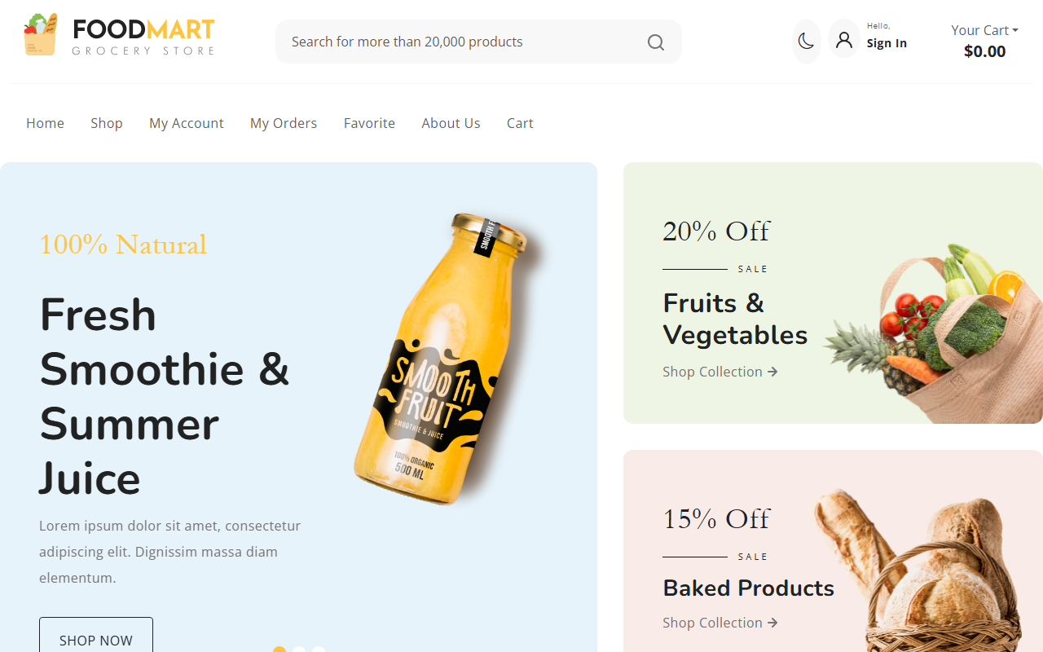

Code (From FoodMart Project)
// File: account.php
<form action="actions/change_password.php" method="POST">
<div class="mb-3">
<label for="current_password" class="form-label">Current Password</label>
<input type="password" class="form-control" id="current_password" name="current_password" required>
</div>
<div class="mb-3">
<label for="new_password" class="form-label">New Password</label>
<input type="password" class="form-control" id="new_password" name="new_password" required>
</div>
<div class="mb-3">
<label for="confirm_password" class="form-label">Confirm New Password</label>
<input type="password" class="form-control" id="confirm_password" name="confirm_password" required>
</div>
<div class="d-grid gap-2">
<button type="submit" class="btn btn-danger">Update Password</button>
</div>
</form>

Exp - 4

Aim
simple DOM manipulation

Output (Screenshot from FoodMart)
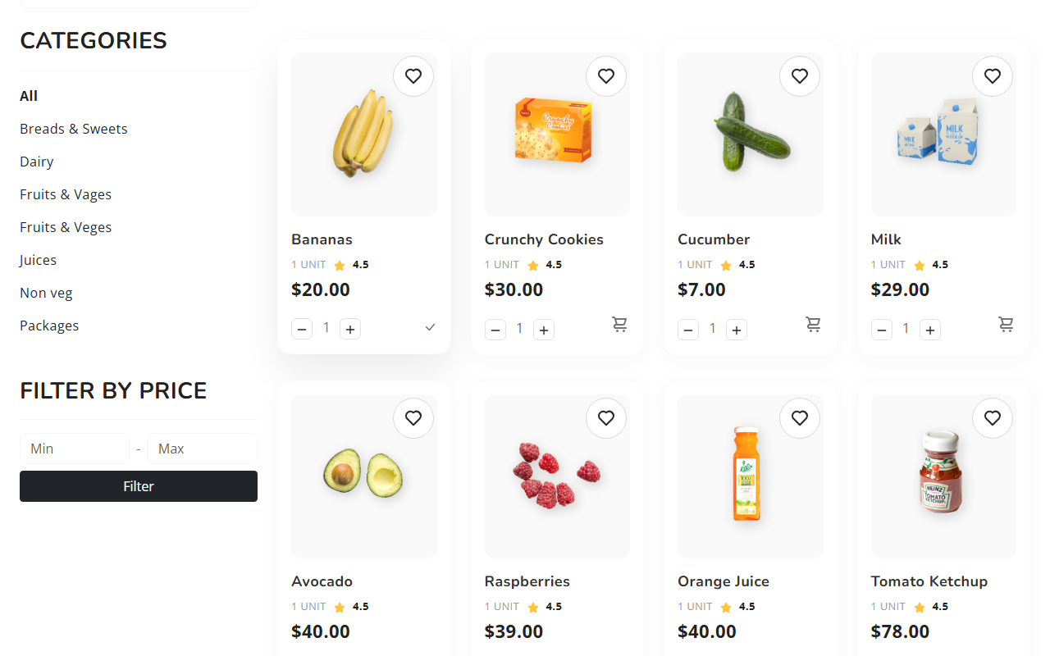

Code (From FoodMart Project)
// File: js/cart.js
// Update Cart Badge
function updateCartBadge(count) {
// Offcanvas badge
$('#offcanvasCart .badge').text(count);
// Header badge (if any, usually same as offcanvas trigger)
}

Exp - 5

Aim
form validation using string method and type conversion

Output (Screenshot from FoodMart)
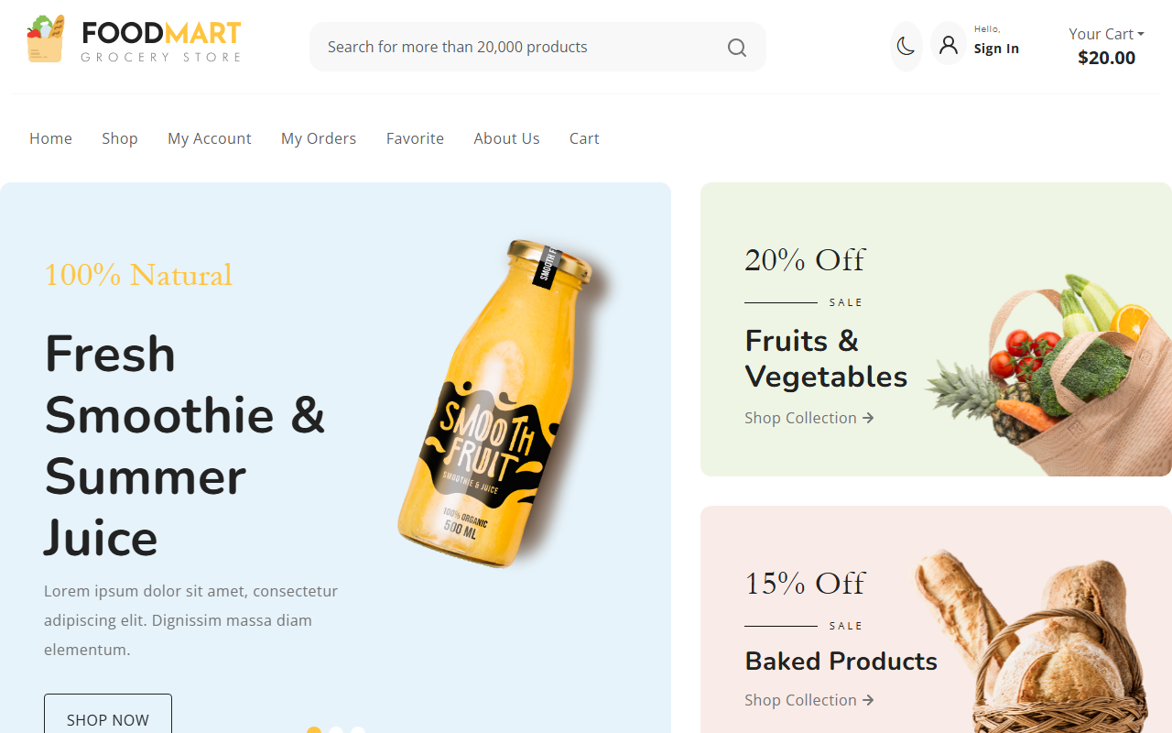

Code (From FoodMart Project)
// File: js/auth.js
// Register Form Submission
$('#registerForm').on('submit', function (e) {
e.preventDefault();
$.ajax({
type: 'POST',
url: 'actions/register.php',
data: $(this).serialize(),
dataType: 'json',
success: function (response) {
if (response.success) {
alert('Registration successful! Please login.');
$('#pills-login-tab').tab('show');
} else {
alert(response.message);
}
}
});
});

Exp - 6

Aim
demonstrate the functions and variable hoisting

Output (Screenshot from FoodMart)


Code (From FoodMart Project)
// File: js/cart.js
$(document).ready(function () {
// Calling function before it's defined (Hoisting)
updateCartBadge(0);
// Add to Cart Click Handler
$(document).on('click', '.btn-add-to-cart', function (e) {
// ...
updateCartBadge(response.cart_count);
});
// Update Cart Badge Function Declaration
function updateCartBadge(count) {
$('#offcanvasCart .badge').text(count);
}
});

Exp - 7

Aim
jquery event listener and animation

Output (Screenshot from FoodMart)
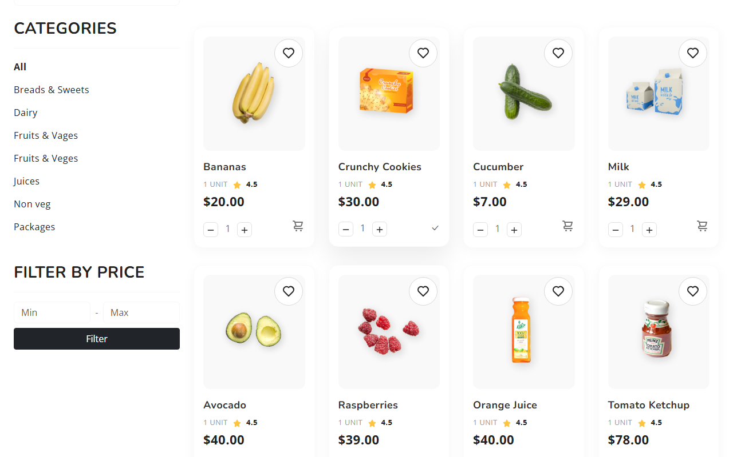

Code (From FoodMart Project)
// File: js/cart.js
// Add to Cart Click Handler
$(document).on('click', '.btn-add-to-cart', function (e) {
e.preventDefault();
var $btn = $(this);
// Animation feedback
var originalIcon = $btn.html();
$btn.html('<i class="bi bi-check-lg"></i>');
// ... AJAX Call ...
setTimeout(function () {
$btn.html(originalIcon);
}, 1500);
});

Exp - 8

Aim
fetches data asynchronously using jquery

Output (Screenshot from FoodMart)
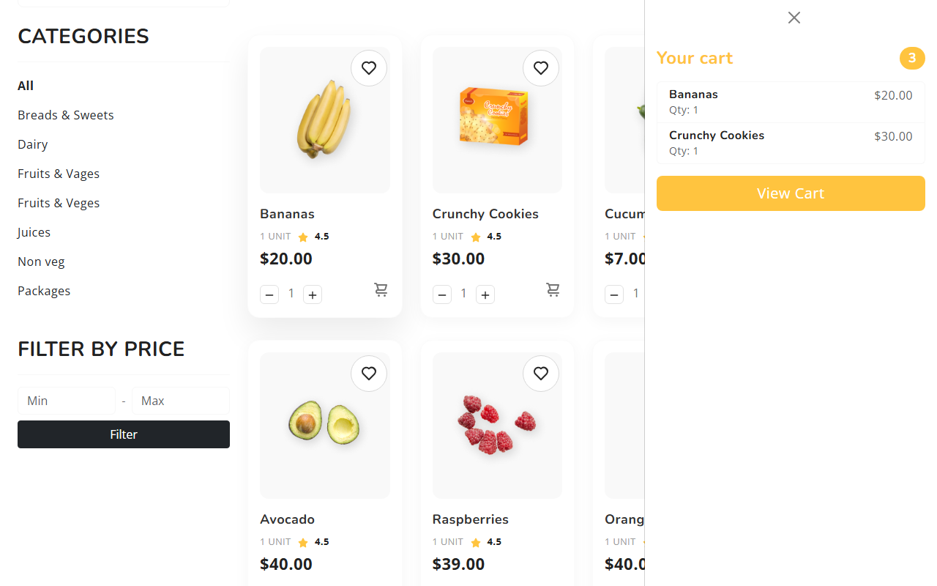

Code (From FoodMart Project)
// File: js/cart.js
$.ajax({
url: 'actions/cart_actions.php',
type: 'POST',
dataType: 'json',
data: {
action: 'add',
id: id,
name: name,
price: price,
image: image,
quantity: quantity
},
success: function (response) {
if (response.success) {
updateCartBadge(response.cart_count);
// Optional: Show toast
}
}
});

Exp - 9

Aim
php scripts that perform sorting searching and merging

Output (Screenshot from FoodMart)
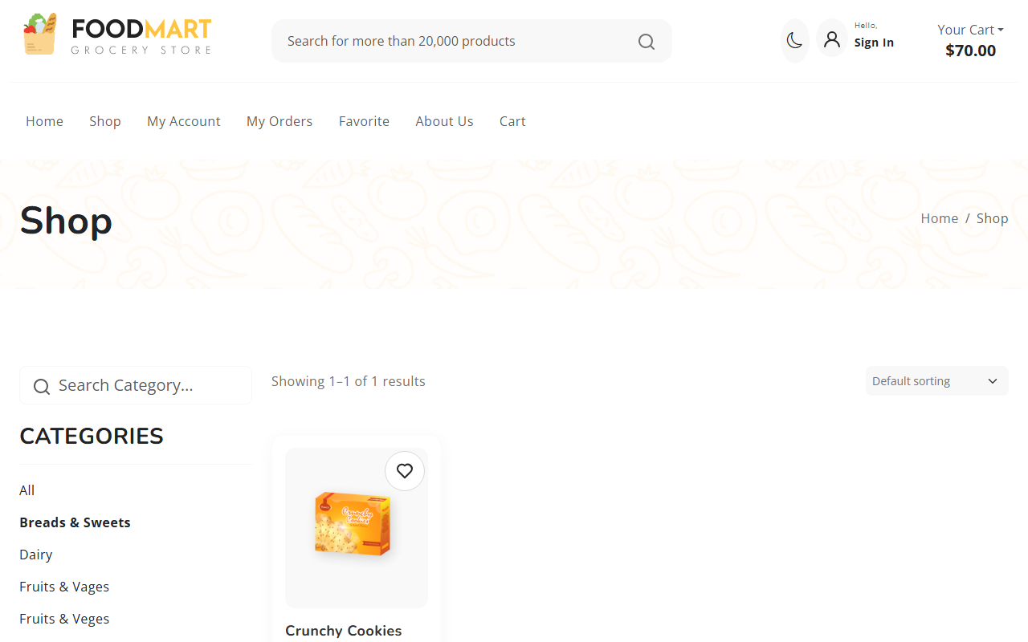

Code (From FoodMart Project)
// File: shop.php
$limit = 12; // Products per page
$page = isset($_GET['page']) ? (int)$_GET['page'] : 1;
$offset = ($page - 1) * $limit;
$category_filter = isset($_GET['category']) ? $_GET['category'] : 'all';
// Build Query for Products
$sql = "SELECT * FROM products";
$params = [];
$types = "";
if ($category_filter != 'all') {
$sql .= " WHERE category = ?";
$params[] = $category_filter;
$types .= "s";
}
$sql .= " LIMIT ? OFFSET ?";
$params[] = $limit;
$params[] = $offset;
$types .= "ii";
$stmt = $conn->prepare($sql);
if (!empty($params)) {
$stmt->bind_param($types, ...$params);
}
$stmt->execute();
$result = $stmt->get_result();

Exp - 10

Aim
laravel based crud using route controller include the user friendly error manage and bootstrap styling (Mapped to raw PHP since FoodMart is raw PHP)

Output (Screenshot from FoodMart)
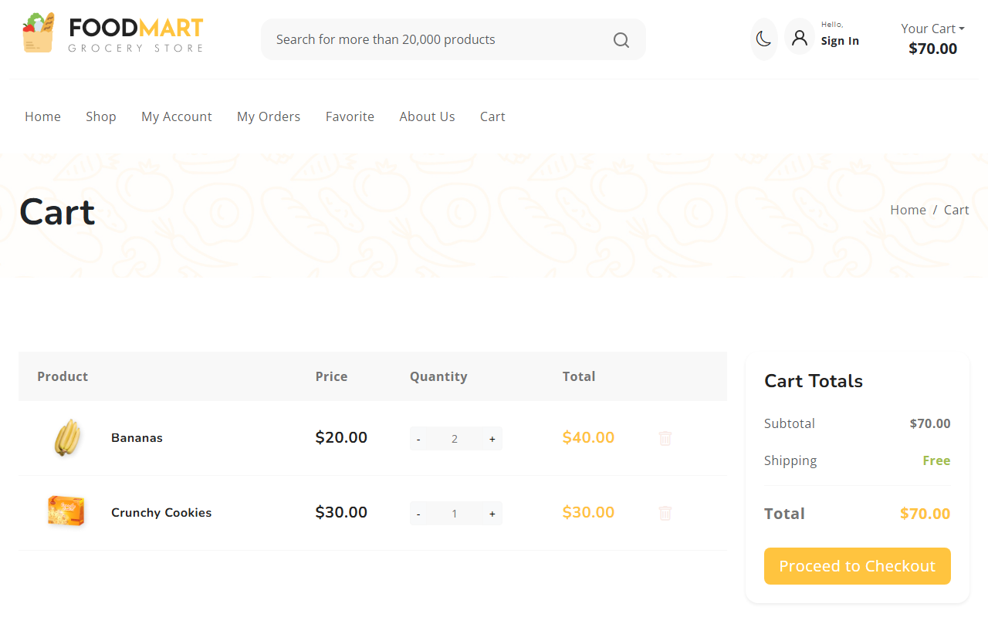

Code (From FoodMart Project)
// File: cart.php & cart_actions.php
// CREATE (Add to Cart)
if ($action == 'add') {
$_SESSION['cart'][$id] = [
'name' => $name,
'price' => $price,
'quantity' => $quantity,
'image' => $image
];
}
// READ (Display Cart in cart.php)
<?php foreach ($_SESSION['cart'] as $id => $item): ?>
<tr>
<td><?php echo htmlspecialchars($item['name']); ?></td>
<td>$<?php echo number_format($item['price'], 2); ?></td>
</tr>
<?php endforeach; ?>
// DELETE (Remove from Cart)
if ($action == 'remove') {
if (isset($_SESSION['cart'][$id])) {
unset($_SESSION['cart'][$id]);
}
}

