**PART - A:**

**Question-1:**

**How many total combinations are possible? Show the math along with the code!**

**Answer**:

To calculate the total number of combinations possible when rolling both dice, we multiply the number of sides of Die A by the number of sides of Die B. This is achieved by taking the size of the list representing Die A and multiplying it by the size of the list representing Die B.

Hence, the total number of combination: 6 * 6 = 36

**Question-2:**

**Calculate and display the distribution of all possible combinations that can be obtained when rolling both Die A and Die B together. Show the math along with the code!**

**Answer:**

* **Math Behind Generating Combinations:**

1. To generate all possible combination pairs, we perform a Cartesian product between Die A and Die B.
2. For example, if Die A has values [1, 2, 3] and Die B has values [4, 5], the pairs generated will be (1, 4), (1, 5), (2, 4), (2, 5), (3, 4), and (3, 5).

* **Math behind Calculating Sums:**

1. For each combination of values (a, b) from Die A and Die B, we compute their sum as a + b.
2. We store these sums in a 2D matrix where each cell (i, j) contains the sum of the ith value from Die A and the jth value from Die B.

**Question -3:**

**Calculate the Probability of all Possible Sums occurring among the number of combinations from (2).**

**Answer:**

* Iterate through all combination pairs, summing the values and incrementing the count of that sum in an array.
* Calculate the total number of combinations as the product of the sizes of Die A and Die B.
* For each sum, calculate its probability by dividing its count by the total number of combinations, then simplify the fraction using the greatest common divisor (gcd) between the count and the total number of combinations.

**OUTPUT:**

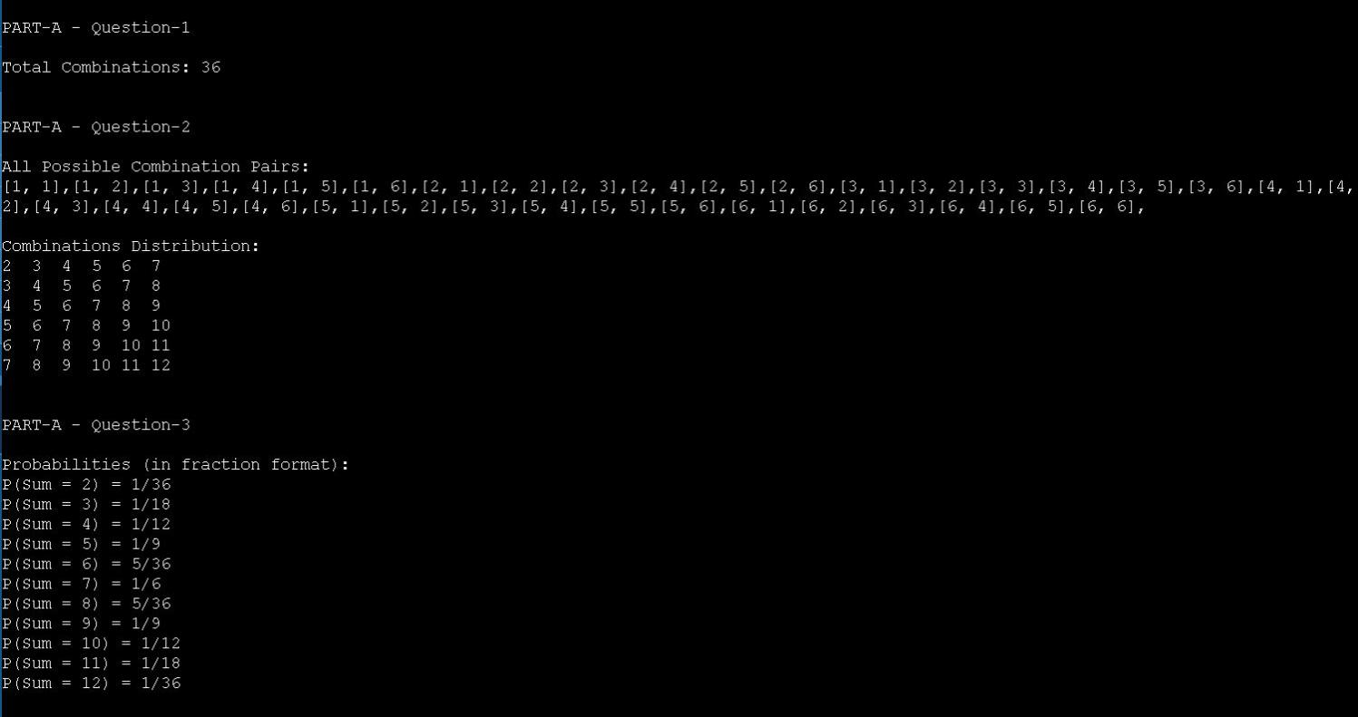

**PART-B**

**Question:**

**Now comes the real challenge. You were happily spending a lazy afternoon playing**

**your board game with your dice when suddenly the mischievous Norse God Loki ( You**

**love Thor too much & Loki didn’t like that much ) appeared.**

**Loki dooms your dice for his fun removing all the “Spots” off the dice.**

**No problem! You have the tools to re-attach the “Spots” back on the Dice.**

**However, Loki has doomed your dice with the following conditions:**

**● Die A cannot have more than 4 Spots on a face.**

**● Die A may have multiple faces with the same number of spots.**

**● Die B can have as many spots on a face as necessary i.e. even more than 6.**

**But in order to play your game, the probability of obtaining the Sums must remain the**

**same!**

**So if you could only roll P(Sum = 2) = 1/X, the new dice must have the spots reattached**

**such that those probabilities are not changed.**

**Input:**

**● Die_A = [1, 2, 3, 4, 5, 6] & Die B = Die_A = [1, 2, 3, 4, 5, 6]**

**Output:**

**● A Transform Function undoom_dice that takes (Die_A, Die_B) as input &**

**outputs New_Die_A = [?, ?, ?, ?, ?, ?],New_Die_B = [?, ?,**

**?, ?, ?, ?] where,**

**● No New_Die A[x] > 4**

**Answer:**

**LOGIC:**

**Generating Combinations:**

Generate all possible combinations for Die A with the condition that no face has more than 4 spots.

Generate all possible combinations for Die B without any restrictions on the number of spots per face.

**Calculate Probabilities:**

Calculate the probabilities of all possible sums for the original Dice A and Dice B combination.

This is done using the probSum method, which counts the occurrences of each sum and divides by the total number of combinations (36 in this case).

**Find New Combinations:**

Iterate through all combinations of Die A and Die B generated in step 1.

For each combination pair, calculate the probabilities of all possible sums.

If the calculated probabilities match the original probabilities, print out the combination pair as the new Dice A and Dice B.

**MATH:**

**Generating Combinations:**

For Die A, we have 4 possible spots (1, 2, 3, 4) on each face, and we need to choose 6 faces. This results in 4^6 combinations.

For Die B, there are no restrictions on the number of spots per face, so we have 8 possible spots (1, 2, 3, 4, 5, 6, 7, 8) on each face, and we also need to choose 6 faces. This results in 8^6 combinations.

**Calculate Probabilities:**

The probability of each sum is calculated by counting the occurrences of each sum and dividing by the total number of combinations.

For example, if the sum 2 occurs 4 times out of 36 combinations, its probability is 4/36.

**Find New Combinations:**

Iterate through all combinations of Die A and Die B and calculate the probabilities for each combination.

If any combination has probabilities matching the original probabilities, it is considered a valid solution.

**OUTPUT:**

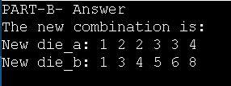

**PART-B- Verification:**

Change the input list in Part-A as the retrieved output list from Part-B code and compare the ouptut, if both the probabilities are equal then the code and output in Part-B is valid.

**OUTPUT:**

