**PREETHA S S**

**22ISR035**

minikube start

Starts a Minikube cluster.

Creates a single-node Kubernetes cluster in a VM or container.

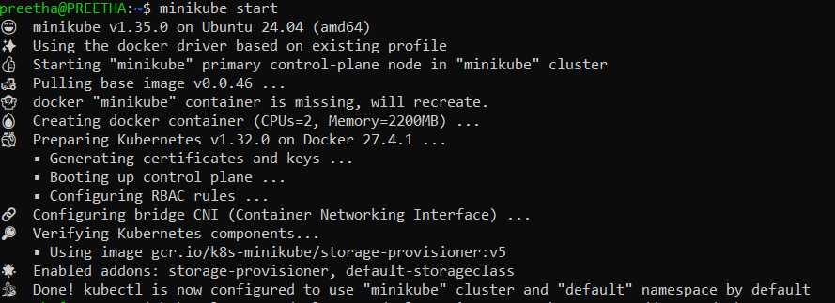

|  |  |
| --- | --- |
| **Command** | **Description** |
| kubectl expose deployment <name> --type=NodePort -port=80 | Creates a service to expose a deployment. |
| kubectl get services | Lists all services. |
| kubectl describe service <service-name> | Shows details about a service. |

The kubectl expose command is used to create a **Kubernetes Service** for an existing resource (Pod,

Deployment, ReplicaSet, etc.), allowing network access.

minikube service <service-name> Opens a service in a browser. Finds the service and launches it.

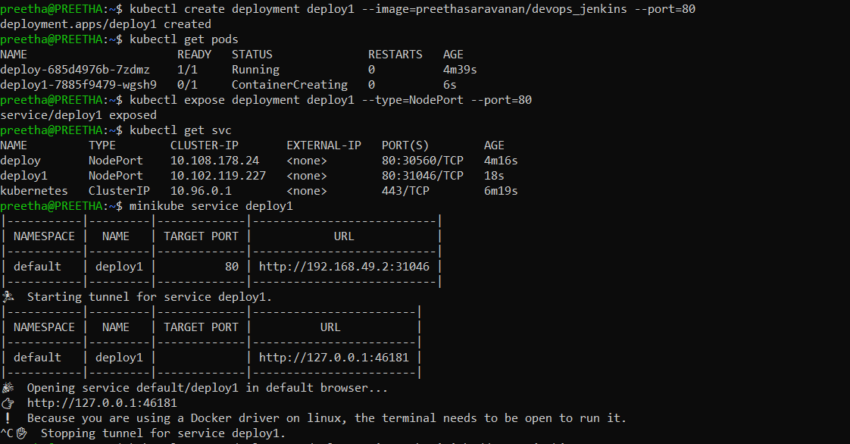

**Output in Chrome :**

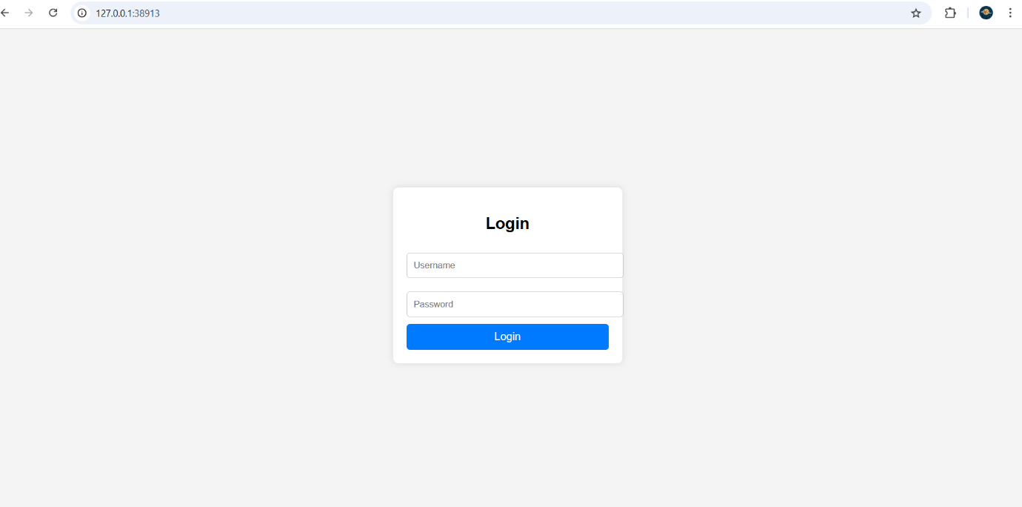

**Output in Jenkins :**

