**Lab 01**

**Build a web application on Azure platform as a service offering**

**Exercise 1:** Build a backend API by using Azure Storage and the Web Apps feature of Azure App Service

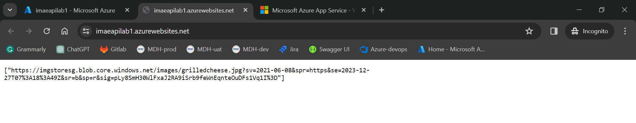

**Exercise 2:** Build a front-end web application by using Azure Web Apps

