**Lab 02**

**Implement task processing logic by using Azure Functions**

**Exercise 3:** Create a function that's triggered by an HTTP request

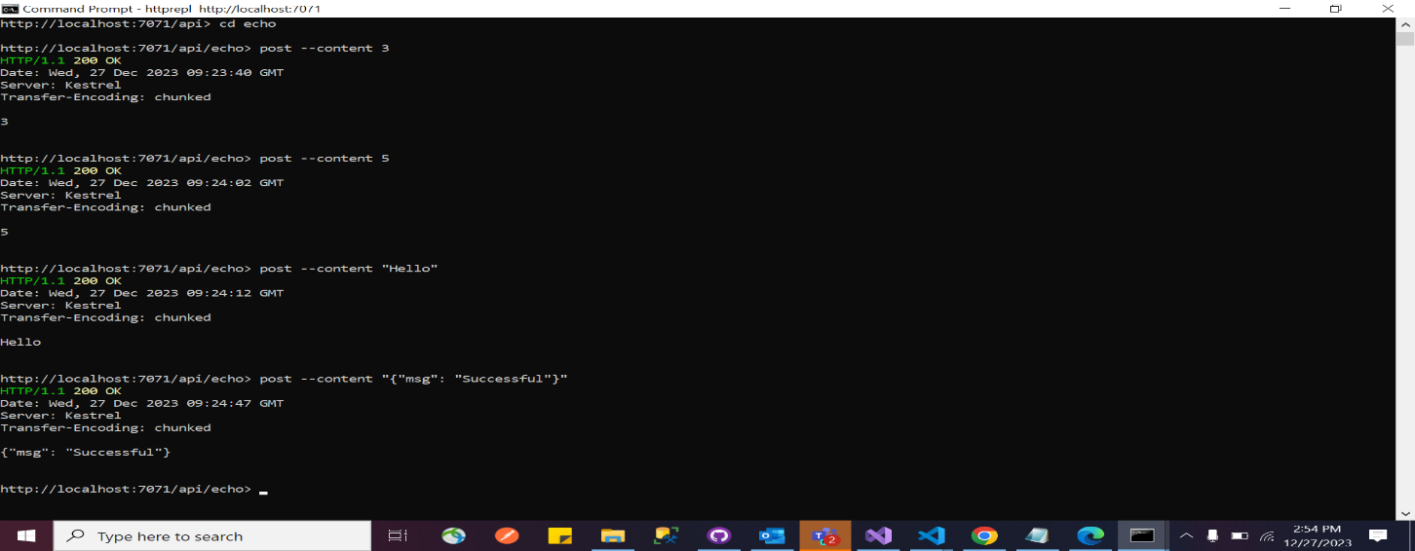

**Exercise 5:** Create a function that integrates with other services

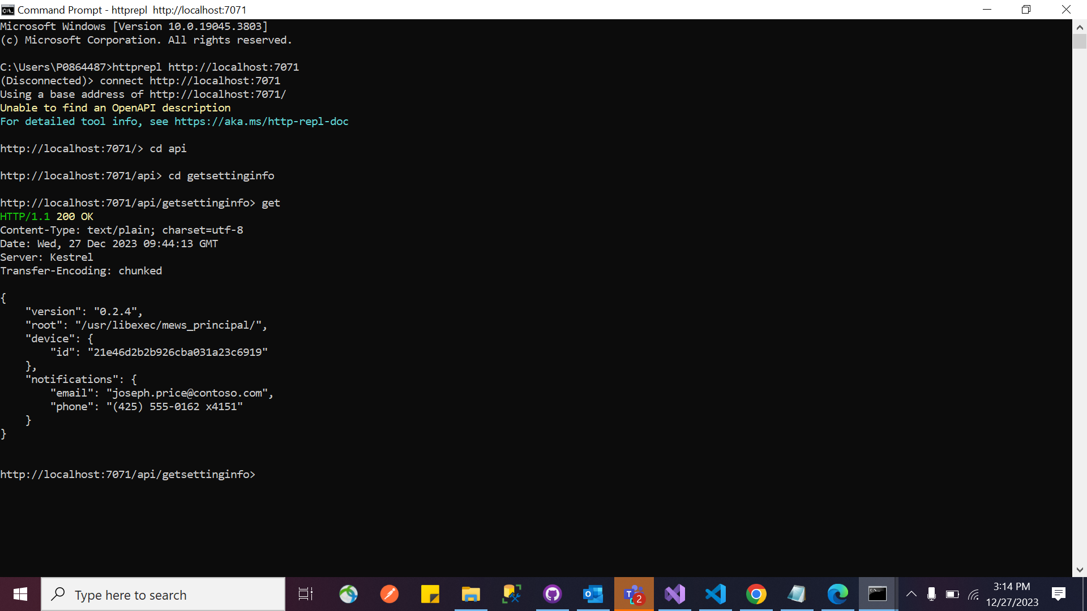

**Exercise 6:** Deploy a local function project to an Azure Functions app

