**Lab 03**

**Upload and analyze a file with Azure Functions and Blob Storage**

**1.** Deploy the code to Azure Functions

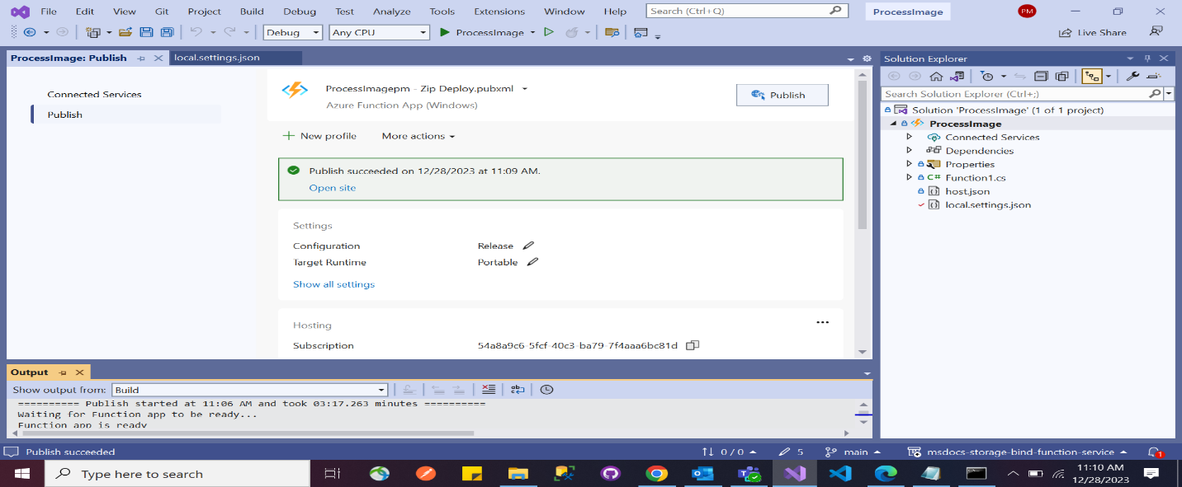

**2.** Upload an image to Blob Storage

