**Lab 06**

**Authenticate by using OpenID Connect, MSAL, and .NET SDKs**

**Exercise 1:** Configure a single-tenant Entra ID environment

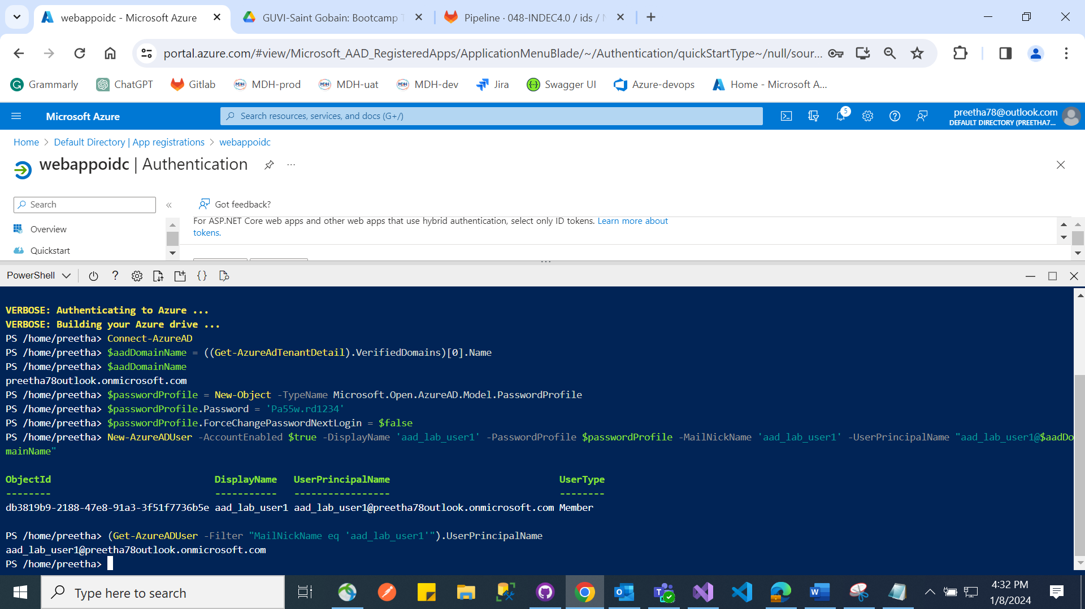

**Exercise 2:** Create a single-tenant ASP.NET web app

