**Lab 10**

**Asynchronously process messages by using Azure Service Bus Queues**

**Exercise 1:** Create Azure resources

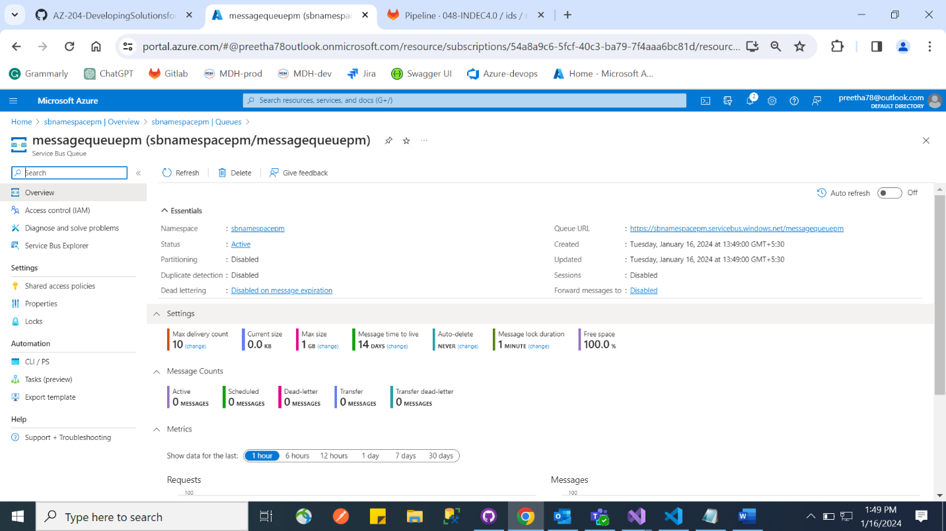

**Exercise 2:** Create a .NET Core project to publish messages to a Service Bus queue

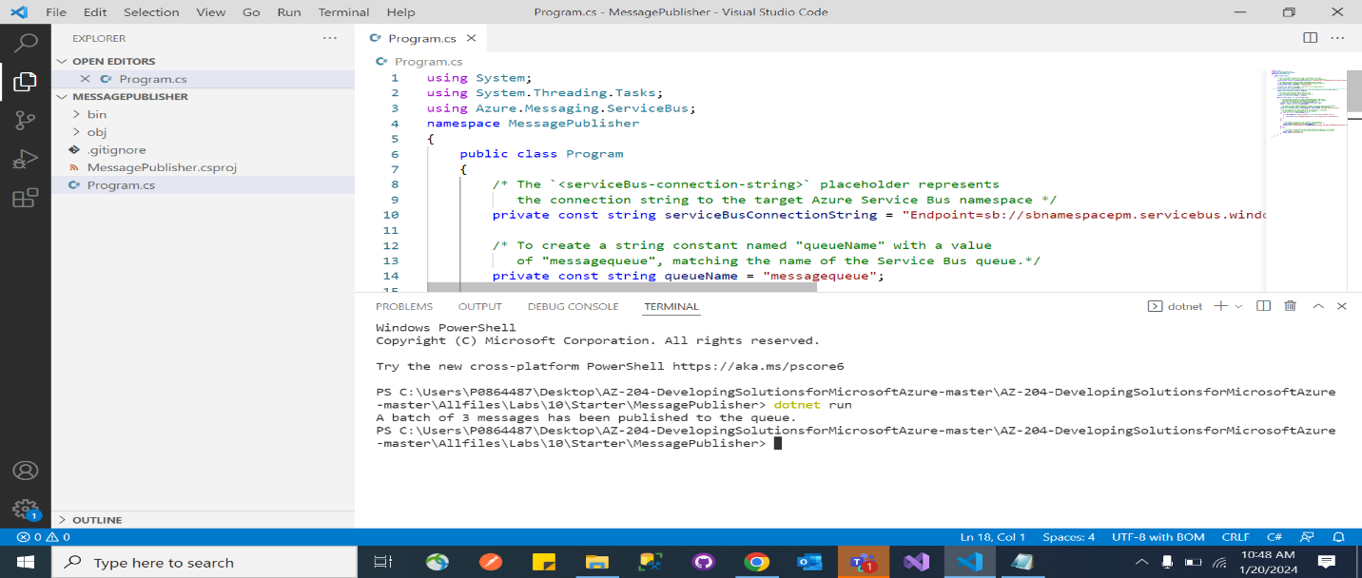

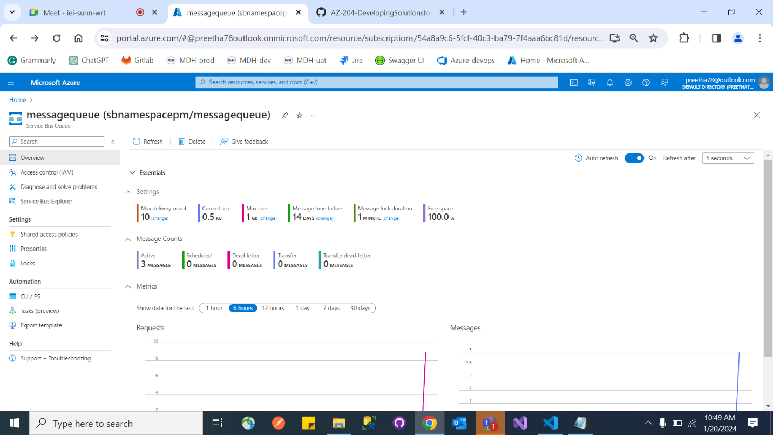

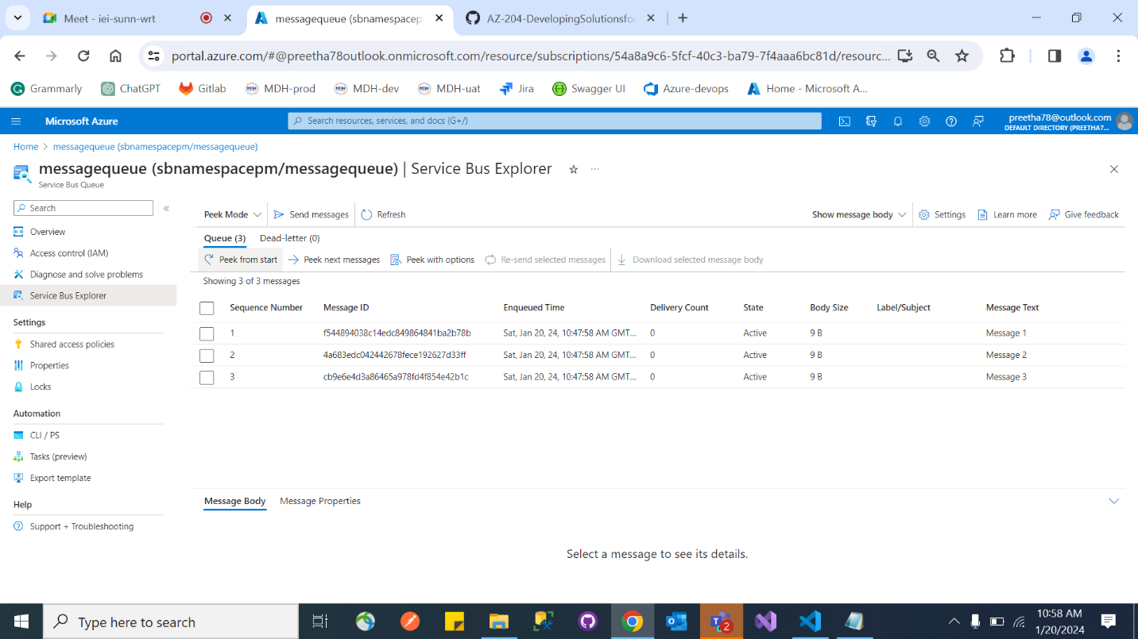

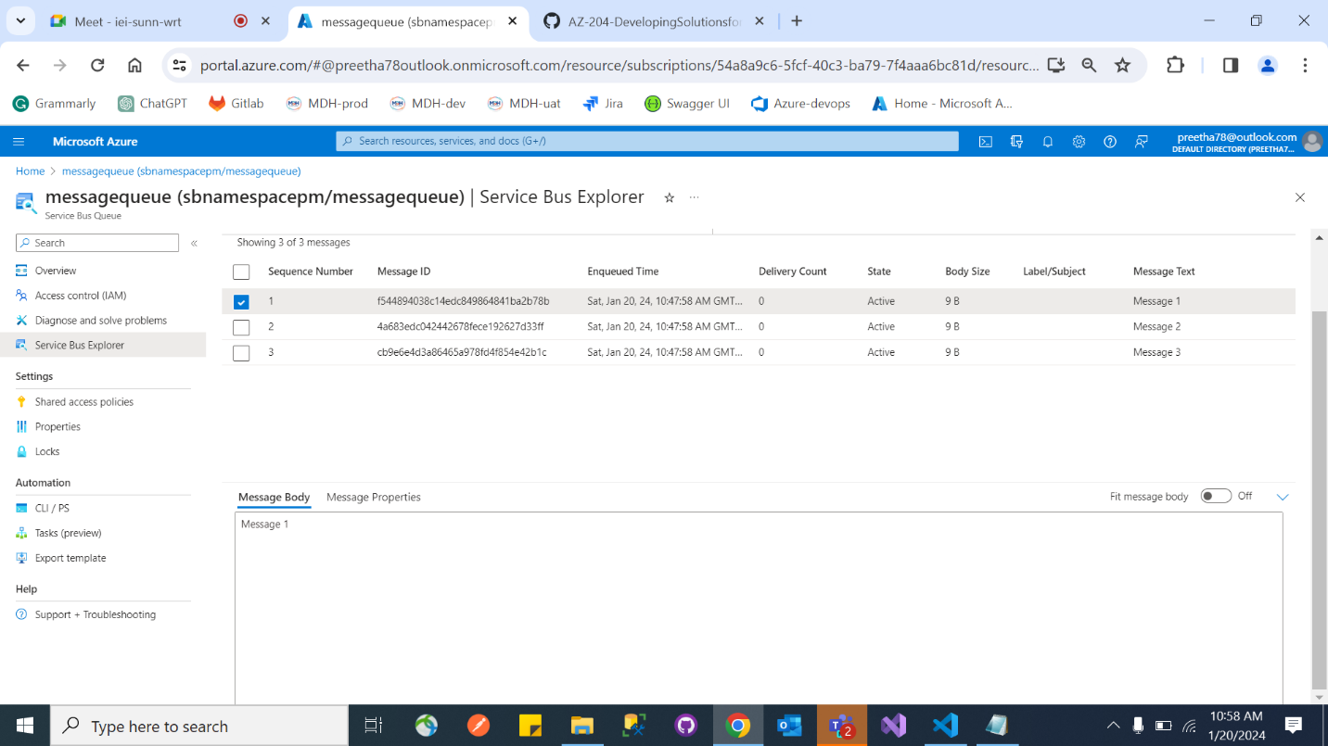

**Exercise 3:** Create a .NET Core project to read messages from a Service Bus queue

