ASP.Net MVC 5.0
Lab Book



.

Document Revision History

Date | Revision No. | Author | Summary of Changes

Table of Contents

Document Revision History 2
Table of Contents 1
Getting Started 2
Overview 2
Setup Checklist for ASP.Net MVC 5 2
Instructions 2
Lab 1. Creating a new Web Forms Project 3
Lab 2. Creating an MVC Controller Using Scaffolding 10

Getting Started

Overview
This lab book is a guided tour for learning ASP.Net MVC 5. It comprises solved examples and ‘To Do’ assignments. Follow the steps provided in the solved examples and work out the given ‘To Do’ assignments.

Setup Checklist for ASP.Net MVC 5
For the lab to work, following are the system requirements:
Minimum System Requirements
- Networked PCs with access to SQL Server 2012 and Minimum 256 MB RAM, 600 MB Hard Disk.
- OS: Windows XP with SP2 or Windows 2003 or Windows Vista
- .NET 4.5.1 Framework Installed
- Visual Studio.NET 2013 with .NET 4.5 extensions.
- MS SQL Server 2012

Instructions
- Create a directory by your name in drive <drive>. In this directory, create a subdirectory aspnet_mvc5_assgn. For each lab exercise create a directory as lab <lab number>.
- You may also look up the on-line help provided in the MSDN library.
- Creating a new Web Forms Project

Goals | - To Understand One ASP.Net unified project experience which allows us to easily integrate Web Forms, MVC and Web API components in the same application
Time | 20 minutes

Task 1: Creating a new site using One ASP.Net experience

In this task you will start creating a new Web site in Visual Studio based on the One ASP.NET project type. One ASP.NET unifies all ASP.NET technologies and gives you the option to mix and match them as desired.
Step 1: Open Visual Studio 2013 and select File|New Project to start a new Solution.
Step 2: In the New Project dialog box, select ASP.Net Web Application under the Visual C# | Web tab and make sure .Net Framework 4.5 is selected. Name the project MyHybridSite, choose a location and click ok.
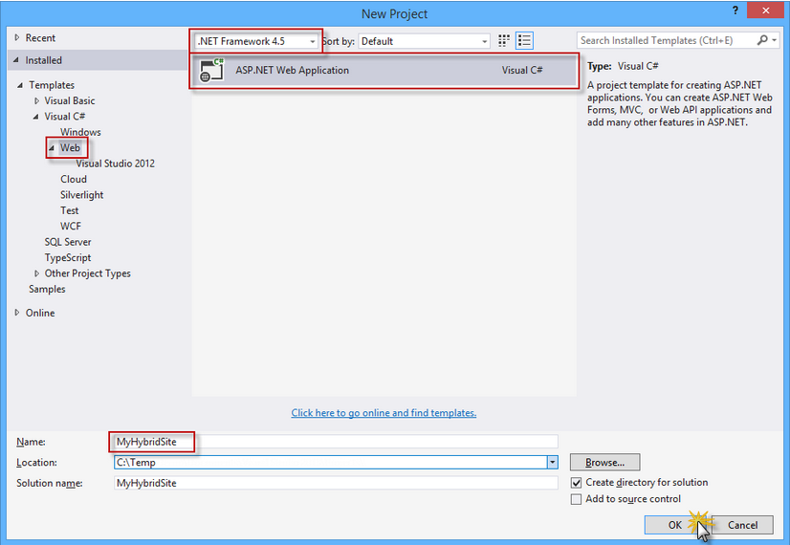

Step 3: In the New ASP.Net Project, select the Web Forms template and select the MVC and Web API options. Also make sure the Authentication option is set to Individual User Accounts. Click Ok to continue.
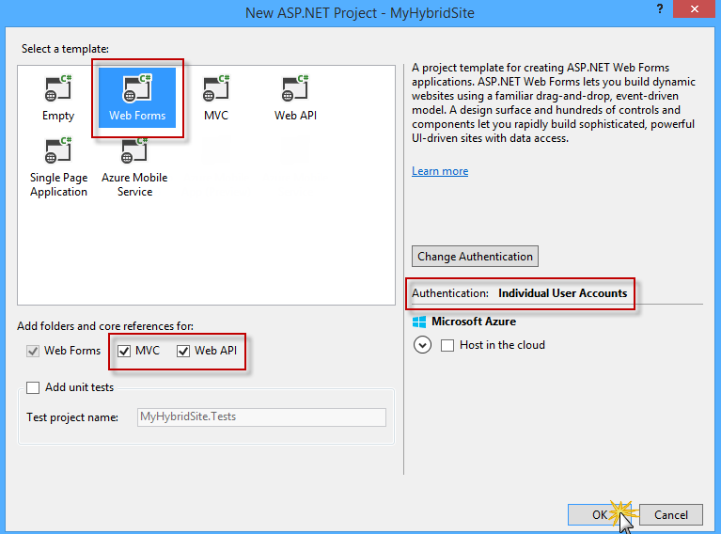
Step 4: You can explore the structure of the generated solution.
- Account: This folder contains the Web Form pages to register, log in to and manage the application's user accounts. This folder is added when the Individual User Accounts authentication option is selected during the configuration of the Web Forms project template.
- Models: This folder will contain the classes that represent your application data.
- Controllers and Views: These folders are required for the ASP.NET MVC and ASP.NET Web API components. You will explore the MVC and Web API technologies in the next exercises.
- The Default.aspx, Contact.aspx and About.aspx files are pre-defined Web Form pages that you can use as starting points to build the pages specific to your application. The programming logic of those files resides in a separate file referred to as the "code-behind" file, which has an ".aspx.vb" or ".aspx.cs" extension (depending on the language used). The code-behind logic runs on the server and dynamically produces the HTML output for your page.
- The Site.Master and Site.Mobile.Master pages define the look and feel and the standard behavior of all the pages in the application.
Step 5: Double click the Default.aspx file to explore the content of the page
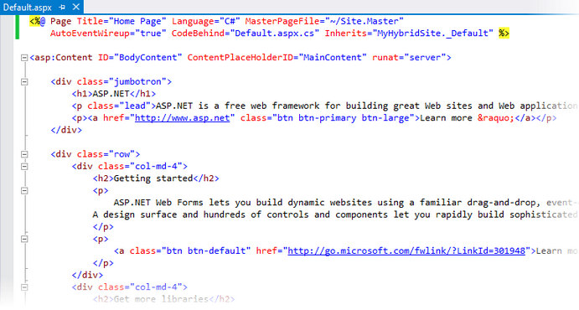

Step 6: Expand the App_Start folder and notice the WebApiConfig.cs file. Visual Studio included that file in the generated solution because you included Web API when configuring your project with the One ASP.NET template.
Step 7: Open the WebApiConfig.cs file. In the WebApiConfig class you will find the configuration associated with Web API, which maps HTTP routes to Web API controllers.
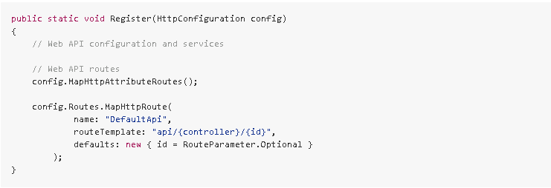
Step 8: Open the RouteConfig.cs file. Inside the RegisterRoutes method you will find the configuration associated with MVC, which maps HTTP routes to MVC controllers.
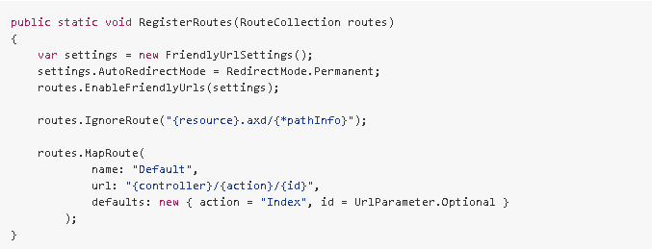

Task 2: Running the Solution
In this task you will run the generated solution, explore the app and some of its features, like URL rewriting and built-in authentication.
Step 1: To run the solution, press F5 or click the Start button located on the toolbar. The application home page should open in the browser.
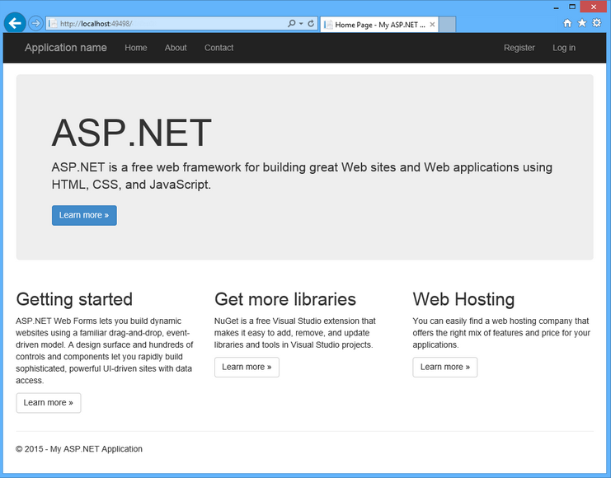
Step 2: Verify that the Web Forms pages are being invoked. To do this, append /contact.aspx to the URL in the address bar and press Enter.

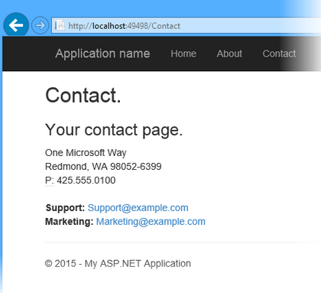
Step 3: You will now explore the authentication flow integrated into the application. To do this, click Register in the upper-right corner of the page.

Step 4: In the Register page, enter a User name and Password, and then click Register.
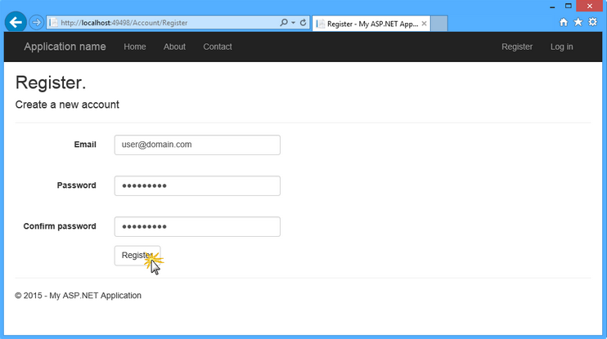
Step 5: The application registers the new account, and the user is authenticated.
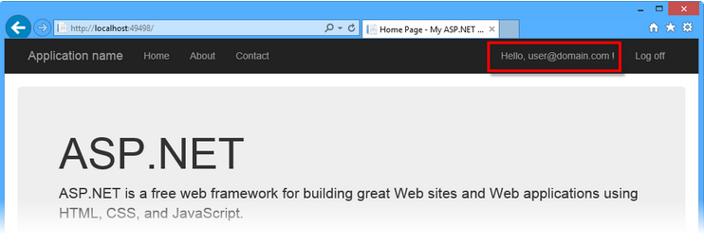
Step 6: Go back to Visual Studio and press SHIFT + F5 to stop debugging.

Stretched Assignments:

- Creating an MVC Controller Using Scaffolding

Goals | - Explain what is Scaffolding  - Understand and implement CRUD operations using scaffolding feature
Time | 25 minutes

In this exercise you will take advantage of the ASP.NET Scaffolding framework provided by Visual Studio to create an ASP.NET MVC 5 controller with actions and Razor views to perform CRUD operations, without writing a single line of code. The scaffolding process will use Entity Framework Code First to generate the data context and the database schema in the SQL database.

Task 1: Creating a new Model
You will now define a Person class, which will be the model used by the scaffolding process to create the MVC controller and the views. You will start by creating a Person model class, and the CRUD operations in the controller will be automatically created using scaffolding features.
Step 1: Open Visual Studio Community 2013 and the MyHybridSite.sln solution which was created previously in Lab 1.
Step 2: In Solution Explorer, right-click the Models folder of the MyHybridSite project and select Add | Class....
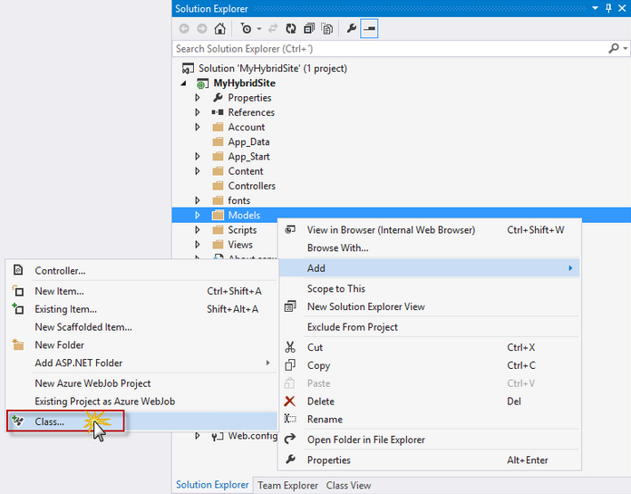
Step 3: In the Add New Item dialog box, name the file Person.cs and click Add.
Step 4: Replace the content of the Person.cs file with the following code. Press CTRL + S to save the changes
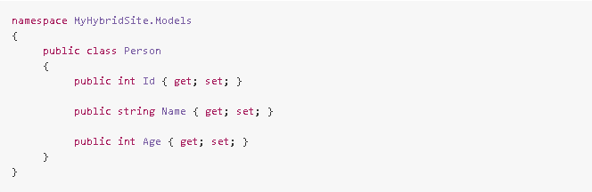
Step 5: In Solution Explorer, right-click the MyHybridSite project and select Build, or press CTRL + SHIFT + B to build the project.

Task 2: Creating an MVC Controller
Now that the Person model is created, you will use ASP.NET MVC scaffolding with Entity Framework to create the CRUD controller actions and views for Person
Step 1: In Solution Explorer, right-click the Controllers folder of the MyHybridSite project and select Add | New Scaffolded Item....
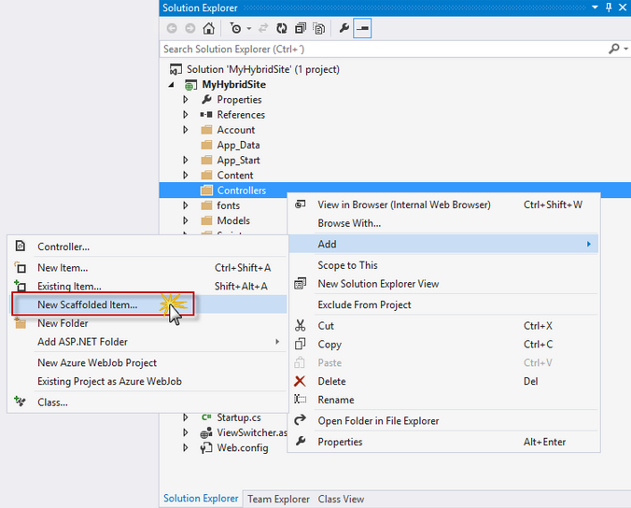
Step 2: In the Add Scaffold dialog box, select MVC 5 Controller with views, using Entity Framework and then click Add.
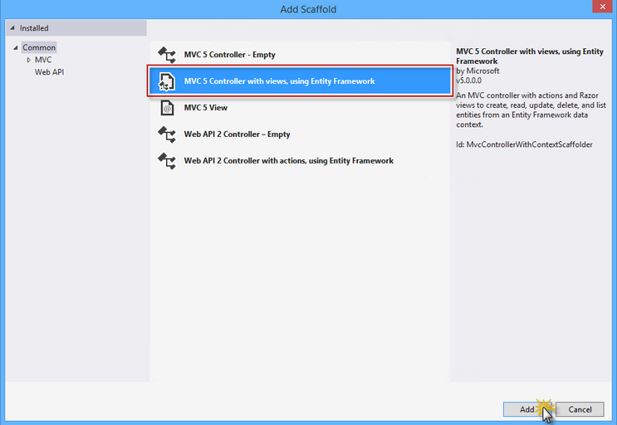
Step 3: Set MvcPersonController as the Controller name, select the Use async controller actions option and select Person (MyHybridSite.Models) as the Model class.
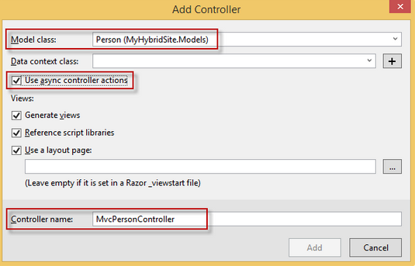
Step 4: Under Data context class, click New data context button.
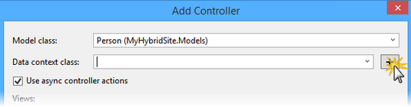
Step 5: In the New Data Context dialog box, name the new data context PersonContext and click Add.
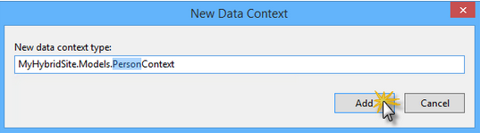
Step 6: Click Add to create the new controller for Person with scaffolding. Visual Studio will then generate the controller actions, the Person data context and the Razor views.
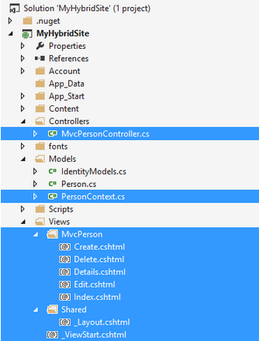
Step 7: Open the MvcPersonController.cs file in the Controllers folder. Notice that the CRUD action methods have been generated automatically.
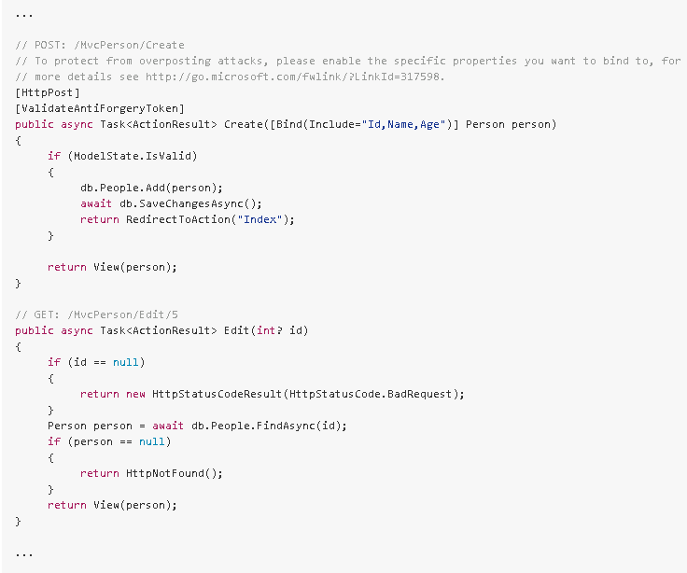
Note: By selecting the Use async controller actions check box from the scaffolding options in the previous steps, Visual Studio generates asynchronous action methods for all actions that involve access to the Person data context. It is recommended that you use asynchronous action methods for long-running, non-CPU bound requests to avoid blocking the Web server from performing work while the request is being processed.

Task 3 – Running the Solution
In this task, you will run the solution again to verify that the views for Person are working as expected. You will add a new person to verify that it is successfully saved to the database.
Step 1: Press F5 to run the solution.

Step 2: Navigate to /MvcPerson. The scaffolded view that shows the list of people should appear

Step 3: Click Create New to add a new person.

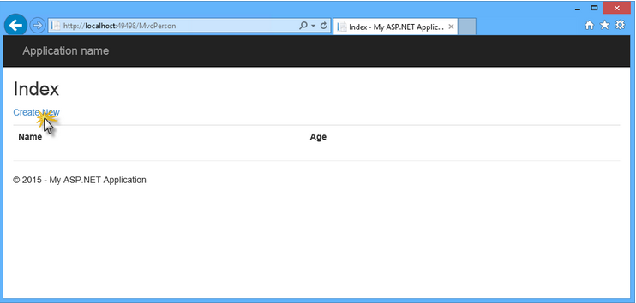

Step 4: In the Create view, provide a Name and an Age for the person, and click Create.

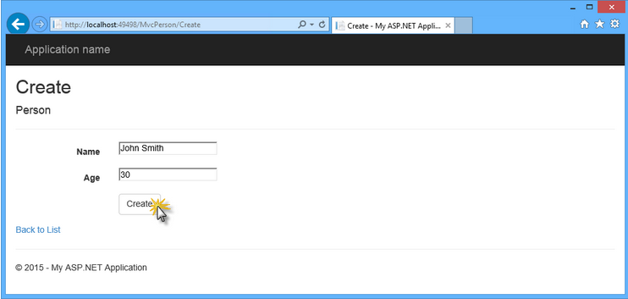

Step 5: The new person is added to the list. In the element list, click Details to display the person's details view. Then, in theDetails view, click Back to List to go back to the list view.

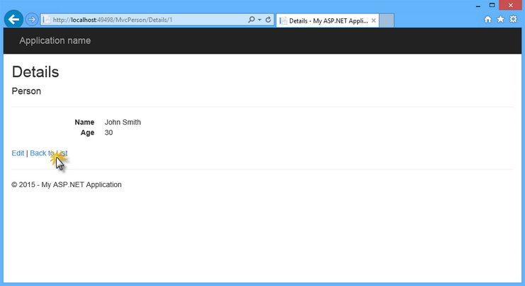

Step 6: Click the Delete link to delete the person. In the Delete view, click Delete to confirm the operation.

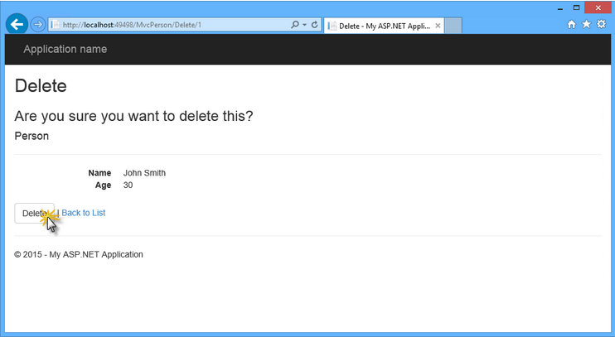
Step 7: Go back to Visual Studio and press SHIFT + F5 to stop debugging.

