- Create an ER diagram for the given airlines database.

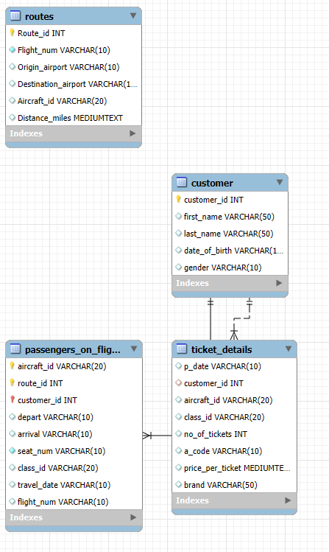

- Write a query to create a route_details table using suitable data types for the fields, such as route_id, flight_num, origin_airport, destination_airport, aircraft_id, and distance_miles. Implement the check constraint for the flight number and unique constraint for the route_id fields. Also, make sure that the distance miles field is greater than 0.

create table Routes(
Route_id int NOT NULL AUTO_INCREMENT,
Flight_num varchar(10),
Origin_airport varchar(10),
Destination_airport varchar(10),
Aircraft_id varchar(20),
Distance_miles long,
primary key(Route_id)
);
ALTER TABLE Routes
ADD CHECK (Flight_num>=1),
ADD CHECK (Distance_miles>0);

- Write a query to display all the passengers (customers) who have travelled in routes 01 to 25. Take data from the passengers_on_flights table.
select * from passengers_on_flights where route_id between 1 and 25;

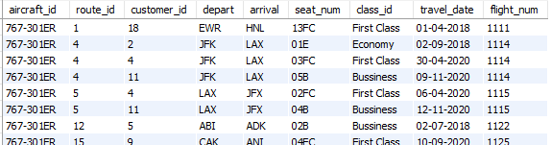

- Write a query to identify the number of passengers and total revenue in business class from the ticket_details table.

select sum(price_per_ticket) as TotalPrice,count(no_of_tickets) as TicketCount,class_id from ticket_details group by class_id;

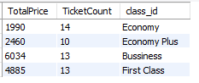

- Write a query to display the full name of the customer by extracting the first name and last name from the customer table.

select concat(first_name," ",last_name) as full_name from customer;

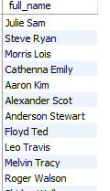

- Write a query to extract the customers who have registered and booked a ticket. Use data from the customer and ticket_details tables.

select c.first_name,c.last_name,c.customer_id,t.p_date,t.aircraft_id,t.class_id,t.brand from customer c
inner join ticket_details t on c.customer_id=t.customer_id order by customer_id;

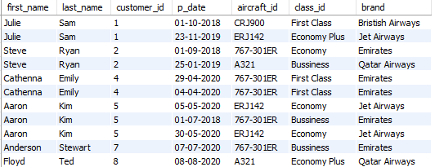

- Write a query to identify the customer’s first name and last name based on their customer ID and brand (Emirates) from the ticket_details table.

select c.first_name,c.last_name,c.customer_id,t.brand,t.p_date from customer c inner join ticket_details t
on c.customer_id=t.customer_id where t.brand='Emirates' order by c.customer_id;

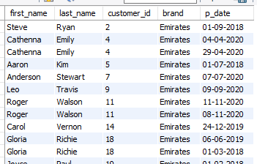

- Write a query to identify the customers who have travelled by Economy Plus class using Group By and Having clause on the passengers_on_flights table.

select c.customer_id,c.first_name,c.last_name,p.class_id,p.seat_num,p.travel_date from passengers_on_flights p
left join customer c on p.customer_id=c.customer_id group by
c.customer_id,c.first_name,c.last_name,p.class_id,p.seat_num,p.travel_date having p.class_id='Economy Plus' order by c.customer_id ;

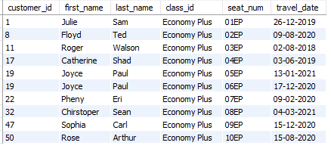

- Write a query to identify whether the revenue has crossed 10000 using the IF clause on the ticket_details table.

select sum(price_per_ticket*no_of_tickets) as revenue,
if(sum(price_per_ticket*no_of_tickets) >10000,'Revenue Crossesd','Revenue Not Crossed') as Profit from ticket_details;

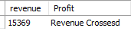

- Write a query to create and grant access to a new user to perform operations on a database.

CREATE USER 'Preetha'@'localhost' IDENTIFIED BY 'preetha123';
GRANT ALL PRIVILEGES ON *.* TO 'Preetha'@'localhost' WITH GRANT OPTION;

- Write a query to find the maximum ticket price for each class using window functions on the ticket_details table.

select distinct(class_id),max(price_per_ticket) over(partition by class_id) as maxprice from ticket_details;
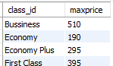

- Write a query to extract the passengers whose route ID is 4 by improving the speed and performance of the passengers_on_flights table.

CREATE INDEX idx_Route_id ON air_cargo.passengers_on_flights (route_id);

- For the route ID 4, write a query to view the execution plan of the passengers_on_flights table.

select * from air_cargo.passengers_on_flights where route_id=4;
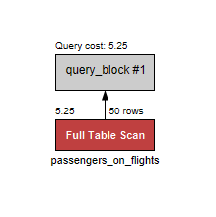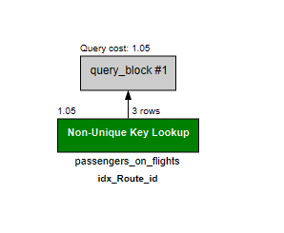

- Write a query to calculate the total price of all tickets booked by a customer across different aircraft IDs using rollup function.
SELECT customer_id,sum(price_per_ticket*no_of_tickets) as totalprice
FROM ticket_details
GROUP BY customer_id
WITH ROLLUP;

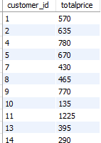

- Write a query to create a view with only business class customers along with the brand of airlines.
create or replace view VW_ticket_details as
select t.customer_id,c.first_name,c.last_name,c.gender,t.aircraft_id,t.brand,t.p_date from ticket_details t left join customer c
on t.customer_id=c.customer_id
where class_id='Bussiness' order by customer_id;

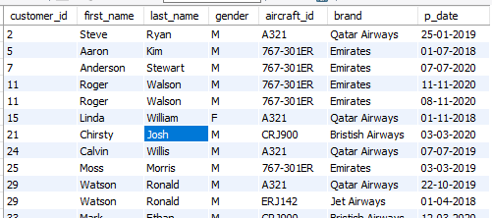

- Write a query to create a stored procedure to get the details of all passengers flying between a range of routes defined in run time. Also, return an error message if the table doesn't exist.

DELIMITER $$
CREATE PROCEDURE AirCargo_CustomerDetails(in route1 int,in route2 int)
begin
DECLARE passengers_table_exists int;
DECLARE customer_table_exists int;
-- check whether passengers table exists
SELECT COUNT(*) INTO passengers_table_exists
FROM information_schema.tables
WHERE table_schema = DATABASE() AND table_name = 'passengers_on_flights';
-- check whether customer table exists
SELECT COUNT(*) INTO customer_table_exists
FROM information_schema.tables
WHERE table_schema = DATABASE() AND table_name = 'customer';
IF passengers_table_exists = 0 OR customer_table_exists = 0 THEN
SELECT 'Error: One or more required tables do not exist. 'AS Message;
else
SELECT 'Table exists'AS Message;
end if;
select c.first_name,c.last_name,c.gender,c.date_of_birth,p.customer_id,p.travel_date,p.flight_num,p.route_id from passengers_on_flights p left join customer c
on p.customer_id=c.customer_id
where p.route_id between route1 and route2 order by customer_id;
end $$

call AirCargo_CustomerDetails(1,7);

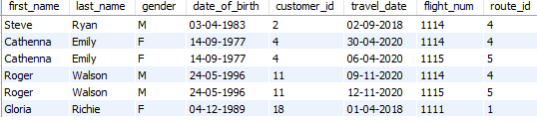

- Write a query to create a stored procedure that extracts all the details from the routes table where the travelled distance is more than 2000 miles.

DELIMITER $$
CREATE PROCEDURE Route_Details()
begin
select * from routes where distance_miles >2000;
end $$
call Route_Details();

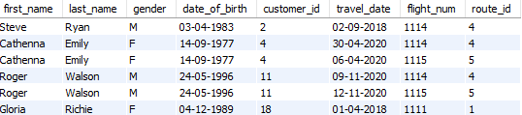

- Write a query to create a stored procedure that groups the distance travelled by each flight into three categories. The categories are, short distance travel (SDT) for >=0 AND <= 2000 miles, intermediate distance travel (IDT) for >2000 AND <=6500, and long-distance travel (LDT) for >6500.

DELIMITER $$
CREATE PROCEDURE DistanceTravelled()
begin
select *,
case when distance_miles >=0 and distance_miles <= 2000 then 'Short Distance Travelled'
when distance_miles >6500 then 'Long Distance Travelled'
else 'Intermediate Distance Travelled'
end as DitstanceTravelled from routes;
end $$

call DistanceTravelled();

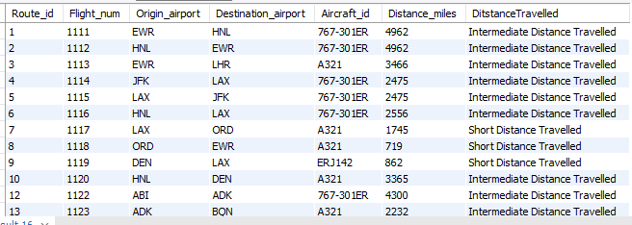

- Write a query to extract ticket purchase date, customer ID, class ID and specify if the complimentary services are provided for the specific class using a stored function in stored procedure on the ticket_details table.
Condition:
- If the class is Business and Economy Plus, then complimentary services are given as Yes, else it is No
DELIMITER //
create function checkComplimentaryService(classid varchar(20)) returns text DETERMINISTIC
begin
declare needService text;
set needService=case
when classid='Bussiness' then 'Yes'
when classid='Economy Plus' then 'Yes'
else 'No'
end ;
return needService;
end //

DELIMITER $$
create procedure proComplimentaryService()
begin
select t.p_date,t.customer_id,t.class_id,checkComplimentaryService(t.class_id) as CheckService from ticket_details t;
end $$

call proComplimentaryService();

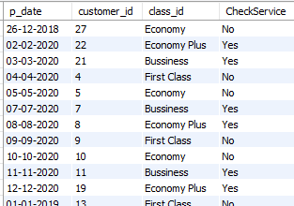

- Write a query to extract the first record of the customer whose last name ends with Scott using a cursor from the customer table.

DELIMITER //
CREATE PROCEDURE CURSOR_GetName()
BEGIN
DECLARE tempFN VARCHAR (100);
DECLARE tempLN VARCHAR (100);
DECLARE CURSOR_1 CURSOR FOR SELECT FIRST_NAME , LAST_NAME FROM CUSTOMER;
OPEN CURSOR_1 ;
REPEAT FETCH CURSOR_1 INTO tempFN,tempLN;
UNTIL tempLN = 'SCOTT'
END REPEAT ;
SELECT tempFN AS FIRST_NAME , tempLN AS LAST_NAME;
CLOSE CURSOR_1;
END;
// DELIMITER ;

CALL CURSOR_GetName();

