CRM Analysis for Customer Retention

1. Project Overview
The goal of this project is to analyse CRM data to understand the key factors influencing
customer retention and churn. By identifying these drivers, the company can implement
data-driven strategies to improve loyalty, reduce churn, and boost profitability.

2. Data Preprocessing
- Cleaned missing and inconsistent values in Total Charges.
- Encoded categorical values to numerical values.
- Created engineered features such as Average Tenure, Overall Churn rate, Revenue Loss.

3. Exploratory Data Analysis
Key Insights:
- Overall churn rate: 26%.
- Short-tenure customers (<12 months) are more likely to churn.
- Month-to-month contract customers show highest churn.
- Higher monthly charges increase churn probability.

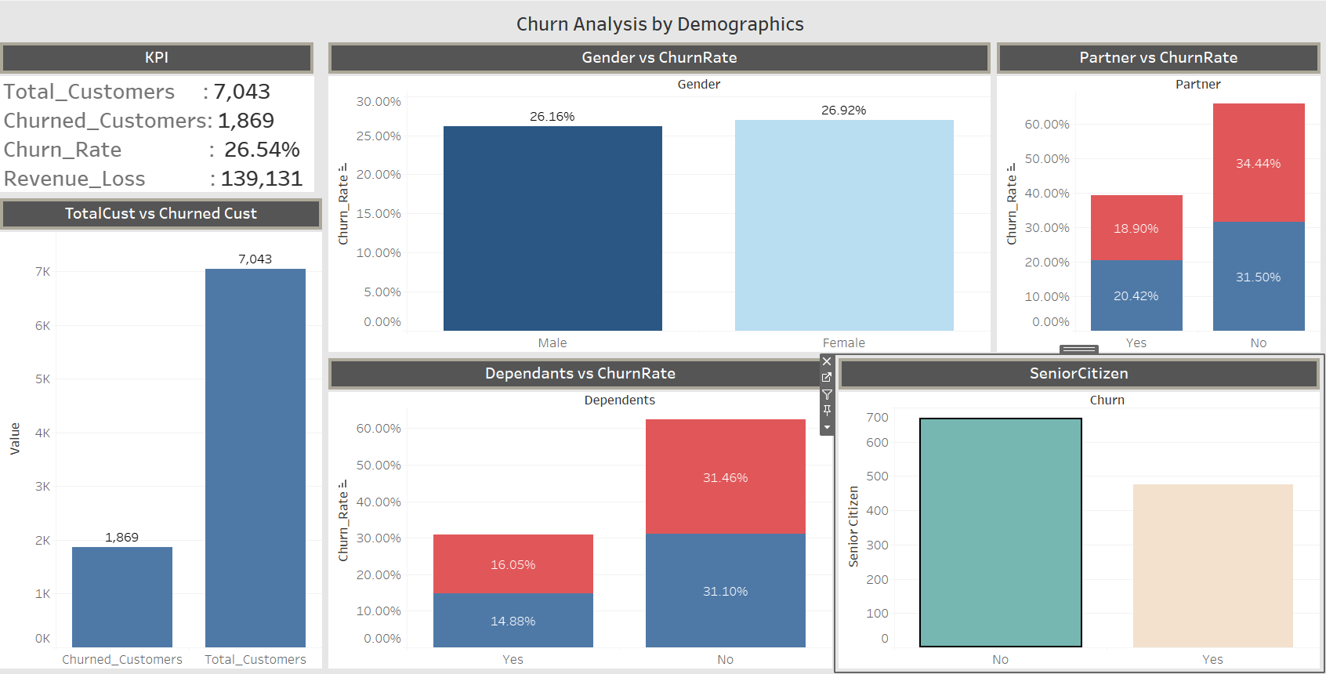
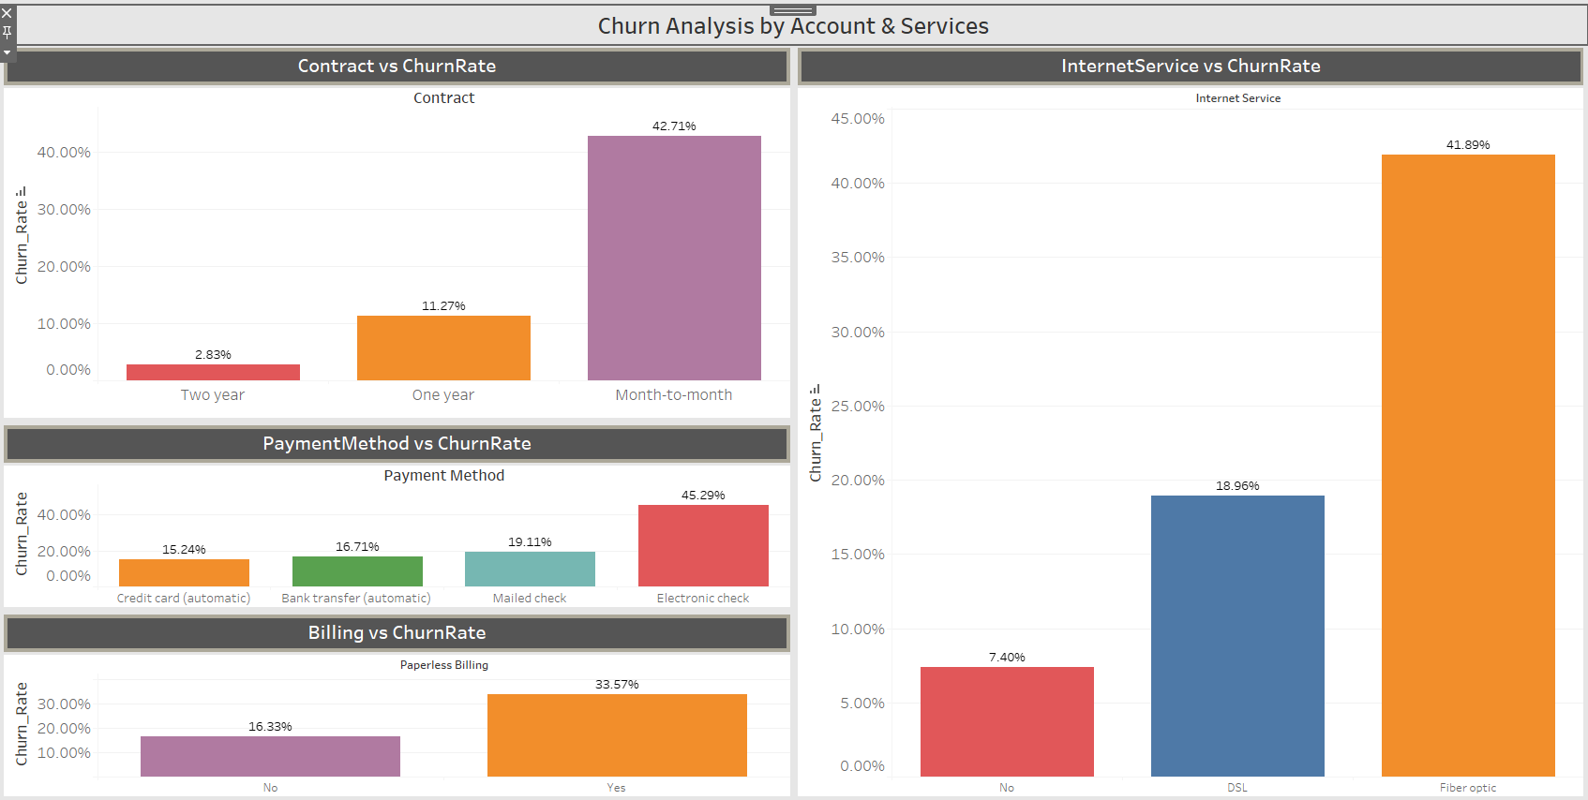

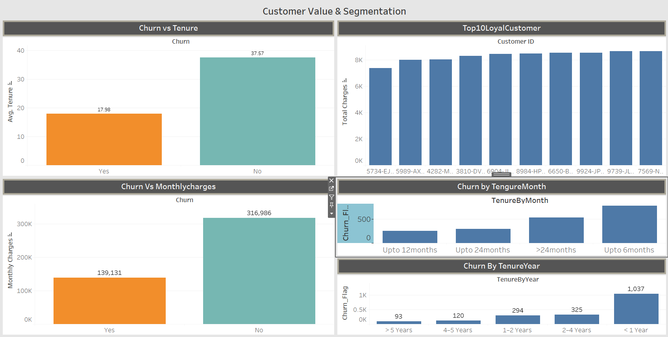

4. Feature Importance
Top Factors Affecting Retention:

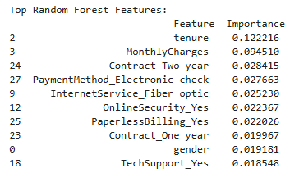

5. Model Development
Tested multiple models including Logistic Regression and Random Forest.

6. Performance Summary
- Logistic Regression: 78% accuracy
- Random Forest: 80% accuracy

7. Key Findings
Top predictors of churn:
- Tenure (shorter = higher churn risk)
- MonthlyCharges (higher = higher churn risk)
- Contract type (month-to-month contracts show higher churn)
- Payment method (electronic check customers churn more)
- Lack of Online Security or Tech Support services increases churn risk

8. Insights and Recommendations
- Offer early loyalty discounts for new customers.
- Provide flexible billing.
- Encourage long-term contracts.

9. Conclusion
The CRM analysis revealed that contract type, tenure, and monthly charges are the key
factors driving churn. By focusing on long-term contracts, pricing optimization, and better
customer support, the company can significantly improve retention rates and overall
profitability.

