To make Playwright no code -Up and Running
Step 1: Open terminal from the root directory and run the following command to install the dependencies:
npm install
in .env file root directory, add the following values for LLM_PROVIDER, LLM_API_KEY and LLM_MODEL
LLM_PROVIDER=GROQ
LLM_API_KEY=
LLM_MODEL=
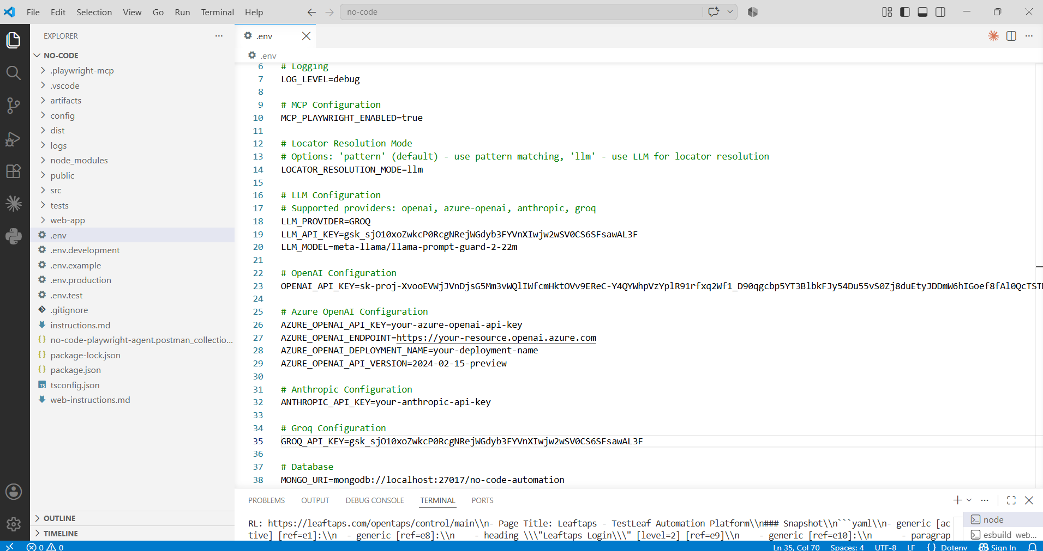
On successful Installation, run the following command
npm run dev
Step 2: Right click on "web-app" and select "Open in Integrated Terminal" and run the following command - npm install
On successful Installation, run the following command - npm run dev
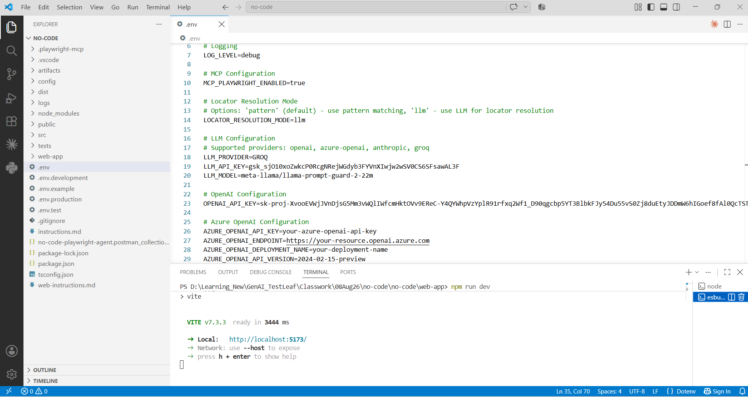
Step 3: The application opens up and we need to paste the feature file inputs in “Editor -> Feature Editor”
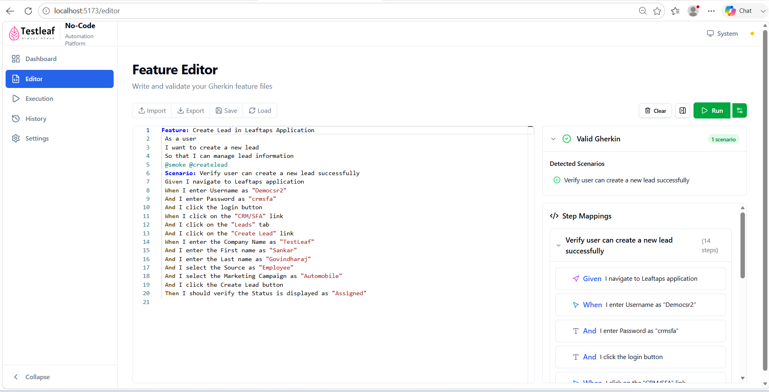
Step 4: In Settings section, add the link “https://leaftaps.com/opentaps/control/main”

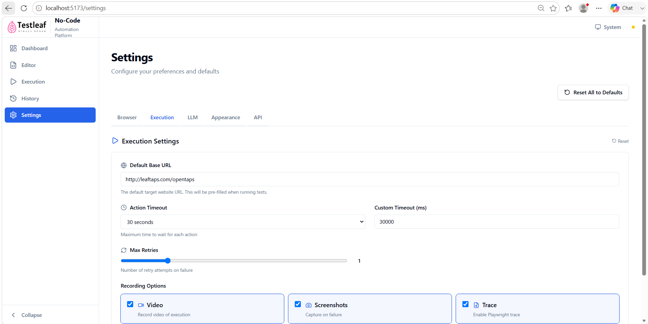
Step 5: Click on “Run” button, Browser will open and run the steps in feature file
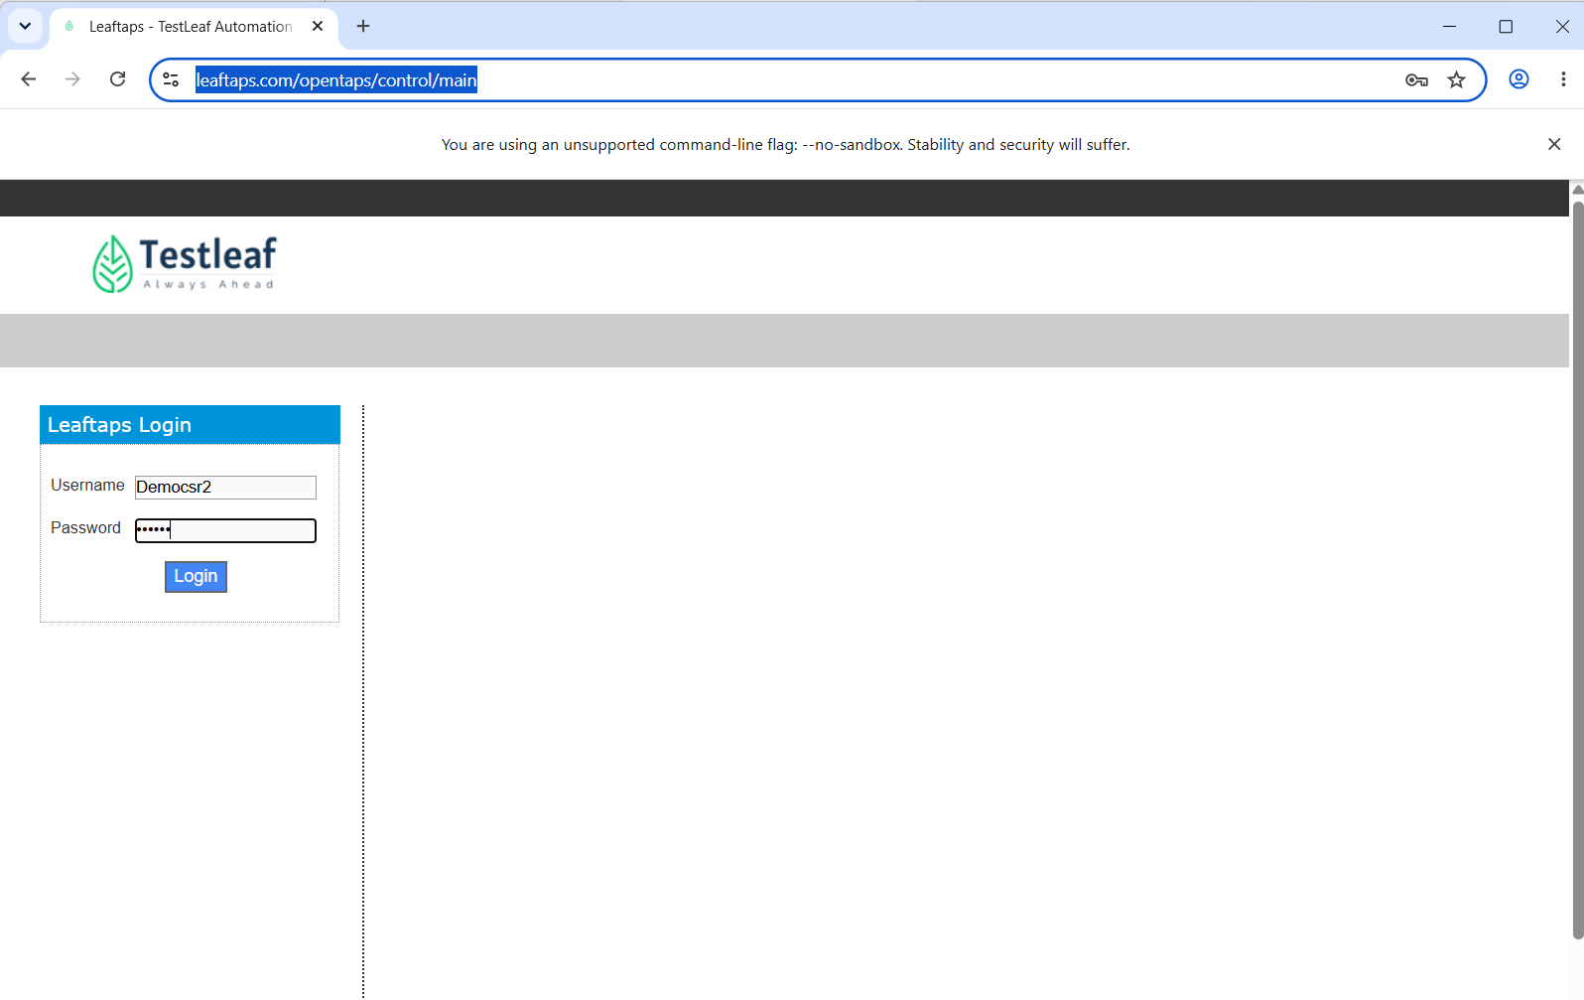

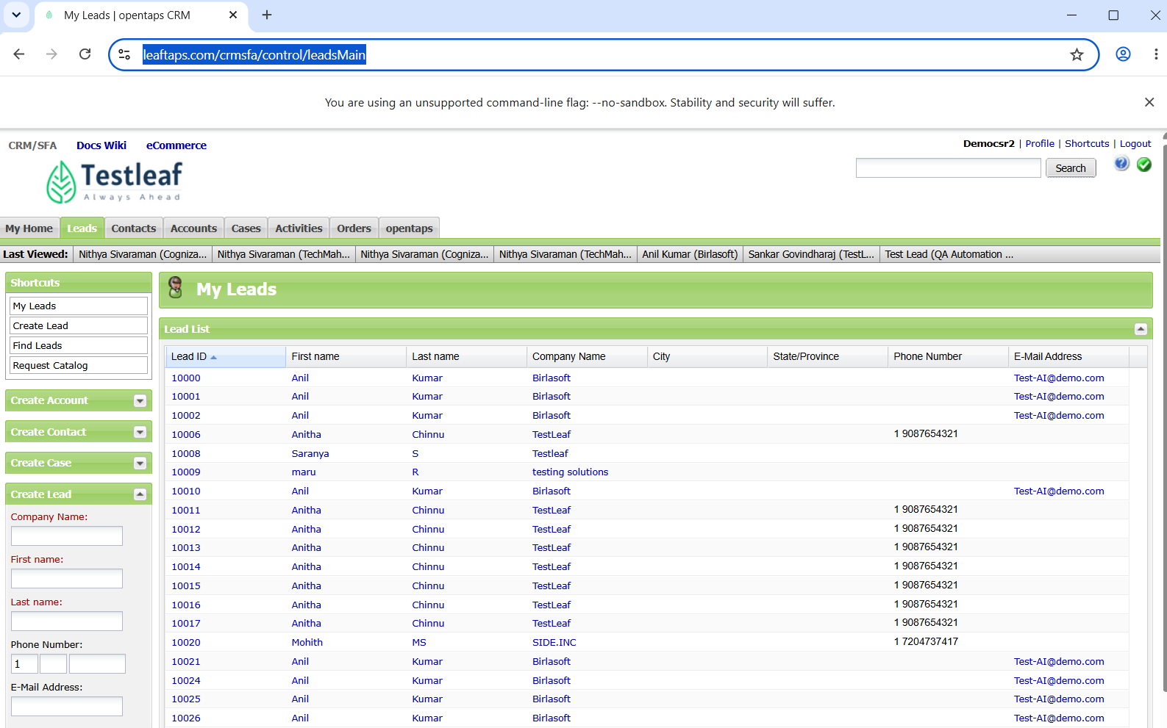
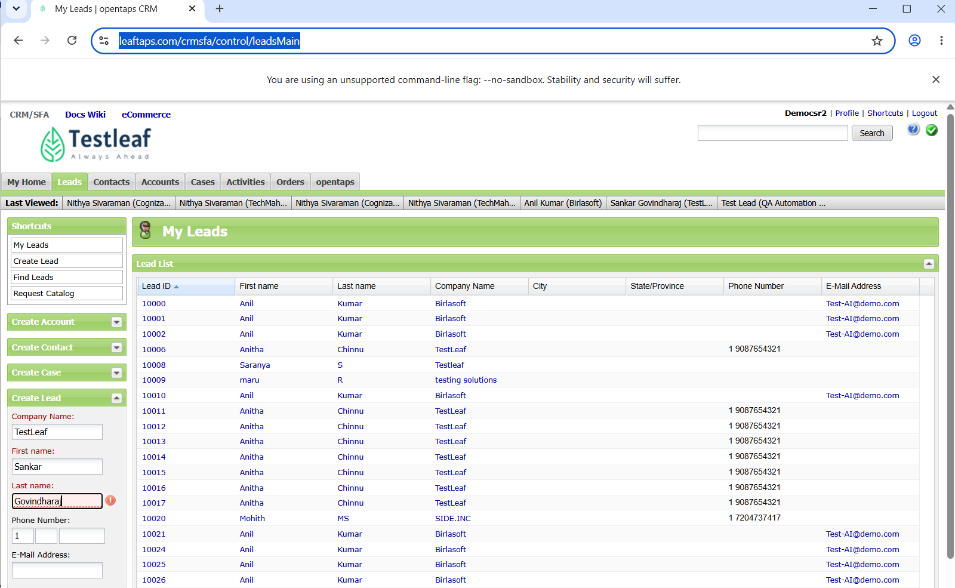
Step 6: you can see the results in the application (along with video)

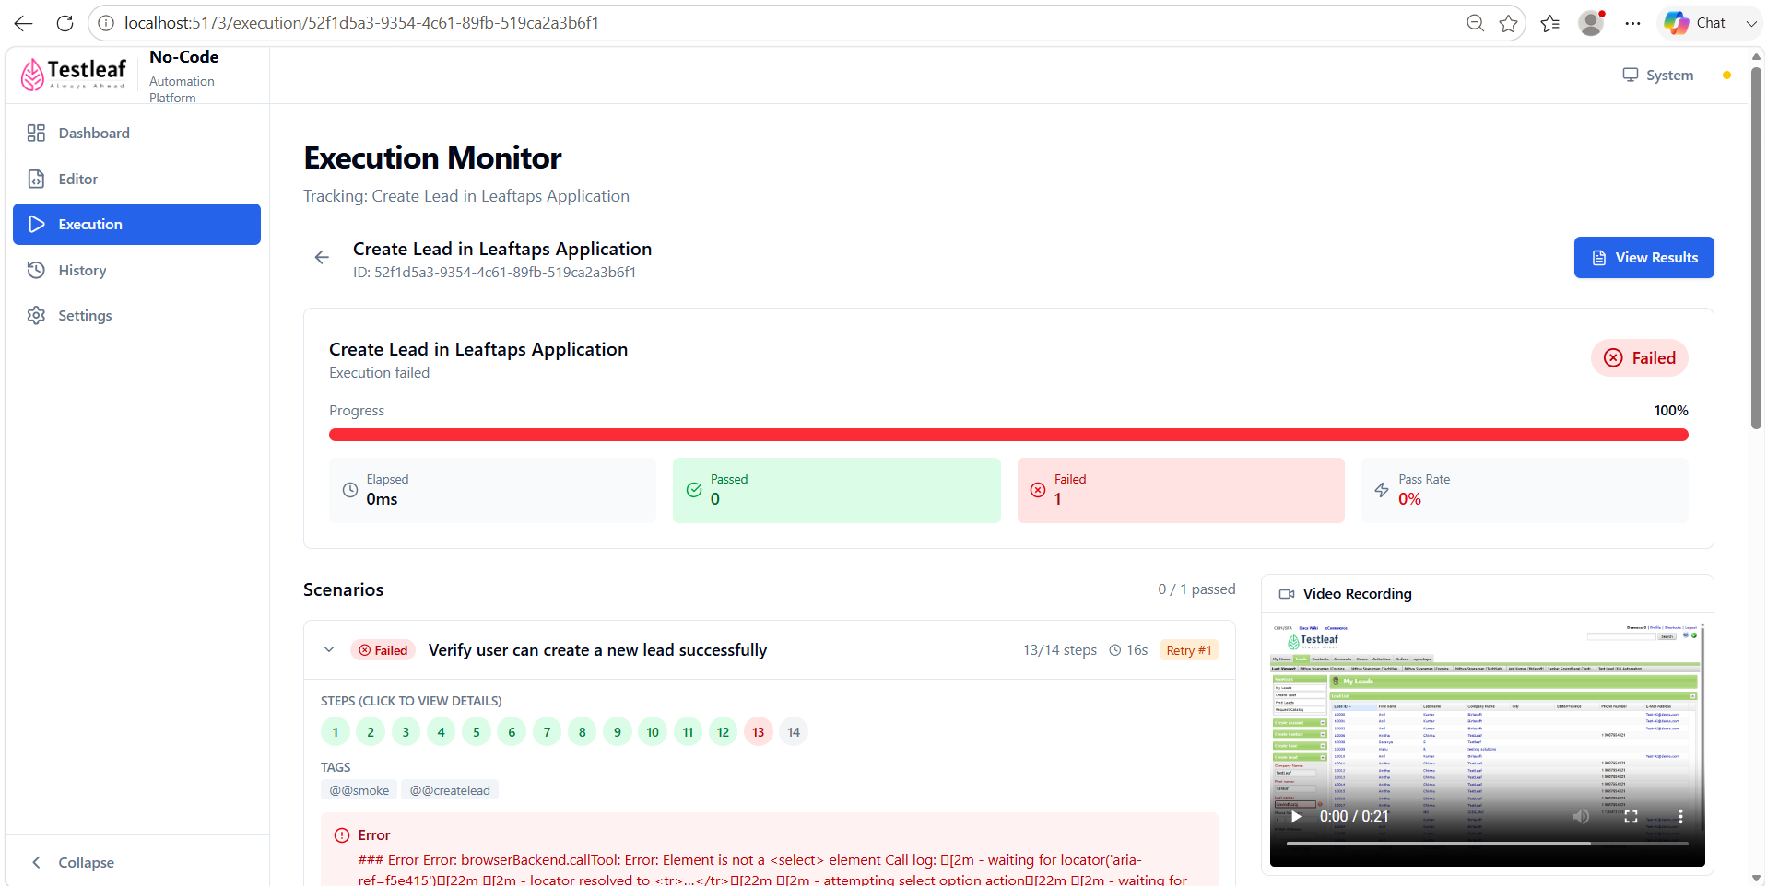
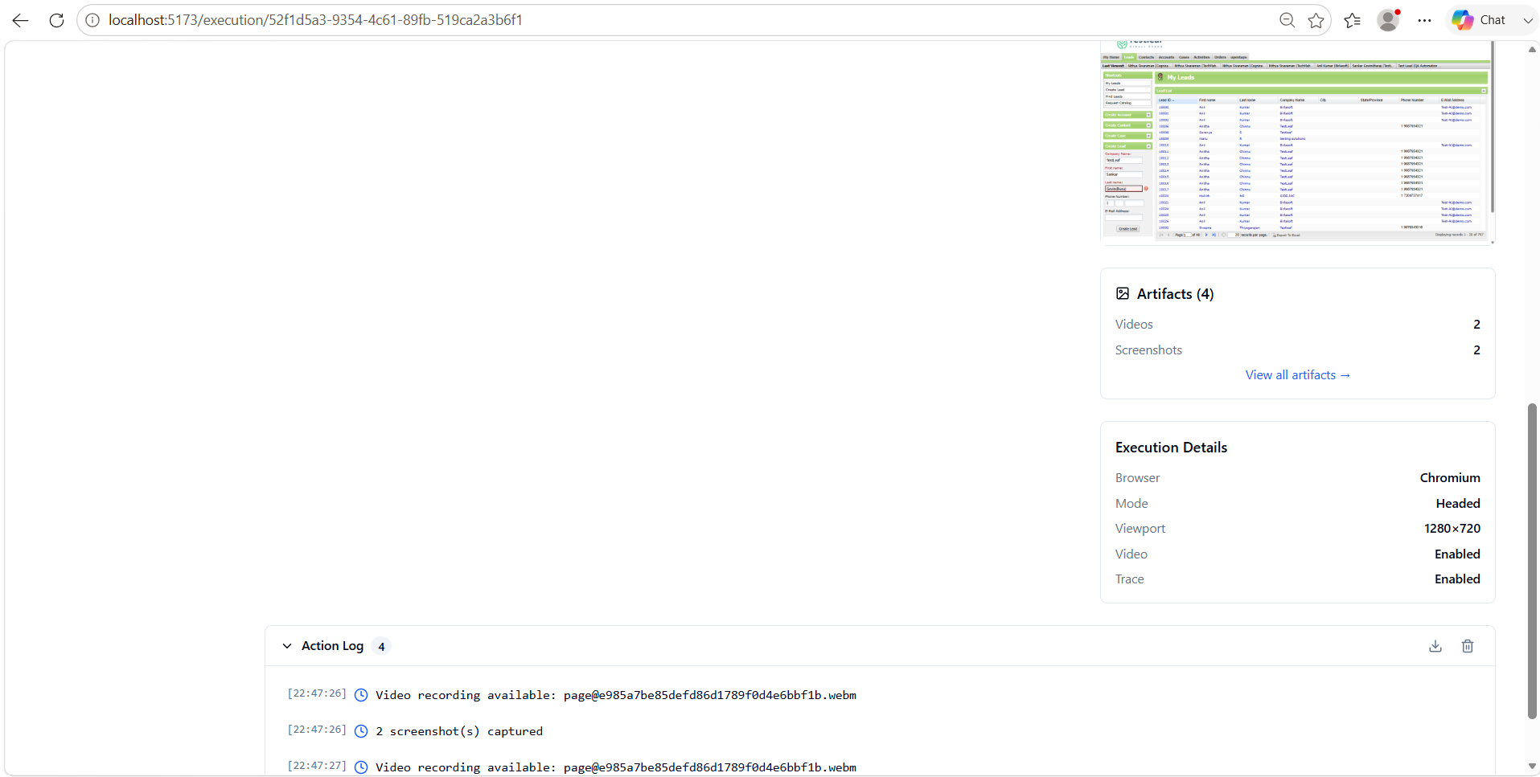
Step 6: History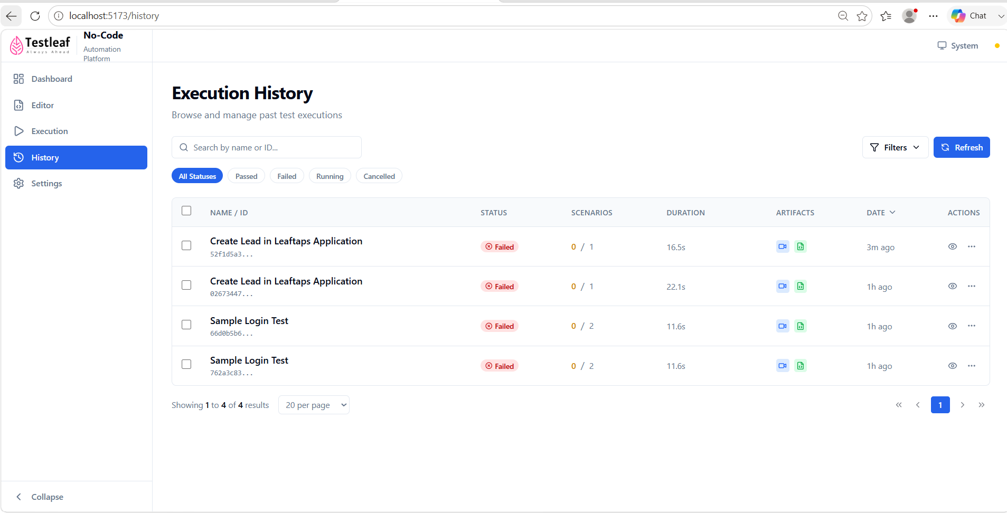
Step 7: Dashboard shows the results
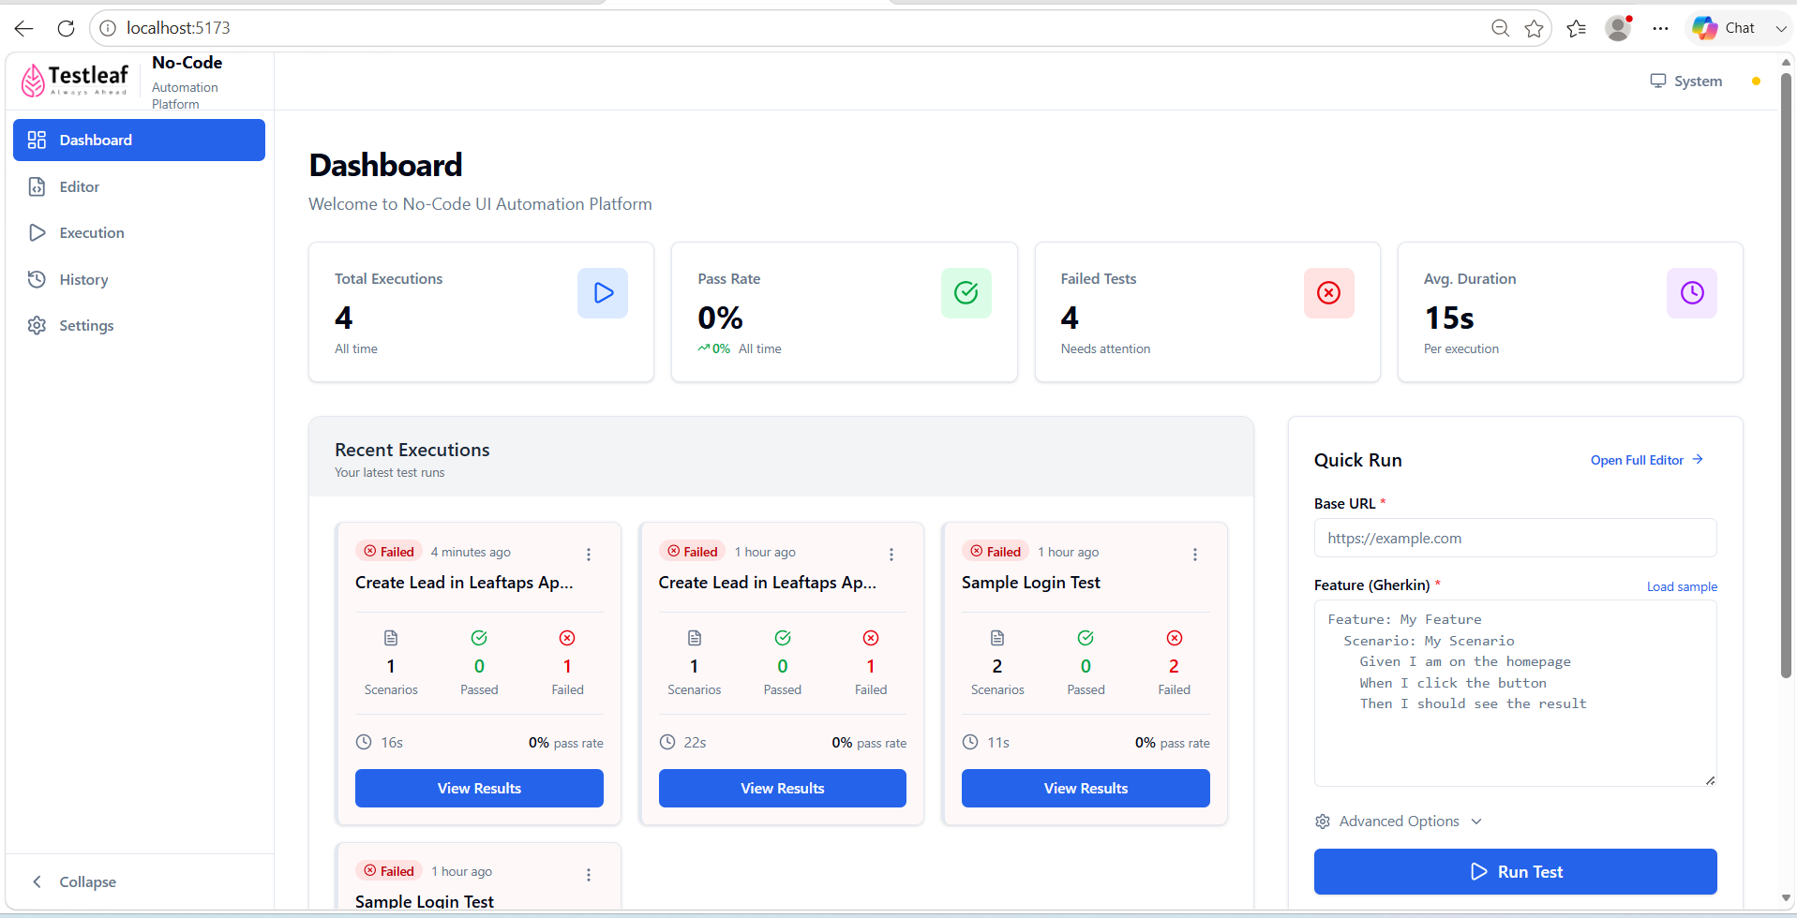
Step 8: Settings
